Partnership to enhance livelihoods and social inclusion of marginalised young people dependent on the informal economy in Tanzania
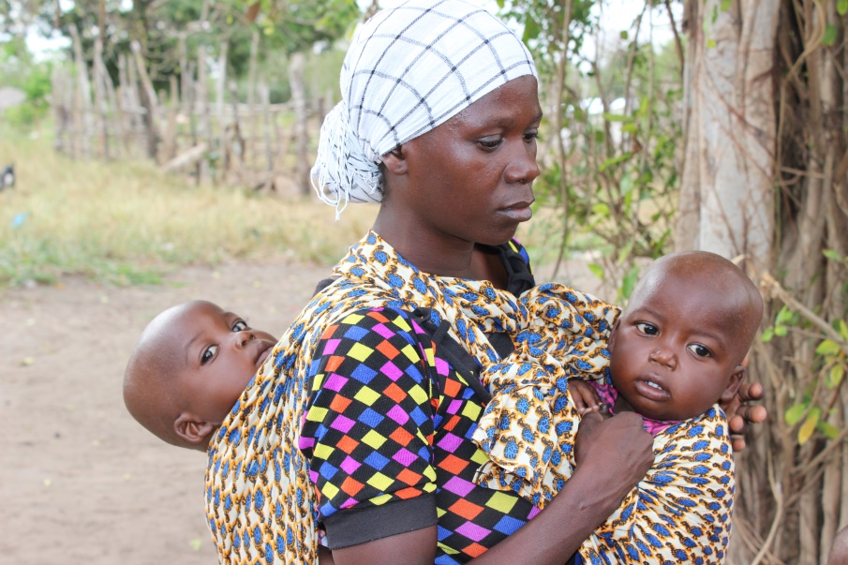
Amina and her little baby twins.

Name: Amina

Project sector: Livelihoods

Implementing Partner: Plan International (UK)

Location: Tanzania

Project: link

Meet Amina. She is a 27 year old married mother of four - two of which are baby twins. She is being supported by Plan UK in Kibaha district, Tanzania with employment opportunities. This project aims to train and empower disadvantaged youth and women to improve their access to sustainable earning potential. Through this approach we are creating a lasting change to lives in the long-term.
Amina’s family depends solely on their agriculture activities to survive. This is severely affected by weather conditions – including drought and floods. She tells us that looking after twins makes earning money very hard.
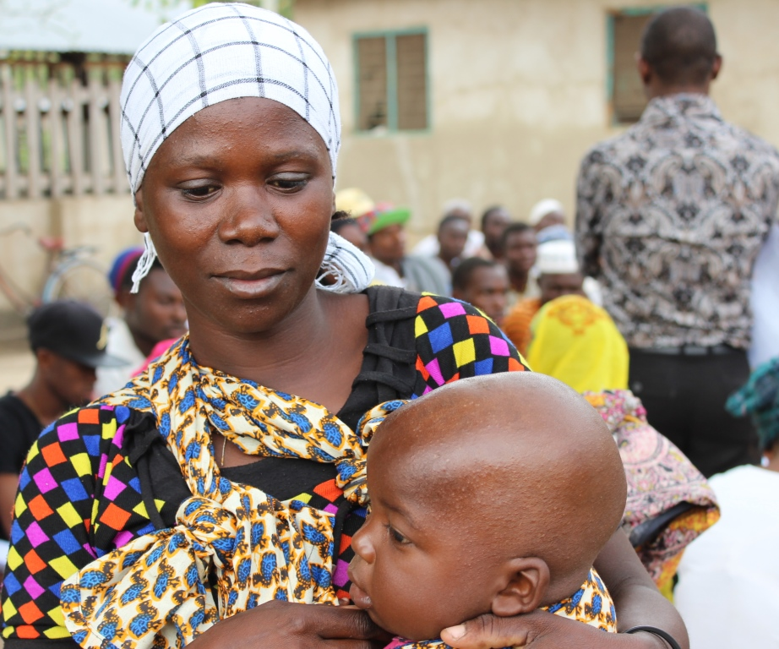
Amina has never gone to school, but has been nursing a dream to do business - especially selling clothes or food with a hope to sustain her family and ultimately to have enough money to educate her children.
Amina’s childhood dream is coming true with this project.

“Although I have never gone to school, I have a dream to be a prominent foodstuff vendor one day in the area and be able to give my children education. The moment I pool starting capital I would venture into the business”, she told us.
Amina’s dream is coming true with this three year project being implemented by Plan UK and the EC - she has already enrolled to do a tailoring apprenticeship.
Through this project she is expected to gain skills to advance her business dreams as well as knowledge on Village Savings and Loan Associations, where she will learn how to manage her earnings.

