Note on Djibouti mission: Improvement of water access in Obock
Date: 29/11/2015
Issued by: JB (WASH Advisor, RO Nairobi)
Background:
The visit (25-26th November, 2015) in Djibouti last 24 hours and was aiming to get more technical information about the water access in Obock and the most relevant and quick way to improve the availability of water within the framework of:
- Already existing water shortage in town prior to arrival of refugees
- Increasing of the refugees population in an area with very limited access to water resources, means also risk of conflict for water access
- Preparedness of El Nino phenomenon in case of drought
The mission aimed as well to in accordance with technical information collected ensure appropriate orientations of the partner activities. In addition, the mission intended to identify potential track of LRRD in Obock with the funds from the Djibouti delegation in the WASH sector.
During the mission, four meetings took place with: EU delegation (Sabina Petrecchia from the cooperation section and her colleagues); FAO/NRC (Leone MagliocchettiLombi, WASH specialist at FAO; NRC: Sandra Hu, Program Manager and Francesca Favini, Technical Advisor from the Emergency unit in stand by for the Yemenis crisis); ONEAD (Mr Nachoian Ahmed, head of technical study for urban system unit); the last one being with NRC (Sandra Hu).
Water access in Obock and Markazi camp situation – Main findings:
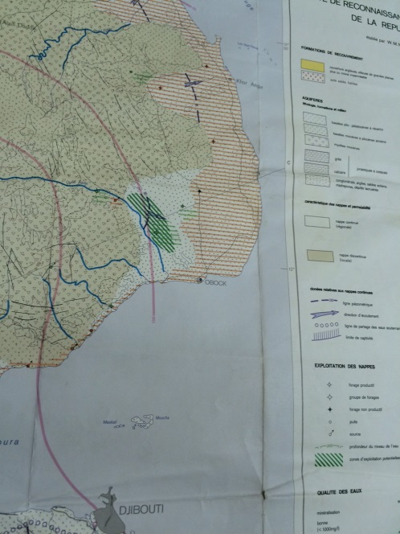
BH, water resources and main supplying line:
Obock town is located on the coast and is populated by about 6000 inhabitants. The town is supplied in water by two BH about 120m deep and located about 12km from Obock inside the land. The pumps of the BH are supply in energy by a 160kVA generator but no backup is in place (meaning that if the generator faces a breakdown the water supply stop). The two BH have their pump connected to the same 11km main supplying connected the BH to the main town storage tank. The connection use to be done by a pipeline made of asbestos cement pipe of 160mm diameter. The pipeline being full of leaks, it increase the hydraulic loss into the pipeline and to balance the loss ONEAD implement a parallel pipeline on most of the length made of PVC pipe 110mm diameter. ONEAD staffs mention that until they started up the second pipeline, they had high jet water (leaks) getting out of the pipeline.
The groundwater resource is apparently an isolated aquifer recharge by temporally wadi.
Pumps:
The two pumps in the BH are directly pumping into the pipeline without intermediary regulation tank and proper booster station. Apparently, the lifespan of the pump is pretty low, 2-4 years according ONEAD so for sure the features of the pump should be affected by the way to pump is operate as a pump should last at least 10 years if the pump selected is adapted to the type of water and if it is protected and properly operate and maintain. Given the length of the pipeline, the flow pumped and the head of the pump, protection against hydraulic hammer should have been implemented as well.
According ONEAD, they pump 30m3/hrs and 24m3/hrs in both BH during 23hrs, which seems to be pretty long duration without recovery time for the groundwater and without break for the generator.
If those data are correct it means that 1134m3 of water is pumped every day for an initial population of 6000persons, which should give about 190L/pp/day without taking into account the leaks in the network.
Water availability:
According an official Djiboutian document (presented by NRC), the distribution network of Obock has an efficiency of 43%, which is a very bad level of efficiency. Even with this level of leaks on the network, given the volume pumped announce by local water authority (ONEAD and local water board), it means that at least 70L/pp/day should be available for the population which is pretty good in the region.
Storage tank and distribution network:
The distribution network is mainly made of asbestos cement pipes and since few years some length has been renewed with PVC and HDPE pipes as asbestos pipe are forbidden as is widely acknowledge that are seriously jeopardizing the public health. Due to the water shortage the supply of water in town is sectorized which means numerous and regular closing and opening of valve that generate hydraulic hammer (elastic wave/vibration to simplify) in the network and then undermine the lifespan of the network by rapid occurrence of important leakage (at every pipe connexion). In addition, asbestos pipe are rigid and can broke easily (more affected by hydraulic hammer than HDPE).
The storage tank according all stakeholders meet is very dirty and the chlorination not anymore functioning. Given the level of leaks (meaning risk of contamination of the water piped) and the way the system is operate, the need to get an efficient chlorination system become almost compulsory.
Gaps and issues:
At the end of the day, much information collected at the local water board and ONEAD in Djibouti are not clear and even sometime contradictory. So, the level of data is not accurate and reliable to clearly understand and diagnosis the system and define the most appropriate way to improve the level of service.
Within the WASH sector the fuel remain the input the affected by diversion as valuable, then we have to consider that this level of confusion in the data could also be in purpose. Actually, this is very weird that there is all this confusion around the amount of water pumping on daily basis as to make work the pump you need the generator to be on and then you need fuel. So, the need of fuel (bought at expensive price) should be known and it should be easy to know from the amount of fuel used at least the working time of the pump, announce at 23hrs per day by ONEAD).
For instance, after discussion with the WASH Specialist from FAO it seems that the hydraulic/piezometric profile of the pipeline from BH to storage tank do not allow such quantity of water as announced by ONEAD and the local water board. For the time it has just been estimated but given the features of the pump and the setup of the system with aged submerged pump flowing directly into two pipelines with one at least being full of leaks, it is clear that this pipeline should be one of the main limitation factor which can explains the shortage of water. Actually, when the ONEAD say that each BH have a water meter, the specialist of FAO who went to visit the site realized that water meter are absent and conclude that thus the way the ONEAD estimate the volume of water pumped per day was just based on the initial pump test report made at time of BH commissioning.
Minimum of additional information needed:
Then, some investigation still has to be performed, and at first:
- Working time of pump/generator should be identify clearly
- And in parallel, the time to fill and empty the only storage tank of Obock should be measured.
- The volume of water billed should also be available (as water board mention that they have water meter at every connexion)
- The length of pipeline confirm as well as length that have been renewed with HDPE or PVC pipe.
- Cleanness of storage tank and chlorination system should also be checked
- Etc…
Risks and assumption:
Today, in addition to the risk of drought coming from the El Nino phenomenon, the hosting of Yemenis refugees in Markazi (location next to Obock close to the storage tank; about 2700 refugees living there) and Obock town (about 3000 refugees living in town) meaning almost double of the host population, imply that the needs to secure and improve level of water supply became compulsory for the town.
In the meantime, especially within the framework of El Nino and the risk of drought it is always more cost efficient to anticipate rather than react to the situation. In addition, the risk of conflict for the water access between refugees and host communities is very high.
Ongoing and planned actions in the WASH sector in Obock/Markazi:
In Obock, NRC is in charge with ECHO funds to develop, operate and maintain the WASH facilities of the camp, including of course the water supply inside the camp. NRC have normally plan as well with the current funding (?) to develop some ad hoc action to improve the global water supply in order to ensure also benefit for the host community.
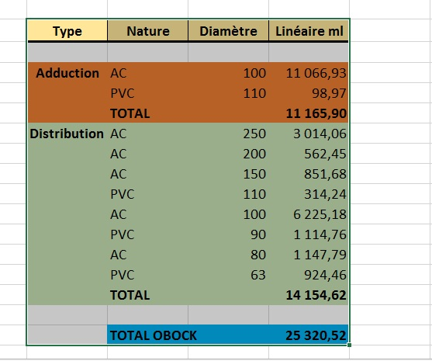
FAO aware about the situation commit themselves upon request from the government to implement a third borehole to increase the water availability. The problem is that they have fund for to complete and equipped the borehole but not to build the supplying pipeline. Meaning, that whether they will use the existing one which seems technically not very coherent if as previously assumes the existing pipeline do not succeed to flow more water and in any case not cost efficient at all as they are going to lose most of the additional water because of the failure (leakage) of the existing pipeline.
Here in front are the different type of pipe diameter and materials composing the water supply system of Djibouti:
General basic analyze related to improvement of water access in Obock – LRRD tracks:
Given the problem highlighted upthere, it is not possible, if deeper investigation confirm the situation of the main supplying pipelines between the BH and the storage tank, to improve substantially the water access in Obock by working only on the distribution network. The first action should then be upstream of the distribution network and the renewing of the main supplying pipeline from the BH to the storage tank with appropriate hydraulic dimensioning should be the first action to be taken.
As a contingency and emergency measure the action on this pipeline could be phased whether the hydraulic calculation required implementation of a big diameter (about 250mm) as the cost increase a lot from 150mm to 200 and then 250mm diameter. Thus, two new pipelines could be implemented, one as first phase from the new BH to the refugees camp to avoid refugees to abstract water from the host communities system; and one as second phase from the two existing BH and the main storage tank with bigger diameter. Those two pipelines could enable a continuous minimum of water supply even in case of heavy breakdown on one of the pipeline. The two systems could be very easily interconnected (the refugee camp is located few meter from the storage tank).
We have to note as well that ONEAD buy all the pipe directly from France, when they are available at least in Kenya where good quality are produced, and even it could be available in Ethiopia… The price of pipe coming from France is for sure very expensive and regional market should be investigated to see how much save could be made on that.
In any way to make the service more affordable for the user the whole system should be rationalized to ensure optimization of its performance and cost efficiency.
Orientation of NRC action and way to improve the water access in Obock:
From NRC as first actions, the following could be envisaged according the fund available:
- Implementation of a chlorination system
- Cleaning of existing reservoir
- Implementation of a backup generator at the BH location
- Construction of a storage tank (50-100m3) to mixed the water from all the boreholes at BH location with connection to the BH and booster station to pump from this mixing chamber (storage tank at BH location) and the town storage tank. Given that it seems that the difference of elevation between the BH and the town storage tank is +45m, economic analyze should be made to see if the system could be partially gravitary and then reduce the fuel consumption, service, …
- In case the option to have two pipelines between BH and town is held, provide the pipes according the budget available or partial replacement of the existing main supplying line until depletion of the budget
- Action on the chlorination, fine tuning, backup and inside the camp water supply system should be complete by NRC in a first stage.
- In a second step according evolving of fund availability complete implementation of the main supplying pipeline could be undertaken (BH-town water tank), as well as implementation of storage tank and if necessary booster station at the locations of BH – check interest of EU delegation for this action as more convenient for their level of budget/ track of LRRD
- In a third step, renewing of the distribution network should be undertaken and phased. The first phase should focus on the main distribution line (bigger diameter) and in any way only on asbestos pipe – check interest of EU delegation for this action as more convenient for their level of budget/ track of LRRD
Apart the action on the main supplying line, others actions mentioned up there have already been considered by NRC. In the initial proposal (for the Djibouti top up money) NRC had plan that some actions will focus on improving the water access or water quality for host communities on the existing hydraulic equipment. The actions were not clearly defined because at stage of the proposal “extension” the situation of the camp was confused as relocation of the site was envisaged by the local authority. In addition, NRC did not complete feasibility assessment and estimate cost estimation of the action yet.
NRC capacity:
In terms of capacity NRC, currently the WASH Specialist of NRC is sharing his time between Ethiopia and Djibouti mission and do not speak French. To implement the activities listed up there, the WASH Specialist should be present in Djibouti during the implementation of the main hardware activities such as storage tank construction stage of storage tank, set up of the hydraulic system, or implementation of chlorination equipment… The presence time of the WASH specialist required will also depend on the modalities of the activities implementation. Whether NRC does not identify a relevant contractor to implement the hardware activities, they will have to directly implement and then the WASH specialist should be present on site during the whole hardware activities implementation.
In case of involvement of NRC in:
- Full or partial replacement of the main supplying pipeline between BH and storage tank with connexion of the third BH
- Or, implementation of an additional supplying pipeline between the new third BH and the storage tank/refugee camp
They will need a permanent proficient WASH staff on the ground ideally speaking French and to identify a relevant contractor.
According availability, the funding of this activity (pipework) could be done by ECHO or EU Delegation (LRRD) if they have fund available for that. If the funding is coming from the delegation, then they will need to identify relevant implementing partners (who could be NRC if there is a permanent WASH specialist and if they have identified a relevant proficient contractor).
Unless the activities mentioned are implemented, the supply of the refugee camp should be done from the existing storage with minimum impact on the level of service usually get by host population.
Wrap up – orientation of the action:
To conclude, given that FAO already plan to complete the third BH, as much as possible action led by our partners or delegation colleagues (in case they are interested to invest on Obock water access improvement) should be complementary to the FAO investment and make it useful and efficient as much as possible.
In any way, prior to necessary action on the distribution network, action should focus on the main supplying pipelines between BH and town storage tank as so far it seems to be the first but not the only one limitation factors. Ideally, the three BH should be connected to the pumping chamber and same pipeline flowing water down to the storage tank of the town with a connexion to the close refugee camps.
According the budget available and the cost estimation of the action, the project could be phased in two stages, the first being the connexion to the refugee camps from the third BH. The unneeded water could then be directed to the town storage tank.
The second stage should be the replacement of the pipeline connected the two existing BH to the town storage tank, then as there is currently two pipelines in parallel in case of budget restriction the oldest pipeline made of Asbestos pipe should be the priority in terms of renewing.
Action on the main supplying pipelines and distribution network will anyway have three relevant impacts:
- Increasing of the water availability
- Improving of the water quality and promoting “good” public heath
- Improving the cost efficiency of the system and then making the system more affordable for the users.
Note about information from the delegation:
By principle they are interested by action to improve water access in Obock, especially as they are push by the government as well to invest more out of Djibouti to balance the service provision between the capital city and the rest of the country. Within the 11eme FED, 63 millions are available for the water and sanitation sector in Djibouti. From the first round of selection our partners NRC has been ejected from the selection process, as delegation colleague consider their proposal not clear enough, which is right and mainly due to the confusion in trying to get reliable technical information. NRC is going to bring a consultant to provide them some technical and strategic insight/assistance.
Apparently, the Vinci group is working in pipe work in Djibouti.
The EU delegation funds the construction of desalinization plant to provide fresh water to Djibouti.
In Obock the construction (funded by the BAD) almost completed of a dam in Sodai upstream to the BH locations should potentially substantially increase the availability of the groundwater and the level of the groundwater table (meaning the pump could have less head and then use less energy).
The colleague from delegation said that the situation of funding is pretty confused especially with many non-traditional donors who are promising a lot, but…. Our colleagues from EU delegation in Djibouti promise to try to get more information about potential funding in the WASH sector in Obock, to see risk of overlapping in case of any involvement.
The EU delegation colleagues whether they could be open to fund an action on water access in Obock, it seems that they need to be a bit driven and especially the cost estimation of the various action envisaged could be presented to get an official position from them regarding their funding potential and interest.

Borehole

