WORKSHOP

Territorial Approaches to Local Development

What does it entail and how can it be fostered

in Eastern and Southern African countries?

Dar Es Salaam, 04-06 April 2016

Organised by DG DEVCO Unit B2

Civil Society and Local Authorities

**Agenda**

Facilitated by

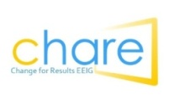

in association with

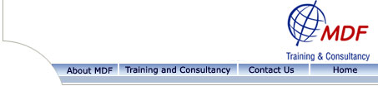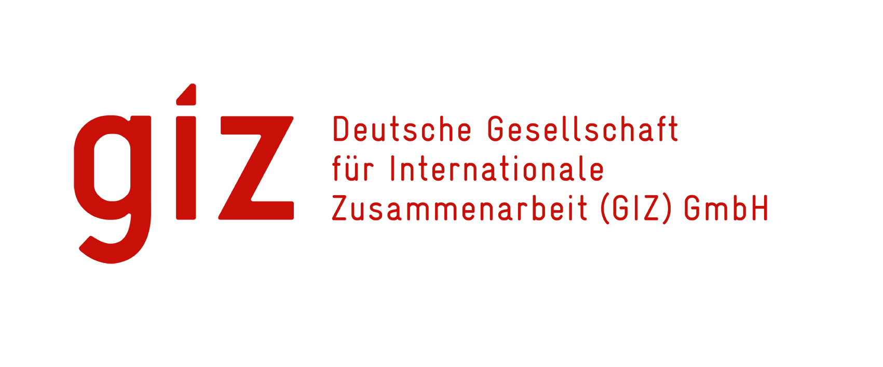ADE_UK_01006433-1

**Day 1**

**Part I: Clarifying the notion of “territorial approach to local development”**

|  |  |
| --- | --- |
| *08.45 – 09.15* | *Registration and welcome coffee/ tea* |
| 09.15 – 09.35 | Welcome by the EUD Delegation (Mr Roeland van de Geer ( HoD) and DEVCO B2 Unit (Rosario Bento Pais (HoU) |
| 09.35 – 10.15 | * Background to this regional seminar & Introduction by Jorge Rodriguez, DEVCO B2 * Getting to know each other: presentation of participants |
| 10.15 – 11.15 | **Session 1.1. The paradigm shift towards territorial approaches to local development (TALD) – Implications and emerging EU responses**   * Presentation by Jorge Rodriguez * Q&A in plenary |
| *11.15 – 11.30* | *Coffee/ tea* |
| 11.30 – 13.00 | **Session 1.2. Understanding the “politics” of decentralization in order to identify the scope for genuine territorial approaches to local development**  Short framing by Jorge Rodriguez providing keys to understand the motivations behind decentralisation reforms and implications for territorial development  Break-up in small groups to apply such a context / political economy analysis to concrete countries from the region -with experts that are familiar with the decentralisation reforms involved  Feedback from the groups to plenary |
| *13.00 – 14.00* | *Lunch break* |
| 14.00 – 15.30 | **Session 1.3. Clarification session II**   * Group exercise: *How do we understand the TALD concepts and definitions?* * Plenary feedback followed by a quick clarification from a TALD resource person if needed |
| *15.30 – 15.45* | *Coffee/ tea* |
| 15.45 – 17.15 | **Session 1.4. Territorial Approach to Local Development and the multi-actor perspective**   * Table discussion (free grouping): sharing our experiences of multi-stakeholder and multi-scalar approaches/work in territorial/local development * Plenary feedback of the table discussion |
| *18.30 – 20.30* | *Social event (details on location will follow)* |

**Day 2**

**Part II: How to work toward a Territorial Approach to Local Development? Implications in terms of knowledge, working methods, roles and capacities**

|  |  |
| --- | --- |
| 9.30 – 9.40 | Recap of day 1 & agenda of day 2 |
| 09.40 – 10.45 | **Session 2.1. The role of CSO in promoting TALD**   * Introduction and framing by Jorge Rodriguez Bilbao * Panel reflecting innovative experiences of promoting joint action CSO-LA from "civil society side” * Discussion with the plenary |
| *10.45 – 11.00* | Coffee/ tea |
| 11.00 – 12.45 | **Session 2.2. The role of the Associations of Local Authorities in promoting TALD**   * Introduction and framing by Alfonso Garcia * Panel presentations reflecting the potential role of ALA in promoting a territorial approach to local development. * Discussion with the plenary |
| *12.45 – 14.00* | *Lunch break* |
| 14.00 – 15.15 | **Session 2.3. Territorial Approach to Local Development from a multi-actor perspective**  Panel session: *How do various actors see the potential of a TALD approach?*  Reactions from and debates between (to be prepared and structured) representatives of central government, national association of local governments, civil society, research institution, consultants, EUD, B2 representative (talking in simple term about the key support mechanisms and the main features for flexibility in the hand of EUD to support a TALD)…  Focus the discussion in 2/3 countries (depending on the participants and typology of country |
| *15.15 – 15.30* | *Coffee/ tea* |
| 15h30-17h | **Session 2.4. Promoting Territorial Development through the thematic line CSO-LA?**   * Unlocking the potential of the thematic line CSO-LA by Jorge Rodriguez * Q & A * Group exercise: Exploring the potentialities and limitations to promote territorial development through the thematic programme * Discussion with the plenary |
| 17h-17h15 | Video local development and gender equality |

**Day 3**

**Part IV EUDs internal workshop: Putting TALD into practice. How to use the different instruments in a creative manner**

|  |  |
| --- | --- |
| 9.30 – 9.40 | Recap of day 1 & 2 |
| 9.40 – 11.00 | **Session 3.1.** **Understanding the context: the role of the ‘Integrated Decentralization Diagnostic Framework’ (IDDF) and its analytical tools”**   * Defining the scope (entry points, foreseen outcomes) of a EU Support program avoiding the “Aid modality” perspective (Jorge Rodriguez Bilbao) * Presentation of the Integrated Decentralisation Diagnostic Framework (IDDF) by Giuliano Bossi   Q&A in plenary |
| *11.00 – 11.15* | *Coffee/ tea* |
| 11.15 – 12h | **Session 3.2. Budget Support in decentralised context.**  Presentation of the main trends of the "Methodological note on Providing Budget Support in decentralised context" by Jorge Rodriguez Bilbao  Q&A in plenary |
| 12h00-12h45 | **Session 3.3. Using Project approach to support/promote TALD**  by Jorge Rodriguez Bilbao  Q&A in plenary |
| *12:45 – 13.45* | *Lunch break* |
| 13.45 – 15:15 | **Session 3.4. Forward thinking: how EUDs should work for defining an EU support programme (linking the supply side and the demand side considering the learning features coming from the CSO and LA contribution on day 1 and day 2)**.   * Working groups – 45’ (1 or 2 countries represented by table, if possible with some proximity of context in term of decentralisation status, cultural/historical/political parameters…) * Plenary sharing of some table reflections (voluntary basis not table by table) – 15’ |
| *15.15 – 15:30* | *Coffee/ tea* |

**Part III: Conclusions and Follow up**

|  |  |
| --- | --- |
| 15.30 – 16.00 | **Session 4.1. Overall summary of the seminar and validation of key conclusions** |
| 16:00 – 16.15 | **Session 4.2. Follow up and closure of the seminar** |