**Determining realistic outcomes and relevant entry points**

After having done these various analyses (in relation to ongoing decentralisation dynamics, political economy factors, government interest in territorial inequalities and the institutional readiness of EUDs) it is time to **clarify the type of outcomes the EU interventions ultimately seek to achieve when supporting decentralisation, local governance and territorial development**. This is a crucial step to determine a feasible set of ambitions regarding territorial development that might be pursued in a given country context through different programs and projects.

EU support in DLGTD may produce **mutually reinforcing *outcomes***in three major categories (see Figure 3.4 below):

1. *Policy Outcomes*. These refer to improvements in the *policy, constitutional, legal and regulatory framework* within which autonomous and accountable local authorities may be able to operate. They may include formulating/revising national decentralization policies and strategies, undertaking constitutional revisions or developing Local Authorities’ organic legislation and related detailed regulations.
2. *Institutional Outcomes*. These refer to improvements of the *institutions of sub-national governance and the local public sector* that may help to exploit the potential developmental role of Local Authorities under a given constitutional and legal framework. They may several of the building blocks of a TALD (see Figure 2.6 above) such as building the institutions and capacities for local political deliberations and policy making, strengthening inter-governmental cooperation and state oversight systems or promoting inclusive local governance and citizens engagement in local public policy formation and implementation. Experience suggests that priority must often be given to improving local public resources management (planning, programming, budgeting, procurement, accounting, and auditing systems and capacities) as a foundation for further local institutional development.
3. *Sector Outcomes*. In this case, EU supported interventions will manly seek to achieve concrete development results through actual investments in social services and infrastructure, local environmental management and local economic development. To this end, LAs are invited to both (i) “localize” and implement national sector programs in order to enhance the outreach and efficiency of national sector programs in the territory and (ii) deliver their own place-based development policies in response to demands of their constituencies, mobilizing additional resources for investments in local economic development (LED) and other local priorities.

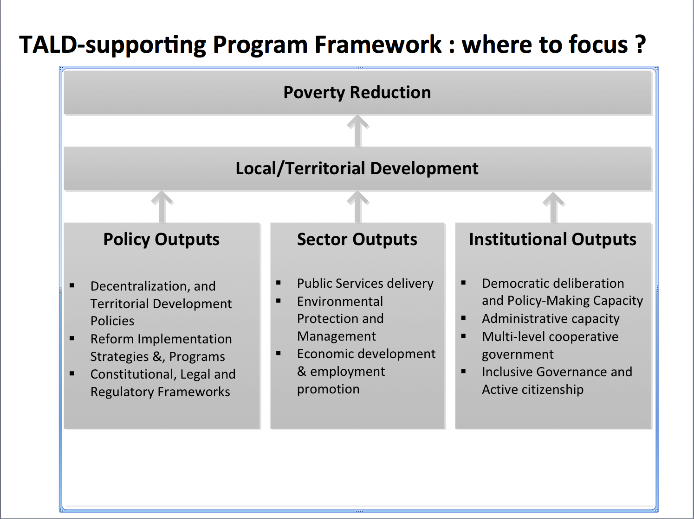

In the past donor agencies have often supported interventions at local level that were confined to the delivery of development (sector) outputs. These programs often lacked a political and institutional vision on the developmental role of local authorities or on the necessary link with broader state (decentralization) reforms and institutions. When using the TALD framework, EUDs are invited to **identify a politically smart and feasible “mix” of outcomes** **in the three spheres** –sector, institutional and policy.

Action **in any of the three areas should not be “held hostage” by progress made in any of the other two.** Progress in each of the three areas is typically affected by a different dynamic and timeframe. Although the policy and legal framework may set the boundaries for institutional development, *some space* is likely to exist for improving local political deliberations and local resources management institutions, within such boundaries. Similarly, there may always be *some space* for empowering local authorities to deliver sector/local development, within an existing, and not entirely satisfactory, set of institutions and capacities. Recognizing this may actually lead to a more realistic and effective programming of EU assistance to territorial development.

**3.4. Choosing relevant entry points for the intervention**

This is the next step in the process of thinking through a possible EU intervention for promoting territorial development. Building on the context / political economy analysis done (see section 3.2) and the various types of outcomes the EUD seeks to achieve (see section 3.3) it is time to identify the most suitable building blocks of the TALD that could serve as ‘entry points’ for the EU intervention.

As explained above, the TALD -as a multi-dimensional national policy- has three main constituent elements or building blocks: (i) local development management systems (pink/red box), supportive national policies (blue box) and institutions and capacities at subnational level (brown box). Within each of these cases, there are a number of important challenges to address in order to enable local authorities as developmental actors and *‘catalysts’* of territorial development (see Figure 3.4).

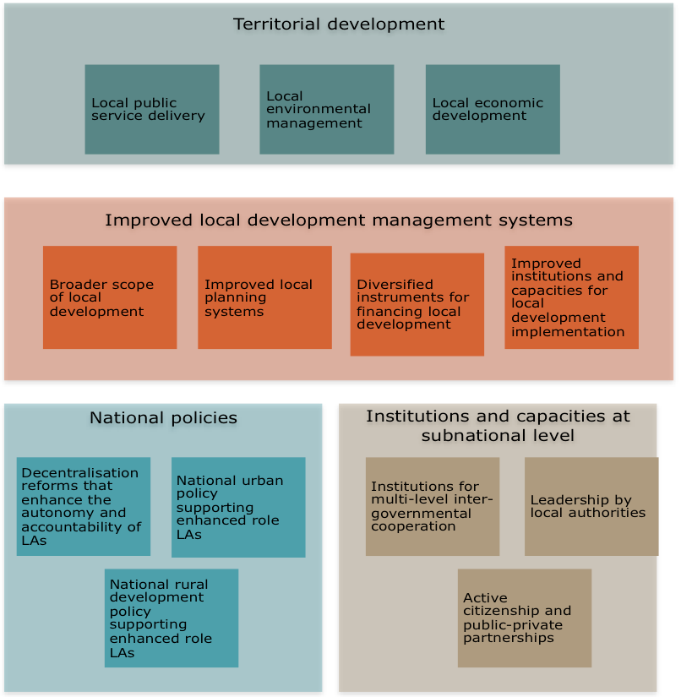

**The most suitable ‘package’ of building blocks to be targeted by EU interventions will differ form country-to-country**. For instance, in a given country there might already be quite some government attention and donor support for strengthening the management systems for local/territorial development (the upper building block of the visual) while other equally critical fields such as supportive national policies (the building block below on the left) or active citizenship (the building block below on the right) receive far less attention. It is also obvious that **EU interventions do not need to address all these boxes**. EU assistance in a given country can perfectly be targeted to those areas where there is real traction and a possibility to effectively promote territorial development through focused and problem-solving approaches.

Critical questions to consider in choosing the most suitable entry points for a EU intervention in a given country are presented in the box below.

|  |
| --- |
| ***Box 3.2. : How to select the most relevant building blocks for applying a TALD framework?***  In order to facilitate the selection of entry points for using a TALD, the following questions deserve attention:   1. What are the priority actions in terms of enabling LAs as *developmental actors*? 2. What entry points are most consistent with the various types of *outcomes* the EU wants to achieve? 3. Where is there sufficient *political traction* to move forward relatively smoothly (considering the power relations, interests and incentives of the various actors involved)? 4. What are *other players* doing (e.g. central governments, donor agencies, civil society actors) in support of territorial development? 5. Where can the EU –as a political player with leverage and resources- *add value*? |

The remainder of the chapter will briefly examine the various building blocks and possible entry points of a TALD.

3.4.1 Entry points for strengthening local development management systems

The first building block is concerned with **strengthening capacities for local development management.** This is not a new area of work. A wide range of activities aimed at enabling local authorities to assume their responsibilities in development processes have been sponsored by central governments, donor agencies, civil society organisations or (European) municipalities involved in decentralised cooperation activities. Available evaluations suggest the track record of these capacity development activities have often been quite limited, as they were generally conceived as technocratic project interventions of limited duration and disconnected from the wider intergovernmental system in which local authorities have to operate. Building on these experiences, **EUDs using the TALD framework** need to adopt a **different lens in providing capacity development support** **to local authorities** (see box below).

|  |
| --- |
| ***Box 3.3: Using a TALD requires a broader scope of ‘local development’***  If the EU seeks to expand the developmental role and capacities of local authorities with a view to unleash the potential of territories, it needs to recognize the conceptual difference and complementarity between *‘****local’*** development planning, on the one hand and the *‘localization’* of national (or even global, as in the case of the SDG) development goals, on the other hand. The first perspective creates scope for territorial approaches to local development; the latter tends to confine LAs in their role as implementing agencies for policies decided elsewhere.  In practice this requires the development of a sub-national planning system that is both *distinct from,* and appropriately *articulated with,* the national planning system. Such system should include and support both (i) the corporate planning processes of autonomous LAs and (ii) effective mechanisms for horizontal and vertical coordination of such plans with those of multiple other planning units (national agencies, higher or lower tiers LAs, private and non‐profit organizations). |

Different changes could be supported in each of the cases of this first building block, as illustrated in the visual below

Diversified instruments for financing local development

Improved institutions and capacities for local development implementation

**Improved local development management systems**

Improved local planning systems

* Improving the regulatory framework of local level procurement (to ensure it is adapted to local level realities)
* Building local capacity to manage procurement all along the cycle
* Identifying relevant territorial scales for integrated spatial development
* Choice of appropriate planning institutions and instruments
* Designing effective local planning process and support systems
* Empowerment LAs through own sources of revenue
* A well-designed system of intergovernmental transfers
* Investment windows and access to capital markets
* Effective contractual financing arrangements

3.4.2  Entry points related to institutions and capacities at subnational level

The second building block is equally crucial for genuine territorial development. It first recognises the need to put in place an **effective system for inter-governmental cooperation**, while preserving the autonomy of local authorities (intergovernmental cooperation instead of hierarchical subordination). In practice this is often difficult to establish because of: (i) the lack of a clear constitutional, and/or legal, *distinction* between central state and local authorities; (ii) capacity constraints and lack of investment in the administration of the newly established local authorities; (iii) control-oriented approaches by central authorities, reflected in institutional arrangements that end up denying local autonomy and reproducing hierarchical relations[1].

This building block is furthermore concerned with developing strong “leadership” at local level and effective administration as well as with the qualityofinteractions between LAs and other actors in the territory and at other levels. Establishing relations of trust is key to foster **joint action** between local stakeholders and **effective partnerships** -that underpin territorial approaches to local development. The leverage of local resources and external resources depends greatly on the strength and continuity of these interactions (both horizontal and vertical).

EUDs that decide to activate this part of the TALD framework can provide following types of support

Institutions for multi-level inter-governmental cooperation

Leadership by local authorities

Active citizenship and public-private partnerships (PPPs)

Institutions and capacities at subnational level

* Promote citizenship engagement beyond instrumental forms of participation
* Invest in building “social capital”
* Help LAs to reduce the commercial and political risks associated with PPPs
* Support concrete PPPs building on lessons learnt from success stories (e.g. linking remuneration to performance)
* Strengthen the **“political capacity”** of LAs (to reach out to other actors, articulate a territorial vision, facilitate collective action and resource mobilization
* Develop the **“managerial and entrepreneurial capacity”** of LAs (to lead a complex local public sector to effective service delivery)
* Support the development of an enabling regulatory framework
* Promote negotiated and institutionalized partnerships between local and central administrations
* Facilitate joint action by LAs (to realize economies of scale

3.4.3  Entry points for supportive national policies

The *third building block* of a TALD encompasses the set of national level policies that are **essential** and **supportive** **to enhance the developmental role of local authorities and foster genuine territorial development**. In the absence of such national policies the risk is real that attempt to unleash the potential of a given territory will fail or remain locked into unsustainable forms of *hyper localism* -disconnected from wider societal and economic dynamics at higher levels. These national policies are a condition to make the critical link between decentralization reforms to territorial development outcomes.

A development-friendly national decentralization policy -which enables LAs- is an obvious target in this building block. Yet equally important is a **new generation of national urban policies** that support territorial development by recognizing (i) the role that urbanization plays for national economic growth, (ii) the importance of correcting social and spatial inequalities that may be associated with growth and (iii) the comparative advantages of LAs in both contributing to set and implement the national urban agenda.

The role of a rural development policy -to link decentralization reforms to territorial development outcomes- is as important as that of the national urban agenda. But it has also been **more difficult to advance in practice**, because of the continuing reliance of top-down sector approaches, stronger central bureaucratic resistances and lower political and administrative capacity of rural local authorities. This also helps to explain the mixed track record of past attempts to plan and manage multi-sector Integrated Rural Development (IRD) projects, dating back from the 1970s.

Packaging and sequencing diverse interventions for maximum effectiveness in any given territory, calls for a degree of multi-level, inter-governmental coordination that is difficult to achieve under any circumstances, but that becomes even more difficult, if not simply impossible, when the **critical, territorial cross-sectoral, coordination role** that empowered **local authorities** could legitimately and effectively play, is negated by a lack of empowerment and/or capacity of the local administrations.

Within each of the cases of this building block, EUDs can provide strategic interventions to empower LAs (as developmental actors) and support territorial dynamics:

National urban policy supporting enhanced role LAs

National rural development policy supporting enhanced role LAs

Decentralisation reforms that enhance the autonomy and accountability of LAs

National policies

* Recognize the multi-dimensional nature of rural development (including need for strong urban-rural linkages
* Work closely with LAs in the design and implementation of policies (to properly identify and flexibly support local initiatives in more dynamic territories)
* Developa more balanced urban settlement system (by targeting national investments to urban nodes with the greatest potential to grow and integrate surrounding and rural areas.
* Strengthen spatial planning by LAs
* Providing incentives and financial mechanisms to tackle critical urban challenges
* Facilitate the adoption of a national decentralization and territorial development policy
* Support the development and revision of legal frameworks
* Help designing medium-term programs for gradual implementation of the reforms

**.**

1. The principle of “non-subordination” implies that no LA should be subordinated to another LA while all should be the subject of the state. Yet central governments have often violated this principle (invoking capacity deficits at local level). This is, for instance, done by reproducing between tiers of local government similar hierarchical relations that exist between LAs and central governments. Another common practice has been the placing of LAs under the control of a centrally appointed regional or local governor (or “préfet” in the francophone administrative tradition).