Two decades of decentralisation and EC support — and the path ahead

**1.1 History and track record of decentralisation reforms**

From the mid-1980s onwards a wave of decentralisation reforms swept across the developing world. A wide range of governments embarked on state reform processes aimed at transferring responsibilities, resources and authority from higher to lower levels of government. Each country followed its own trajectory, depending on historic legacies, geographic features, political factors, prevailing socio-economic conditions or culture. Decentralisation has occurred in unitary systems as well as in federal/quasi-federal systems.

The push factors behind decentralisation varied from region to region. In Latin America the drive towards decentralisation originated in the need to transform the political system from military dictatorship to democracy. In Eastern Europe and the former Soviet Union, it has been part of the political and economic transformation process from a socialist system to a market economy. In Africa, decentralisation was generally pushed from the outside and linked to the dual imperative of structural adjustment and democratisation/good governance (following the end of the Cold War).

Conventional theory ascribes important potential benefits to decentralisation reforms. The transfer of responsibilities may enhance the quality and efficiency of service provision through improved governance and resource allocation. The proximity of local governments may induce citizens to participate in public life and exercise more influence on local officials. This, in turn, may help to reduce corruption and improve accountability.

Three decades later, the overall track record of decentralisation is mixed. Though decentralisation dynamics vary hugely across regions, it is possible to identify some common elements that shed light on what worked and what did not work that well. Table 1.1 presents a bird’s eye view on positive evolutions as well as recurrent constraints that can often be observed in the process of carrying out decentralisation reforms in partner countries[1].

**Table 1.1 Panoramic overview of progresses achieved and bottlenecks encountered**

| POSITIVE EVOLUTIONS | OBSTACLES TO EFFECTIVE DECENTRALISATION |
| --- | --- |
| Countries have adopted constitutions and laws providing for subnational elections, some degree of autonomy and revenue sharing | Major gap between legal framework and practice. Competences are devolved without adequate resources. Revenue sharing remains very low and hampered by too many conditions |
| The institutional landscape has changed profoundly by the emergence of a ‘local public sector’ | In many countries there is not yet an effective intergovernmental system that adequately integrates the local public sector and fosters inter-agency cooperation in delivery of public goods and services |
| Within this local public sector, local authorities seek to become autonomous actors with an own identity (as a representative of a political community) legitimacy and added value in development | Many local authorities remain characterised by elite capturing, weak governance, low institutional density and overall fragility. Countries often opt for a ‘managerial type’ of local authorities –limited to executing the tasks conferred by central government |
| New local elites have appeared with an interest in local development, wealth creation and accountable management of public affairs | Progressive local authorities -that are eager to expand their autonomy and promote local development- tend to encounter fierce resistance (from politicians, sector ministries or traditional authorities). They are seldom recognised as distinct political entities, including by donor agencies (who tend to bypass them in their budget support operations or other programmes). |
| Decentralisation has stimulated citizens to engage in local public policy-making, budget processes and service delivery | Lack of effective service provision hampers the legitimacy of local authorities. It reduces citizen willingness to engage or pay taxes. Frameworks for local participation are often dominated and utilized by the power holders to foster their interests |
| Civil society organisations invest in local governance and in building legitimate and capable local authorities | Conflict rather than cooperation often characterizes CSO-LA relations. Civil society initiatives often bypass local authorities or interfere in competences conferred to them. Societal demand for decentralisation is often limited |
| Local authorities have organised themselves in associations at different levels (global, regional, national) to defend the local dimension of development and the prerogatives of local authorities | The dominance of central powers remains high. In several countries, competences are recentralized . The independence of LA Associations is often compromised by national party politics. |

In practice, the actual state of decentralisation in a given country will not fit neatly in any of the above boxes. It will rather be a specific mix of ingredients in each country, which moreover changes over time. This is in line with the non-linear nature of decentralisation reforms, characterised by unpredictable ups and downs.

Yet despite this diversity of experiences with two decades of worldwide decentralisation reforms a *few generic lessons have been learnt:*

* *Decentralisation is a highly political process*. The mixed track record of reform should not come as a surprise. In the real world, decentralization is driven by politics, not by development objectives. The course of decentralisation in a given country (including its timing and sequencing) is primarily determined by the balance of power between the different stakeholders involved and their relative ability to bargain and shape policy design and implementation. In many countries, the coalition of interests is such that reforms do not necessarily lead to more autonomous and accountable local authorities -endowed with adequate resources to play an effective role as development actors.
* *The missing link between decentralisation and development*. The link between decentralisation and development is notoriously problematic. Not only is empirical evidence limited and inconclusive, the very conceptualisation of the link is open to questions. The fact that in the real world decentralisation is invariably driven by politics inevitably means that there is no direct link with the promotion of local/territorial development.
* *The importance of a democratic foundation*. Countries that have put in place a development-friendly decentralisation process typically allow for some degree of ‘free administration’ by elected officials. This is a necessary but not sufficient condition for decentralisation to yield development outcomes. There is also a need for a democratic foundation –in the form of individual freedoms, space for meaningful citizen engagement and effective accountability mechanisms. In many countries, the political culture –based on strong centralization of power, loyalty to the hierarchy, patronage and fiscal incivility- seriously hampers progress on local democracy and development.
* *Risk of ‘spatial blindness’ and ‘uneven development’*. National development policies have often followed outward looking approaches, focused on accessing global capital and world markets However, the spatial model associated with this strategy tends to create growing territorial imbalances. This uneven development brings along high social and political costs (e.g. reduced growth prospects, raising inequalities, conflicts) and hampers the ability to unleash the potential of territories.
* *The critical importance of an effective intergovernmental system.* Decentralisation reforms across regions have often focused on managing the reform in a top down manner. They concentrated on building the state’s technocratic capacity while largely neglecting bottom-up dynamics and the role of local authorities as development actors. Yet experience suggests that the collaboration between different layers of government is required to effectively deliver quality public services and goods.

1.2 The learning curve of the EC regarding decentralisation, local development and local authorities

Over the past three decades, EC involvement in these matters has gone through a cycle of experimentation and learning by doing. Building on this, a coherent policy framework was gradually developed. This process has been driven at different times by dynamics in partner countries (such as the re-emergence of a decentralisation agenda), changes in international thinking on development (e.g. the growing recognition of local authorities as a distinct set of actors) and evolving EC priorities in terms of development and governance.

When overlooking this period, four major phases of EC engagement strategies can be distinguished (which run into each other without clear points of rupture):

Phase 1: Development projects at local level (1980 - mid 1990s). The EC has a longstanding tradition of intervening in local development, including through several generations of community-driven micro-projects schemes, mainly aimed at fostering rural development and providing basic infrastructure. Following the new wave of decentralisation reforms of the early 1990s, local authorities emerged as new actor in the local arena. It took some time before they could establish a basic institutional existence and claim space. However, as they became more visible, the EC started to explore ways a means to involve this new institutional player in its cooperation. It led to a new generation of micro-projects embedded in a wider approach to local development, to be propelled by ‘joint action’ between communities and local authorities. Initially, there was no clear policy framework to guide EC interventions. These were generally confined to the local level and lacked a clear political-institutional and systemic vision. This was compounded by a strong donor preference to mainly work with central governments on policy matters and with NGOs at local level for implementing projects. All this explains why local authorities remained for a long time rather marginalized actors in development and EU development cooperation, both as dialogue partner and recipient of funds.

Phase 2 - Evolution towards actor-based approaches and ‘systems thinking’ (mid 1990s-2010). As local authorities started to acquire more legitimacy and credibility there was growing interest at EC level to provide more tailored forms of support. A first generation of projects targeting local authorities as a distinct ‘actor’ saw the daylight, both a country level (e.g. municipal development projects) and at regional level (such as the successful URB-AL or URB Asia programs). Over time, they helped to enhance the capacity of local authorities to address issues such as social cohesion, local economic development, environmental sustainability or internally displaced persons. They also supported organizational strengthening and good governance at local level. Such efforts were complemented by a variety of ‘decentralized cooperation’ schemes driven by municipalities from European countries.

Yet as these actor-based support programmes were rolled out, the EC realized that local authorities are not operating in splendid isolation. They are part of a wider system of relations with other levels of governance. The delivery capacity of local authorities ultimately depends on the quality of this intergovernmental system. This explains why the EC got increasingly engaged (from 2000 onwards) in supporting national decentralisation reforms, particularly in Francophone Africa. It also invested more in building its internal knowledge base (as reflected in the 2007 Reference Document on ‘Supporting Decentralisation and Local Governance in third countries’).

Phase 3: Recognition and mainstreaming of local authorities in EC cooperation (2005 onwards). The growing international recognition of local authorities as development actors –propelled by vocal Associations of Local Authorities at different levels- led the EC to gradually integrate local authorities in its cooperation processes.

From 2005 onwards the following steps were taken to this end:

* Incorporation of specific provisions regarding local authorities in the revised Cotonou Agreement (2005)
* Creation of a new thematic financial instrument of the European Commission for both non-state actors and local authorities (2006)
* Formulation of the first dedicated Communication on local authorities (2008)
* Full-fledged involvement of local authorities in the ‘Structured Dialogue’ process (2010-2011) aimed at rethinking partnership approaches[2]
* Elaboration of the landmark Communication of May 2013, which invites the EC to contribute to the empowerment of local authorities as catalysts of local/territorial development
* Launch of a new strengthened thematic program dedicated to civil society organisations (CSOs) and local authorities (LAs) for the period 2014-2020
* Growing efforts at mainstreaming the participation of local authorities in policy dialogue processes (at various levels) as well as in geographic instruments (including budget support operations)
* Establishment of ‘Framework Partnership Agreements’ (FPAs) with five Associations of Local Authorities acting at global and regional levels, therefore formalizing at the highest political level the new EU policies regarding local authorities
* A new cycle of learning is now set to start with the Post 2015 agenda and related challenge to ‘localize’ the implementation of the new sustainable development goals through an active involvement of LAs.

Phase 4: Reconnecting decentralisation and development through territorial approaches (2013 and beyond). The May 2013 EU Communication provides an opportunity to make a qualitative jump forward in how the EU deals with decentralisation, local development and local authorities. It may lead to the elaboration of a more coherent EU response strategy, which overcomes the limitations of the forms of engagement used in the earlier phases described above.

The initial EC approach of the 1980-1990s focused on the local level and sought to promote genuine bottom-up processes of local development –increasingly steered by both civil society and local authorities. While these programs yielded concrete results at local level, it was less evident to ensure scaling-up and sustainability. This triggered a new phase where the EC shifted its attention to national framework conditions, by supporting decentralisation as a public sector reform process aimed at transferring functions and resources to subnational entities. Yet this focus on national systems and institutional changes meant that the development dimensions of the reforms were somehow lost.

The new EU policy framework of the May 2013 Communication -with its focus on empowered local authorities and territorial approaches- holds the potential to reconnect the dots and re-establish the link between decentralisation and development. It seeks to combine the bottom-up approach to development (enriched by a broader territorial perspective) with the elaboration of supportive national (decentralisation) policies and institutional changes (that help to create the conditions for genuine territorial dynamics).

Figure 1.1 illustrates the EC trajectory and learning curve regarding approaches towards decentralisation and local/territorial development.

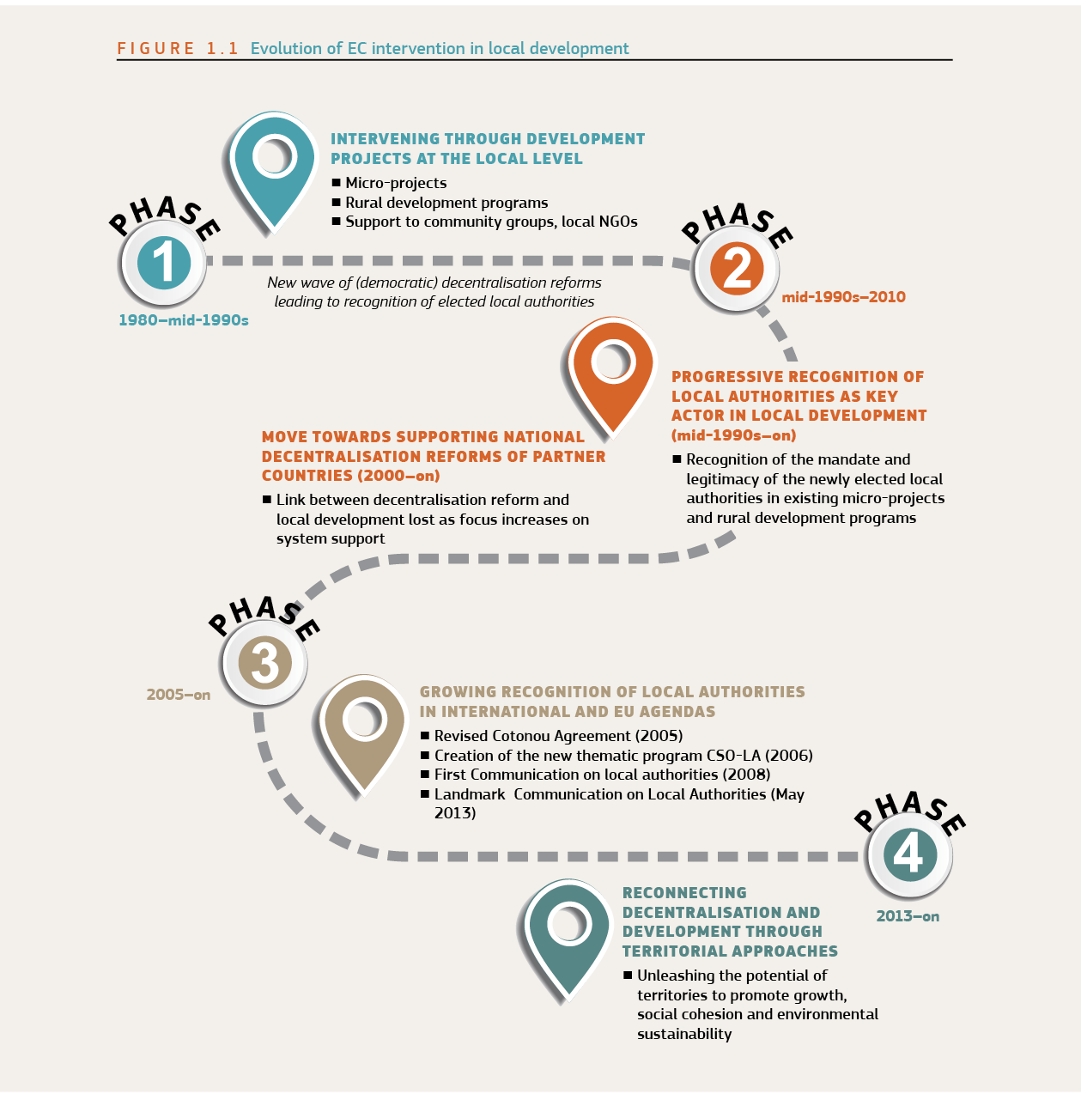

1.2.1 Where did the funding go?

These various forms of EC support were channelled though a wide range of partner regions and countries. Figure 1.2 provides a panoramic view of the destination of the funding for the period 2002-2014 (see Annex 1 for a more detailed analysis of countries that benefitted in each region from EC support to decentralization, local governance and local/territorial development).

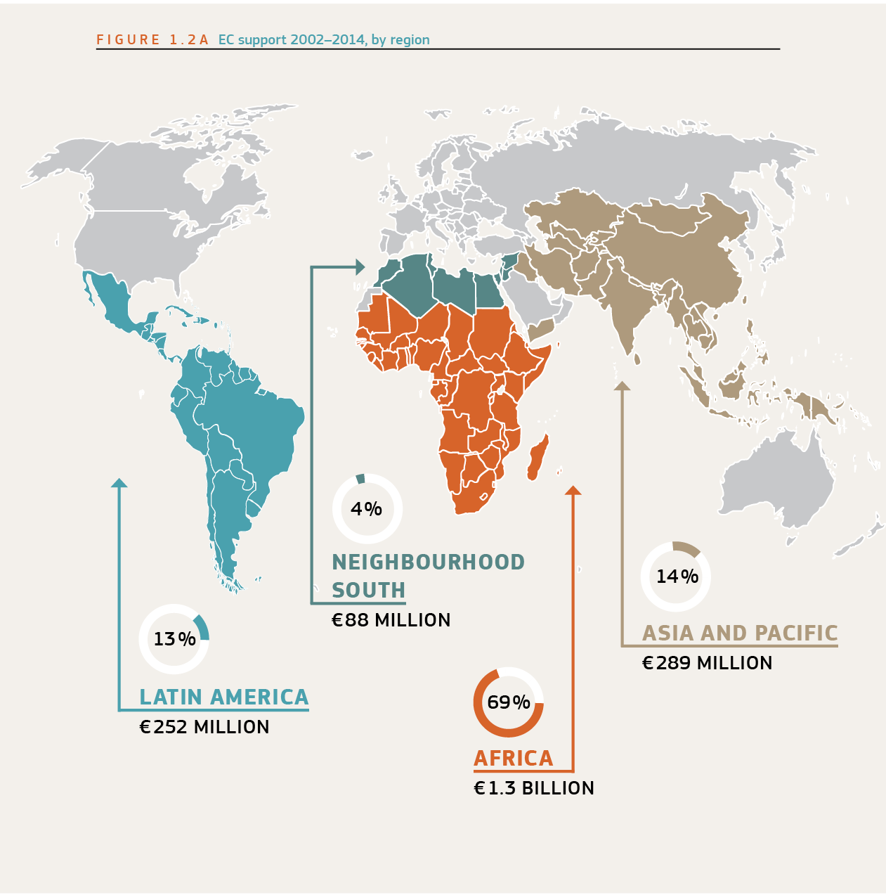

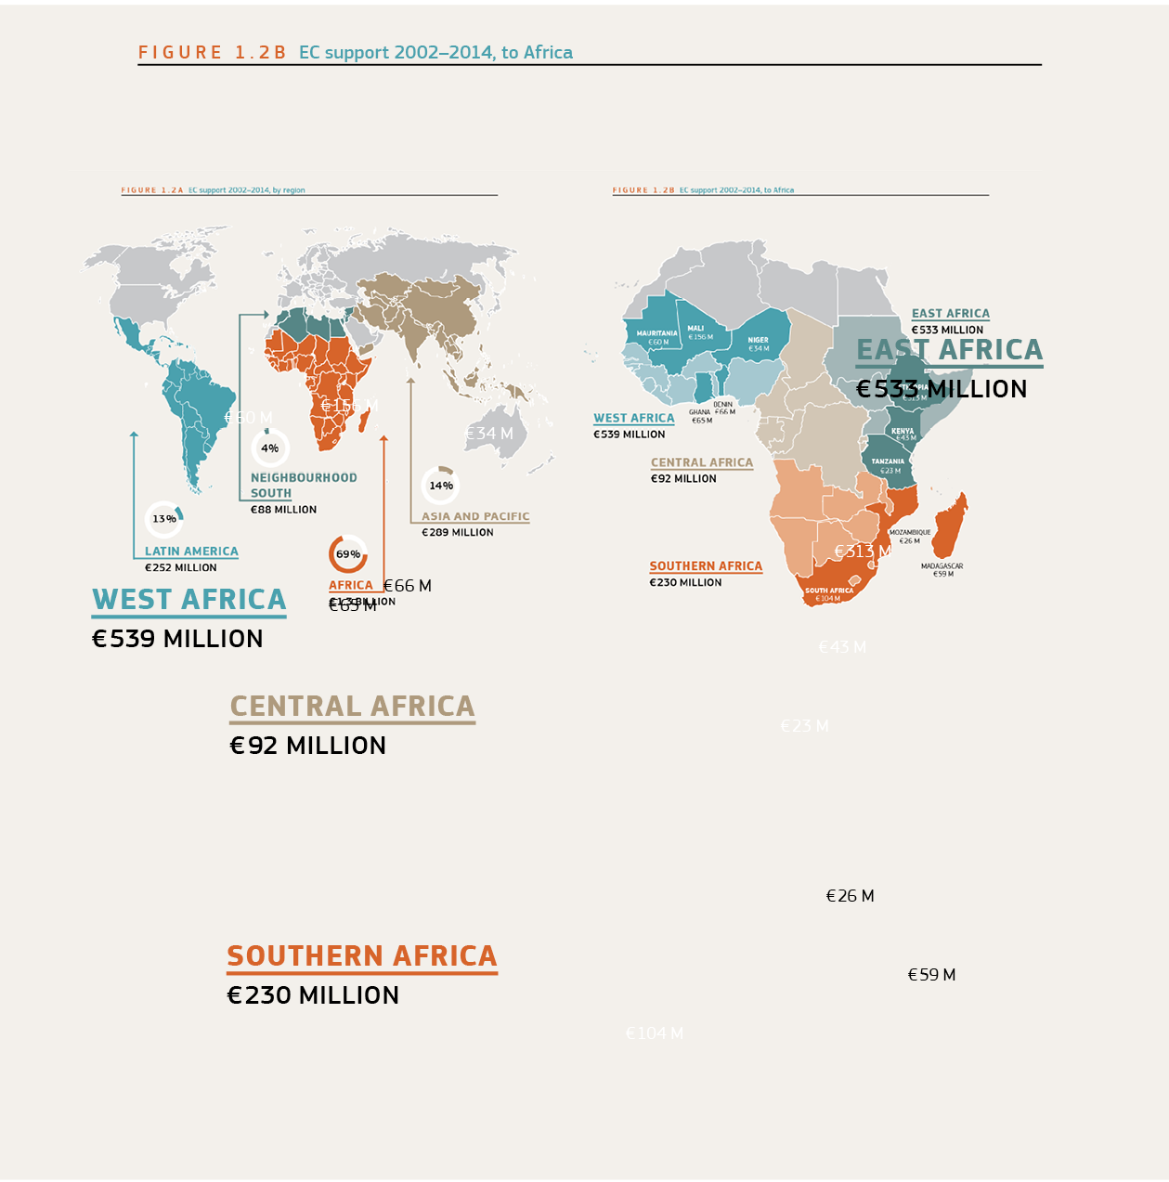

These data reveal the following global features:

* EC financial contributions for direct support to national decentralisation policies were spent in a limited set of countries (Tanzania, Benin, Mali, Madagascar, Liberia). From 2008 onwards, there has been a striking decrease in new major interventions in support to national reform agendas[3].
* In terms of geographic breakdown of the funds for decentralisation, local governance and local development, 68,86% of the funds (1,3 billion Euro) went to Africa (particularly francophone Africa), 14,29% to Asia and the Pacific (289 m€ ), 12,48% to Latin and Central America (252,4m€ ) and 4,37% to Neighbourhood South countries (88,3 m€ )[4].
* Within Africa, the countries from West Africa got the major share of the resources (539 m€ or 26,62%), followed closely by East Africa (532,6 m€ or 26,33%). Lesser amounts were dedicated to Southern Africa (230 m€ or 11,36%) and Central Africa (92 m€ or 4,55%)
* The overview table also indicates the share of resources that individual countries received for activities related to decentralisation, local governance and local development. The top-three is occupied by Ethiopia, Mali and South Africa.
* Most financing went through the geographic instruments[5] though a significant part was channelled through a variety of thematic instruments, including Rehabilitation, Decentralised Cooperation, NGO co-financing, European Initiative (later Instrument) for Democracy and Human Rights (EIDHR) and Non State Actors and Local Authorities (now re-baptized the thematic line for civil society and local authorities)[6].

1.2.2 Assessing EU support to decentralisation and local governance: the 2011 Thematic Evaluation

A recently conducted thematic evaluation of the Commission’s support to decentralisation (covering the period 2000-2009) sheds some light on this question. It points to areas where the EC could add value and others that proved more difficult to address effectively (see Figure 1.3).

Based on these findings the Evaluation Report concludes that the EC has *“a unique, but largely unrealised, potential for global support to decentralisation in partner countries”*. In order to tap into that potential, the central recommendation invites the EU to develop “an explicit response strategy that clearly embeds future support for decentralisation reforms within a wider public sector reform agenda” while intensifying efforts to better understand the politics of the reform process, broadening country ownership and ensuring concrete development outcomes (such as qualitative and sustainable local services).

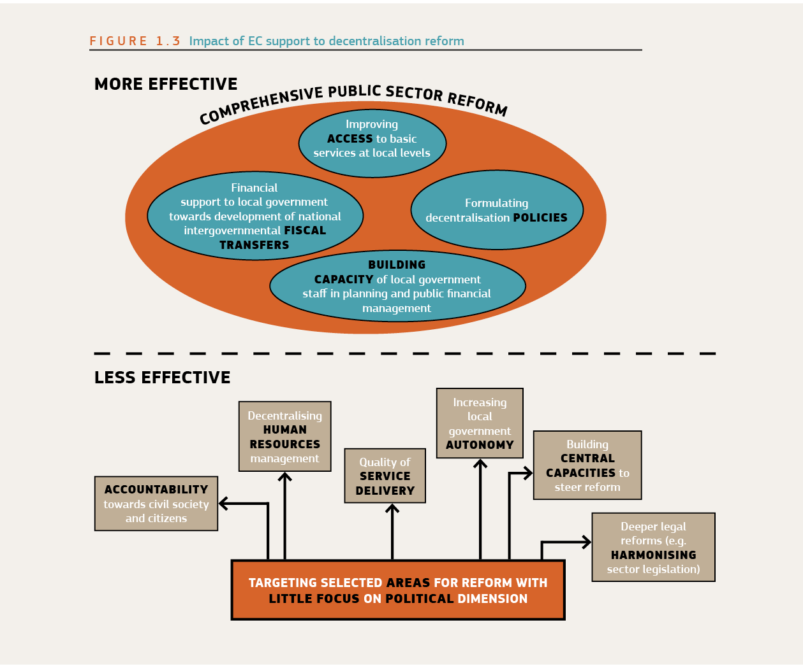

1. This table is largely based on the outcome of the regional exchange seminars organized by DEVCO in Latin America and Africa in 2013-14.
2. The Structured Dialogue (SD) for an efficient partnership in development took place between 2010-2011 and brought together more than 700 CSOs and LAs from all over the world, as well as participants from the EU Member States, the European Parliament and the European Commission. During a wide range of seminars participants identified ways to improve the effectiveness of all actors involved in EU development cooperation. These were confined in the so-called Budapest Declaration (2011). The SD heavily influenced the subsequent EU Communications regarding civil society (2012) and local authorities (2013).
3. This is linked partly to the programming cycles of the EC (new cycle will start in 2014), but could also indicate a declining commitment to provide direct support to decentralisation.
4. Factors contributing to the low figure of aid to decentralisation processes in Asia include the limited demand for interventions in this area and the presence of other donors with more experience than the EC (such as the World Bank and the Asian Development Bank). The two largest contributions in Asia were targeted at Cambodia and Afghanistan –countries with a rather poorly developed public sector structures and with no significant degree of fiscal decentralisation.
5. EU geographic instruments relate to the funds allocated to particular countries and regions under the various cooperation agreements (ACP, ENPI, ALA).
6. This thematic budget has proven difficult to access for local authorities, amongst others because of the high transaction costs and ill-suited nature of the Call for Proposals system.