Micro power economy roll-out in Tanzania


November, 2015
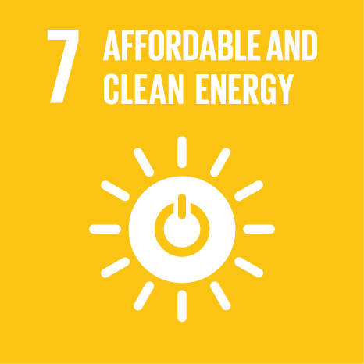
In partnership with the European Union

The project “Micro Power Economy, Tanzania Roll-out”, developed by the micro-utility JUMEME and its international partners, aims at implementing and operating Solar-Hybrid Mini-Grids in remote settlements in Tanzania to provide reliable, affordable and clean electricity to households, agricultural enterprises, businesses and public infrastructures.
Key Information

Sector: Rural Electrification / Mini-grid / Solar Power
Lead Partner: INENSUS GmbH
Other Partners: JUMEME Rural Power Supply Ltd, St. Augustine University of Tanzania, TerraProjects e.U., Excel Hort Consult Ltd, Sustainable Business Institute e.V
Budget: EUR 16 million (EU funding 7.4 million)
Duration: 2014 – 2018
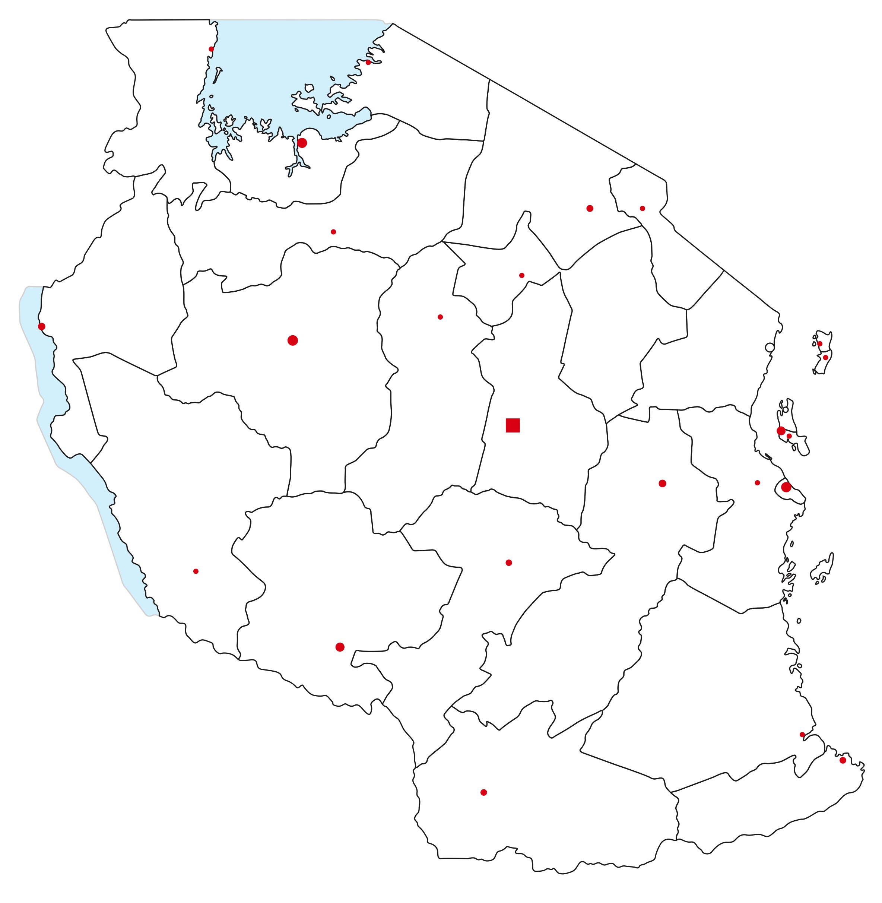

Background

At the end of 2013, about 18% of the households in Tanzania had been electrified. In urban areas, the percentage was about 45% and in rural areas somewhat below 6%.

Increasing access to electricity is a major objective for the Government of Tanzania. By 2020, 50% of the population shall have access to electricity, further increasing to 75% by 2035.

According to the Scaling-up Renewable Energy Program it has been estimated that around 20% of the currently un-electrified people in Tanzania (around 8.4 million people) are best electrified through mini-grids. The EU project presented here only targets 1% (81,000 people) of this group potentially best served by mini-grids.

Preliminary estimates from IED preparatory work for the Rural Electrification Masterplan of Tanzania in 2013 identified 522,000 people living in very remote regions with extremely high potential for profitable mini-grid electrification and a further 3,848,000 people living in remote regions and communities with acceptable population density signifying an attractive target group for mini-grid electrification.

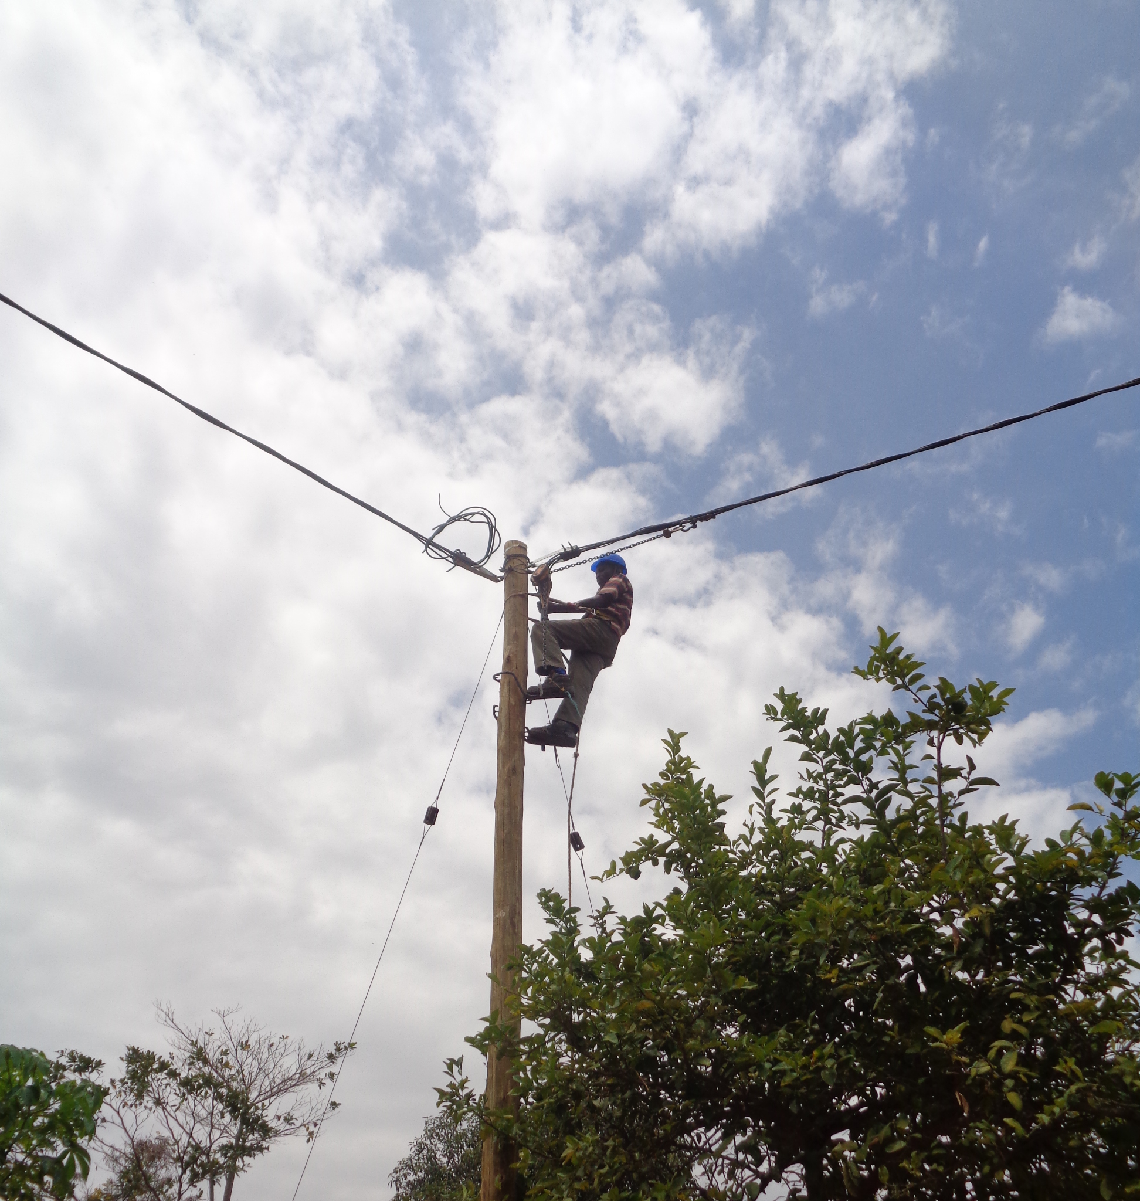

Expected Results

In the first year of project implementation the consortium successfully established the mini-grid utility JUMEME and hired and trained its first staff. Strong relationships were established with relevant authorities at local, regional and national level. Furthermore, the consortium conducted detailed demand assessments in more than 24 villages, signed multiple MoUs with targeted communities, and finished the ESIA for the first island. An ESIA is currently being undertaken for further islands in Lake Victoria. The detailed technical design for the pilot project has been completed. Installation of the power house and LV lines started in July 2015 and was completed in November 2015. Procurement of generation equipment for the pilot site is in progress and commissioning is expected in Q1-2016. In parallel, the preliminary technical system design has been finalized for another 18 villages.

The main end-result are the final beneficiaries reached - the electricity customers of JUMEME. By 2018, the company will provide access to electricity to:

- 81,000 people
- 11,000 households
- 2,600 businesses
- 42 public offices
- 32 schools
- 12 health centres
- 77 religious buildings

Furthermore, 500 new businesses will be created, in particular agro-businesses and productive users. JUMEME will also become a fully functioning, sustainable and profitable electricity company by 2018. Good monitoring and evaluation processes will be set up allowing wide communication, dissemination and replication in Tanzania and internationally. Further impacts, including but not limited to increased access to food and water, improved environment, and gender equality, will be generated.

Contact

JUMEME – RURAL POWER SUPPLY
C/O ST. AUGUSTINE UNIVERSITY OF TANZANIA (SAUT)
P.O. Box 307 – MWANZA - TANZANIA
Tel: +255 763052748
Email: jumeme@inensus.com

Project Details

The overall project objective is the sustainable development of entire rural areas in Tanzania through providing access to electricity. To achieve this objective, the project will establish a profitable private mini-grid utility – JUMEME - which will provide affordable, clean and sustainable electricity to a minimum of 16 rural villages and towns in Tanzania.

JUMEME will provide around 50% of the project cost through private finance (both equity and debt). The business model used in the solar-hybrid mini-grids is the award winning “Micro Power Economy” business model developed by INENSUS. This business model incorporates a combination of community-oriented governance, modular capacity planning, smart meters for demand and load management, as well as a tariff block structure. In the end, more than 16 pre-identified rural towns and villages will directly benefit from the electrification and the development of improved income generation opportunities.

Other donors, besides the EU, are supporting JUMEME in its rural electrification activities. The EEP project “Micro Power Economy Demonstration Project in Rural Tanzania” co-finances the establishment of the pilot system and supports the project development of further project sites. GCPF provides technical assistance grants for the ESIA and the demand assessment. Additionally, both the Sustainable Energy Fund for Africa (SEFA, AfDB) and the US-Africa Clean Energy Finance (ACEF, OPIC) support the project through technical assistance grants in its scaling activities. Through this support additional project partners and sub-contractors are involved in JUMEME’s electrification activities, including GVEP International, Innovation Energie Développement (IED), Water and Land Centre Consult, Statera Capital, Rainer Lemoine Institute (RLI) and other independent consultants.



