DG DEVCO
Task Force Knowledge Performance and Results
Unit 05 Operational Information Systems in collaboration with Unit R6
Project Charter
OPSYS Phase 1: "Results Management and Operational Entities"
Date: 12/04/2016
Doc. Version: <v3.0>

Document Control Information

Settings | Value
Document Title: | Project Charter
Project Title: | OPSYS Phase 1: "Results Management and Operational Entities"
Document Author: | Lucile Petitpierre (BM DEVCO 05) and Eric Pasteleur (ITPM DEVCO R6)
System Owner: | Thierry Mathisse
System supplier: | Fernando Centurione
Doc. Version: | <v3.0>
Sensitivity: | Public
Date: | 12/04/2016

Document Approver(s) and Reviewer(s):
NOTE: All Approvers are required. Records of each approver must be maintained. All Reviewers in the list are considered required unless explicitly listed as Optional.
Name | Role | Action | Date
Thierry Mathisse | System Owner | Approve
Fernando Centurione | System supplier | Endorse

Document history:
The Document Author is authorized to make the following types of changes to the document without requiring that the document be re-approved:
- Editorial, formatting, and spelling
- Clarification

To request a change to this document, contact the Document Author or Owner.
Changes to this document are summarized in the following table in reverse chronological order (latest version first).
Revision | Date | Created by | Short Description of Changes
V0.0 | 23/02/2016 | Lucile Petitpierre | First draft
V1.0 | 25/02/2016 | Giuliano Rosciglione | Second draft
V1.1 | 29/02/2016 | Eric Pasteleur | Third draft
V2 | 08/03/2016 | Lucile Petitpierre | Approach and methodology parts
V3 | 12/04/16 | Lucile Petitpierre | Final draft

Configuration Management: Document Location
The latest version of this controlled document is stored in \\Net1\devco\DG\05\6. OpSys IMPLEMENTATION\7. RELEASE 1\0. GOVERNANCE\Project Charter Project 1

TABLE OF CONTENTS
1 Executive Summary 4
2 Considerations on the Business Case 5
3 Project Description 6
3.1 Scope 6
3.1.1 Includes ("IN" Scope) 6
3.1.2 Excludes ("OUT" Scope) 8
3.1.3 Scope Statement 8
3.2 Success Criteria 9
3.3 Business Needs 9
3.4 Deliverables 10
3.5 Features 11
3.6 Constraints 12
3.7 Assumptions 13
3.8 Risks 13
4 Cost, Timing and Resources 14
4.1 Cost 15
4.2 Timing and Milestones 16
4.2.1 High level roadmap 16
4.2.2 Agile iterations & milestones 16
4.3 Planned Resources 17
6 Approach 19
6.1 Methodology 19
6.2 Change Management 20
6.2.1 Project Change 20
6.2.2 Configuration Management 20
6.2.3 Organisational Change 20
7 Governance and Stakeholders 22
7.1 Structure 23
7.2 Roles 24
7.2.1 Business Manager (BM) 24
7.2.2 IT Project manager (ITPM) 25
7.2.3 Process Owner 25
7.2.4 Domain User Group 26
7.2.5 Product owner 25
7.2.6 Scrum master/Team coordinator 27
7.2.7 Architecture Owner 27
7.2.8 Development team 28
Appendix1: References and Related Documents 30

Executive Summary
Project 1 “results management and operational entities” is the first of the 6 core projects to be implemented in the framework of OpSys programme supporting OpSys strategic objectives which are increasing productivity, improving quality, simplifying and harmonising processes and increasing results transparency.
The project will be implemented using an Agile Method with a great emphasis on stakeholders' collaboration. Since requirements cannot be fully captured at the beginning of the project, continuous user involvement is essential. With Agile the stakeholders are active members all along the process. In order to ensure a full project success, it is necessary to regularly give the opportunity to selected stakeholder to test the system and provide continuous feedback. This approach guarantees that the final solution satisfies stakeholder's prospects and requirements.
The Project Charter provides a high-level basis for the more detailed project requirements. It captures the "essence" of the envisaged solution in the form of high-level requirements and constraints to give an overview of the final project deliverable(s). It starts from establishing a business idea which evolves as the stakeholders understanding and knowledge of the project improves.
The current project "Result and operational entities" is the first project of OpSys programme and should lead to the achievement of the following key outputs:
- Allow to manage operational entities (Output 1 – Operational entities)
- Facilitate encoding, storage and consolidation of results and related monitoring through an integrated approach (Output 2 – Result management)
- Facilitate reporting on key milestones and events related to projects and programme activities (Output 3 – Monitoring)
- Allow interoperability and integration with others systems(Output 4 – integration)
- Offer an improved user-experience and a single entry point for operational information systems (internal portal) (Output 5: internal portal and user experience)
- Allow external users to encode key information directly into the system (Output 6: external access)
Project 1 will take place from 2016 to 2017. Key milestones for project 1 are the following:
- December 2016: Deployment in pilot EUDs (around 7 EUDs)
- June to September 2017: roll-out in all EUDs and HQ units
The project will be supported by a change management strategy, based on best practices which support effective business transformation and on the strategic objectives of OpSys programme namely Increasing productivity (efficiency, processes), Improving quality (data/operations), shifting to a result orientation mind-set and transparency/c to external partners.
The change management strategy will be further elaborated by the change manager expert in and analysis of stakeholder, sponsorship, change network and resistance to change supported by training, communication and support plans.
Main activities of the change management included:
- For communication purpose:
  - July or September 2016: 1 workshop with pilot EUDs to present the first elements developed for project 1
  - March 2017: 1 workshop with pilot EUDs to collect feedback on the pilot phase
- For training purpose:
  - From September to December 2016: visit to all pilot EUDs,
  - From January to march 2017: development of a training package for the roll-out
  - In 2018: monitoring mission in selected EUDs
- For support purpose:
  - From May to September 2016: analysis of pilot EUDs portfolio and encoding of key elements (action logframes, scope of Projects and programmes)
  - From September to December 2016: training of IT support
  - From January to June 2017: support and monitoring of the pilot phase
  - From June 2017: full support for all EUDS

Considerations on the Business Case
The project is covering the needs of DEVCO (all DEVCO financial instruments), of DG NEAR (IPA II, ENI) as well as the one of the FPI (IcSP, Partnership instrument).
The business case has shown the urgent need to start to capture the Results in a structured way not only for achieved projects and programmes but only for the ongoing one. The need is particularly urgent for DEVCO which has not yet automated any tool to support Results management; NEAR is covering its most urgent needs with its MIS system (IPA II). Results management remain one of the top priorities of the Commission as evidenced by the recent initiative launched under the leadership of Vice President Georgieva of “EU Budget for results”.
Further, the business case has shown the importance of shaping the foundations of the whole OpSys programme with the setup of operational entities, and particularly for projects and programmes. Il will allow to then move ahead more easily with project 2A “Action and level 1 commitment” and 2B “contract and level 2 commitment”, paving the way for the phasing out of CRIS Decision and CRIS Contract.
In the context of the OpSys PROJECT 1 Business Cases, done in Q4 2015, 4 different options have been in depth analysed to support the Results management and Operational Entities solution.
The 4 options were as follows:
- Do nothing;
- Re-using of the GMS solution from DG RTD (built on Compass and Sygma), analysed under the sponsorship of DIGIT, seeking for a Corporate Solution, in close collaboration with DG RTD;
- Use of the DG Near/Results Solution;
- Development of OpSys Results on a Java platform, built on the European Commission standard architectural compounds from DIGIT and DEVCO.
After an independent analysis of the 4 options, PROs and CON's and SWOTs analysis, the target solution is to go for the Java platform which offers as key advantages to cover the identified needs for results management and operational entities, in line with the adopted EU result framework and the related project results approaches and workflows, to lay the foundation for phase 2A (deepened coverage of operational entities) and 3 (other implementation aspects), and to be easily adaptable with regard to the IT architecture. Of course, this Java Platform solution requires covering the business needs expressed by DG NEAR and legibly already supported by MIS, in order to provide a cross-DG solution as well as ensuring non-regression for the DG NEAR users related to Results Management.

Project Description

Scope

Includes ("IN" Scope)
A proper encoding, storage and consolidation of results on an ongoing basis for all EU projects and programmes with a clear link to the assessment of performance of projects and programmes would be significantly enabled by a dedicated IT system.
In order to perform these tasks, it will be first of all necessary to define pivot operational entities around operations at programming, identification, formulation, implementation and evaluation phases. Those will be clearly linked to financial and legal entities such as decisions and contract currently at the basis of CRIS, but not fully equivalent.
With the objective of replying to those needs, the "Result management and operational entities" will:
- Allow to manage operational entities (Output 1 – Operational entities)
OpSys will not anymore be centred exclusively on legal and financial entities like decision and contract as they currently exist in CRIS, but on Operational Entities which support the main business processes throughout the defined Project Cycle Management, with a particularly focus on those which are used during implementation.
The shift from financial management based IT system to operational based systems will allow to fill the gap in terms of operational portfolio management and in terms of relations between operational entities across the cycle of operation namely:
- MIP (Multi-Annual Indicative Programming) during the Indicative Programming stage, concluded by a Commission (Implementing) Decision
- Action(called to replace CRIS decision) during the Identification and formulation stage
- Programme and Project(where the operational focus is) at implementation stage
All operational entities will be linked to their related commitment and legal entities (FA, contract) and to each other to follow, drill down and navigate through them all across the cycle of operations.
Following the principle of no duplication of data, MIP, CRIS Decision, contract and their underlying commitments will be retrieved from CRIS as long as CRIS is operating.
Each entity will be filled with a minimum set of data and linked to categories of users (programme manager, head of section, country, unit, directorate, etc.).
These entities will also be used also in phase 2 and further phases.
- Facilitate encoding, storage and consolidation of results through an integrated approach (Output 2 – Result management)
The system will allow operators to manage structured results across the cycle of operation in a seamless way: sector intervention framework (at programming level), logframe (for project modality) or indicative list of results indicators (for Budget support modality) from identification, formulation to implementation stage and to follow-up the related indicators, baseline and targets (all sex-disaggregated when relevant).
Result management will be automated through an integrated approach allowing real time aggregations for all categories of managers: results information will be systematically entered using commonly understood and comparable headings, and then stored and retrieved by managers across the organisation on regular basis.
By comparing actual results with baselines and targets, the operational manager will assess the overall performance of its project or programme. He will report directly on key performance indicators on the use of resources, the likelihood to achieve expected outputs and risks related to outcomes.
The system will generate and display automatic color-codes and percentages or the operational manager will be able to manually encode a scoring based on indicator values (including for indicators of BS programmes), progress from baseline towards milestones and targets, and comment on it in order to visualize easily the progress of projects and programmes and be able to support these key performance indicators (KPI) with a narrative report.
This assessment will allow the manager to decide where and when intervention is needed (field visit, ROM, evaluation).
Whenever relevant, Operational managers will have the possibility to link their indicators to an EU RF indicator or to other matching indicators when priorities are not reflected in the EU RF indicators (thematic, country reporting, specific implementation modalities such as blending, Cross border cooperation, trust funds, budget support).
Results will be linked, when relevant, from Programming to implementation to ensure coherence of the results chain across the cycle of operation.
Aggregated/combined result information will be available in standard presentations of results data (by matching indicators, EUDs/HQ units, Sector, country, regions, year, etc.) for all projects and programmes, allowing a proper real time assessment of the portfolio performance at all levels.
Results information will then be used to regularly report on results to internal and external stakeholders such as management and EU Member States (accountability).
- Facilitate reporting on key milestones and events related to projects and programme (Output 3 – Monitoring)
Implementing partners will be able to report on individual outputs progress (commenting on related activities whenever necessary) as well as overall project and programme progress.
EC Operational manager will be able to build its own monitoring plan by accessing a calendar to schedule key events and milestones of their Project or Programme (site visits, steering committees, ROM missions, and other Programme events, such as meetings, commissioning and closing events, evaluation and audit missions, etc.) and according to its specific needs.
- Allow interoperability and integration with others systems (Output 4 – integration)
The system should allow interoperability and integration with others systems:
- Geo-localisation attached to actions, programmes and results
- Link with the EAMR module with respect to project/programmes related indicators (indicatively: KPI 5(implementation progress), KPI 6(achieving results), KPI 18(projects visited), KPI 19 (evaluation), Rr (Rom request), I-4 (Project communication plan). Relevant information for building these KPIs will originate from OpSys. Therefore these KPIs should be updated at least once a year on the basis of the data encoded along the year into OpSys as part of operational management, thus offering a coherent workspace to operational managers to manage their projects/programmes and providing the data allowing entities like EUD to manage their portfolio. The values of these KPIs should be reflected in the EAMR report, which could retrieve the data through the data-warehouse.
- IATI: Compliance with international obligations in terms of transparency on results management (completeness and availability of data);
- Knowledge sharing (C4dev)
- Migration of MIS results management data
- Offer an improved user-experience and a single entry point for operational information systems (internal portal) (Output 5: internal portal and user experience)
User-experience is an interactive approach making the way people work more efficient, intuitive in an aim of increased productivity for all actors in the end-to-end process and sustainable business results.
As of today, the daily workflow of EC programme managers and operators is divided into several different IT tools, each one with its own interface, its way of interaction and its goals. Interoperability among systems is lacking and often time is wasted in processes that could be smoother and/or automatic.
OpSys aims to provide an intuitive “look and feel” and navigation system (menus, links, feature access screens) and an innovative user-friendly interface coherent all over the workflow. The objective is to make OpSys the unique one-stop shop business portal to be used by programme manager to support, monitor and facilitate their daily work.
The use of a single and standardised interface will also facilitate transparency and consistency among available data. In addition, it will be possible to take advantage of the same look and feel of the system in order to publish selected data and information into external websites.
The interface will also be consistent when accessed via mobile devices, enhancing the actual interaction between internal and external operators through the system. This innovative approach will improve the corporate identity and, in long terms, increase productivity.
Project 1 will bring a first step for user experience which will be progressively achieved throughout further OpSys projects.
- Allow external users to encode information directly into the system (Output 6: external access)
Addressing data quality issues is one of the major objectives assigned to OpSys. For that purpose a number of principles are mainstreamed in the design of the new system: data encoding is done by operators that are the closest ones to the source, no re-encoding, user friendliness, user benefit for the encoding effort and accountability.
Project 1 will offer a first step of external partners access, waiting for SEDIA initiative which is called to become the access portal for implementing partners.

Excludes ("OUT" Scope)
The following elements are excluded from the scope of this project:
- Project 1 will be focused on Operational Entities and Results. It will not replace CRIS in its financial and contracting features. CRIS Decision and CRIS Contract will continue to operate.
- Project 1 is not covering the scope of project 2A “Action and level 1 commitment” particularly in term of MIP management (validation process, MIP creation, collaborative work), Actions management (manage operational data from Action documents, financial agreement, Addendum), Level 1 commitment management (creation, validation process), main budgetary functionalities (budget allocation, financial breakdown, link to deviation and prior approvals) and sector tagging (free tagging, corporate sector, etc.).
- Project 1 is not covering the scope of project 3 containing the remaining functions related to implementation phase in term of providing a full internal monitoring tool, capturing all project management data, all milestones and key events, country and sector information management, ROM and evaluation management.
- The system will provide key operational project data, but it will not overlap with communication or knowledge sharing tools and systems (EUDs internet websitesCapacity4Dev). On the opposite, the systems will interoperate and will share key information on project and programme results.
- In the long term OpSys is expected to be the main entry point for all operators and to include all information necessary for a close follow up of all projects and programmes. Its first release however will not substitute the current other systems in place such as ROM, EVAL, AUDIT modules.

Scope Statement
The scope of Results management and operational entities project can be summarised by the following graph.
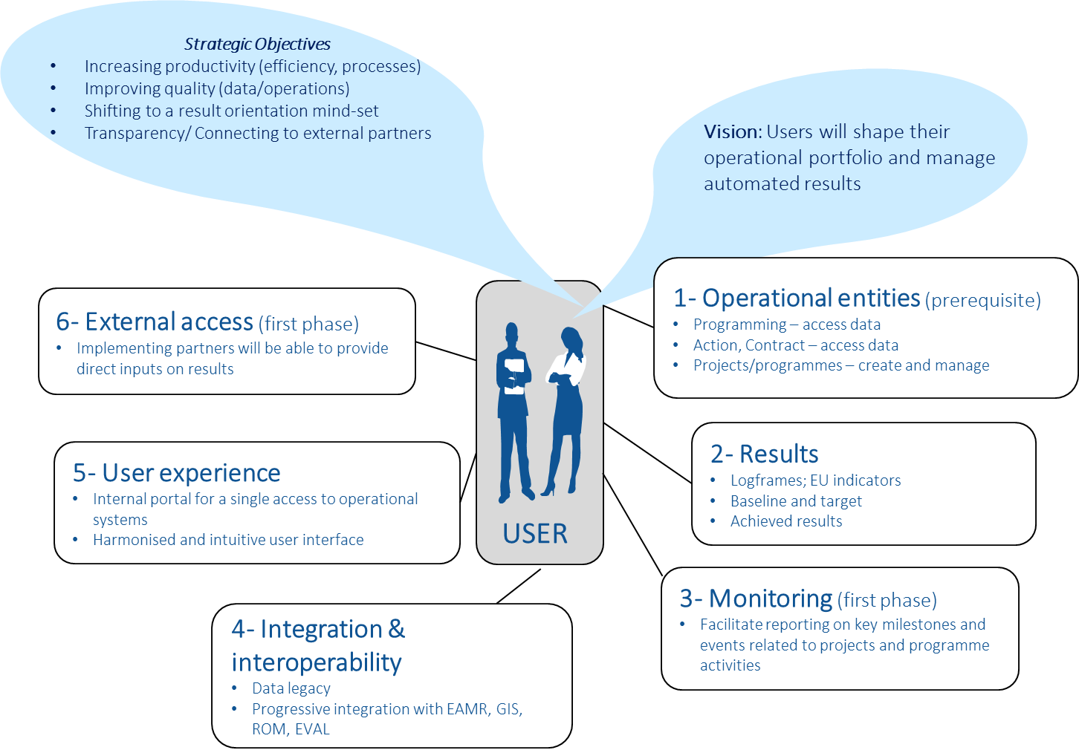

Success Criteria
Success criteria by which the proposed solution will be considered as a success are, by end of 2017:
- Use of OpSys module "results management and operational entities" by all concerned EU Delegations and HQ(s) units
- The End of Project Result Reporting exercise for Projects/Programmes ending in 2016/2017 is done in OpSys and not anymore on Excel tables. Availability of results data for reporting purpose covering at least 90% of projects and programmes in value
- Satisfaction of users and managers with results management and operational entities features

Business Needs
This section lists the key needs of the stakeholders and users that the project shall address. The priority as been set based on two different targets: before the end of 2016 and to be implemented during 2017. A more detailed list of business needs translated in EPICs is available in Annex. Target dates of individual business needs may be subject to adjustment.
ID | Output / Business needs | MoSCoW | Target
Output 1 | Operational entities (create and retrieve operational entities)
1.1 | Create/retrieve operational entities | MUST | 2016
1.2 | Link operational entities with financial information | MUST | 2016
1.3 | Add additional information on operational entities  - retrieve information already encoded in other systems (such as CRIS, MIS)  - enrich entities with additional relevant information | MUST | 2016
1.4 | Link operational entities across the cycle of operation (from Instrument, Domain, MIP, Action, Commission Financing Decision to CRIS Decisions and Contracts) | MUST | 2016
1.5 | Ensure harmonised terminology between DEVCO-NEAR-FPI (or manage different terminologies) | MUST | 2016
Output 2 | Results (manage and monitor results)
2.1 | Encode, update, retrieve and display results across the cycle of operation an link them when relevant from Programming stage, identification and formulation stage, to implementation stage | MUST | 2016
2.2 | Select relevant indicators and manage future aggregation:  - Be guided in the selection of relevant indicators  - Be able to match indicators with EU result framework (EU RF) indicators or other corporate indicator (NEAR, FPI) or other matching indicators (OMI) (thematic priorities, country priorities) | MUST | 2016
2.3 | Monitor results across cycle of operation:  - Enter current/achieved results in the system (done either by the Operational manager or the implementing partner)  - Allow implementing partner to upload key documents related to monitoring  - Generate/ encode and display color-coded scorings on projects and programmes performance | MUST | 2016
2.4 | Quality control encoded results across cycle of operation:  - Be able to quality control of data/documents encoded by the implementing partner  - Be able to quality control of EU RF, other corporate indicator (NEAR, FPI) and OMI matching relationships | MUST | 2016
2.5 | Display aggregated/combined results information:  - Aggregate results by EU RF indicators or other corporate indicators (NEAR, FPI) or OMI  - Display/combine results by projects/programmes, countries, region, year, EUDs/HQ Units, financing instrument | MUST | 2016
Output 3 | Monitoring (Further monitoring of activities at implementation phase)
3.1 | Report on individual outputs progress by the implementing partner | MUST | 2016
3.2 | Plan and monitor key events and activities from the EC Operational manager | MUST | 2017
Output 4 | Integration (integration, migration and interoperability with other systems)
4.1 | Interoperability with documents storage systems | MUST | 2017
4.2 | Migration of Results information from other systems/local tools | MUST | 2017
4.3 | Interoperability for reporting (EAMR) | MUST | 2017
4.4 | Interoperability for ROM and Evaluation (ROM module, Evaluation module) | MUST | 2017
4.5 | Interoperability for transparency, communication and knowledge sharing purpose (GIS, IATI, EUDs internet websites, C4dev) | MUST | 2017
Output 5 | Portal and user experience
5.1 | Security (interface comply with protection rules) | MUST | 2016
5.2 | Information (interface has correct, readable and up-to-date content) | MUST | 2016
5.3 | Functionality (Interface works and don't break) | MUST | 2016
5.4 | Usability (Interface allows users to complete tasks quickly and accurately) | MUST | 2016
5.5 | Aesthetic (Interface looks unique, friendly and professional) | MUST | 2016
5.6 | Customization (personalized dashboard, notifications) | SHOULD | 2017
Output 6 | External access (Allow external users to encode or visualize information)
6.1 | Provide permission to external user to provide inputs | MUST | 2016
6.2 | Provide permission to external user to visualize information | SHOULD | 2017

Deliverables
The table hereunder identifies the main outputs of the project.
ID | Output | Output Description
Output1 | Operational entities | Retrieve all related data already available in CRIS, such as MIP, Sectors, Decisions, Contracts, etc. and create the newly defined operational entities such as Actions, Programmes, Projects, contributing projects, etc. through the new system.  this output will facilitate the full exploitation and dissemination of already available data and documents and will constitute the foundation of all future base of information on programme and projects;
Output2 | Result management | Manage and monitor results in a structured format: including expected results, indicators and their related baseline, intermediary targets (milestones), target and current value and consolidation of the logframes according to the incumbent entities and enabling to collect the data on achieved results and monitor scheduled resources, risks, progress from baseline, progress towards milestones, targets, intermediary years and comment on it.
Output3 | Monitoring | Offer additional projects and programmes monitoring facilities to plan and monitor key events, activities and related milestones for Operational Managers and Implementing partners.  The system will be fully transparent also for external users and will allow to follow-up on implementation and alert when intervention is needed.
Output4 | Integration | Offer an integration with the following existing systems: geo-localisation (GIS), EAMR, ROM, CRIS (temporarily, access to decisions and contracts), and with EVAL, under development.  At the same time the system will facilitate the integration with other portal of information on projects and programmes such as the DEVCO website as well as the websites of EU Delegation, managed by the European External Action Services.
Output5 | Internal portal and user experience | Offer a first step towards an improved user experience and a unified user interface.
Output6 | External access | Offer an external access allowing to encode structured results data from the implementing partners. Each information and data on project results will be directly encoded and updated by the organisation in charge of its implementation, following the principle of subsidiarity.

Features
The following key features are identified:
- Unified and Ergonomic Graphical User Interface (GUI): One of the main needs expressed by the users is the possibility to have one single entry point for accessing and encoding all information and, at the same time, have a coherent GUI among the entire work flow. OpSys Project 1 aims at building the foundation of this concept, developing an advanced and ergonomic interface that will be adopted by all the programme releases.
- Access from any browser. Unlike CRIS, that is only accessible through Internet Explorer, OpSys PROJECT 1 will support available browsers such as IE, Firefox, Chrome and Safari. As a matter of fact, Firefox is the independent browser mainly used in EU Delegations, while Google Chrome is the worldwide most used browser (more than 60% of total users). To summarise, the supported browsers should be the 2 latest versions of Chrome, Firefox, Internet Explorer and Safari.
- Mobile friendly. The system design will be developed since the beginning with the needs of mobile users in mind. It will be accessible and usable by mobile devices and it will thus include readable and large buttons and menus, screens resize functions, etc. The system should be accessible through all main mobile operative systems such as iOS, Android, Windows phone and potentially Blackberry will be supported.
- Security and external access. The application will be accessed and used by internals as well as external users. Security and permission functions will be ensured and managed through Secunda (XSEC). Each selected user will have his/her own specific access rights (read, write, restricted) to each specific screen, function and document.
- Search Features. The search functions should allow advanced searches among metadata as well as within documents. Search will be free text as well structured by entity/category (including auto-complete, filter, phrases in double quotes, Boolean search, exclusion). In this perspective, the enterprise Search function (DIGIT Corporate search), will be duly assessed and possibly adopted.
- Stability and accessibility. The system will be accessed by more than 30,000 potential users worldwide, it's stability and availability 24/7 (except for planned maintenance and with an affordable down time of less than 1 day in case of breakdown or a serious issue) is thus a key element of success. The system will also be bandwidth responsive in order to ensure an acceptable response time in all EU Delegations with possible offline and auto-save functionalities (automatic savinbg back-ups, proper undo, no accidental lose data)
- Interoperability. Due to the variety of applications eligible to be interfaced with OpSys project 1, interoperability functions will be developed. These functions can make use of the DWH system to import/export information from/to other systems, or make use or develop REST/WEB Services for the same purpose. Applications like Capacity4Dev, EAMR, ROM, EVAL and IATI will exchange information with project 1. Document management will be ensured through interoperability with HERMES.
- Versioning. The OpSys project 1system will include a versioning function; users should be able to see changes and modifications to key system elements, including author and date.
- Notifications and workflows. Notification of the performed actions (creation, update, delete) will be implemented across OpSys project 1 as well as to external applications when relevant. With regards to the external applications, the Collaboration will be enabled through the use of a Workflow engine, potentially Compass. For 2016, the workflow function will be supported by DEVCO COPA WF. Systems like Capacity4Dev, EAMR, ROM, Eval and IATI could benefit from the collaboration functions.
- Multilingual. In order to support the various users across the 128 EU Delegations as well as external users, the OpSys project 1 will be developed as a Multi-lingual system. The 4 used DEVCO languages should be supported: French, English, Spanish and Portuguese.
- Help and support. Advanced and contextual help functions will be provided to the end users, auto-complete suggestions when entering a field, question mark guidance, reference to the user guides, tips, short e-learning explanations, etc. should all be included
- Geo-localisation. The existing GIS system should be integrated in the OpSys project 1 together with additional features aiming at associating multi-media functions such as the possibility to link photos and videos to programmes and automatically geo-localise them.
- Customisation. The system should allow to customise its key elements so that every end-user should be able to tailor his own dashboard, displaying the programme-project-actions he is in charge, enabling to add specific entities that he would like to monitor, enabling breakdowns according to countries, etc.

Constraints
Key constraints are as follows:
- Dependence from other Commission projects: rationalisation inside the Commission, requires to consider or prototype several options,
  - MIS re-use (result management part)
  - Compass prototype, whose results will be known in June 2016. Compass solution, made of Compass Core (used for Workflows) as well as Compass GUI is a powerful solution to support the notification processes inside project 1. Nevertheless, the use of a Corporate solution presents limit, as the adaption and requests for changes expressed by DEVCO/NEAR and FPI will have to go through the DG RTD user committee, and answer to our adaption requests may not receive nor a quick nor a positive answer in most of the cases
  - DIGIT Enterprise Search Project, aiming at providing a corporate and "Google like" search function, enabling to search not only in the titles and indexes, but also in the content of the documents
  - SEDIA project: SEDIA will offer in the medium term a single access to Commission information systems for economic and non profit operators; external access and access for implementing partners should be designed in a way to be compatible with SEDIA
- DEVCO is requested to produce annually a report on achieved results; timeline for project 1 should be designed in a way to allow the use of automated results management for the 2018 report (results achieved in 2017);
- The so far available budget for 2016 for project 1 (IT supplier: € 1 million for phase 1, Business side €1.1 million)
- The use of PM2 and agile@EC standards; it implies a learning curve for agile methodology both for the IT supplier and business side (only one full experience on PADOR for the IT supplier)

Assumptions
Key assumptions for the solution are as follows:
- Business units (DEVCO, NEAR, FPI) and Delegations will dedicate enough time for their business experts and users to be part of DOMAIN user groups and bilateral discussions
- Selected EU Delegations and business units identified timely for the deployment of the final pilot
- OpSys sponsorship is mobilised and enough visibility is given to OpSys programme
- Enough resources mobilised to support the IT supplier and the system owner according to identified needs
- An agile methodology will be used by the IT supplier (key for respecting the timeframe and for reaching the user centric objective)
- The re-use analysis of MIS/result management is finalized timely and confirms the choice made when exploring the possible alternatives
- COMPASS proof of concept is conclusive and does not delay phase 1
- DIGIT will timely provide the hosting environment
- Change management activities are implemented on time
- Unique location for the agile development team. The recent evolution of the contractual environment fosters the recruitment of IT resources in proximity" mode. In general as well as in particular, in the contextual of Agile developments, the location of the development team (development team + product owners) in a single location is something as important as having the staff with the right skills and the right motivation.

Risks
The following key risks have been initially identified at this stage (H=High, M=Medium, L=Low);
For project 1 two additional crucial risks have been identified/re-evaluated in addition to the two crucial risks identified at business case level (complexity and resistance to change): business involvement into needs definition and testing as well as mobilisation of resources (scalability of system owner and IT supplier teams).

ID | Type | Risk Description & Details | Likelihood | Impact | Mitigation measures  Details
1 | Technical | Complexity of OpSys programme implying a more complex project 1 (shaping the foundations for the full OpSys):  - Common with NEAR FPI  - Governance structure with multiple layers leading to lengthy approval processes  - Wider scope with operational entities, user experience and access for implementing partners  - Harmonisation work  - anticipation of needs to be covered by further OpSys projects | H | H | - shift non-essential identified needs for project 1 to other phases  - Inclusiveness of user groups and Programme steering committee  - Deployment of project 1 in two stages (first in pilot units and EU delegations)  - Temporary solution for external access
2 | Manage-ment | Resistance to change linked to:  - Effort to enter into a new system  - recent effort made by NEAR/IPA II to move into MIS/results discouraging a new effort  - Mistrust outside usual ways of working; e.g. agile methodology | H | H | - Communication plan and activities upstream  - Comprehensive change management strategy  - Strong and inclusive involvement of users since the beginning including EU delegations  - Training and support on agile
3 | Manage-ment | Business involvement into needs definition and testing: recent staff cuts have increased the sense of negative priorities | H | H | - Strong sponsorship in DEVCO, and NEAR, and FPI, in order to make OpSys a positive priority
4 | Manage-ment | Scalability of the OpSys unit 05 and of the IT supplier R6 and their ability to support the project:  - with the right staff resources, competences and financing; including programme office management  - ability of the IT supplier to provide the environments, the GIT code branches in project ramp up phase | H | H | - 05: right mix of statutory staff and intra-muros experts  - 05 and R6: appropriate training  - Budgetary revision when necessary
5 | Technical | Methodology: the agile methodology is not applied when relevant (e.g. distance between users and developers); adherence to PM2 standards throughout the project lifetime | M | H | - OpSys unit being part of methodology choices and steering for IT development  - restrict the communication on agile methodology to avoid misunderstandings  - Starting early prototyping
6 | Technical | Taxonomy: harmonisation of terminologies, conceptual data model | M | M | - Strong sponsorship from business side from DEVCO, NEAR and FPI allowing to refer if necessary to management meetings  - Acceptance of differences in critical situations
7 | Technical | Wrong technology choices for the enterprise architecture (development technology, IT components) | L | M | - Work with DEVCO IT unit and DIGIT B1 to ensure the full IT architecture coherence with OpSys needs, associating NEAR IT Unit
8 | Technical | Integration and migration of data from existing tools in order to preserve the data legacy; integration of existing tools like GIS, ROM, EAMR, CRIS DEC and CTR | M | M | - Prioritisation and if necessary postponement of non-priorities to further OpSys phases

Cost, Timing and Resources

Cost
 | Experts needs |  |  | Implementation costs (in K€)
 | Categories of expert |  |  | 2016 | 2017 | 2018 | 2019 | 2020 | Total (K€)
Business costs | 1 Business Manager (100%) | Lucile Petitpierre | DEVCO 05 | 94 | 147 | 37 | 37 | 37 | 351
Business costs | 1 User experience expert (40%) | To be defined | DEVCO 05 | 50 | 62 | 0 | 0 | 0 | 48
Business costs | 1 Change management expert (50%) | To be defined | DEVCO 05 | 93 | 136 | 23 | 23 | 0 | 275
Business costs | 1 Glossary manager (50%) | To be defined | DEVCO 05 | 84 | 39 | 0 | 0 | 0 | 69
Business costs | 1 Migration expert (50%) | Michel Lonneux | DEVCO 05 | 80 | 80 | 40 | 0 | 0 | 201
Business costs | 1 Programme architect (50%) | Emmanuel de Kerchove | DEVCO 05 | 69 | 52 | 0 | 0 | 0 | 121
Business costs | 2 Junior experts - migration & support (100%) | To be defined | DEVCO 05 | 160 | 220 | 110 | 110 | 110 | 710
Total Business costs |  |  |  | 630 | 736 | 210 | 170 | 147 | 1,775
IT Costs | 1 IT Project manager | Eric Pasteleur | DEVCO R6 | 77 | 123 | 46 | 23 | 0 | 269
IT Costs | 1 Product owner (100%) | Giuliano Rosciglione | DEVCO R6 | 117 | 171 | 51 | 26 | 26 | 390
IT Costs | 1 Architect manager (50%) | Johan GAUDIN | DEVCO R6 | 53 | 82 | 66 | 66 | 0 | 266
IT Costs | 1 Scrum master (50%) | To be defined | DEVCO R6 | 53 | 82 | 33 | 33 | 0 | 200
IT Costs | 1 Analyst (20%) | Alessandro Sanfilippo | DEVCO R6 | 20 | 15 | 0 | 0 | 0 | 35
IT Costs | 1 GUI Designer (50%) | Matthias Wille | DEVCO R6 | 40 | 60 | 28 | 28 | 0 | 155
IT Costs | 1 Developper (Gizra) (100%) | Nader Safadi | DEVCO R6 | 134 | 208 | 0 | 0 | 0 | 342
IT Costs | Developers Team 1 (100%) | To be defined | DEVCO R6 | 248 | 380 | 121 | 61 | 0 | 809
IT Costs | Developers Team 2 (100%) | To be defined | DEVCO R6 | 165 | 396 | 121 | 61 | 0 | 743
Total IT costs |  |  |  | 906 | 1,514 | 466 | 296 | 26 | 3,208

Other costs (direct ONLY) |  |  | Implementation costs (in K€)
Categories |  | Unit cost | 2016 | 2017 | 2018 | 2019 | 2020 | Total (€)
change management and training | Travels and perdiem in Pilot EUDs | Local visit to pilot EUDs:  3 days in 7 EUDs for 2 experts:  7 *3.000€* 2 experts | 42 |  |  |  |  | 42
change management and training | Travels and per diem for change management, communication, and continuous training | Local visit in approx. 20 EUDs covering 2017-2019 (only 50% on project 1)  7*3000 € * 1 expert x 50% |  | 10 | 10 | 10 |  | 30
change management and training | Monitoring mission in selected EUDs | Local visit to selected EUDs:  3 days in 7 EUDs for 2 experts:  7 *3.000€* 2 experts |  |  | 42 |  |  | 42
Training | Training material | Preparation of the training supports & materials |  | 60 | 60 | 60 |  | 180
Communication | Communication material | Lum sum | 20 | 80 |  |  |  | 100
Total other direct costs |  |  | 62 | 150 | 112 | 70 | 0 | 394

Planning
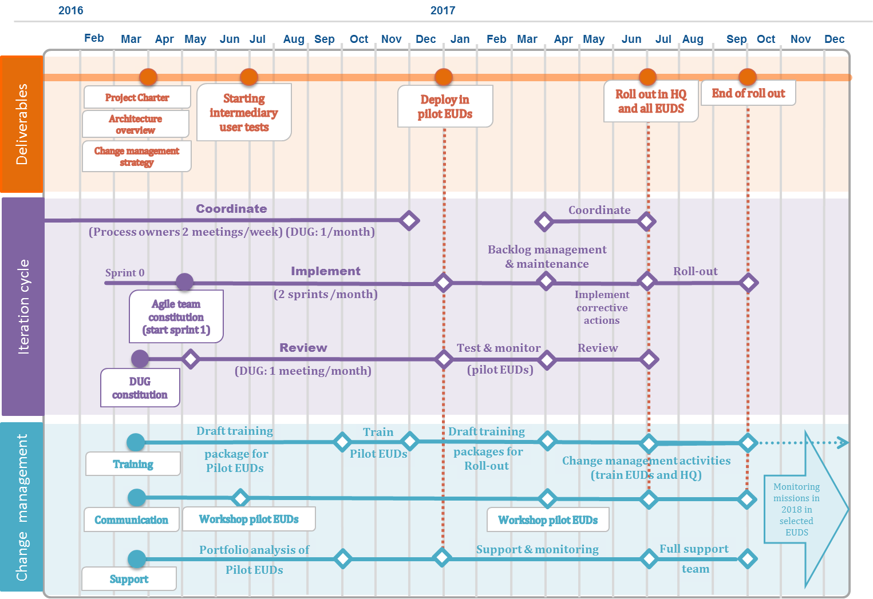
The dates of deployment in pilot EUDs may be subject to adjustment as it will be agreed with them, in order to optimise workload related to the phasing in.

Planned Resources
The following table gives an overview of the profiles and their workload for the project. We a detailed estimated workload by months for 2016 and 2017. Years 2018, 2019, 2020 are high level estimations.

Planned resources by year from 2016 to 2020
 | Experts needs |  |  |  | W/days
 | Categories of expert | Expert | DEVCO Unit | Nb | 2016 | 2017 | 2018 | 2019 | 2020 | Total w/days
Business costs | 1 Business Manager (100%) | Lucile Petitpierre | DEVCO 05 | 1 | 144 | 226 | 56.5 | 56.5 | 56.5 | 539.5
Business costs | 1 User experience expert (40%) | To be defined | DEVCO 05 | 1 | 64 | 80 | 0 | 0 | 0 | 62
Business costs | 1 Change management expert (50%) | To be defined | DEVCO 05 | 1 | 120 | 175 | 30 | 30 | 0 | 355
Business costs | 1 Glossary manager (50%) | To be defined | DEVCO 05 | 1 | 109 | 50 | 0 | 0 | 0 | 89
Business costs | 1 Migration expert (50%) | Michel Lonneux | DEVCO 05 | 1 | 110 | 110 | 55 | 0 | 0 | 275
Business costs | 1 Programme architect (50%) | Emmanuel de Kerchove | DEVCO 05 | 1 | 80 | 60 | 0 | 0 | 0 | 140
Business costs | 2 Junior experts - migration & support (100%) | To be defined | DEVCO 05 | 2 | 320 | 440 | 220 | 220 | 220 | 1420
IT Costs | 1 IT Project manager | Eric Pasteleur | DEVCO R6 | 1 | 110 | 175 | 66 | 33 | 0 | 384
IT Costs | 1 Product owner (100%) | Giuliano Rosciglione | DEVCO R6 | 1 | 151 | 220 | 66 | 33 | 33 | 503
IT Costs | 1 Architect manager (50%) | Johan GAUDIN | DEVCO R6 | 1 | 88 | 136 | 110 | 110 | 0 | 444
IT Costs | 1 Scrum master (50%) | To be defined | DEVCO R6 | 1 | 88 | 136 | 55 | 55 | 0 | 334
IT Costs | 1 Analyst (20%) | Alessandro Sanfilippo | DEVCO R6 | 1 | 40 | 30 | 0 | 0 | 0 | 70
IT Costs | 1 GUI Designer (50%) | Matthias Wille | DEVCO R6 | 1 | 80 | 120 | 55 | 55 | 0 | 310
IT Costs | 1 Developper (Gizra) (100%) | Nader Safadi | DEVCO R6 | 1 | 155 | 240 | 0 | 0 | 0 | 395
IT Costs | Developers Team 1 (100%) | To be defined | DEVCO R6 | 3 | 450 | 690 | 220 | 110 | 0 | 1470
IT Costs | Developers Team 2 (100%) | To be defined | DEVCO R6 | 3 | 300 | 720 | 220 | 110 | 0 | 1350

Planned resources by months for 2016 and 2017
 | Experts needs |  |  | 2016 |  |  |  |  |  |  |  |  | 2017
 | Categories of expert | Expert | DEVCO Unit | May | June | July | August | September | October | November | December | TOTAL | January | February | March | April | May | June | July | August | September | October | November | December | TOTAL
Business costs | 1 Business Manager (100%) | Lucile Petitpierre | DEVCO 05 | 18 | 22 | 11 | 17 | 20 | 21 | 20 | 15 | 144 | 20 | 21 | 20 | 21 | 18 | 22 | 11 | 17 | 20 | 21 | 20 | 15 | 226
Business costs | 1 User experience expert (40%) | To be defined | DEVCO 05 | 8 | 8 | 8 | 8 | 8 | 8 | 8 | 8 | 64 | 8 | 8 | 8 | 20 | 20 | 8 | 8 | 0 | 0 | 0 | 0 | 0 | 80
Business costs | 1 Change management expert (50%) | To be defined | DEVCO 05 | 10 | 10 | 10 | 10 | 20 | 20 | 20 | 20 | 120 | 20 | 20 | 20 | 10 | 10 | 10 | 10 | 20 | 20 | 20 | 10 | 5 | 175
Business costs | 1 Glossary manager (50%) | To be defined | DEVCO 05 | 18 | 22 | 20 | 9 | 10 | 10 | 10 | 10 | 109 | 10 | 10 | 10 | 10 | 10 | 0 | 0 | 0 | 0 | 0 | 0 | 0 | 50
Business costs | 1 Migration expert (50%) | Michel Lonneux | DEVCO 05 | 15 | 15 | 15 | 10 | 15 | 15 | 10 | 15 | 110 | 10 | 10 | 10 | 10 | 10 | 10 | 10 | 5 | 10 | 10 | 10 | 5 | 110
Business costs | 1 Programme architect (50%) | Emmanuel de Kerchove | DEVCO 05 | 10 | 10 | 10 | 10 | 10 | 10 | 10 | 10 | 80 | 10 | 10 | 10 | 10 | 10 | 10 | 0 | 0 | 0 | 0 | 0 | 0 | 60
Business costs | 2 Junior experts - migration & support (100%) | To be defined | DEVCO 05 | 40 | 40 | 40 | 40 | 40 | 40 | 40 | 40 | 320 | 40 | 40 | 40 | 40 | 40 | 40 | 20 | 20 | 40 | 40 | 40 | 40 | 440
Business costs |  |  | Total (man days) | 119 | 127 | 114 | 104 | 123 | 124 | 118 | 118 | 947 | 118 | 119 | 118 | 121 | 118 | 100 | 59 | 62 | 90 | 91 | 80 | 65 | 1141
IT costs | 1 IT Project manager | Eric Pasteleur | DEVCO R6 | 15 | 15 | 15 | 10 | 15 | 15 | 10 | 15 | 110 | 15 | 15 | 10 | 15 | 15 | 15 | 15 | 15 | 15 | 15 | 15 | 15 | 175
IT costs | 1 Product owner (100%) | Giuliano Rosciglione | DEVCO R6 | 18 | 22 | 19 | 12 | 22 | 21 | 20 | 17 | 151 | 20 | 20 | 20 | 10 | 20 | 20 | 15 | 20 | 20 | 15 | 20 | 20 | 220
IT costs | 1 Architect manager (50%) | Johan GAUDIN | DEVCO R6 | 12 | 12 | 12 | 6 | 12 | 12 | 10 | 12 | 88 | 12 | 12 | 12 | 6 | 12 | 12 | 10 | 12 | 12 | 12 | 12 | 12 | 136
IT costs | 1 Scrum master (50%) | To be defined | DEVCO R6 | 12 | 12 | 12 | 6 | 12 | 12 | 10 | 12 | 1113 | 12 | 12 | 12 | 6 | 12 | 12 | 10 | 12 | 12 | 12 | 12 | 12 | 136
IT costs | 1 Analyst (20%) | Alessandro Sanfilippo | DEVCO R6 | 5 | 5 | 5 | 5 | 5 | 5 | 5 | 5 | 1113 | 5 | 5 | 5 | 5 | 5 | 5 | 0 | 0 | 0 | 0 | 0 | 0 | 136
IT costs | 1 GUI Designer (50%) | Matthias Wille | DEVCO R6 | 10 | 10 | 10 | 10 | 10 | 10 | 10 | 10 | 1113 | 10 | 10 | 10 | 10 | 10 | 10 | 10 | 10 | 10 | 10 | 10 | 10 | 136
IT costs | 1 Developper (Gizra) (100%) | Nader Safadi | DEVCO R6 | 20 | 20 | 20 | 20 | 20 | 20 | 15 | 20 | 1113 | 20 | 20 | 20 | 20 | 20 | 20 | 20 | 20 | 20 | 20 | 20 | 20 | 136
IT costs | Developers Team 1 (100%) | To be defined | DEVCO R6 | 60 | 60 | 60 | 30 | 60 | 60 | 60 | 60 | 1113 | 60 | 60 | 60 | 30 | 60 | 60 | 60 | 60 | 60 | 60 | 60 | 60 | 136
IT costs | Developers Team 2 (100%) | To be defined | DEVCO R6 | 0 | 0 | 0 | 60 | 60 | 60 | 60 | 60 | 1113 | 60 | 60 | 60 | 60 | 60 | 60 | 60 | 60 | 60 | 60 | 60 | 60 | 136
IT costs |  |  | Total (man days) | 152 | 156 | 153 | 159 | 216 | 215 | 200 | 211 | 1462 | 214 | 214 | 209 | 162 | 214 | 214 | 200 | 209 | 209 | 204 | 209 | 209 | 667

Approach

Methodology
The Project will follow the Agile@EC methodology for all project activities but with some tailoring regarding the documentation to make. The following table contains the list of artefacts that will be produced for this project.
Legend
Responsible: They do the work and also lead others that Support (also do work).
Accountable: They authorise and approve work. There is only one person Accountable
Supports: As part of a team, they work with the person responsible. Unlike the Consulted role, the Support role helps to complete the task.
Consulted: These roles provide input to the activity.
Informed: These roles will be informed (kept up to date).

RASCI Matrix
 | Business manager | IT Project manager | Process owner | Domain user group | Product owner | Scrum master /Team coordinator | Architecture Owner | Development team | IT Board | ITSC | PSC | PUC | System Owner | System supplier | PMO/Programme Manager | IT Programme Manager | Coordinator BM | Coordinator ITPM
Artefacts | Project level |  |  |  | Agile team level |  |  |  | Upper governance bodies and Programme level
Business Case | R | S | C |  |  |  |  |  | I | C | C | C | A | C | I | I | S | I
Project Charter | R | S | C | C | S |  |  |  | I | C | C | C | A | C | I | I | I | I
Architecture Overview | C | A |  |  | C |  | R | S |  |  |  |  |  | I | I | I | I | I
Operational Model | I | A |  |  | I |  | R | S |  |  |  |  |  | I | I | I | I | I
Change management strategy | R | C | C | I |  |  |  |  |  | C | C | C | I |  |  |  | A | I
Development Handbook | C | A | I | I | C | R | C | C |  |  |  |  | I | I |  |  | I | I
Work Item List (Backlog) | S | A |  |  | R | S | S | S
Project workplan (incl Release Plan) | S | A |  |  | S | R | S | S |  |  | I | I | I | I |  |  | I | I
Iteration testing plan |  | A |  |  | S | R | S | S
User Acceptance Test (UAT) plan | S | S |  |  | R |  |  |  |  |  |  |  |  |  |  |  | A
Development Status Report | I | A |  |  | S | R | S | S
Project status report | S | S |  |  |  |  |  |  | I | I | I | I | A | C | R | C | S | S
Project-End Report | S | R |  |  | S | S | S | S |  |  |  |  |  |  |  |  |  | A

Change Management

Project Change
Project change management aims to bring transparency, accountability and traceability to all project improvements and modification to be implemented during the project life cycle. It ensures that changes with a significant impact in any of the dimensions (i.e. scope, time, cost, quality or risk) are properly assessed, agreed upon and approved by the appropriate level of authority.
A project change can result from a change in scope, a new requirement, an improved quality, a newly identified issue, a preventive action to reduce the risk level, or from a decision taken to change any of project baselines (scheduling, staffing or budget).
In Agile project the team commits to delivering on a fixed date for a certain cost, and to do that there must be flexibility in scope. As set in the Agile@EC principles and in the aim of continuous improvement and learning: "Requirement changes are welcome".
The entire system will be developed in a way to allow maximum flexibility and scalability in order to be ready to incorporate changes and improvements that will be welcomed during the entire development phase. As a matter of fact, the backlog artefact will include all user stories and will be linked to their related pages for development. As soon as additional user stories will be defined and approved, they will be prioritised and planned for the successive sprints

Configuration Management
Project 1 Confluence page managed by DEVCO R6 is a repository for all key information on the project. It is composed of 4 different sections: OpSys master plan, OpSys release plan, OpSys modules documentation, OpSys open workspace.
Link to confluence page: https://webgate.ec.europa.eu/CITnet/confluence/display/OpSys/
Project 1 Traceability matrix maps the Business Requirements (Epic Stories, User Stories) and the Jira link to the Jira product backlog (work items list). It also documents the date of the user story, its status (under validation by process owners, under development, under testing, done), the MoSCoW flagging and which of them are associated with a particular sprint.
Link to traceability matrix:\\Net1\devco\DG\05\6. OpSys IMPLEMENTATION\7. RELEASE 1\2. EPIC and USER STORIES
Project 1 product backlog contains a prioritised list of user stories, features or technical tasks which the team maintains and which, at a given moment, are known to be necessary and sufficient to complete a project or a release. It represents the team's state of knowledge of at a particular moment and it is expected that it changes throughout the project's duration as the team gains knowledge.
The information on each prioritised work items have varying degrees of detail (higher priority implies having more details so that it is possible to estimate and develop; lower priority suggest that detailing can happen at a later stage of the development).
It also includes the iteration backlog as a subset of the Work Items List that will be addressed during the time-boxed iteration.
Link to Product backlog in Jira: https://webgate.ec.europa.eu/CITnet/jira/browse/OpSys/

Organisational Change
Change management strategy is critical for reducing resistance and achieving project objectives. It is a set of tools, processes, skills and principles to successfully adopt change in order to drive organizational success and outcomes.
Effective change management enables the transformation of processes and technology to enhance performance and ensure continuous improvement in an ever-changing environment. It can positively impact achieving project outcomes and helps to ensure that all personnel affected by the change receive support to help them manage the change.
The project 1 "Results management and operational entities" change management strategy is based on best practices which support effective business transformation and on the strategic objectives of OpSyS programme namely Increasing productivity (efficiency, processes), Improving quality (data/operations), Shifting to a result orientation mind-set and Transparency/ Connecting to external partners
Change management activities will take in place three different phases.
The Change management Strategy (Phase 1) is a high-level document that outlines the approach to managing change throughout the project lifecycle and for the transition to a steady state of operational business.
It will be supported by a change management plans (Phase 2) that will drive the regular activities of the change management team and will be developed in accordance with the Change management Strategy. The details of the change management plans will be customized and based on the specific needs of each stakeholder group affected by the project. It will be composed of a stakeholder's assessment and management plan (including the use of change agents and sponsors), a communication plan, a training plan, a support plan and will run in parallel with other project activities for the period of the project.
Finally, the post-implementation review period (post-implementation monitoring and evaluation plan) (Phase 3) should lead to adjustments/optimisation of the programme.
The main activities will be implemented:
 |  | Main activities
Stakeholders assessment | Stakeholders analysis | - list of all individuals affected by the changes (stakeholders)  - list of the changes these individuals will undergo to support the new processes and any gaps they have in understanding this transformation  - plan to target how we will fill theses gaps, either through training, communications, sponsorship or other means  - Any follow-up activities or assessments that need to be done after we roll out the project to ensure that they are effective
Stakeholders assessment | Sponsorship | - List of leaders and managers who need to be on board and actively engaged in leading the change. Sponsorship should help gain support within the end-user community and provides a positive influence for the project.
Stakeholders assessment | Change agents | - Establishment of a network of individual to help empower the users and generate a clear vision throughout the organisation.  - List of change agents who are champion within the organisation who can help the end user of the new processes and systems understand the value of the new model and who can encourage support and usage.
Resistance to change | Resistance to change strategy | - Identify critical gaps and possible points of resistance  - Define and communicate issue with reasons to change  - Develop, share, and encourage through intensive training and communication  - Actively listen and handle ongoing concerns
ACTION PLANNING | Communication plan | - Regular meetings: Regularly scheduled meetings with the PSC, PUC and D-UG to and special meetings for one Unit or EUD (videoconferencing)  - Paper-based tools: newsletters, articles, direct mailings, posters, leaflet, etc.  - Web based tools: Post on Intranet site and any other relevant websites  Two special events to be organized in 2016 and 2017:  - One workshop of 1,5 days in July or Septmber 2016 in Brussels involving operational managers and a sample of implementing partners from pilot EUDs to present the main progress in “results management and operational entities” project and OpSys Programme implementation  - One workshop in mid-2017 involving operational managers from the pilot EUDs to monitor change and collect feedback on the 3 firsts months of the project implementation
ACTION PLANNING | Training plan | Training activities:  - Custom-made training for pilot EUDS: From October to December 2015, two days training sessions will take place in each pilot EUDs  - Training for roll-out : online E-learning, FAQ, mouse hoover tips and quick reference guide  - Support training (for IT helpdesk)  - Training opportunities (PPCM and other training)  - Monitoring mission in 2018 in selected EUDs
ACTION PLANNING | Support plan | - Migration: The aim is to migrate most of online and offline results data in the new system including end of project result reporting exercises, MIS data, offline logframe, action documents logframe, etc. Two full-time junior experts with the support of the migration manager in Unit 05 will perform this task.  - Operational Helpdesk: a helpdesk in DEVCO 05 will be put in place to answer to questions that may raise on the new system though the DEVCO 05 functional mailbox.  - IT Helpdesk: DEVCO application support will act as first level support for all questions or issues on IT aspect of the OpSys result system.

Governance and Stakeholders
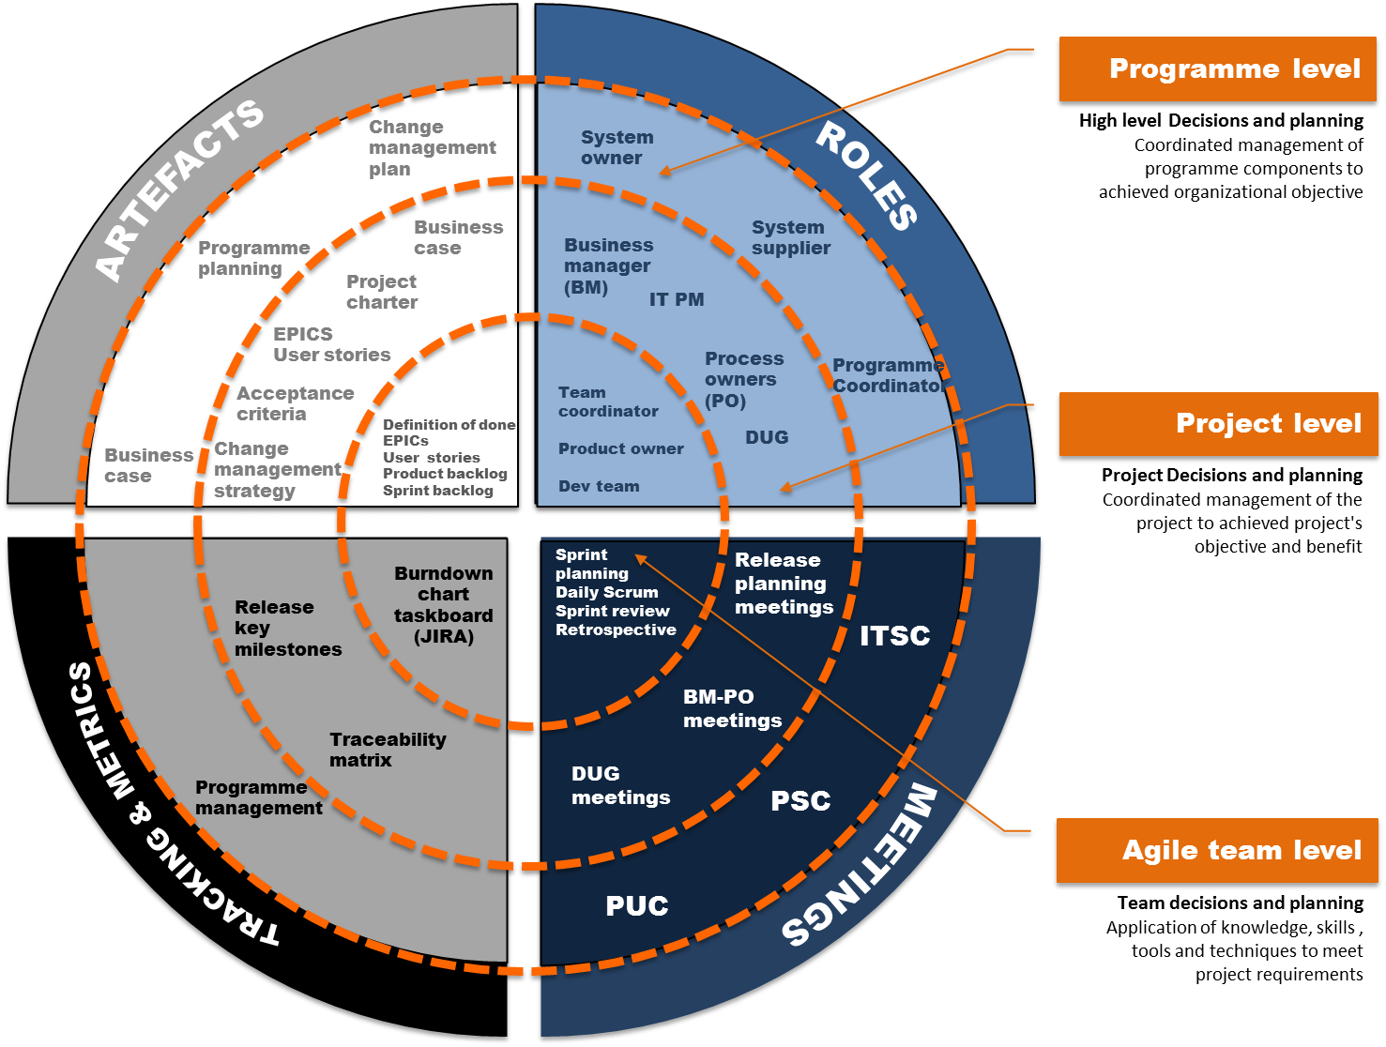

Structure
The following figure depicts the structure of the project management team. The specific roles and responsibilities are explained in the next subsection.
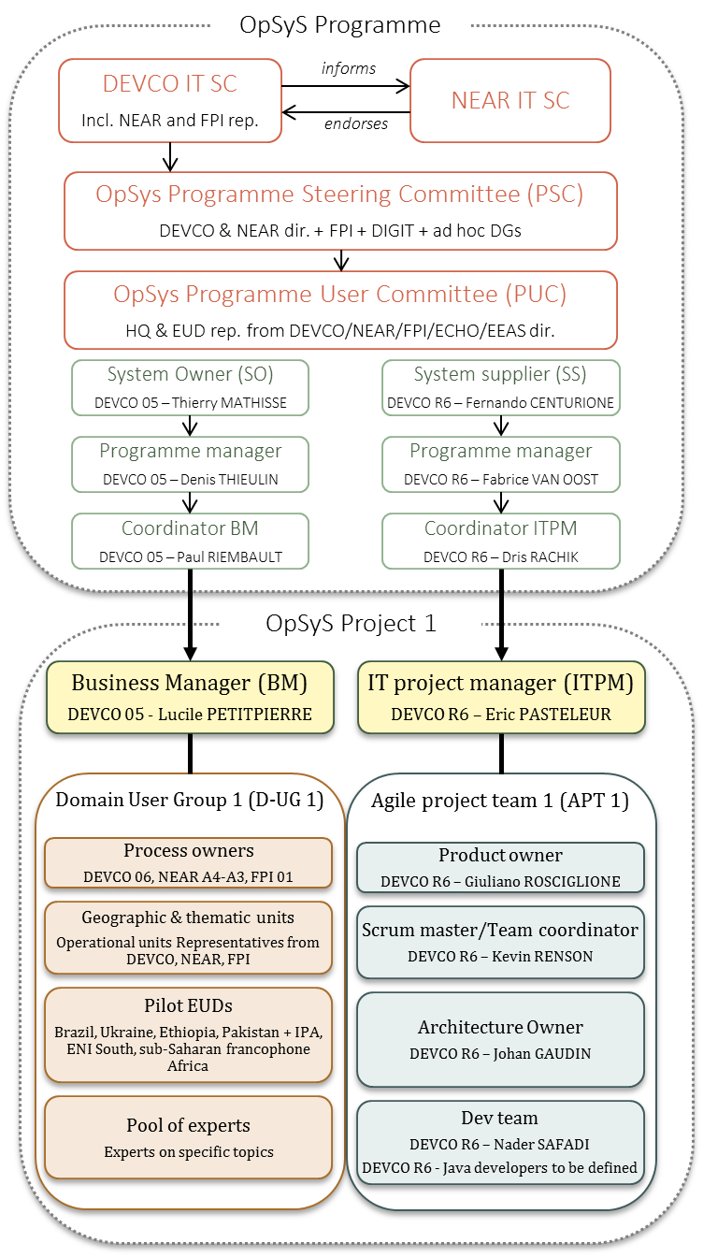

Roles
This section elaborates on the roles of the major players in the project and their responsibilities including the expectations, rights and duties of each participant in the project.

Business Manager (BM)
Lucile PETITPIERRE (DEVCO 05)
Description
Acts on a daily basis on behalf of the System Owner (SO). The BM manages the project on a daily basis and is responsible for the qualitative product delivery within the imposed constraints.
Responsibilities
Collaboration
- Establishes and guarantees an efficient collaboration and communication channel with the IT Project Manager (IT PM) and Product owner though regular meetings.
- Ensures constant and effective communication between all stakeholders.
- Ensures under the leadership of the ITPM the interoperability and integration of the different projects in terms of experience and service to the users
Business needs specification
- Drafts the business part of the business case and project charter
- Manages the business side activities for the project including the definition of business needs the support of the process owners
- Seek approval of the process owners and DUG on the business needs specification
- Supports the Product owner in the transposition of Business needs in EPICs, user stories and features and draft acceptance criteria
- Run and chair the DUG meetings on regular basis with the support of the product owner.
Business needs implementation
- Seeks approval of the process owners and DUG on the business needs implementation (validation of acceptance criteria in UAT)
Change management activities
- Ensures that the business organisation is ready to accommodate and employ the final project product once delivered from the System Supplier
- Coordinates the schedule and delivery of user training (and production of necessary user support material).
Planning, monitoring
- Performs risk management for project business related risks.
- Provides to the PSC the documents for high-level monitoring.
- Escalates unresolvable project issues to the PUC and PSC with the support of the BM coordinator
- Ensures that project objectives are achieved within the quality, time, and cost objectives to meet stakeholders' expectations taking preventive or corrective measures where necessary.
Artefacts
- Is responsible to create key management artefacts (Business case, Project charter) and proposes them for approval to the Project Steering Committee (PSC).
- Draws up in collaboration with the ITPM the main project management documents (defining the human and financial resources needed).
- Manages the business part of the project logs (risk, issues)

IT Project manager (ITPM)
Eric PASTELEUR (DEVCO R6)
Description
The IT Project Manager is appointed by the System Supplier. The IT project manager manages the IT part of the project on a daily basis and is responsible for the qualitative IT product delivery within the imposed constraints.
Responsibilities
Collaboration
- Establishes and guarantees an efficient collaboration and communication channel with the BM and Product owner though regular meetings.
- Ensures under the leadership of the Enterprise Architect the interoperability and integration of the different IT projects and component related to IT deliverables, systems, services and applications.
IT activities
- Drafts the IT part and features of the business case and project charter
- Daily manages and coordinates the Agile team activities, making optimal use of the allocated resources.
Planning, monitoring
- Compares project actuals and expenditures to what was planned
- Performs risk management for IT related risks.
- Escalates unresolvable project issues to the BM, BM coordinator and ITPM coordinator
- Ensures that project objectives are achieved within the quality, time, and cost objectives to meet stakeholders' expectations taking preventive or corrective measures where necessary.
Artefacts
- Draws up in collaboration with the BM the main project management documents (defining the human and financial resources needed).
- Is accountable for key IT management artefacts (Project workplan, Development handbook, Work items list, iteration testing plan)
- Manages the IT part of the project logs (risk, issues, decisions, change requests log)

Product owner
Giuliano ROSCIGLIONE (DEVCO R6)
Description
The Product Owner (PrOw) represents mainly client and end-users concerns. This role should develop deep understanding of the needs and desires of the stakeholders. This understanding allows the Product Owner (PrOw) to better capture and set priorities for the work items. This role can be seen as the "one voice of the stakeholders" within the project organisation team and ideally should work in the same physical environment of the rest of team
Responsibilities
Collaboration
- Establishes and guarantees an efficient collaboration and communication channel with the BM, IT PM and developers though regular meetings.
- Clarifies domain-related questions that the Agile team may have or ensures that a channel with the BM is open for collaboration and clarification.
Business needs specification
- Transposes the Business needs in EPICs, user stories and features and draft acceptance criteria with the support of the BM
- Facilitates requirements gathering and modelling sessions
- Ranks work item on business priorities
- Business needs implementation
- Facilitates the presentation of project's intermediate outputs to the Business manager, process owner and DUG (demos)
- Participate and support the BM in the preparation and facilitation of DUG meetings
Planning, monitoring
- Prioritizes continuously the user stories to be addressed by the Agile team in alignment with the feedback from both the Business manager and the Agile team
- Provides feedback on iteration achievements
Artefacts
- Prepares and maintains the product backlog

Process Owner
DEVCO 06, NEAR A3, A4, FPI .1
Description
The Process Owner is one or several DEVCO-NEAR-FPI unit(s) that has/have the full knowledge of a process from its origin to its end. The Process Owner guarantees that process representations are complete, valid and up-to-date. He drives process evolution and improvements.
Responsibilities
- is knowledgeable about one, several, or part of one DEVCO-NEAR-FPI Macro-Processes
- has a clear understanding about all the steps, actors, documents, related systems and information dealt by the Macro-Process.
- Acts as the business representative for one, several, or part of one Macro-Process. Hence, the Process owner is able to provide a single version of the business reality and he is in a position to advise the System Owner on potential changes in the systems (system change requests).
- Works in collaboration with the business manager on the validation of business needs
- Is a key member of the Domain User group
- Advises and supports System owner and the Business manager in case they need information on the related process.

Domain User Group
Process owners, Geographic & Thematic Operational units, Pilot EUDs
Description
Represents the interests of the users in the project.. Involving the user representatives throughout the project is important, as they gain visibility of project activities and gain a sense of ownership and motivation, which ensures that the deliverables are fit for business purpose.
Responsibilities
- Helps finalize business needs and requirements.
- Ensures that the project specifications and deliverables meet the needs of all users.
- Approves on behalf of the users the project specification, and acceptance criteria.
- Performs the user acceptance tests.
- Participates in demonstrations and pilot phases as needed.
- Participates to the glossary finalisation and the harmonisation of terminology

Scrum master/Team coordinator
Kevin RENSON (DEVCO R6)
Description
The Team Coordinator (TeCo) acts as a facilitator and team coach whose main purpose is to create and maintain the conditions (e.g. resources, issue resolution) to allow the team to be focused on achieving specific objectives and being successful. This role's responsibilities typically focus on the technical aspects of the work and on "hiding" the project management concerns from the Agile Team), such as the overall project's work planning and estimation. The Team Coordinator (TeCo) facilitates or guides the team in performing technical management activities instead of taking on "alone" these responsibilities.
Responsibilities
- Ensures the effectiveness and continuous improvement of the way the Agile Team works.
- Facilitates the collaborative and cooperative working environment within the Agile Team.
- Coordinates the planning and estimation activities, as well as the work progress report with the Business Manager (BM).
- Ensures that the Agile team can be fully dedicated to delivery-related activities and on achieving the defined specific goals.
- Facilitates the decision making within the Agile Team
- Works actively to identify and remove all obstacles preventing the team to achieve the iteration objectives.

Architecture Owner
Johan Gaudin (DEVCO R6)
Description
The Architecture Owner (ArOw) is the solution architect responsible for the architecture decisions for the Agile Team. ArOw facilitates the creation and evolution of the overall solution design and ensures that the solution takes into account existing or planned investments made in other information systems/components.
Responsibilities
- Guides the creation and evolution of the architecture of the IS that the team is working on, avoiding dictating the architectural direction in favour of a collaborative, team-based approach. Note that the Architecture Owner (ArOw) is not solely responsible for the architecture but leads the technical discussions.
- Leads the initial architecture envisioning effort at the beginning of the project and support the initial requirements envisioning effort (particularly when it comes to understanding and evolving the non-functional requirements for the IS), focusing on the project lifecycle and also on the evolution and maintainability of the IS.
- Ensures the alignment of the architecture of the IS with the guidelines and recommendations of the Architecture Office (AO) and support of established Enterprise Architecture principles.
- Leverages existing and/or planned IT investments in the organisation by continuously promoting a culture of reuse and interoperability within the Agile Team
- Contributes to the organisation's set of reusable IT assets by considering the overall domain which the IS will support and the IT strategy of the organisation.
- Informs the Enterprise Architect , the Team Coordinator (TeCo) and the ITPM of the main architectural risks and contribute to define the adequate risk management strategy

Development team
Agile team members (R6)
Description
The Development team focuses on producing the actual IS that is part of the project's solution to the stakeholders needs. This role encompasses different disciplines of IT development such as architecture, analysis, design, programming, testing, planning and estimation. Thus, a Development team has cross-disciplinary skills, the degree of specialization in each discipline varying from individual to individual. The main message is that Development team has the ability to collaborate with the rest of Agile team members, independently of the background and experience in a skill-growing environment. Team members of the Agile Team can be seen as the generalization of the more traditional, highly specialized roles such as developer, analyst and tester
Responsibilities
Collaboration
Communicates and collaborates with the rest of the Agile Team.
Business needs specification and implementation
- Understands and implement user stories
- Participates in the solution architecture design.
- Develops part of the information system, in collaboration with the solution architecture design.
- Tests developments.
Planning, monitoring
- Participates in planning and estimation of sprints.
- Provides progress information to the Team Coordinator
- Demonstrates product increment
- Runs retrospective

Other transversal roles impacting project 1
Programme Management office (PMO)
Responsibilities
- Manages and monitor programme workplan
- Manages and monitor programme logs (risk, issues)
- Manages and monitor interdependencies between projects

Benchmarking and quality control experts
Responsibilities
- Provides high level advice and benchmarking with respect to the following programme/projects outputs: programme management deliverables, organisation, time and budget invested versus expected benefits.
- Provides high level advice and benchmarking on business process optimisation opportunities at programme and projects level. Provides recommendations based on best practice use cases collected across industry.

Enterprise Architect
Responsibilities
- Ensures coherence between business goals and processes together with systems and IT building blocks
- Manages and monitor business processes, roles, and data models and their interdependencies between projects and the programme level

Change expert
Responsibilities
- Draft change management plans
- Implement change management plans

Migration manager
Responsibilities
- Responsible for data migration
- Responsible for integration (including with ABAC)
- analysis of Databases/excel
- technical support
- Quality control business analysis

Glossary, information management expert
Responsibilities
- Information management for project 1
- Draft glossary
- Refinement of the conceptual data model
- Taxonomy harmonisation and simplification wherever possible

User Experience expert
Responsibilities
- Provides recommendations in the field of behaviour change, change management and user experience concerning the different categories of actors of the processes managed by OpSys.
- Provides recommendations on how to improve productivity of the different categories of actors of the related processes and ease their adoption of the changes and their journey in the system.
- Provides recommendations about the use of an harmonised front-end and experience on top of the different IT components in order to improve productivity

Appendix1: References and Related Documents
ID | Reference or Related Document | Source or Link/Location
1 | General OpSys Business case 09-2015 | GOVIS
2 | OpSys report "lets move to the 21st century" 04-2015 | GOVIS
3 | OpSys reply to the concerns of the IT Board from 23/12/2015 | Ares 4133831
4 | Business case – Project 1

