CHANGING LIVES THROUTH VOCATIONAL SKILLS
At 23, Allan Martin, a form four graduate at Ifakara District in Morogoro region did not expect that he would one day wake up to find a free and clear path that would eventually change his life. After graduating from his o-level education in 2013 at Kibaoni secondary school, he wanted to be a heavy truck driver but had no means to pay fees for driving lessons.
He says his father died when he was just five years old and his mother who was doing small businesses had to take care of him and his three siblings struggling to ensure they all go to school. Though the situation was tough, his mother could at least afford to pay his fees in a government run primary and secondary schools. In 2014, he went to live with his brother but he dad to be a casual laborer until September 2015 when Plan International Tanzania in partnership with other partner organisations ( Voluntary Services Oversee, Vocational Education Training Authority, Community Development Relief Trust and Uhifadhi was Mazingira Kisarawe) launched the Youth Economic Empowerment (YEE) project in his district. YEE project was launched in September 2015 by the former Vice president of the United Republic of Tanzania Dr Mohamed Gharib Bilal. Among other things, the project aims at improving and increasing opportunities for wage and self-employment among marginalised young men and women dependent on the informal sector in Dar es Salaam, Pwani, Morogoro, Lindi and Mtwara regions.
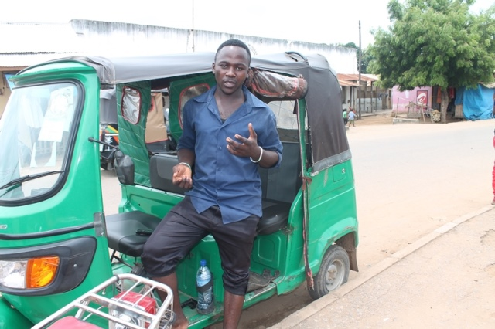
Allan explaining about past life before he could be enrolled for vocational training.(Photo: Nicodemas)

The Project is funded by European Union (EU) which has injected more than 3 million Euros and is implemented by Plan International as a lead organization in partnership with VSO, VETA, UHIKI and CODERT. The project targets at benefiting 9100 young men and women whereby 53 percent are women and 47 percent men. Out of this number, 10 percent of the total beneficiaries are going to be people with disabilities.
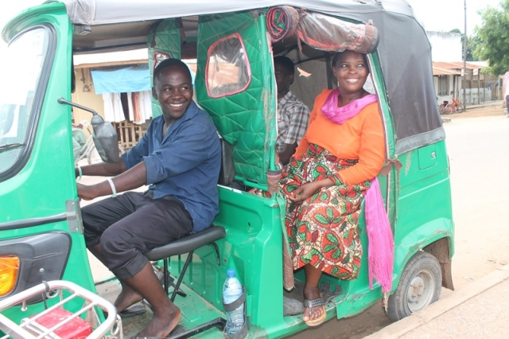
Allan with his passengers ready to take a trip to another destination (Photo by Nicodemas)

Allan is one of the beneficiaries who was enrolled in a free six months driving course and is now employed as a Bajaj (tricycle) driver. “After obtaining a driving license and a certificate indicating that I have attended a course at VETA, everything changed completely as I was able to be trusted and given a Bajaj by a certain boss in February, 2016”. In their contract, Allan must present to his a boss a total of 18000/=TZS on daily basis and the remaining amount is his profit. He earns a maximum of 30,000/= and a minimum of 22,000/=TZS per day as his profit. He further added that, life has generally improved and he is now assured of fulfilling his basic needs and can comfortably support his brother’s family. Allan dreams of owning his own tricycle (Bajaj) by 2017 and save money for further studies until he gets a license allowing him to drive heavy trucks and one day own his own fleet of trucks.
Allan advises other youth to effectively use the opportunities that come around their areas and find ways of self-employment. He urges youth to invest the little that they earn to attend vocational training centers and obtain skills which would enhance their employability.
The project has so far reached 2030 young people in this year out of which 45 youths have already reported to have begun enjoying the fruits of the vocational skills they have acquired.
Story written by:
Nicodemas Gachu (Governance and Advocacy Officer)

