Site Visit to Implementing Partners and
Networking with Informal Economy Related Experts in India
7-11 March and 15 March 2016
Draft

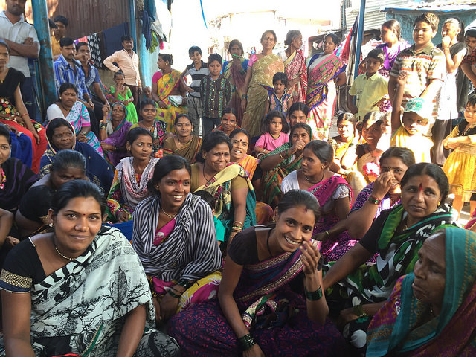
(Photo from site visit to Nashik, community members engaged
with ActionAid India project)

Table of Contents

1 Introduction 3
2 Summary of Information Collected During Implementing Partner Visit 4
3 List of Implementing Partners Key Potential Successes/Good Practices 5
3.1 List of Identified Good Practices from Site Visit 6
3.2 List of Identified Lessons Learned from Site Visit 8
3.3 Challenges Encountered in the Project and (Potential) Solutions 9
3.4 Summary of EC Delegation meeting with Anasuya Gupta 10
Annex 1- Summary Notes Field Visit - ActionAid India and ActionAid India Implementing Partners 11
Annex 2 – Networking Meetings 22
Annex 3: List of persons met, position in their agency, name of agency, location 27
Annex 4 - Schedule of Meetings 29

Introduction

Name of Agency and country being visited: ActionAid, India

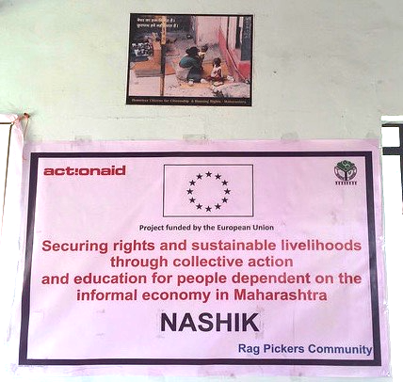

(Photo from site visit to Nashik, sign on wall
with ActionAid India project)

Dates and Background of mission:

Key Expert 1, Mei Zegers, carried out a field visit to ActionAid, India, from the 7th to the 11th of March 2016 with an additional networking meeting on 15 March 2016.

The purpose of the mission was to:
- Identify project areas that could benefit from strengthening. Though the visit was not evaluative in nature as that is the task of the delegation and Implementing Partners (IPs) themselves, it did include focus on identifying eventual bottlenecks. The analysis included focus on how the organisation functions to reach the EC funded project objectives as well as the actual fieldwork. The process included:
- Meetings with senior staff at ActionAid Headquarters
- Several site visits in Delhi, Mumbai and Nashik, India to see fieldwork and to discuss with project beneficiaries. The field discussions include some focus groups and observations of work of project community members (beneficiaries).
- Identify successes and challenges and associated good practices and lessons learned of the IP
- Provide linkages to other experts as needed
- Strengthen interactions and collaboration with IP to strengthen interest and networking across IPs and with the RNSF team.
- Obtain IP buy-in to share their good practices and lessons learned with a broader audience.

The fieldwork was comprised of 3 days of meetings in Delhi, one day in Mumbai and one in Nashik. Interviews were carried out with ActionAid staff, their implementing partners, and government experts and human rights defenders. The expert also visited
- Housing for the homeless in two different sites in Delhi
- A public advocacy event in Mumbai
- Rehabilitation housing for people dependent on the Informal Economy (IE) in Nashik.

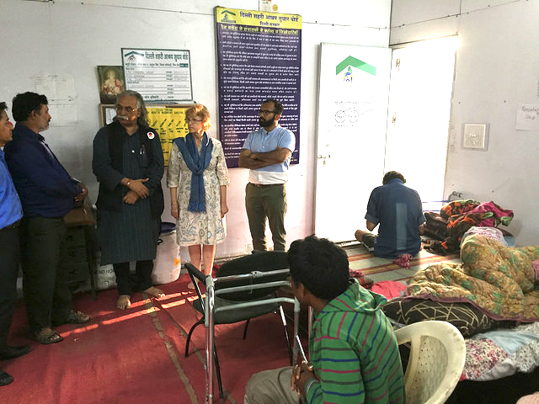
(Photo from site visit to Delhi Homeless People’s
with ActionAid India project staff)

See Annex 1 for summaries of the interviews with ActionAid India, some of its Implementing Partners and County experts. Note that, at each meeting an overview of RNSF, its functioning, purpose, was provided.

See Annex 3 and 4 for an overview of the schedule and persons met.

Summary of Information Collected During Implementing Partner Visit

  - Brief Overview of RNSF linked Implementing Partner project: “Securing rights and sustainable livelihoods through collective action and education for people dependent on the informal economy in India”

Objective of the action:
The overall aim of the action is to secure sustainable livelihoods and protect the social and economic rights of vulnerable people dependent on the informal economy in 32 cities and18 districts in 15 states of India.
The specific objective is to secure sustainable livelihoods and protect the social and economic rights of vulnerable people dependent on informal economy in 14 states of India. Therefore, marginalised people in rural and urban areas dependent on the informal economy are empowered to access social protection and decent work.

Beneficiaries: 100,000 marginalised people in rural and urban areas dependent on informal economy.

Expected results:
- Marginalised people dependent on informal economy have increased awareness of and better access to their socio-economic rights and entitlements relating to decent work.
- People dependent on the informal economy, particularly women and youth have the skills and capacity to access a wider range of livelihoods through skills building and vocational training.
- Creation of knowledge base and information sharing platform to train civil society actors working with People Dependent on the IE (PIE) and government officials for two-way linkages between grassroots work and policy level knowledge.

Project duration: 48 months.

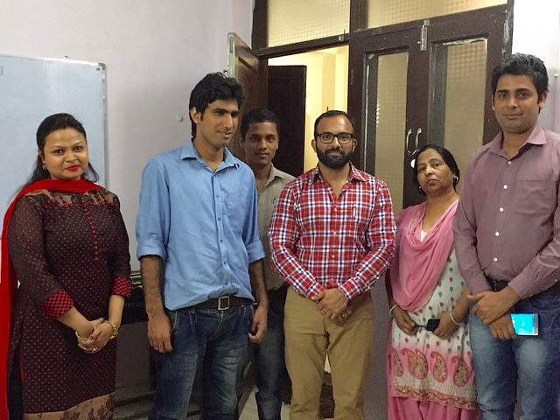

(Photo from site visit to Mumbai ActionAid office)

List of Implementing Partners Key Potential Successes/Good Practices

Note that, at the request of people met, the RNSF expert spent considerable time in each meeting explaining the purpose of the RNSF project. It was apparent that even in the ActionAid headquarters office there was a need for a more thorough discussion of the project since those met did not attend the project launch workshop in Brussels that had been held in June 2015.

The good practices and lessons learned were collected during site visits using interviews, focus group exchanges with two of the project community member groups, and from observation.

List of Identified Good Practices from Site Visit

1) Good Practice: NGOs and other non-State Actions involve the government stakeholders and work with them and not “only be their watchdogs”.

As part of its advocacy, ActionAid India involves government stakeholders and not only acts to monitor the government’s implementation of actions to address the rights of the population. One of the ActionAid employees is now a board member on issues related to people dependent on the IE. The government is supporting the NGO by paying for his salary for five years while he acts as a bridge between ActionAid and the government.

2) Good Practice: Social Behaviour Change Methods Used to Raise Awareness of Social Protection and Other Available Programming

The organisation interviewed uses a combination of approaches to raise awareness and change behaviours of community members so that they access available social protection and other available supportive community development programming. The NGO found that relying on just one approach will not bring about results; rather a combination of approaches must be used to attain the objective of changed attitudes and behaviours.
The population is also stimulated to participate in advocacy with government themselves so as to improve services in their localities.

The combination approach includes:
- Inclusion of female staff to ease the interaction with the women in the community, as they are the main focus of the NGO.
- Inclusion of men in the awareness raising on rights issues and available social protection services. Example from a previous project included forming 8 young male groups. Every group had 15-20 members who were educated about women’s rights, sexual rights, and domestic violence. Why women also have decision-making powers that can contribute to household welfare.
- Implementation door-to-door visits and personal discussions with households.
- Holding of various types of community events that include group discussions on the major topics on rights and access to social protection and other services.
- Conducting meetings in NGO offices and use technology such as showing movies and involving them in holding motivational speeches.
- Carrying out direct actions to help the community members open bank accounts, obtain identity cards, and access other services
- Organising street vendors to engage in advocacy on their rights with the local government.
- Being persistent despite initial challenges in changing attitudes and behaviours. The NGO found that, in the beginning, it was very challenging but persistence in SBCC resulted in change. These concepts were new for the population and both women and men were not ready to accept them. They did not know about the rights and thought rights were only for men.

3) Good Practice: Focus on building strong personal relationships with local government to provide more support to people dependent on the IE.

The organisation focuses a great deal on building strong personal relationships with local government officials to make it easier to advocate for the rights of people dependent on the IE. The organisation conducted meetings in the communities, with government officials, strategized in depth in their own office after every interaction and returned to the community to start the cycle again. This continually process, which also included the direct voice of the community, eventually led to the building of personal relationships with local officials. Of course, if they are moved to new offices, the organisation and community members will need to ensure that they continue to focus on building relationships with their replacements in the government offices.

4) Good Practice: For effective advocacy include focus on strengthening the capacities of the population to engage in their own advocacy.

The organisation raises awareness and strengthen capacities of people dependent on the IE to do own advocacy as they are they can be their own most effective voice. As the interviewee stated, once community members are involved it is good but it is not the end, as there are many competing interests. The population needs to be literate if possible as they cannot properly protect their own interest if they are not and need to learn effective means to advocate for their own rights. This should be combined with organising the community members.

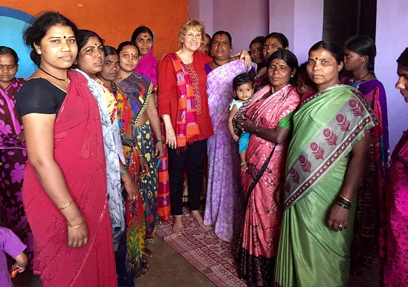
(Photo from site visit to Nashik to organised rag picker community)

List of Identified Lessons Learned from Site Visit

1) Lesson learned: Ensure that young people are involved as much as possible in situations where the attitudes, knowledge and practices of the population on rights are addressed.

The organisation found that it is much easier to change the attitudes of someone who is in their twenties than older people. For this reason the organisation focuses more on changing the attitudes of both male and female youth. Social Behaviour Changes Communications (SBCC) is thus oriented to and involves the whole community but special emphasis is placed on working with youth.

2) Lesson Learned: In slum rehabilitation ensure that ensuring decent working conditions, including space for work, is adequately considered when planning new housing.

Slum rehabilitation comes with many challenges that affect the quality of life of people dependent on the IE. These challenges are often insufficiently considered when developing these areas. For example there is:

- Often no consideration of the needed workspaces for people doing home-based work when they are provided with rehabilitated housing.
- Too little flexibility in the housing rehabilitation projects in response to the realities faced during rehabilitation. This is largely due to existing the regulations and planning. Advocating for the inclusion of greater flexibility in the planning phase of rehabilitation is thus important.
- Often a lack of ability to prove a family’s right to flats with consequent subsequent evictions. More important is that they are often moved away to areas with difficult access, which affects their ability to secure and develop their livelihoods.
- Developers are not actually providing the space that they are supposed to according to the official agreements and regulations. Only a small proportion of the people who are supposed to get the space are actually provided with the space. They develop the area nearby but the slum dwellers do not benefit, as they do not get real employment there.
- There is already a great deal of large developed space while the current need is to create smaller tenements. In fact, ActionAid and its partners believe that it is better to regularise the available areas and retrofit them. This means, giving the dwellers the rights to the land, amenities, soft loans, technical know how, etc. Advocacy is carried out for access to expanded social protection so community members can access the housing.

3) Lesson learned: Use a rights based holistic approach when addressing the needs of people dependent on the IE.

The organisation noted that it is not sufficient to just focus on livelihoods, promoting savings groups, etc. There are common challenges such as access to identify registration cards, drainage, sanitation, health, domestic violence, illegal alcohol shops and related, criminal violence, child marriage, etc. The organisation thus noted that it is important not to just focus on livelihoods but realise that it is essential to also address other issues to truly improve the lives of people dependent on the IE. Further, when addressing health and education, people spend less on medical costs and will eventually have increased education so that they can manage their incomes better and may also be able to access better livelihoods opportunities.

4) Lesson Learned: When developing advocacy for ensuring the rights of people dependent on the IE are addressed, identify issues that all can agree on and work on these first.

The organisation learned that, to interact effectively with government officials and have successful advocacy, one should not immediately take a hard stance but initially work on issues that all can agree on, such as health and education. Addressing certain rights sensitive issues is challenging so it is important to address other issues first. Once there has been success on commonly agreed to issues, it is easier to obtain government officials’ support on other more sensitive issues.

5) Lesson Learned: Informal Economy Operators and Workers need to be organised in substantial numbers so that a critical mass can be achieved to advocate with the government to address the needs.

The organisation noted that it is important to realise that there is strength in numbers, a point that is evident but is often be forgotten in advocacy. The organisation noted that for any success in advocacy, many group partners and individuals have to be involved. Much stress, whether at community level to advocate with local leaders or at district, state or national level should be placed on having as many community stakeholders as possible involved.

Challenges Encountered in the Project and (Potential) Solutions

The principal challenges that the project faces are in the area of ensuring successful advocacy resulting in real change to improve the lives of people dependent on the IE. In fact, the project is already implementing quite a few good practices and is actively learning from their experiences. Lessons learned are used in a good monitoring systems based approach to feed back into and improve on-going actions. Nevertheless, ActionAid India staff has expressed strong interest in exchanging more experiences with other RNSF Implementing Partners (IP). They have indicated that they will be more active on the IESF and look forward to participating in and sharing their own good practices and lessons learned with other IP in a regional workshop and other formats.

Key Expert 1 found that the main recommendation was to increase further networking with others Implementing Partners (IP)in the RNSF. This is because ActionAid India would benefit but also, especially, the IP would likely benefit from ActionAid’s vast experience with advocacy.

Summary of EC Delegation meeting with Anasuya Gupta

Meeting included time providing information to Ms Gupta on the RNSF. Ms Gupta indicated that she would support the RNSF and that she will share past projects and good practices, lessons learned. She indicated that she would write an email to colleagues to ask them to share information.

She noted that the EC has CRIS, which is an internal site where the contracts are based though it is being phased out and replaced with a new systems. She further stated that, “This will be done in the next 3-4 months. The process of rolling out has been started but it may take time. We could give you just contract numbers and then you can access it yourself. Not all the reports are uploaded but they have evaluation reports, progress reports. You should also have contact with the delegations in other countries. Go to them and also ask them for information, as the quantity of projects is less in India. Bangladesh, Nepal, Sri Lanka etc. should all be approached. Even when we have regional projects some of them can be interesting.”

Annex 1- Summary Notes Field Visit - ActionAid India and ActionAid India Implementing Partners

In most cases the text is written out in the first person summarising the points that the interviewees made.

Indu Prakash Singh- Leader Urban Knowledge Activist Hub, Sushant Agrawal – Project Manager – Skills development

We have a group of Muslim youth who are being trained in the community on hairdressing and cosmetology. We did a needs assessment in the area, we identified a training based on what they themselves asked for. This is a community where you have to work with the cultural situation. How can they come together, talk about their rights, labour issues in a protected setting that is suitable to the women involved.

The Working People’s Charter is one area we work on. (See associated Quote from Cap4Dev IESF Platform: “ActionAid initiated a project called, “Working Peoples’ Charter”. The aim of undertaking this project has been to bring together organisations working with informal sector worker under one banner and to address the current challenges faced by the informal sector workers, which have been largely ignored by the central trade unions. With people from different forces coming together on the issue organically, the idea is slowly growing in a much larger process than just being limited to a project.” - See more at: http://capacity4dev.ec.europa.eu/iesf/blog/speakers-corner-how-your-project-supporting-empowerment-vulnerable-groups#sthash.meCuD1ai.dpuf

ActionAid is monitoring and advocating on the implementation of Government policies and programmes. One example is their skills development programming.

Lesson Learned
We also see that we have to work together with the government, not only be their watchdogs but involve them as well.

We have now also got one of our ActionAid employees in the government. He is a board member with government; his salary is paid by the government for 5 years. This is really important, as they are a bridge to the government. We also had various advocacy approaches that we used to get people involved with the working people’s charter.

The Urban Action school: we see that there is a gap between activists and Government. So we organised training for people from different backgrounds and different parts of the country. For 21 days this training concentrated on identifying the participants’ urban issues and also sharing between the participants and the ActionAid India staff. Since we have been active on urban issues in India for the last 16-17 years, we have a long history of contact with people of different types from all around the country. We work as equals with such people. The Urban Action School activity thus helps us to identify and address the issues. These activities integrated into the wider “Global Platform for the Right to City” that is based in Brazil.

The EC funded project that we have helps us to bring many of these scattered activities into one project.

There are also things that we do that go beyond this work for the EC or even other work. For example, we identified a gap and we created a network called Urban Rights Forum with the homeless. We started raising a voice on different issues. The issue of the cold in wintertime was an important problem for homeless people that had to be addressed. So we used the media together with the Urban Rights Forum and were able to get the attention on this subject. We then filed affidavits in the courts. (Note that affidavits are written statements confirmed by oath or affirmation and are used as evidence in court proceedings.) We were able to convince the courts that we were supporting them so we did not even have to pay.

We build flexibility into what we are doing so that we continuously identify gaps and opportunities and work on them. This is important as strict planning without flexibilities makes it impossible to identify and address gaps and opportunities.

We also have a two-way process with the different staff member we have in the regions. We do not simply monitor what they do, we get their inputs, and their opinions on what we are doing and how we are doing it.

We find that we have to be very innovative to identify what works and how. We have to get the ideas of the staff, which they in turn also get from the population. We did this in the case of female rickshaw drivers and honey making. The same applies to tailoring, for example, we found that it was better to train people to make uniforms for hospitals and sell directly to the hospital instead of learning a wide range of types of clothes.

We also have a mobile app, for skilled technical people like electricians and plumbers. It functions like Uber taxi. The technical person’s ratings will be there, his/her cost, his/her photo, etc. People can be called to come and carry out a task. The technical person can then click if he or she is available. We worked with an information technology specialist to develop this.

We are also identifying issues such as the need to run the project actions in the locations where the people are actually living. Training should be provided in the facility that is convenient for them to access.

EFRAH: Empowerment for Rehabilitation Academy and Health (ActionAid India partner)

We started our work in 1999. We work on education, health, VET, and especially work in South Delhi. We have field offices in different parts of the city.
The nature of our work is the same everywhere. We do rights-based work. We want to educate the population on their rights, we also do advocacy and find out what the people’s needs are and then help them to access their rights.

Peoples’ main concerns in this area centre on their fundamental rights. We also run gender resource centres activities with Delhi government staff. Also work on supporting people dependent on the IE. To support them we provide skills training in accordance with the people’s needs. In this locality we provide a hairdressing and cosmetology beauty, computer hardware and software repair, and tailoring.

What we find is that the people in Muslim communities are not accessing their rights. I have done some work in other communities and not seen that anyone has worked with these people, especially the women. I worked with other people in other more mixed religious communities where there is more work on accessing rights happening.

We are happy to work in a community where people are really lacking every kind of support. Women were unable to come out of their houses before. This is a male dominated society. It is very common for women to have to stay in their homes and we faced so much criticism. Women were not coming out, people were very suspicious of us. Now it has been 4-5 years that we have been working with ActionAid. So many people are more capable of accessing their rights, especially with regard to their ability to access social protection programmes.

There are so many social security programmes that the government has but these populations have not been able to avail of them. The community members were not applying for the available support and government was not reaching out to the people to tell them the available services.

Trainees are interested in starting their own business in beauty and wellness. There are not a sufficient number of beauty shops in the area so they (and we) believe the demand exists for such services. It is a community of 85,000.

The community also faces other challenges that need to urgently be addressed. There is no drinking water in this community until now. People pay 20 rupees for 20 litres. There is a water purifying plant. There is no secondary school in this area.

We made it very clear to the population from the beginning what the kind of project was that we were working on. We went to the community and mobilised their members and informed them of their social protection rights. There were also simple things like how they can access scholarship programs and the things like the 15 points program.

Note from the author of the present report: The 15 Points Programme is a government supported programme for minorities that focuses on ensuring that minority groups can access education including early childhood integrated child development services, support for access to self and wage employment, skills training, housing, decent living conditions through slum up-gradation and access to rural housing schemes.

Good Practice: Social Behaviour Change Methods Used to Raise Awareness of Social Protection and Other Available Programming

The organisation uses a combination of approaches to raise awareness and change behaviours of community members so that they access available social protection and other available supportive community development programming. The NGO found that relying on just one approach will not bring about results; rather a combination of approaches must be used to attain the objective of changed attitudes and behaviours.
The population is also stimulated to participate in advocacy with government to improve services in their localities.

The combination approach includes:
- Inclusion of female staff to ease the interaction with the women in the community, as they are the main focus of the NGO.
- Inclusion of men in the awareness raising on rights issues and available social protection services. Example from a previous project included forming 8 young male groups. Every group had 15-20 members who were educated about women’s rights, sexual rights, and domestic violence. Why women also have decision-making powers that can contribute to household welfare.
- Implementation door-to-door visits and personal discussions with households.
- Holding of various types of community events that include group discussions on the major topics on rights and access to social protection and other services.
- Conducting meetings in NGO offices and use technology such as showing movies and involving them in holding motivational speeches.
- Carrying out direct actions to help the community members open bank accounts, obtain identity cards, and access other services
- Organising street vendors to engage in advocacy on their rights with the local government.
- Being persistent despite initial challenges in changing attitudes and behaviours. The NGO found that, in the beginning, it was very challenging but persistence in SBCC resulted in change. These concepts were new for the population and both women and men were not ready to accept them. They did not know about the rights and thought rights were only for men.

One lesson learned from the organisation is that it is much easier to change someone who is in their twenties than older people. For this reason the organisation focuses more on changing the attitudes of both male and female youth.

“Working with younger generation, they are more interested in change, they have more patience. The older people have less patience, they want results more quickly. (Opposite of what one might expect). The older generation always asks ‘what will I get’ while the younger generation is more interested in the benefits for the family. Right now the project is focusing on people in the age group of 15-30 so we have very little interaction with the older generation.”

Sandhya Lakshmi- Senior Manager ActionAid India

ActionAid Int’l is actually a federation. We are autonomous organisations within the larger ActionAid federation. We at ActionAid India are very much an Indian entity. Our strategy papers show that our work matches to the Indian situation.

Major funders are composed of individual donors from 6 countries. About 65% of our funding comes from these main funding agencies. We also have people who make monthly contributions to support ActionAid.

We have 3 projects with EC funding right now. We also have a bank in Spain and a foundation in Italy that supports us. Also there are UNFPA, UNICEF, UN Women, etc. they fund work that we do on children and women’s rights. We also have funders from corporate foundations, both Indian and foreign. We have a company screening policy in terms of corruption, labour rights, and other rights before we agree to take funding from donors.

The interviewee goes on to describe some of the other projects that ActionAid India is implementing:
One of our projects is on access to public schemes. It was announced in 2012, the project started in 2014. We just had a ROM for this last week. It is in 5 states of India, it works mostly in governance.

Instrument for stability- it is implemented in the Northern part of India and it works on conflicts arising over access to natural resources.
These are much smaller than the one the EC is funding that RNSF is involved with.

Field Office Project Partner ActionAid Mumbai

We are working primarily with women home-based workers. Especially in minority areas, mostly Muslim women. They find it easier to operate from home. There is now the formalisation of the economy, so there is development of the value chain.

There are people in the unorganised sector who are only doing a very small part of the value chain. We are trying to bring people together in 5 different communities in the area.

Our agenda includes trying to understand whether home-based work is really empowering. Is it really helpful for the women?

I think that the women need to be directly linked to the market. Maybe it would be an alternate market. One needs to first understand how to bring about change and include them. There is a lot informality in the areas where they live and they do not have security, whether on the personal level or in terms of living standards.

A lot people are also dependent on the rehabilitation situation, not all of them are really happy with the property that they may have been given. So they prefer to rent it out instead of living there.

Lesson Learned

Slum rehabilitation comes with many challenges that affect the quality of life of people dependent on the IE. These challenges are often insufficiently considered when developing these areas.

The original idea is that the slum dwellers would ask a developer to develop a place. But now this is not the case anymore and developers approach the dwellers to do slum rehabilitation. Consequently there are many challenges as the developers have the main initiative and dwellers have difficulty in expressing their wishes.

For example, one of the project findings so far is that there is no consideration of the workspaces that are needed for people doing home-based work when they are provided with rehabilitated housing. There is a need for a space that could be a floor in the building where home-based workers could meet and work. If they work in a joint space they could also share care activities for their children. This should be feasible. They could be asked to provide a small fee for the maintenance. It has to be financed of course but this idea could be good for such women. This will be useful for many such women. You could also have time-share where the space could be used for community management and meetings.
We also did not know it would become so problematic but we learned as we went. The idea sounds good but in practice it does not work.

What we find is that there is too little flexibility in the housing rehabilitation projects, we realise the realities and have to change things in our projects. Sometimes we need to make changes but cannot due to the regulations and planning. But also the government, they want to know what we change so that is also difficult. If it is a budget change then it is a problem.

There is often a lack of ability to prove a family’s right to flats with consequent subsequent evictions. More important is that they are often moved away to areas with difficult access, which affects their ability to secure and develop their livelihoods.

There is already a great deal of developed space while the current need is to create smaller tenements. In fact, ActionAid and its partners believe that it is better to regularise the available areas and retrofit them. This means, giving the dwellers the rights to the land, amenities, soft loans, technical know how, etc. If this is done then they will actually improve their living space on their own.
Only people living in the most dangerous places should be moved to other areas.

The problem is that these developers are not actually providing the space that they are supposed to. Only a small proportion of the people who are supposed to get the space are actually provided with the space. They develop the area nearby but the slum dwellers do not benefit, as they do not get real employment there, maybe as a guard.

The land is actually leased to the developers but belongs to the government. The government also taxes the people more once they are in rehabilitated flats.
There are cases where people were put in transit camps while they were still in grievance processes as they were not able to access the flats eventually. Then they are eventually evicted from the transit camps and they are homeless.

What we are doing is promoting the sale of tenements on ground floor for a low rate. For people on upper floors they can be provided with subsidies to fix and buy their flats. We advocate for an expanded social protection to people so they can access this.

There might need to be land reclamation but there is actually some area available still in Mumbai.

Nashik Project Work with Rag Pickers

We are trying to register home-based workers, rag pickers, and domestic workers. In fact the rag pickers have already been registered.

We started our current work one year ago. The project started since April 2015. In 10 communities. Out of 187 slums in Nashik these are the ones predominantly populated by the rag pickers. City has 1.8 million inhabitants.

The overall intervention here started in 2009 as a trade union, which has been registered.
There was an eviction/demolition an area where rag pickers lived and we then became inspired to work with the rag pickers.

We have been working in association with ActionAid since 2004. We were involved with different Implementing Partners (IP) during this time and got a good experience on the issues with ActionAid.

We have 1500 registered domestic workers. There are different sub-groups, one for rag pickers, and one for home-based workers.

There is a welfare board for domestic workers since 2006 in this state. There are some national unions AITUC, INTUC, that worked with them to fight and finally had an act passed in 2005. In 2009 the board was formed in the state.

We started our project with the rights based approach. This is different from other projects that had been doing things like just organising savings groups.

Lesson learned: Use a rights based holistic approach when addressing the needs of people dependent on the IE.

When I started I observed that the problems that are common are registration cards, domestic violence, drainage, sanitation, health illegal alcohol shops and violence related to that, criminal violence, child marriage, etc. etc. It is important not to just focus on livelihoods but realise that it is essential to also address other issues. When these are addressed, such as when addressing health and education, people waste less on medical costs and with increased education they can manage their incomes better and may also be able to access better livelihoods opportunities.

Lesson Learned: When developing advocacy for ensuring the rights of people dependent on the IE are addressed, identify issues that all can agree on and work on these first.

To interact with the government officials you should not take a hard stance right away and instead work with them to address issues that all agree on, like health and education. If you take want to address certain issues, especially if they are sensitive rights based issues, and you know that they are not favourable to these issues then it is important to address other issues first. Once there has been success on commonly agreed to issues, it is easier to obtain their support on other more sensitive issues.

We tried to stop the alcohol shops but there were criminal gangs but we involved the local government representatives (municipal officials) and the two main shops were closed within one hour. They are still closed.

The drainage was very poor in one area. The government did not serve the area for 2 years, the drains were clogged, people did not understand how to use them, and children would fall into the drains.

Now we have written a petition to the health officer of the municipal commission and through that with the construction department. Over time there was a temporary fix that did not work but now the semi-permanent fix works. There is now a regular clean up. If the drains get clogged the population contacts the city and they do fix it. It is more regularly cleaned now than before. So the people are empowered to address the issues themselves. There are more than 2000 households.

Rag pickers have become more aware about sanitation but there are also others who also live who live upstream who also keep dumping in the drains, which continues to cause problems.

There are 2 slums that are adjacent to a local government school. Since this school is on prime plot of land at the heart of the city there was a plot to take the land away and build on it. The rag picker children could go to the school because it was close for them.

We carried out a survey for 7-8 days but we learned that there are 182 children registered in the school who were not actually going there.

Municipal government was supposed to help these children be reregistered. So the union has helped them to re-enrolled as the municipality is not doing is and 70 children have been reregistered until now. A lot of other organisations came together to work on this issue but we took the lead on this.

Good Practice

Focus on building strong personal relationships with local government to provide more support to people dependent on the IE. Having build strong personal relationships with local government officials makes it easier to advocate for the rights of people dependent on the IE.

Right now 500 women have been formally identified and registered as rag pickers and are being given ID cards. This is important as these women were initially criminalised from their rag picking work. To obtain this result we had to make visits to communities, the municipality, back to our office for strategizing, and continue this process until we were able to reach our goals.

We worked with the municipality on various issues such as health and education and we built a rapport with them. When the Kumbh Mela happened we found that the government had already signed up some in the contract workers to assist with keeping the city clean. It was clear that the number was very limited number and additional workers were required. Consequently we were able to organise 465 rag pickers from these communities who got employment for 3 months as a result of our good personal contacts.

Through this intervention the municipality recognised our strength as an organisation. At the city level we are now consulted. There is the program on the smart cities and we made sure that we were consulted in those discussions. We are recognised as a group represent the rag pickers in these discussions.

The rag pickers’ payments went straight to their accounts which we helped them to establish if they did not yet have them. We also trained them on how to obtain access to the provident fund (a type of pension fund), getting a bank account, and training on using ATM. By being registered in the provident fund they are also automatically registered with the tax department, which gives them future chances of easily being integrated in other available government actions.

Every year this community has been working invisibly anyway as rag pickers and keep the city clean but were not being paid for the work. Their only income came from possible reselling of waste. This opportunity provided them with their first chance to have a contract with the government.

The funds that were paid were used also to help them get an asset that is a down payment on a public flat in housing being built by the government. The rag pickers received 18000 rupees that many of them used for this purpose.

Regional Hub manager- South – South Solidarities, Benny, Senior Manager

I came in 3 years ago for ActionAid to come in to support South – South collaboration. We look within the ActionAid framework. They already have a lot of this exchange internally. Our work has broadly been on monitoring India’s foreign policy on trade and other issues.

This includes technical cooperation such as provision of aid to Ethiopia. Development Partnership Administration centralises this. Things are not yet very clear of what they want to do. We have been equipping the Indian Civil Society to contribute to the discussions.

There are lots of interesting initiatives on enhancing livelihoods in different areas. We want to see how the international actions have an influence on the people in the IE. The issues of tariffs, investment rights given to corporations. A lot of our work is for the peasant groups to go into these issues. Part of the work is the demystifying the agreements, etc. How does the international architecture impact the livelihoods of farmers, etc.? We conduct workshops and try to influence policy in these areas. We are also looking at GP from other areas of the world on these issues.

The way forward that we see is to enhance livelihoods in the rural off-farm areas. We need to learn from other experiences. We recently had energy, agriculture and rural non-farm workshop on an international level where experiences were shared. We wanted to see if these interesting GP are linked to enabling environment issues. A lot of the work we do is to develop information together with different groups.

On trade and development finance, the government is very interested in the inputs from the people who are involved with us. There is a limit with regard to this but it is important to them that they can show that they have consulted the civil society.

A lot more projects need to work with a range of actors, especially when it comes to advocacy.

We also have some work on the issue of how one look at the parallel CSO agencies in different areas of the world. India will host the BRIC summit in 2016 in July.

The SAARC summit is in November in Islamabad. These occasions are important times for ActionAid to be there. We want to co-host with Oxfam and Green Peace and others events where they can also come together to talk about the issues.

We have contacts in South Africa, Brazil and India where we work on these issues.

ActionAid M&E specialist-

We have an accountability system, which is a guiding document of ActionAid, from 2006 onwards. We have a global M&E matrix also. We align our indicators with the global ones. There are 52 indicators worldwide and we align with 22 of them. Our main focus is on qualitative indicators mostly because the NGOs we work with are not able to do much quantitative monitoring. We use community registers, there are collected and analysed at a local office, then it is collated in our regional office. We then review it at national level.
We have 12 regional offices, and 258 CSO partners with whom we have worked, 83 are long term and the rest are short term.

We have our country strategy paper. This is the last year of our current country strategy paper. From June this year onwards we will have internal and external evaluators who will come to study what we are doing. The next one will start in 2017.

We work a lot with government officials, so we also bring their contributions into focus in our M&E system.

We ask for gender-disaggregated data. We also have a separate process where we collect the data on how the women of the community have been involved, are they in the committees. We are slowly moving towards more quantified results measurement.

Wherever we go for impact study we try to always determine what the impact is at the different levels. We learn a lot from this, especially on how to link the local level platforms to the higher level one. We have started linking up this more in the last 6-7 years.

We have one more component where we collect critical stories of change. We usually do this using a journalist. These are there on our website. We also have small impact videos but also issue based videos.

Jyoti Awasthi- Laxmi

We work with rickshaw and construction workers. We have a central government act on street vendors that we are also involved with. I also represent the street vendors in the meetings.

The government has not yet understood the whole issue. The intention is not there. They do not pilot anything. They just go with a loud bang. Some local estates want to do it in an organised way.

We work with some local communities that are also facing eviction from where they live. We work on building their capacity to claim their rights. We have been able to stall the eviction but it is quite difficult. Almost all of them have applied to several housing schemes but the housing is not going to the right people. We try to bring all kinds of evidence that they are needy. Our role as an organisation is that we try to find ways to deal with the situation with them. We help them meet ministers, write letters.
They need to express themselves in the right way so we try to empower them to express themselves.

There has been a huge shift in government policy because there is defence land that is not being used at all. There is some discussion on this in the central government.

There is no standard definition of urban poor in India. People do not know if they are eligible to apply for something so they do not access available social protection measures.

When the authorities plan for how many people are being added in terms of middle and upper class housing, they do not consider how many people will actually will be working for these middle class level people on in new housing areas. The more fancy cities that are coming up are exclusively focusing on the wealthy not realising that the actual reality is different, the poor will also be there. There is no standard also for how many houses to add for people who are being added to a growing city. So this means that a number of questions are not being addressed regarding the people who will end up working for the people who live in the new housing. Where are these people going to live? That is the question. There is hardly any provision for poor.

The new middle and upper income housing does not have public toilets, water taps, etc. for such workers. Why will a private investor who is there to reap the profits give space for this?
The new builders have to add 25% housing for the poor but they are not doing it.

Annex 2 – Networking Meetings

Networking – Delhi Urban Shelter Improvement Board, Mr Bipin

The office is part of the Delhi government and poverty alleviation state government. It was part of the Delhi Development Authority that deals with land issues. DDA separated it from the Slum Board.

The purpose is to enhance the life of slum dwellers. It was part of the MCD. There were different rules on enhancing their skills.

They asked to be independent from MCD; we had a different role, which is rehabilitation of slum dwellers. There was an act passed in 2010 that established this office. The office was established before but it became a free independent body at that stage.

The mandate of this department is to rehabilitate the slums and we include work on sanitation. The sanitation issue is important and also dealing with homelessness.

The same department thus takes care of homelessness in Delhi. Last year we came with a new rehabilitation policy. In this policy we have to declare the rights of slum dwellers. Develop our protocols for doing this in the future. We also developed the criteria for slum dwellers to access such a scheme.

The cut-off date is currently 2015. Whoever was living in Delhi up to 2015 and had any kind of identity to prove that they are based here, is allowed to access the services. For example, their name should be on voter list on at least one of the years of 2010-2015. If they can show their name in the voter list they are eligible.

We also only recognise the slums that existed before 2006.

A person who is living in the slum during the survey will be counted. , So only the people who have been proven to actually live there are eligible. If the person is found they are eligible. We include the Members of Legislative Assemblies, board commissioners, and the ward level responsible persons in the survey.

If they a household or person missed the survey they can still make a claim and a special survey will be done.

We are doing 0-5 km in situ land up-gradation. Our primary focus is to safeguard their livelihoods so we want to keep them as close to their site. Many people do not agree to move so that is why we do in situ up-gradation.

Sanitation is one of the major areas also. The central government launched a campaign “clean India’. We are the northern department of Delhi government that takes care of this issue. The mandate is to stop the open defecation. We have 1600 WC across the region. This is done through community toilets. What we are targeting is 2000 additional toilets this year. One complex has 30-60 toilets. Next year we are targeting the building of 20,000 more toilets.

We tried to put toilets in some places but there is no drainage system or there is no space. In some of the slums we have bio-toilets. We also are doing a pilot test of 40 toilets inside rickshaws. It goes to a place in the morning and then people can use, it is also being tested in places where the homeless live. There is one person assigned to keep it clean, right now it is on a need basis.

It is a Pune based company that is doing this. They also have a system to put advertisements on another system.

We also have homeless shelters; the data shows that as per my interpretation, there are 50 to 100,000 people living on the street.

262 shelters are provided in Delhi, 200 are permanent and the others are temporary. The capacity is 19,000 can be accommodated. Near Kashmiri gate there are 30 shelters in one area.

We are considering having some skills development in the daytime in those shelters.
We want to work with different departments to help these people to develop their skills. In my experience 40% of the drug and alcohol addicts will not be helped, 20% will come and go and 40% will be better.

We plan to integrate services with the health and education departments.

We are interested and willing to be on IESF and share experiences and learn from others.

Additional Municipal Commissioner, Jiwan Sonwane, Nashik Municipal Authority

Briefing only, Commissioner stated he had no special comments to share.

Labour Rights Human Rights Defenders, Ramendra, Trade Union Activist; Dharmendra, Human Rigths Defender

We are a federation of workers unions who focus on social protection and improvement of labour rights of people with special focus on those dependent on the informal economy.

The government of India mentioned that the social security of the informal worker needed attention, as it was very limited. They are 93% of the population but there was no support for them. There was only support for those in the formal economy.

There are so many forms of informal economy workers. In 2004-5 we stared a campaign demanding comprehensive legislation to address this issue of social protection of people in the IE. We had a large protest day from people from all over the state to advocate for change.

Things moved ahead and many organisations have joined together to advocate for and obtain the needed results. Subsequent to conducting this advocacy a government standing committee on labour requested suggestion from the campaign groups. We submitted our own draft and, accordingly there were another 4-5 on the social security though we wanted 1 draft from all of the stakeholders. There were different opinions so we submitted all of them.

The subsequent recommendation of the Standing committee was actually good and they really integrated the points but it was not implemented. The Ministry of Finance rejected it saying that they could not identify the workers, that there was no way to identify a method to collect inputs and then be able finance the funds from the workers and employers. The actual issue from the government is that they did not want to identify or collect from the employers of people dependent on the informal economy.
The recommendation from the standing committee was diluted to a 4 page 2008 Act without any provision of implementation. So this has not been implemented. In 2009 10 billion rupees were allocated but the money never came.

We in turn said that the employers and workers could also join together to make a Welfare Fund.

There are 10 states that have formed Welfare Boards to address issues of IE workers but they are not functioning.

For the construction workers there is some positive work, there are some acts with provisions for the workers welfare. The contractors have to provide between 1 and 2% to allocate for the welfare of workers. Unfortunately, however, it was mostly not implemented. Kerala state is the only exception and it works there. There is some work on this also in Tamil Nadu but it is not functioning very well.

There are 35 construction worker Welfare Boards in different states now but they are not working very well either. They have collected funds but the political parties are trying to control this money.

There is a national convention of the boards and we participated in this discussions. It was the first time that this was done and it was very good. A lot of issues were discussed. We are more hopeful now after this convention as people were enthusiastic and willing to work forward more concretely. All states have now constituted this board in fact now.

For the street vendors they organise but there is no social security for them. The only security is that they work for the day so we have to protect their livelihood.

The growth we see is that the jobs are not being created in the informal economy. The growth in the agricultural sector only grew by 1-2% maximum despite the growth of 7-8% nationally.

These displaced workers moved to the urban areas to start businesses. The first idea was to make their livelihood formal. We worked on this for more than one decade.

The key moment came in 2014 on protection of the street vending. So regulating and also protecting their rights. It sounds quite friendly to the vendors but it is the state authorities that decide the state rules. Like other sectoral dilemmas we have to find ways to address this in each and every state.

In Delhi we have 20,000 members. We are not so weak in Delhi and we intervene for this project in other areas. The Delhi government is somewhat positive. They adopted a rule on street vending but there was no participation in the decision-making so there was no ownership. The details were not good, like street vendors can do no cooking and only on sell on pavements that are more than 7 feet wide. We fought this and we have a revised rule and it was decided to address these issue. To a certain extent we are satisfied on some aspects but there are other parts that still need improvement.

The problem we have with street vendors is also that they need land. This is different from some other fields like domestic workers who do not need land.

We feel there have to be strong vetting committees of which at least 40% are street vendors and of these at least 30% have to be women. The government is now recognising this and sees that it is key to have more participation. For Delhi we have a committee since 2014, but mot many meetings have yet been held. We want to have a better and new committee.

Lesson Learned: Workers have to be organised in substantial numbers so that you can have a critical mass to advocate and pressure the government to address their needs.

We still have a lot of space more work to fully organise them. The more people are involved the more likely that advocacy will be effective.

We should state that it should be recognised that, once you get any act at the grassroots level it is the result of many partners.

Good Practice on advocacy
We raise awareness and strengthen capacities of how people dependent on the IE can do their own advocacy. Once they are involved it is good but it is not the end, as there are many competing interests especially when we talk about urban commons. Advocacy by itself is not sufficient, you need to build the capacities of the organised to do advocacy. The population also need to be literate if possible, as they cannot properly protect their own interest if they are not.

The problem is that many of the domestic workers are also not educated so you have to do that first so that they can at least understand the issues. Then you can organise them and have them push for their issues. It is not simple to do the advocacy.

I work with domestic workers. National Commission for Women legislation for domestic workers.
In 1996 we formed the Delhi Domestic Worker Union. The idea was to get better wage, day off, and better working conditions. In 2006 it was regular collective and it was limited to a small geographic area.

Even the domestic workers had no respect for their own work; they felt it did not look good that they were domestic workers. Some even would deny that they were domestic workers.
We tried to help them to understand that their work is also important. It took 10 years. The Welfare Association recognised that they could have health support, for example, but it was still too limited. Like they could take a day off but not Sunday as the employers said they were needed on Sundays.

We realised that we needed legislation especially for domestic workers such as what we had done with the construction workers.

We said that there has to be comprehensive legislation to also address issues like the domestic placement offices. The National Commission for Women agreed and we all worked on this. There has been a huge consultation that was included ILO and the other major stakeholders.

Initially the government did not agree with the ILC recommendation but several years later it has been passed.

One national policy draft was passed in 2011. It was more or less good. There was a congress government but nothing happened. We had more than 2000 domestic unions and organised them in a platform and then pushed for this but it never really worked.

In the previous government they said that they would support it but that the policy should be done and the legislation will follow but the current government will not accept anything as this was developed by the previous government.

There are placement agencies that also place the minors from poor and remote areas, especially children. They will say that they have 50-60 workers but they 400-500. They also cheat the workers and say they should be paid instead of paying the workers directly, etc. etc. Some of the placement agencies even call themselves NGOs, associations, etc.

There was one case where the government developed the policy without consultation and came up with the employers’ friendly policy, instead of for the worker.

We had a long process that started then with enthusiasm with the support of a Delhi government official. There was a first draft, which was agreed to but then needed to be presented to the Delhi government. But it has stalled there because the employers will not want to be registered and do not want to have to support a social security program. Every time you move forward but then it stalls again. It is hard for us, as we have to answer also to our members who want to know what has happened.

We asked them to make a comprehensive bill instead of a partial bill that is not useful and the members will not be expected.

In the case of Delhi it is not as hard as the Delhi government is more wiling to listen to us. It is harder in other states like in Rajasthan, UP etc. It really makes a difference who is behind the desk. We have a political class that is not willing to listen in many places. There are some people in the bureaucracy that do put confusion into the minds of some of he officials who want to work with us. They talk about voter banks, etc.

Annex 3: List of persons met, position in their agency, name of agency, location

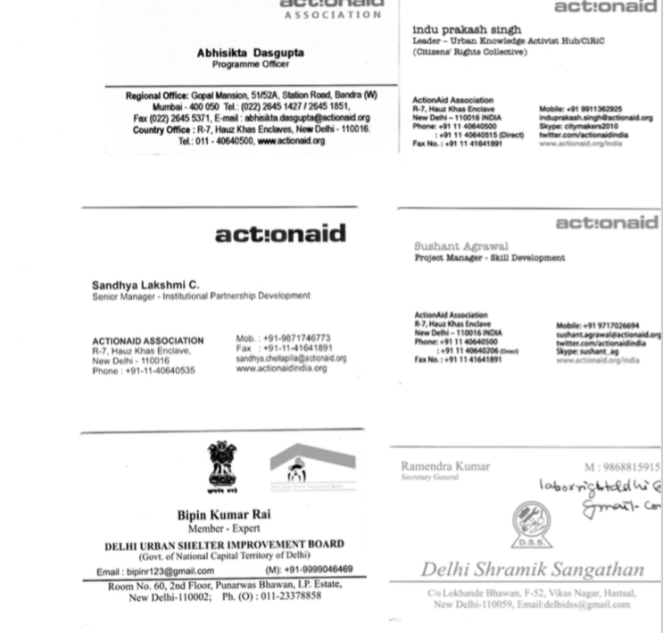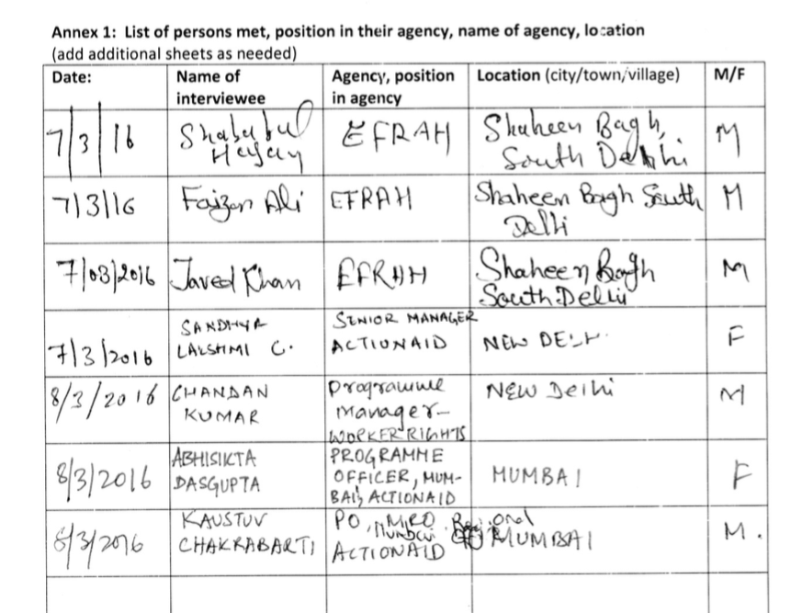

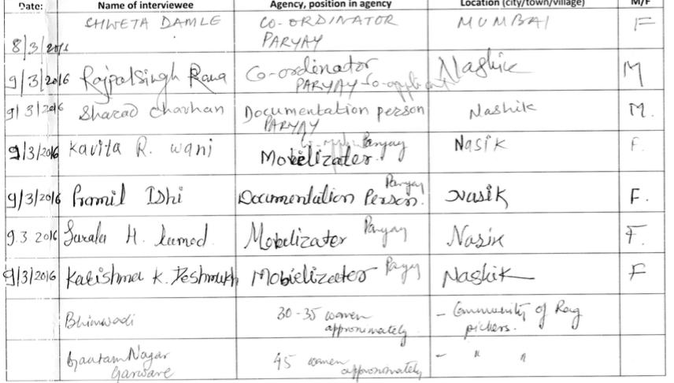

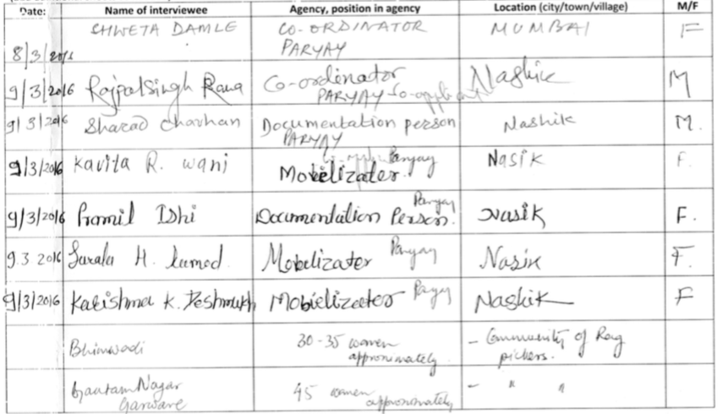

Summary of Two Focus Groups Met

If focus group or other discussion is held with project community members:

List number of persons attending by gender: All female, groups 1 about 3035, group 2, 45 women

Type of group and support provided: multipurpose group on promoting the rights of rag pickers, improving work and living conditions, increase incomes through actions to support their finding of work and livelihoods

Location of group: Nashik, India

Annex 4 - Schedule of Meetings

7 March: meeting with ActionAid staff and field visit to South Delhi project site
8-9 March: field visit to Mumbai and Nashik. Interviews in ActionAid Mumbai Office, field visit to public advocacy event, travel to Nashik. Meetings in Nashik with ActionAid Implementing Partner, government official, and two focus groups. Visit to housing rehabilitation site.
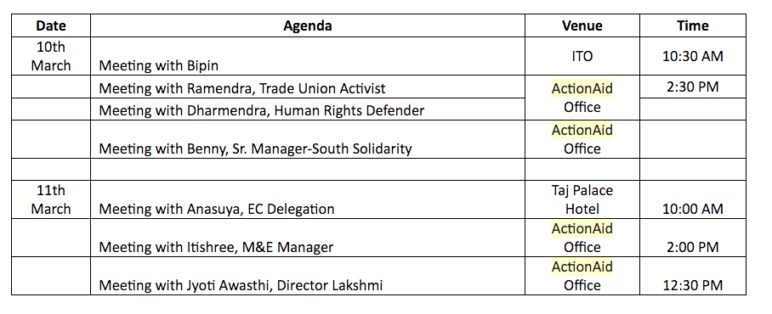
Annex 6 – References

ActionAid page on the Cap4Dev IESF Public Group (2016) website. Available from: http://capacity4dev.ec.europa.eu/iesf/minisite/3-projects.

Government of India (2005). Guidelines for Implementation of Prime Minister’s New 15 Point Programme for the Welfare of Minorities. New Delhi: India, Government of India.

Wikipedia (2016) Kumbh Mela. Available from: https://en.wikipedia.org/wiki/Kumbh_Mela. Website accessed 25 April, 2015.

Not in this order. Day 1 was in Delhi, Days 2-3 in Mumbai and Nashik, Days 4 and 5 in Delhi.
Information in section 1.1 is adapted from the ActionAid page on the Cap4Dev IESF Public Group (2016) website. Available from: http://capacity4dev.ec.europa.eu/iesf/minisite/3-projects.
See interview with Indu Prakash Singh- Leader Urban Knowledge Activist Hub Sushant Agrawal – Project Manager – Skills development in Annex 1.
See interview with EFRAH: Empowerment for Rehabilitation Academy and Health (ActionAid India partner) in Annex 1.
See interview Nashik ActionAid Implementing Partner and Project Work with Rag Pickers in Annex 1 for further details and an example of the results of this method.
See interview Networking Labour Rights Human Rights Defenders, Ramendra, Trade Union Activist; Dharmendra, Human Rigths Defender in Annex 1.
See interview with EFRAH: Empowerment for Rehabilitation Academy and Health (ActionAid India partner) in Annex 1.
See interview with Field Office Project Partner ActionAid Mumbai in Annex 1.
See interview Nashik ActionAid Implementing Partner and Project Work with Rag Pickers in Annex 1.
See interview Nashik ActionAid Implementing Partner and Project Work with Rag Pickers in Annex 1.
Government of India (2005). Guidelines for Implementation of Prime Minister’s New 15 Point Programme for the Welfare of Minorities. New Delhi: India, Government of India
Major festival, which happens every 12 years. See Kumbh Mela https://en.wikipedia.org/wiki/Kumbh_Mela. Website accessed 25 April 2015.
Noting that there are many workers in the IE who work for formal or informal operators but without having formal labour contracts. Consequently they are IE workers.

