Chipinge is a remote district in Manicaland Province in Zimbabwe where most of the young people in this district do not have much access to skills training or any other youth empowerment initiatives. Salvation for Loveness Taedzerwa came from the EU working through Young Africa in the provision of vocational skills to disadvantaged young people using the outreach mobile method. After training in Hair Dressing in December 2015 Loveness went on to open a Hair Salon at Rimbi Centre in Chipinge District.
“I am thankful to the EU for affording me this opportunity to learn how to do so many hair styles without paying a single cent. With an average daily take home of $15 life will never be the same for me and my family.” Loveness Taedzerwa 2016

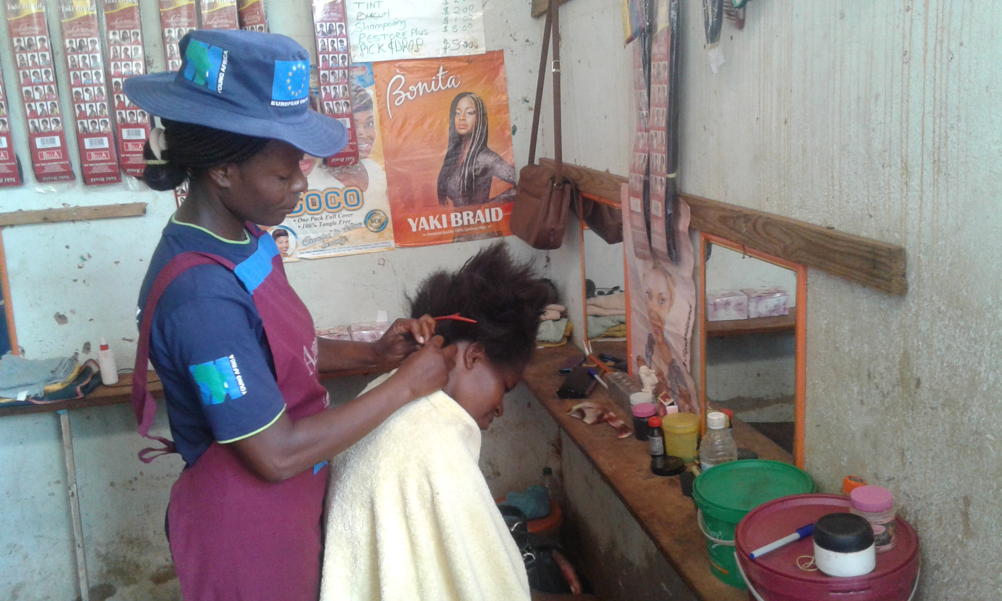
Loveness working on a client in her salon

