**W**ith the aim of strengthening Health Systems in Bangladesh, the European Union supported SHARE (*Strengthening Health, Applying Research Evidence*) project is building capacity of public health managers and service providers one use of Management Information systems’ (MIS) data through District Health Information Software 2 (DHIS2) platform. In collaboration with MIS unit, Directorate General of Health Services (DGHS), UNICEF and GIZ, SHARE project has achieved the milestone of conducting seven divisional workshops on strengthening

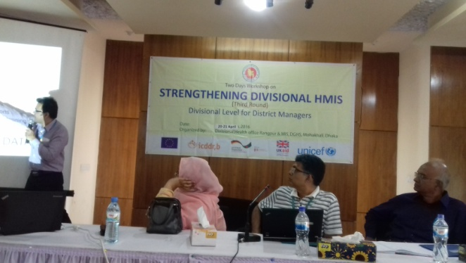Health Information System for the divisional and district Health Managers, IT focal persons and statisticians during the period of April and May 2016. Three-member technical expert team consist of Dr. Jannatul Ferdous, Md. Masud Parvez and Md. Saiful Islam and led by Dr. ATM Iqbal Anwar, SHARE Project Director, has spearheaded this capacity building program from icddr,b to increase efficiency of district health managers and statistician on data analysis, interpretation and creating their own Dashboards in DHIS2 with charts, pivot tables and GIS maps to monitor progress of health programs and strengthen local health planning. icddr,b and other development partners have joined hands for supporting DGHS to generate flawless health data from different tiers of health facilities through this capacity building programme which will contribute in transforming data into evidence for health policy making. Reliable health data is directly linked with people’s health care. Therefore, icddr,b through its SHARE project will continue strengthening health data management during the lifespan of the project which is expected to create desired accountability and transparency in the performance of health sector.

