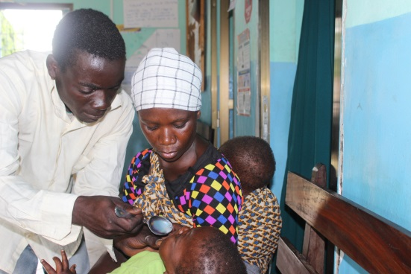
Amina and her husband, who are being supported by the project.

Name: Amina

Project sector: Livelihoods

Implementing Partner: Plan International (UK)

Location: Tanzania

Link:

Amina is a 27 year old married mother with four children, two of which are baby twins. She is being supported by Plan UK in Kibaha district, Tanzania. This project aims to train and empower disadvantaged youth and especially women to improve their access to sustainable earning potential. Through this approach we are creating a change to lives in the long-term.
Previously she told us that her family depends solely on their agriculture activities to survive. These are severely affected by weather conditions, such as drought and floods. Having to look after her children, especially the baby twins, makes earning money very hard. But things have started to look up for her since she was enrolled on a tailoring apprenticeship as part of the project. Her dream to own her own business has started to become within her reach.
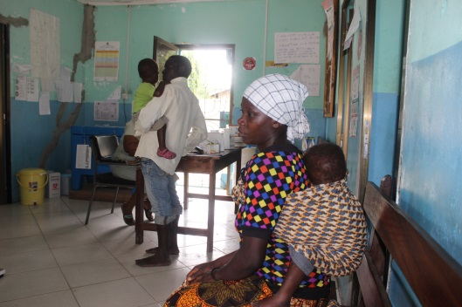
Amina was struggling to cross the river during the rainy season to attend the course and to find childcare. In an attempt to support her, her husband was accepted on the same course. Her husband told us “Whatever affects my wife, affects me as well. When the children become sick, we all carry them to the health centre. I have got this golden chance of undertaking the course to be able to accrue some income to sustain our family”.
Despite Amina’s baby twins being sick over the last six months, Amina is dedicated to finishing the course.

The Plan project coordinator, Adolf, noted “We are always supporting many mothers who are facing the challenge of babysitting and Amina is given priority due to socio-economic difficulties she faces”.
Dedicated to improving her family’s situation and pursuing her dream of having her own business, Amina told us her ultimate goal now is to finish the course in the next few months.
“I am optimistic to complete the course despite the circumstances” she concludes.

