

***P:\Logo\Cardno%20Logo%20JPG_white.jpg***flag_2colors

Project Nº 2016/372-621

**Support to implementing partners of SORUDEV, ZEAT-BEAD and FSTP**

**Report of Technical Review Panel and State-Level Workshops held on 18 May, 15 June and 21 to 23 June**

**Period covered:**

**21 to 23 June 2016**

Prepared by

Omotayo Alabi

on behalf of

**Cardno Emerging Markets (UK) Ltd**

TA implemented by

CARDNO

**European Commission**

This TA is funded by

The European Union

**Key data**

|  |  |
| --- | --- |
| **Name of Project:** | **Support to implementing partners of SORUDEV, ZEAT-BEAD and FSTP** |
| **Contractor:** | **CARDNO EMERGING MARKETS (UK) LTD**  Address Oxford House, Oxford Road, Thame, Oxon, OX9 2AH, UK  Phone +44 1844 216500 Fax +44 1844 261593  Web [www.cardno.com/emergingmarkets](http://www.cardno.com/emergingmarkets) |
| **Contracting Authority:** | Delegation of the European Union to the Republic of South Sudan |
| **Beneficiary:** | Government of the Republic of South Sudan |
| **Start/End Date:** | 21 March to 21 July 2016 |
| **Primary Location:** | Juba, Wau and States where projects are located |

**DISTRIBUTION LIST FOR Workshop Report**

|  |  |  |
| --- | --- | --- |
| **Recipient** | **Copies** | **Format** |
| EU Delegation South Sudan | 1 | Electronic copy |

**Acknowledgements**

The Technical Assistance Team wishes to acknowledge the full support of the staff of the Delegation of the European Union and the staff of the national stakeholder institutions engaged during the Inception Phase.

|  |  |
| --- | --- |
| **Report Quality Controlled by**  **Michael Gutteridge, Framework Contractors’ Project Director**  P:\Signatures\Mike Gutteridge - colour.jpg  **Signature:** |  |

***This report has been prepared with the financial assistance of the European Union. The views expressed herein are those of the consultants and therefore in no way reflect the official opinion of the European Union***

**Support to Implementing Partners of SORUDEV, ZEAT-BEAD and FSTP**

**Report of Technical Review Panel and State-Level Workshops held on 18 May, 15 June and 21-23 June 2016**

**Table of Contents**

[1 Introduction 1](#_Toc456091876)

[2 Validation meeting and launch of the Agricultural Extension Guides and the National Agricultural and Livestock Extension Policy (NALEP) 1](#_Toc456091877)

[3 Second Meeting at State level: VSLA Training of Trainers (ToT) workshop held in Wau from 21 to 23 June 2016 2](#_Toc456091878)

[3.1 Recommendations and conclusions from the meeting 2](#_Toc456091879)

**Annexes**

[Appendix 1: Report of 2nd Training of Trainers (ToT) Village Savings and Loan Association (VSLA) Workshop (21 to 23 June 2016)](#_Toc456163441)

[Appendix 2: Report on the Launch of the National Agricultural and Livestock Extension Policy (NALEP), the South Sudan Agricultural Extension Guides and the South Sudan Forum for African Agricultural Advisory Services (15 June 2016)](#_Toc456163443)

[Appendix 3: Report of Final Validation Workshop of Agricultural Extension Guides (18 May 2016)](#_Toc456163444)

# Introduction

A technical panel of experts drawn from the Ministry of Agriculture, Ministry of Livestock, and partners of the South Sudan Rural Development Programme (SORUDEV) and the Food Security Thematic Programme (FSTP) met on 3 June 2016 to revalidate the content of the extension guides before submission to the press for printing. The input provided at the meeting ensured that the content of the three guides remains relevant to the South Sudan context and that the relevant Government ministries still considered them a useful set of documents to support the weak extension system in South Sudan. An agreement was also reached among the SORUDEV, FSTP and Zonal Effort for Agricultural Transformation/Bahr-el-Ghazal Agricultural Development (ZEAT-BEAD) partners on the cost-sharing arrangement for the printing. This led to printing of the extension guides and a seminar session, which culminated in the national launch of both the guides and the National Agricultural and Livestock Extension Policy (NALEP) document. On the same day the South Sudan Forum for African Agricultural Advisory Services was launched, with the three events combining to result in the informal declaration of an ‘Agricultural Extension Day’ and a commitment to mark the day annually.

The second activity organised by the Technical Assistant (TA) is the Technical Workshop on Advanced Village Savings and Loan Association (VSLA) methodology. The workshop took place in Wau from 21 to 23 June 2016 with both SORUDEV and FSTP partners participating. The objectives and content of the workshop were structured to build on the initial training sessions held in 2014 which provided basic understanding of the VSLA methodology to the participants. SORUDEV Lakes State Projects.

This report details the proceedings of both the meeting and the workshop.

# Validation meeting and launch of the Agricultural Extension Guides and the National Agricultural and Livestock Extension Policy (NALEP)

The validation of 3 June was held in Juba and hosted by the Norwegian Refugee Council (NRC). The meeting led to the printing of the Extension Guides (by SORUDEV and FSTP partners) and of NALEP by the Food and Agricultural Organisation (FAO, see Appendix II for details). The two documents along with the South Sudan Forum for African Agricultural Advisory Services were launched on 15 June 2016 at an event that brought key stakeholders together. The event, dubbed the Agricultural Extension Day, was chaired by Mr Duku, the Hon. Minister of Animal Resources and Fisheries. The event also saw the inauguration of the Forum and the distribution of some of the booklets and policy information printed by FAO.

Attendees included the Ambassador of the EU to South Sudan and the FAO Representative in South Sudan, along with nearly 100 people from UN Agencies, the diplomatic community and Government from all 10 of the previous States in the country. This is the first time on record in the history of South Sudan that a day has been dedicated to discussing agricultural problems and proffering workable solutions, such as i) the launch of a policy framework to guide agricultural and livestock extension programmes; ii) the inauguration of a multi-stakeholder extension forum to ensure that all contribute to keeping agricultural issues on the agenda; and iii) the development and launch of the Agricultural Extension Guides, which addressed the fundamental problem of limited availability of extension materials for community-based extension staff.

Please see Appendix I for details.

# Second Meeting at State level: VSLA Training of Trainers (ToT) workshop held in Wau from 21 to 23 June 2016

Six organisations attended this training in Wau. The cost of the workshop was jointly shared by Cardno and the six partners (World Vision, Norwegian People’s Aid (NPA), Concern Worldwide (CWW), NRC, the Hope Agency for Relief and Development (HARD) and Vétérinaires Sans Frontières Germany (VSF-G), again demonstrating the extent of coordination and ensuring value for money through the sharing of common resources. This was the second major training workshop organised for the partners since the inception of SORUDEV in 2014. The objectives of the workshop were:

1. To equip participants with a broad understanding of micro-finance and agricultural lending;
2. To equip participants with advanced skills in the principles, best practices and operational procedures involved in VSLA methodology;
3. To improve participants’ skills in the use of monitoring tools and assessment techniques;
4. To introduce and equip participants with analytical tools and create an Excel platform; and
5. To facilitate experiential learning in the integration of literacy and numeracy with VSLAs.

## Recommendations and conclusions from the meeting

The following tasks are still to be completed:

1. Collation of data from the VSLA questionnaire that was administered in May. The data were incomplete and in many cases incoherent and as such, could not be used to analyse the activities or progress of VSLAs in the Greater Bahr-el-Ghazal region;
2. Distribution of extension guides and dissemination of NALEP documents across the country;
3. The marking of Agricultural Extension Day as a calendar event with possible rotational hosting by partners (SORUDEV, FSTP and ZEAT-BEAD), with emphasis on seminars and the sharing of ownership with the South Sudan Forum for African Agricultural Advisory Services; and
4. The provision of support to the Forum by the EU and partners implementing food security projects as a broad-based platform for extension which also brings together all actors in the agricultural value chain. This is a cost-effective platform that should leverage support from numerous agricultural organisations and innovation platforms at regional and continental level, foster budding regional cooperation and develop the human resources which South Sudan desperately needs.

Appendix 1: Report of 2nd Training of Trainers (ToT) Village Savings and Loan Association (VSLA) Workshop (21 to 23 June 2016)

|  |  |  |
| --- | --- | --- |
| Funded by the European Union  C:\Users\Tayor\Desktop\Technical Assistant Extension Juba South Sudan\Coordination Secretariat doc\European_Union-logo-75776F70C0-seeklogo.com.gif | European Union/South Sudan  Cooperation | Government of South Sudan  C:\Users\Tayor\Desktop\Desktop Juba South Sudan\SORUDEV_ South Sudan\Logo\South Sudan Flag for SORUDEV logo.jpg |

2nd Training of Trainers (ToT) Village Savings and Loan Association (VSLA) Workshop

Food Security & Rural Development Programme

(ZEAT-BEAD, SORUDEV & FSTP)

**21 to 23 June, 2016**



**1.** **INTRODUCTION**

The 2nd ToT in VSLA methodology for the South Sudan Rural Development (SORUDEV) Programme and the Food Security Thematic Programme (FSTP) project officers took place in Wau at the Rose International Hotel from 21 to 23 June 2016. Participants were VSLA practitioners from Norwegian People’s Aid (NPA), the Norwegian Refugee Council (NRC), the Hope Agency for Relief and Development (HARD), Vétérinaires Sans Frontières Germany (VSF-G) and Concern Worldwide (CWW) from the old Lakes, Warrap, Western Bahr-el-Ghazal and Northern Bahr-el-Ghazal States. A total of 30 participants were expected but about 20 participants actively attended. The workshop was facilitated by Charles Vuldra of the Innovative Institute of Agriculture with co-facilitation by Tayo Alabi, TA Extension to the EU food security programmes in South Sudan. The workshop was opened by Dominic Albino (representing Cleto Kunda, the Director of HARD) and closed by Cleto in person on the third day.

**2. OBJECTIVES OF THE TRAINING**

The ToT sessions aimed to achieve the following objectives:

1. To equip participants with a broad understanding of micro-finance and agricultural lending;
2. To equip participants with advanced skills in VSLA methodology principles, best practices and operational procedures;
3. To improve participants’ skills in the use of monitoring and assessment tools and techniques;
4. To introduce and equip participants with analytical tools and create an Excel platform; and
5. To facilitate experiential learning in the integration of literacy and numeracy with VSLAs.

**3. THE VILLAGE SAVINGS AND LOAN ASSOCIATION (VSLA) SNAPSHOT**

The workshop began with a reflection on the current status of the five VSLA groups created at the start of SORUDEV implementation in July 2014, at which time the VSLA concept and methodology was introduced by the TA Extension to the SORUDEV partners across the four States. Following this introduction, partners identified or employed individuals and staff within their organisations. A common facilitator was identified and training in VSLA technology took place from September 2014 to February 2015. From that point on, VSLA groups began to be formed albeit at different speeds. As of the end of April 2016, the table below shows the total number of groups, total membership of the groups and the number of direct beneficiaries served during the period under review. The number of direct beneficiaries served is calculated based on the presence of 6 people per household.

|  |  |  |  |  |  |  |  |  |
| --- | --- | --- | --- | --- | --- | --- | --- | --- |
|  | **Organi-sations** | **Old State in Greater Bahr-el-Ghazal** | **Number**  **of VSLAs facilitated** | **Minimum membership of the VSLAs** | **Total member-ship** | **Number of direct beneficiaries** | **Accumulated savings**  **(SSP)** | **Accumulated loan**  **(SSP)** |
| 1 | NPA | Lakes | 80 | 25 | 2,000 | 12,000 | 658,677 | 411,645 |
| 2 | NRC | Warrap | 85 | 25 | 2,125 | 12,750 |  |  |
| 3 | VSF-G | Warrap | 12 | 25 | 300 | 1,800 | 663,455 | 84,650 |
| 4 | HARD | Western Bahr-el-Ghazal | 39 | 25 | 975 | 5,850 | 173,748 | 59,065 |
| 5 | CWW | Northern Bahr-el-Ghazal | 110 | 25 | 2,750 | 16,500 |  |  |
|  | **Total** |  | **320** |  | **8,150** | **48,900** |  |  |

**4. EXPECTATIONS OF THE PARTICIPANTS**

Participants in the ToT expected to gain detailed knowledge and skills in:

* VSLA management;
* Tools to work with (handouts);
* VSLA operational procedures;
* Solutions to common challenges, such as how to operate VSLAs in differing environments;
* Linkage of VSLAs to other financial service providers such as micro-finance institutions and banks;
* Harmonisation of working tools for VSLA management;
* Integration of literacy and numeracy skills into VSLAs.

Participants also expected to receive a certificate as proof of their participation in the training.

**5. PRESENTATIONS**

The session on micro-finance and agricultural lending was facilitated by the TA. The presentation explained the various terminologies involved and sought to clarify the confusion unintentionally created by the interchangeable use of the terms ‘Micro-finance’, ‘Rural finance’, ‘Rural micro-finance’, ‘Micro-insurance’ and ‘Agricultural lending’. The presentation explained the use of VSLA methodology as a micro-finance tool which helps achieve the broad goal of the direction and provision of financial services to meet the needs of poor individuals and groups. The target beneficiaries of micro-finance through the VSLA are the individuals or groups who would otherwise have no other means of accessing financial services. The main goal of micro-finance is to give low-income people an opportunity to become self-sufficient by providing a means of saving money, borrowing money and benefiting from access to insurance. It is a vital tool in the promotion of inclusion. The presentation clarified the roles of formal banking institutions, cooperative financial institutions, Non-Governmental Organisations (NGOs), MFIs, community-based organisations (CBOs) and the traditional providers of financial services.

The presentation explained the two basic approaches to micro-finance: the individual approach and the group approach (group lending being mostly character-based as opposed to the collateral required by the formal financial systems).

**6. REVIEW OF VSLA METHODOLOGY INCLUDING LEADERSHIP AND GROUP MANAGEMENT**

Using PowerPoint presentations, flip charts and video clips the participants reflected on the approaches and methods they had used in various fields and locations. Those who had seen VSLAs in action in Uganda (Aga Khan Foundation) and Bangladesh (World Vision) also shared their experiences.

**7. PRESENTATION OF WORKING TOOLS USED BY THE FIELD OFFICER**

Participants at the workshop presented the common tools they deployed in their various organisations. These mainly consisted of forms, many of which are irregular and use different formats. Following their presentations, the participants were introduced to various tools employed by VSLAs, e.g. a Constitution, Minute Book, Visitor Attendance Record, Social fund contribution form/record, Social fund payment form/record, Savings form and VSLA loan form. It was agreed collectively that a set of forms should be adapted for common rollout. The participants worked on the forms.

**8. INTRODUCTION TO DATA ANALYSIS AND ADOPTION OF AN MS EXCEL TRACKING WORKSHEET**

Participants were introduced to the basics of MS Excel and the Statistical Package for Social Scientists (SPSS) software, with simple trials attempted. They also tried inputting data from the common set of VSLA monitoring data collected in April and May 2016. Expectedly, this was a long session as for 80% of the participants this was their first experience of data entry and analysis using SPSS. Assignments were allotted overnight to ensure participants were fully engaged. The participants reviewed the Excel-based tracking and monitoring worksheet and adopted one in a simple format.

**9. LITERACY AND NUMERACY**

The participants discussed how best to promote literacy and numeracy among VSLA members. Emphasis was placed on the use of symbols, colours, cards, posters, pictures, illustrations, physical examples from their surroundings and the use of songs to improve both identification and memorisation. The need for proper understanding of records is essential to the VSLA to ensure that counting is done correctly and that figures are written correctly and clearly in record books. Addition and subtraction are the two main functions used by the majority of the members. Multiplication is rarely used but knowledge of division is essential. Central to effective training in adult learning is the role and effectiveness of the facilitators. With reference to REFLECT[[1]](#footnote-1) methodology, the roles of facilitators include the following:

* *Organisation*: Explain how to do each activity, keep an eye on the time and ensure everyone gets to participate equally;
* *Encouragement*: Help each individual to feel they are accepted and encourage them to participate. Be aware of the difficulties that face the group; and
* *Motivation*: Encourage self-confidence in the participants and promote initiatives that motivate the group. Persuade participants to organise themselves as a CBO and create an atmosphere of friendliness. Give adequate opportunity to all participants to help them accept differing opinions. Calm the situation whenever someone's personal opinion is not accepted by giving them a chance to justify it further or otherwise convincing them not to become frustrated.

It is important to have regular breaks to interrupt the monotony of the educational process and make regular fresh starts. Use should be made of the available references to all the subjects in this manual or any other subject chosen by the participants.

**10. RECOMMENDATIONS**

Acquisition of the entire range of adult learning skills requires more time and could not be covered in this training. Each partner organisation will need to prepare a more intensive training for their staff. Focus could be on REFLECT or on the acquisition of basic functional adult learning skills. The VSLA questionnaire administered in May focuses on obtaining a snapshot of the group activities and has only limited use, as it was not intended to capture individual members’ progress or to document precise information on the individual business activities or income-generating endeavours of the members. This information is also missing from all the field reports generated so far by the SORUDEV and FSTP partners and should be regularly collected by partner VSLA project officers through 6-monthly questionnaires.

There is strong demand for peer reviews and learning visits. It was expected that the participants in the training would document and analyse the information collected during the VSLA survey deployed in May, but this was not possible because the data were provided late and were largely incomplete.

**11. CONCLUSIONS**

It is generally agreed that the five organisations (NPA, NRC, HARD, VSF-G and CWW) have made progress in establishing VSLAs and ensuring that the members remain active. There is also uniformity in approaches as a result of staff having undergone similar training. The common challenges are the prevailing insecurity in the country, the high cost of basic household commodities (including food) and the role played by seasonal changes, including the uneven distribution of rainfall during the last cropping season. Many have suggested that these factors are responsible for a drop in the amount mobilised by the group; however, the majority of the members who are in dire need have had to depend on the VSLA loans for survival, so the VSLA has served as an important safety net. Overall, the participants rated the training workshop very highly based on the content of the training, facilitation style, key learning points and recommendations.

**Annex I: Participant Photographs**

|  |  |
| --- | --- |
| **Participants at the workshop** | |
|  |  |
|  |  |
|  |  |

Appendix 2: Report on the Launch of the National Agricultural and Livestock Extension Policy (NALEP), the South Sudan Agricultural Extension Guides and the South Sudan Forum for African Agricultural Advisory Services (15 June 2016)

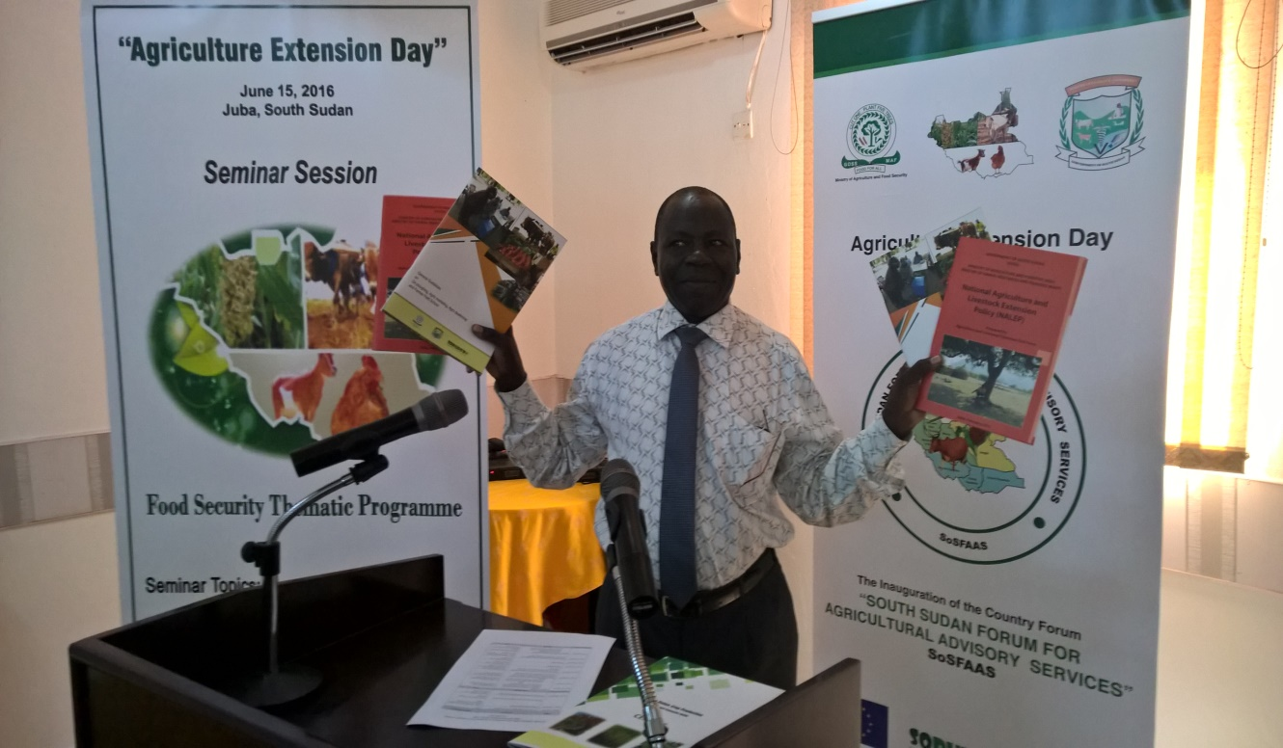

**Aron International Hotel, Juba**

**15 June 2016**

Table of Contents

[Introduction 2](#_Toc454544918)

[Background to and objectives of the event 2](#_Toc454544919)

[Sessions and proceedings 3](#_Toc454544920)

[Launch of NALEP and Agricultural Extension documents 4](#_Toc454544921)

[Closure 4](#_Toc454544922)

[Annex I: Programme Sheet 5](#_Toc454544923)

[Annex II: Photographs 6](#_Toc454544924)

[Annex III: Attendance List 7](#_Toc454544925)

**Introduction**

The Implementing Partners (IPs) of the European Union (EU)-funded food security programme participated in the “Agricultural Extension Day” event of 15 June 2016 in Juba, South Sudan. The occasion united IPs of the Zonal Effort for Agricultural Transformation/Bahr-el-Ghazal Agricultural Development (ZEAT-BEAD) programme, the South Sudan Rural Development (SORUDEV) Programme and the Food Security Thematic Programme (FSTP), plus representatives of the National Ministries of Agriculture and Food Security (MAFS), the Ministry of Livestock and Fisheries (MLF) and Foreign Affairs, along with representatives of all State Ministries of Agriculture and Animal Resources and members of the press and diplomatic community.

The three main activities of the day were the launch of the National Agricultural Livestock and Extension Policy (NALEP), the launch of common Agricultural Extension Guides and the inauguration of a Country Forum for Agricultural Advisory Services. Among the participants were the Head of the EU Delegation to South Sudan, the Country Representative of the Food and Agricultural Organisation (FAO) and representatives of the Japanese International Cooperation Agency (JICA) and German cooperation (GIZ). The event was chaired by the Minister of Animal Resources and Fisheries, Hon. James Janka Duku, who opened and closed it. A total of 92 participants attended the event and consisted primarily of DGs of agriculture and livestock from 9 of the former States (excluding Upper Nile), along with Ministry staff and representatives of Development Partners (donors), universities, agricultural training centres and media houses.

**Background to and objectives of the event**

SORUDEV, FSTP and ZEAT-BEAD are the 3 main EU-funded food security programmes that contribute to reducing food insecurity in South Sudan. SORUDEV and ZEAT-BEAD are designed to support mostly smallholder farmers, while FSTP supports marginalised farmers through improved extension services and the adoption of simple technologies to improve production and productivity, livestock husbandry, value addition and access to markets.

The National Agricultural and Livestock Extension Policy (NALEP) is the overarching Government policy framework within which the 3 above programmes are conceived and implemented. There is a common agreement that extension and advisory services to support farmers are poor-quality, incoherent, lacking in qualified staff and poorly funded. Since its approval by the Committee of Ministers in 2011, NALEP has neither been launched nor disseminated widely. It is on this basis that the launch of the Policy and the dissemination thereof became a major activity of ZEAT-BEAD (implemented by FAO) on the one hand while SORUDEV and FSTP (implemented by a range of international and national NGOs) have focused on improving extension packages to include effective message delivery, especially at County, Payam and Boma level where the need is found to be most dire.

As a result, FAO reproduced the NALEP documents in a format that is readable and presentable and the NGOs (over a period of one year and with the support of the EU Technical Assistant (TA) for Extension) developed common Agricultural Extension Guides. The guides cover cultural agronomic practices for crops, husbandry practices for livestock and best practices for marketing, group mobilisation and Farmer Field Schools (FFS). Within the purview of Government, the MAFS and MLF inaugurated a platform to build the capacity and coordination of value chain actors and stakeholders in the public and private sectors.

It is against this backdrop that the IPs of the EU-funded food security programmes (ZEAT-BEAD, SORUDEV and FSTP), in partnership with the MAFS and MLF, launched the NALEP document and the South Sudan Common Agricultural Extension Guides and officially inaugurated the South Sudan Forum for African Agricultural Advisory Services.

**Sessions and proceedings**

Broadly, the one-day programme was divided into 3 sessions. The first session comprised an overview of NALEP with a presentation by Augustino Atillio (DG Extension, MLF) and one of the authors, followed by the morning seminar (which was originally to be an activity of the World Vision FSTP project but was later incorporated as part of the event). The two seminar topics discussed were: i) Extension Dissemination (by Dr George Leju, DG Agricultural Production and Extension, MAFS); and ii) Challenges and opportunities in the livestock production sector in South Sudan (by Dr Makuei Malual Kaang, Undersecretary, MLF). A feedback session from the attendees followed.

In between these were remarks from the FAO Representative Dr Serge Tissot and the Head of the EU Delegation Stephano de Leo. Joseph Akim, Director of Extension at the MAFS, gave a presentation on the South Sudan Common Agricultural Extension Guides and their expected contribution to community extension advisory services. This was followed by the final presentation of the day on the role and function of the South Sudan Forum for African Agricultural Advisory Services by Dr George Leju.

Feedback and response to the various issues raised following the seminar and subsequent presentations included the desperate need for farmers to source quality seeds. Seed production, certification and marketing are major problems in South Sudan. Most seeds are imported from East African countries (in particular Uganda) and are not local to the specific agro-ecologies of South Sudan. In many cases they have lost viability by the time they reach the farmers. The country needs a seed bill. The high cost of inputs such as machinery and the poor condition of the feeder road network multiply the cost of production and make farming less profitable. It was also noted that the conflict between the cattle keepers (who are nomadic) and the crop farmers is far more severe than reported. This was described as the most likely trigger of another war in South Sudan as it is widely believed that the nomadic cattle keepers intentionally allow their cattle to forage on crops, which often results in fights and bloodshed. The need for support to large-scale farmers remains largely unmet and in all cases, DPs focus only on smallholder and vulnerable farmers. Large farmers have made requests for subsidies and this is recognised as a gap.

The following responses from the EU, FAO and MAFS addressed some of the concerns and sentiments expressed by participants:

* The EU Delegation pledged to support the Government of South Sudan in the drive to achieve food security. To ensure that this happens it is essential that the Government, through its various organs, ensures the ratification of all pending bills and important international protocols such as the Cotonou Agreement. It was also noted that there is an urgent need to diversify the economy away from its current dependence on crude oil, especially as prices are unstable and production is finite. As a follow-up action, the EU Delegation will engage the Government in modalities to strengthen the linkage between the States and the national Government;
* FAO representatives pointed out that many of the problems and challenges identified by the farmers are in many ways universal. A seed policy for the former Sudan has existed for some 10 years; the problem is about internalising it with the right human resources and funding. FAO will ensure that 70% of seeds distributed are sourced locally. Another problem is seed certification which requires a specific and high-level skill set, especially as regards research. An independent organisation is needed to certify seeds and to issue certificates that can be trusted. Responding to the request for subsidy, the reality is that subsidy is not feasible; it is expensive and has been proven to be unsustainable. The alternative is to improve and strengthen the financial sector and thus improve access to credit by farmers through the commercial or cooperative banking system, while simultaneously improving support to developing a land tenure system for the country; and
* The MAFS clarified that a Seed Policy is in place and has already been approved by the Council of Ministers. There are 7 seed growers in the country recognised by the MAFS. The Ministry has initiated classification of South Sudan’s terrain into different agro-ecologies: 1) Arid Belt, 2) Flood Plains, 3) Green Belt, 4) Hills and Mountains, 5) the Ironstone Plateau and 6) the Nile and Sobat Corridor.

**Launch of NALEP and Agricultural Extension documents**

The Minister of Animal Resources and Fisheries, Hon. Minister James Janka Duku, officially unveiled the logo of the South Sudan Forum of African Agricultural Advisory Services and through this, launched the NALEP document and the three Agricultural Extension Guides. He promised to lead (in consultation with his colleague, the Minister of Education) to improve the delivery of agricultural sciences in schools and to recommend the use of both NALEP and the extension guides. He encouraged private sector involvement in food security and reaffirmed the commitment of the Government of South Sudan to food security and the peaceful coexistence of all citizens, as demonstrated in the recently formed national transition government brokered by the South Sudanese and the international community. The Ministry of Animal Resources and Fisheries will improve control systems through quarantine at all border posts. On that note the Minister officially declared the extension day event closed.

**Closure**

Distribution of the NALEP and 3,000 copies of the Agricultural Extension Guides (which were printed by FAO with funds from its EISS project) followed. The remaining 6,000 booklets to be distributed, mainly in the Greater Bahr-el-Ghazal region, will be printed by the Norwegian Refugee Council (NRC), Norwegian People’s Aid (NPA), Concern Worldwide, Vétérinaires Sans Frontières Germany (VSF-G), World Vision and the Hope Agency for Relief and Development (HARD), with NRC as the lead partner. FAO will ensure that the NALEP documents and Extension Guides are distributed to the State Ministries of Agriculture through the MAFS and MLF. The SORUDEV and FSTP partners will also contribute 20% of their production to the national MAFS and MLF to complement the quantity to be distributed to the agricultural training centres and the universities.

**Annex I: Programme**

|  |  |  |
| --- | --- | --- |
| **TIME** | **ACTIVITY** | **RESPONSIBLE** |
| 08.30 to 09.00 | Arrival and registration of participants | All |
| 10.00 to11.00 | Welcome remarks and objective of the event  Official opening of event | Nehru Essomba – Project Manager  Minister of Animal Resources and Fisheries |
| Overview of NALEP | Augustino Atillio – DG Extension, MLF |
| **11.00 to 11.30** | **TEA BREAK** | **ALL** |
| 11.30 to13.30 | Seminar: Effective Dissemination of Extension Messages in South Sudan | Dr George Leju – DG Agriculture Production and Extension, MAFS |
| FAO remarks | Dr Serge Tissot – FAO Representative in South Sudan |
| EU remarks | Stephano de Leo – Head of EU Delegation to South Sudan |
| Seminar: Challenges and opportunities in the livestock production sector in South Sudan | Dr Makuei Malual Kaang – Undersecretary, MLF |
| Presentation of the South Sudan Extension Guides and their expected contribution to community extension advisory services | Joseph Akim – Director of Extension, MAFS |
| The role and function of the South Sudan Forum for African Agricultural Advisory Services | Dr George Leju – DG Agricultural Production and Extension, MAFS |
| Remarks by Hon. Minister (MLF) | Hon. Minister James Janka Duku – Minister of Animal Resources and Fisheries |
| Speech of the Hon. Minister (MLF)   * Launch of the NALEP * Launch of the Extension Guides * Official inauguration of the Forum | Hon. Minister James Janka Duku – Minister of Animal Resources and Fisheries |
| **13.30 to 14.00** | **LUNCH and Closure** | **ALL** |

**Annex II: Photographs**

|  |  |
| --- | --- |
| The Minister of Animal Resources and Fisheries with the members of the high table | The EU Head of Delegation to South Sudan delivering his address |
|  |  |
| The FAO Representative delivering his remarks | Hon. Minister James Janka Duku delivering the keynote address |
|  |  |
| Augustino Attilio giving NALEP overview | Cross-section of participants |
|  |  |
| Dr Makuei Malual Kaang, Undersecretary, MLF delivering his seminar presentation | Dr George Leju – DG Agricultural Production and Extension, MAFS delivering his seminar presentation |
|  |  |
| Logo of the South Sudan Forum for African Agricultural Advisory Services being unveiled | Banner of the Seminar Session |
|  |  |

**Annex III: Attendance List**

The attendance list is separately submitted.

Appendix 3: Report of Final Validation Workshop of Agricultural Extension Guides (18 May 2016)



Government of South Sudan

Funded by the European Union

European Union/South Sudan

Cooperation

**Final Validation Workshop of Agricultural Extension Guides**

SORUDEV and FSTP Food Security Programmes

Wednesday 18 May, 2016

Hosted by the Norwegian Refugee Council (NRC)

**Workshop Report**

**Opening**

The final validation workshop of the agricultural extension guides was held at the NRC Head Office in Juba on 18 May, 2016. It was officially opened by the NRC Director of Programmes and Acting Country Director Ms Carina Vedvik Hansen, who welcomed all participants and highlighted the importance of making the extension guides available for use by both government extensionists and development partners’ extension staff. The output of the effort put into compiling the guides will hopefully support the drive to ensure food security in the country, particularly during this period in the nation’s history. She pledged the support of NRC in this endeavour and thanked the European Union for the funding and assistance provided to all partners of the South Sudan Rural Development Programme (SORUDEV).

**Objectives**

The purposes of the session were to i) review the guides for the last time before they were printed; ii) secure their endorsement by the Government, iii) confirm and obtain the financial commitment of all partners (SORUDEV, the Food Security Thematic Programme (FSTP) and the Zonal Effort for Agricultural Transformation/Bahr-El-Ghazal Agricultural Development (ZEAT-BEAD) programme) to funding the production of the guides; and iv) discuss the launch and dissemination plan.

**Review of the documents**

The general look and design of the booklet was endorsed as readable and attractive. The following corrections to the content were made:

1. All tables should be in black and white;
2. The pictures in the booklets should be captioned;
3. The booklets should be detribalised to allow for use across the country without reservation;
4. Any reference to old States should be kept since compilation of the booklets started in 2015;
5. Maps should be removed.

The logos of both the Ministry of Agriculture and Food Security, and Ministry of Livestock and Fisheries (MLF) should be on the cover in that order.

1. The EU logo should be prominent on the acknowledgements page as agreed in Yei;
2. The list of references should be replaced with a bibliography; and
3. Many of the tables in the 3rd booklet (general guidelines) are out of place and a few pictures do not have the right resolution and should thus be replaced (work can be done with the designer to correct these problems).

**Discussion on financial commitment**

In line with the agreement reached in Yei in 2015, participants at the final review meeting agreed to produce 300 copies of each of the booklets bringing the total to 9,000. Six SORUDEV and FSTP partners will fund the printing of 1,000 booklets each. The breakdown is as follows:

|  |  |  |  |  |
| --- | --- | --- | --- | --- |
| **Organisation** | **Crop Production Booklet** | **Livestock Production**  **Booklet** | **General Guideline Booklet** | **Total** |
| Norwegian People’s Aid (NPA) | 380 | 310 | 310 | 1,000 |
| Concern Worldwide (CWW) | 380 | 310 | 310 | 1,000 |
| Norwegian Refugee Council (NRC) | 380 | 310 | 310 | 1,000 |
| Vétérinaires Sans Frontières Germany (VSF-G) | 380 | 310 | 310 | 1,000 |
| Hope Agency for Relief and Development (HARD) | 380 | 310 | 310 | 1,000 |
| World Vision | 380 | 310 | 310 | 1,000 |
| Total | | | | 6,000 |

The primary distribution channel will be at State level. However, each NGO will donate 10% of the booklets funded to the national MAFS (5%) and MLF (5%)[[2]](#footnote-2).

**Agreement of procurement and printing**

The participants again affirmed their confidence in NRC to lead the production of the booklets on behalf of the partners. To this end, the preferred arrangement is for NRC to proceed with sourcing quotes from at least 3 printing houses in Juba, analysing these and sharing the analysis with the partners. This process will be documented and the selected printing press contracted and paid. NRC will issue an invoice to each partner after production and partners will collect and reimburse NRC accordingly.

**Launch and Distribution**

The Extension Guides will be launched on Wednesday 15 June 2016 to coincide with the launch of the National Agricultural and Livestock Extension Policy (NALEP) by FAO and the official inauguration of the South Sudan Forum for African Agricultural Advisory Services. The World Vision seminar session will also be incorporated into this event. The proposed seminar topics and speakers are: i) “Adoption of Improved Agricultural Practices: Challenges and impact on Food Security in South Sudan” by Prof. Matthew Udo, Undersecretary, MAFS; and ii) “Challenges and opportunities in the livestock production sector in South Sudan” by Dr. Makuei Malual Kaang, Undersecretary, MLF. This day will be informally dubbed the “Agricultural Extension Day”.

**Closing**

The review workshop was closed by Mr. Anthony Raymond, DG Special Projects at the MLF. He thanked the participants for their significant contribution to and critique of the documents from the perspective of user and technical practitioner and stated that the extension guides were excellent-quality documents of importance to the development of extension and agricultural advisory services by the Government. He and his colleagues at the Ministries are grateful to the EU for funding the process and to development partners for their commitment to the production of the booklets from day one. He looks forward to the production, distribution and launch of the booklets and gave special appreciation to NRC for hosting the final review session.

**Annex 1: Attendance List**

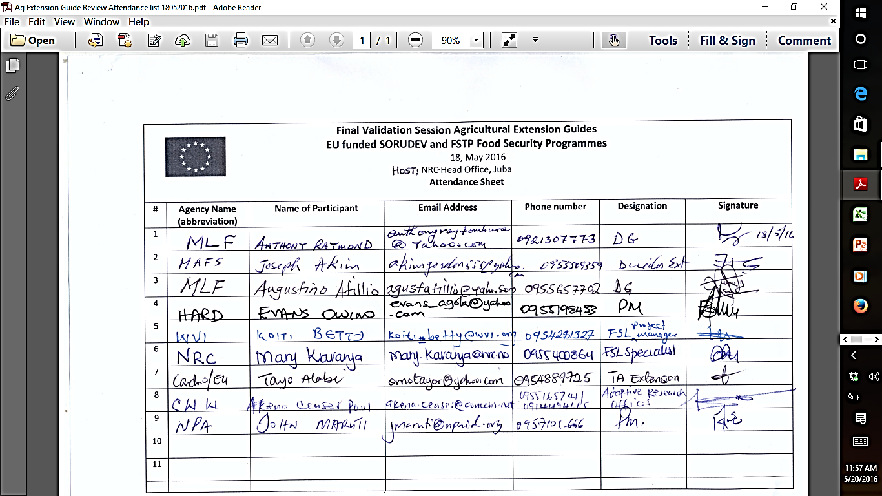

**Annex 2: Photographs**

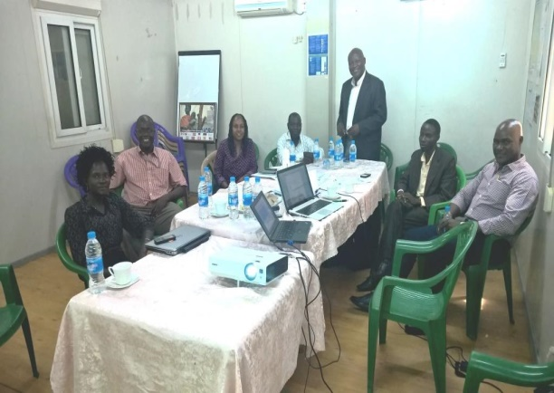 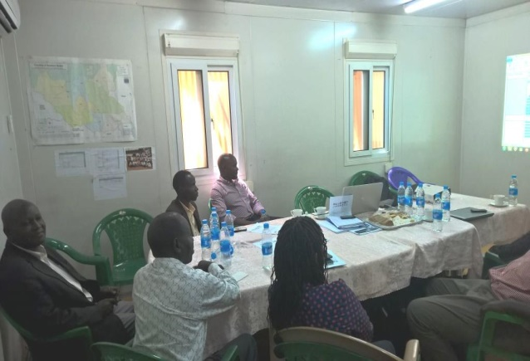

Participants during the final review workshop in Juba

**Annex 3: Agenda**

**Final Review of Agricultural Extension Guides**

Wednesday 18 May 2016

Host: Norwegian Refugee Council (NRC)

**Agenda**

\_\_\_\_\_\_\_\_\_\_\_\_\_\_\_\_\_\_\_\_\_\_\_\_\_\_\_\_\_\_\_\_\_\_\_\_\_\_\_\_\_\_\_\_\_\_\_\_\_\_\_\_\_\_\_\_\_\_\_\_\_\_\_\_\_\_\_\_\_\_\_\_\_

**Objectives:**

1. To carry out final revision of the guides (technical details and design layout);
2. To finalise, discuss and secure the commitment of partners to printing costs and quantities; and
3. To agree on the next steps with concrete actions to meet the launch date of 15 June 2016.

|  |  |  |
| --- | --- | --- |
| **Time** | **Activities** | **Responsible** |
| 8.00-8.30 | Arrival, introduction and registration | TA-EU |
| 8.30-8.35 | Welcome remarks by the Norwegian Refugee Council | NRC |
| 8.35-8.40 | Objective, procedure and process of review | TA-EU |
| 8.40-9.40 | Guideline on livestock management | MLF |
| 9.40-10.30 | Guideline on crops | MAFS |
| 10.30-10.45 | Tea Break | NRC |
| 10.45-11.45 | Guideline on agricultural marketing, VSLAs, community mobilisation and Farmer Field Schools | FAO |
| 11.45-12.30 | Next steps: Printing, launch (15 June) and distribution | TA-EU |
| 12.30 | Closing remarks | MAFS & MLFI |
| 13.00 | Refreshments | NRC |



1. “Regenerated Frierean Literacy through Empowering Community Techniques" [↑](#footnote-ref-1)
2. It is hoped that the 4,000 copies will be printed by FAO. Most of these will go to the national Government for distribution to research and academic institutions and to other States outside the Greater Bahr-el-Ghazal area. [↑](#footnote-ref-2)