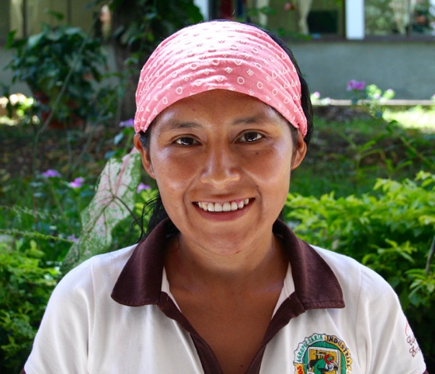
Name: Dora Tomás Vargas.

Age: 26.

Organization: COAINE.

Location: Colonia Juan del Valle, Caranavi.

There are four women working in Dora’s cafetal because her parents are divorced and she has only sisters.

“Since I was fourteen I used to help my parents with the coffee plantation after school; later I had to move to La Paz in order to attend the Colegio since in my area there are not any high schools.
Now that I get back home and we are only women in my family I actually realize how difficult is to be a cafetalera. Although women hold few roles in our associations, we usually work more than men and we have also to look after our families. In harvest time we even have time to eat during the day! Unfortunately, we still have not any acknowledgments for such sacrifices. By the time we get older we also need to deal with the illness related to our age and life struggles
Sadly, we often care more of our parcels, of production etc. but none cares about our health.
If a woman gets ill there is not any insures that could protect her, she only can hope to alleviate the ache using some home made traditional remedies. If you are healthy you can work, if health is lacking you cannot do nothing! A best health care system should help especially women.”

Dora attends the course promoted by the Project Café Correcto, which has the main aim to make leaders of the coffee producers associations of the areas of Caranavi and Nor Yungas. Cafe Correcto provides necessary instruments to take part of a platform with other technicians in law. The common aim is to elaborate a proposal for a new law that could help them to get a health insurance and a decent working condition.

“I feel that this project is helping me to get that knowledge useful to suggest my own proposal and opinion about the health care system in Bolivia for coffee producers. I hope to be useful together with the other cafetaleros to solve this problem.”

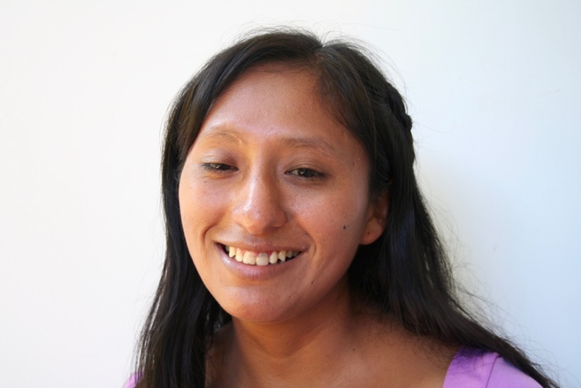
Name: Noemi Perga Mamani.

Age: 25.

Organization: Mejillones

Location: Calama, Caranavi.

“Since I was a child I grew up in our family cafetal helping my parents during the harvest time”, she told me while she smiles looking back her childhood.

“When I was three years old I already used to help my parents moving coffee grains and make them drying up under the sun in order to avoid that coffee could get mouldy. When I grew up enough I finally followed my parents with my coco, a special basket tied at the bust, that we use to gather ripe coffee grains. “When I finished high school I moved from Calama to Caranavi in order to attend the ITC (technical institute of Caranavi) where I would like to specialize in coffee farming and transformation.
Courses cost 20Bs.- per month and the project Café Correcto has given to me a scholarship which allows me to pay the daily meals..”

Suddenly, Noemi becomes sullen and takes up to pour out:

“I had something that happened when I was seventeen; I got pregnant and I became an unmarried mum. I wanted to study and fortunately my family helped me economically. More over during the week my family usually looks after my daughter and in the week end, when there aren’t any courses, I can take care of my baby.”

I ask her how her peers and she feel that the project will help them.

“This project is a good chance since it is helping us to grow up and to get more knowledge about coffee production. Thanks to Café Correcto fifteen young students got scholarships that is allowing them to continue their studies. Now I am studying hard because I would like to come back to my village and my family, I would like to change something not only in my parcel but also in my association; actually few women play a relevant role in the association. Most of us usually work more and more than man but they cannot take decisions in the community life.

I ask Noemi if she wants to tell me something about the cafetaleros families’ daily life. She is happy to pour out about the difficult conditions of cafetaleros due to the coffee plagues and t low harvests, which have characterized last years.

“Most of cafetaleros are owners of their parcels and they have to work night and day without being sure to gain something.. Neither at the end of the harvest period they cannot rest because they have to mow weeds and fix the Muchch, that is a kind of fence useful to keep the humus that otherwise could be taken away by the rainfalls.
Nowadays producers have not enough resources to employ day labourers and they reach the point that we help each other for free. If someone of my family gets ill how should I do? Who should work for us? We don’t have any insurance.
Fortunately I am learning a lot at school and one day I want to have my own parcel of coffee to cultivate in an organic way as we already do anyway. I learnt that if you use an organic fertilizer coffee grow up sweeter. We usually buy manure by shepherds in tablelands or we use fowl dung made by our chickens. By the way my dream is to have a complete farm with other production, because coffee can be harvest only once per year, and I need to earn something each month!”

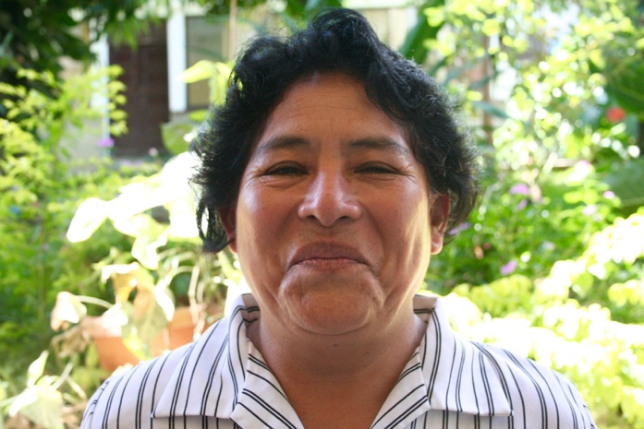
Name: Elena Vergara Huanca.

Age: 53.

Organization: ACCOPCA (asociación central de

comunidades productoras de café).

Location: Coripata, Nor Yungas.

Elena tells me prideful the story of her family that from Apolo has colonized the Yungas.
“By the time of the land reform in 1953 lots of campesinos came in this part of the country from the high lands to catch a parcel to cultivate with coffee.
At that time the main problem was represented by the coffee brokers whom used to buy green coffee by the cafetaleros for few moneys.
My parents were also catechists and, sustained by the Church, they reach to round up some coffee producers of the five communities of Coripata (San Juan, Siete Lomas, Inca Pukara, Markiribe e Santiago Chico), and to found an association of producers in order to put together all the resources and take up to transform the raw coffee so that create added value.
In the following years, the members registered were around 720 and they have been able to export around 5 containers of transformed coffee, mainly toward Europe.
Our association built also 2 processing plants and established scholarships for the sons of the members.
After this golden period several problems arose in our association. in 1985 a governmental project called Agroyungas which had the main aid to improve the coffee production in order to discourage coca production, had donated many coffee plants of a new better variety known as Catuai which unfortunately carried on a new coffee plague, the Broca.
Later an other plague arrived in our region, the Roja, together with recurring droughts.
Sadly, the last administrative committee has led us to bankrupt because it was deeply corrupted and we lost everything. But in 2009 some members using their own savings have rebuilt the association and have reached to take back one of the two processing plants. We also have replaced the old coffee plantations and this year we have had the first harvest.
Unfortunately, nowadays many coffee producers have replaced coffee plantations also with coca plantations since is more convenient. Roasted coffee is sold in Bolivia 88Bs.- per Kg while green coffee is exported thanks to the Fair Trade 1,90$ per pound. Otherwise coca is sold 1200Bs.- per Taqui (50 pounds);
I cannot live only with my coffee, fortunately I am also prosthodontist and I work part time in a clinic so that I can pay a basic health insurance but anyway I won’t get any retirements. In the past time we struggled a lot in order to obtain a kind of insurance suitable for coffee producers; We had proposed to address a percentage of the exportation to our pension but no way, none listened to us. We still have not any national insurance good for us. When we get ill we have to pay everything by ourselves. It is easy to get sick because it is an hard job. Nowadays young people often prefer to find out a job less heavy and more profitable. My parents had opened patches in the forest despite the youngest doesn’t want neither to live far from the main road!
Why I am still producing coffee? I love my cafecito! One of my two son would like to get at least 2 hectares of coffee plantation and then roasted his coffee beans to create added value, this is the way to work here!”

