Aurelio Martínez laughs every two sentences, even when he describes the crimes of colonialism and slavery. Maybe, he says, it’s because Garifunapeople are happy people. The Garifuna are a community of mixed-race people who inhabit Central America’s Atlantic coast, particularly in Honduras, where Martínez is from.
The Garifuna people originated in the island of St. Vincent in the Caribbean. In 1635, the survivors of the wreck of a Spanish ship carrying people from Biafra, in modern-day Nigeria, to be sold as slaves in the Americas, were welcomed by the local Caribs. A few years later, another ship, this time Portuguese, suffered the same fate, and would-be slaves from Congo and Ghana joined their fellow Africans in St. Vincent.
The Caribs, originally from nearby modern-day Venezuela, had immigrated to this island before and had killed most of the Arawak locals, but kept their women and started to have families with them. The African men and women joined them and adapted to their customs, creating a culture, which became known as Garifuna, for one of the last free islands in the Caribbean.
However, beginning in 1719, both French and English troops tried to conquer the island and subject its inhabitants. The local resistance was strong, though, and the English were only able to topple the Garifuna in 1795, almost eight decades after their initial attacks. Two years later, the English decided to expel the Garifuna and ship them to Roatán, an island off the coast of what is now Honduras. From there, they expanded to their current territories.
This is the tragic, but proud history that shapes every Garifuna like, and it is the backdrop of his music. He sings exclusively in the Garifuna language, but that is no impediment for his crowds around the world, who never seem to get on his feet and dance to his tunes.
We caught up with Martínez after his presentation at the Afro-Latino Festival in Brooklyn to talk about his music, Garifuna culture, and breaking away from tradition.
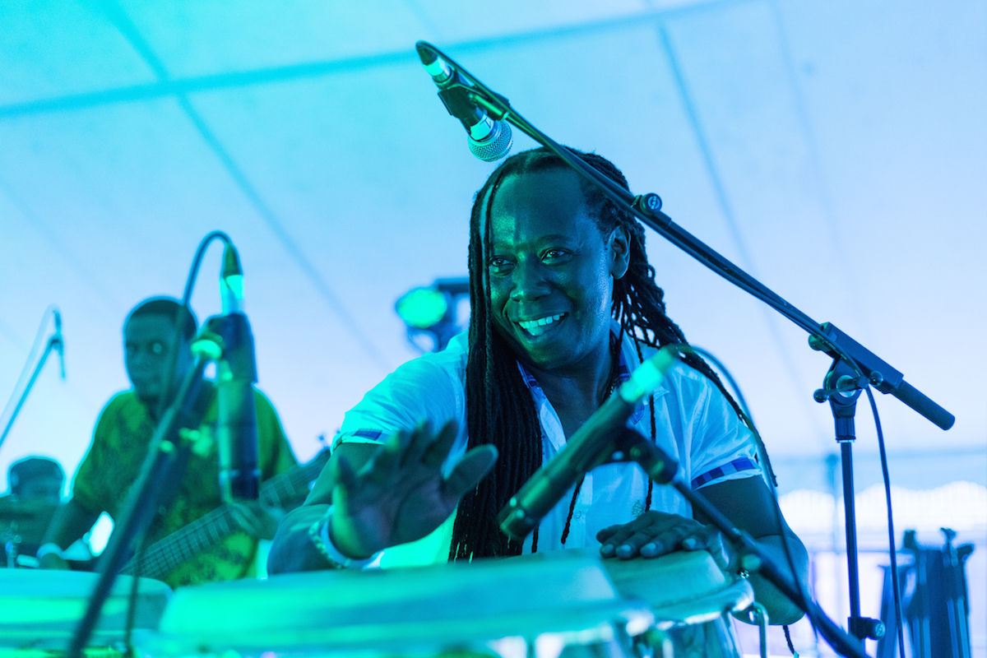Aurelio Martinez at Afro Latino Fest NYC. Photo: Ailyn Robles.
Can you talk a little bit about the Garifuna people?
Aurelio Martínez: The Garifuna represent the resistance of African-ness in the Americas. We were never enslaved, that’s why we still have the structure of our culture, which was born in St. Vincent, in the Antilles, a mixture of Arawak indigenous people with African black people. Garifuna people have remained in Central America for 219 years after being expelled from St. Vincent. After the Caribbean, the Garifuna went to Honduras. From there, we went to all of the Central American Atlantic coast, Guatemala, Nicaragua, Honduras, and Belize, those four countries. Though now we have a lot of exiles and emigrants, like the rest of cultures in the world.
We Garifunas have 46 communities in Honduras, eight in Belize, two in Nicaragua, and two in Guatemala. We still maintain our mother religion, our food, our dances, chants, drums, it all still exists, but it’s dwindling. Me, in particular, I never knew when I spoke Spanish and when I spoke Garifuna, they are two mother tongues to me. I am bilingual.
“The Garifuna represent the resistance of African-ness in the Americas.”
Garifuna culture is a minority in every country, but it has been dominated by Central America in regards of identity. It was declared by UNESCO as intangible cultural heritage of humanity, but that’s an irrelevant declaration when the Garifuna culture is disappearing. Kids don’t speak Garifuna anymore, their parents are not teaching them. So what we are doing right now is trying to maintain our pride so kids have a role model within their culture, and they can preserve their culture. Our work is very important because in our countries’ radios you can hear more R&B, bachata, merengue, whatever, but not Garifuna music. That’s one of the reasons our culture is in decline.
Yet, we are very happy people. If you ever go to a Garifuna town, people will receive you with open arms, they’ll hug you and love you, that’s who we are.
How did that history of the Garifuna culture influenced the music you do?
Well, Garifuna music first comes through “punta,” which is what we call the traditional rhythm that we Garifunas play, but is really a ceremony we do when someone dies. We believe that there someone new is born to replace the one that dies. Women dance around fire while men watch them, which symbolizes intimacy acts by which a dead Garifuna can be replaced by a new one. It’s a dance that extols human fertility.
There is also “parranda,” a very festive music that talks about daily themes, like if someone has some issues with someone else, they would sing a song mocking them instead of fighting them. We are a peaceful people, our music comes from that. So what I’ve done is to take that music and not only talk about local issues, but also about issues that connect with the rest of the world. It’s socially conscious music, for example talking about migration to the United States, or to the rest of the world, HIV, or other issues. We use music to say things that we wouldn’t usually be able to say in another context.
I have tried to steer this music into a social revolution. That’s what the world needs right now, I think. Garifuna music and culture still have a lot to offer to the world, because of the simple way in which we live.
So why do you write your songs in Garifuna?
Well, first, we do it, as I said, as a way to maintain young Garifunas in our communities proud of our own culture. But, also, when I write in this language, I don’t have to clash with Donald Trump or anyone like that. When I say things in Garifuna I just want to alert our own people about the problems we are facing. And if someone is very interested in my lyrics they’ll have to research deep to figure out what am I saying and will probably learn something from that.
Also, music is an universal language and it has a soul that can connect with anyone, in the way that it is played, in the way that it is performed. So I can’t make a song unless I really feel it. If I don’t feel it, I can’t sing it. I’m a very spiritual person, and that spirituality comes from Baba, the god we Garifunas believe in, the supreme being, the God of Good.
Is your music considered traditional Garifuna music, or are there other elements that you are adding in?
For me, traditional Garifuna music has passed. Even though I sing traditional Garifuna songs, we have tried to insert them in a global context. If you come as a foreigner to our community and listen to our music, you’ll get tired of it quickly, because it’s the same groove all night. But since our people understand the lyrics and the whole structure of the song, the cultural themes within, we don’t get bored. But someone from outside would get annoyed by the repetition. So I have tried to do arrangements and add international influences so I can show this music to other people around the word.
What would you say are your most important influences?
I am a great follower of Afro-Cuban music, in particular trova, I like reggae from Jamaica, also blues, jazz… so many things, even country music. Garifunas have not been static, we have assimilated and evolved with the things we have found in our paths. For example, numbers in garifuna are: aba, biama, üruwa, gadurü, sengü, sisi, sedü, vidü, nefu, disi… you can see some French influence there. There are so many things with which we connect, I can’t really list them all.
Another example is the guitar, which wasn’t an instrument we used, but after the contact with Spaniards, after we were expelled from St. Vincent by the English, flamenco became an important influence in our music. So we have been picking up things from everywhere as a way to advance our culture. Parranda used to be a kind of music with drums, maracas and claves, then the guitar entered and harmony with it. We are not a static people, we keep evolving. I am just a part of that evolution of Garifuna music.
Is the language you sing in a problem to make this music reach a wider audience abroad?
Well, people who know me from before maybe have a problem with it, because in Honduras I also sing music in Spanish, merengue, bachata, all of that. In order to survive by making music you have to be willing to play anything. But when I go abroad, I bear a flag, the Garifuna flag. I don’t have any problems with people around the world. Maybe I’ll find an Honduran that will ask me a song in Spanish, but anyway.
I’m still interested in playing Garifuna music in Garifuna, just as any other culture in the world, people from China, Russia, etcetera, who sing in their own mother tongues. And Europe in particular is a market that is very open to cultures from other parts of the world.
So do you ever sing in Spanish?
Well, if I have to sing popular music… In our community I have to sing everything, because otherwise I’ll be kicked out [laughs]. You have to know what stage are you standing in, and give people what they want. But when it comes to playing abroad, I am not influenced by that, I don’t have anyone telling me in what language I should sing, so I always sing in Garifuna.
You have said that you feel more part of the Garifuna Nation, than part of the Honduras nation…
Sure. I don’t represent any country in particular, I represent the Garifuna Nation, which is a people that was forcefully removed from Africa, subject in St. Vincent, then mixed with Caribs and Arawaks, and then were expelled, I represent that people, I’m more Garifuna than Honduran, even more Garifuna than Central American.
What I am aiming at by saying this is trying to unite the people and preserve its culture. Many people of the Americas have had their cultures destroyed and replaced with other cultures, and I think each should be able to preserve it. The God of Good is not against any of these cultures, because just as he created Paradise with many colors, and birds of different colors, trees with diverse fruits, he also created humans with different identities. It’s important to respect those identities so we can keep living that diversity that we have in the world.
“I don’t represent any country in particular, I represent the Garifuna Nation, which is a people that was forcefully removed from Africa… I’m more Garifuna than Honduran, even more Garifuna than Central American.”
So is that identification with the Garifuna Nation also reflected in Garifuna music? Is there an unity among Garifuna musicians from different countries?
Language is what unites us, as is our common history, we all come from St. Vincent. Every Garifuna from Central America comes from the same place, all came in the same boat. We are the same people, we are the descendants of Barauda and Satuye, our great leader. That’s our history in Honduras, but it’s the same history for those in Belize, Nicaragua, Guatemala, and everywhere. We are the same family.
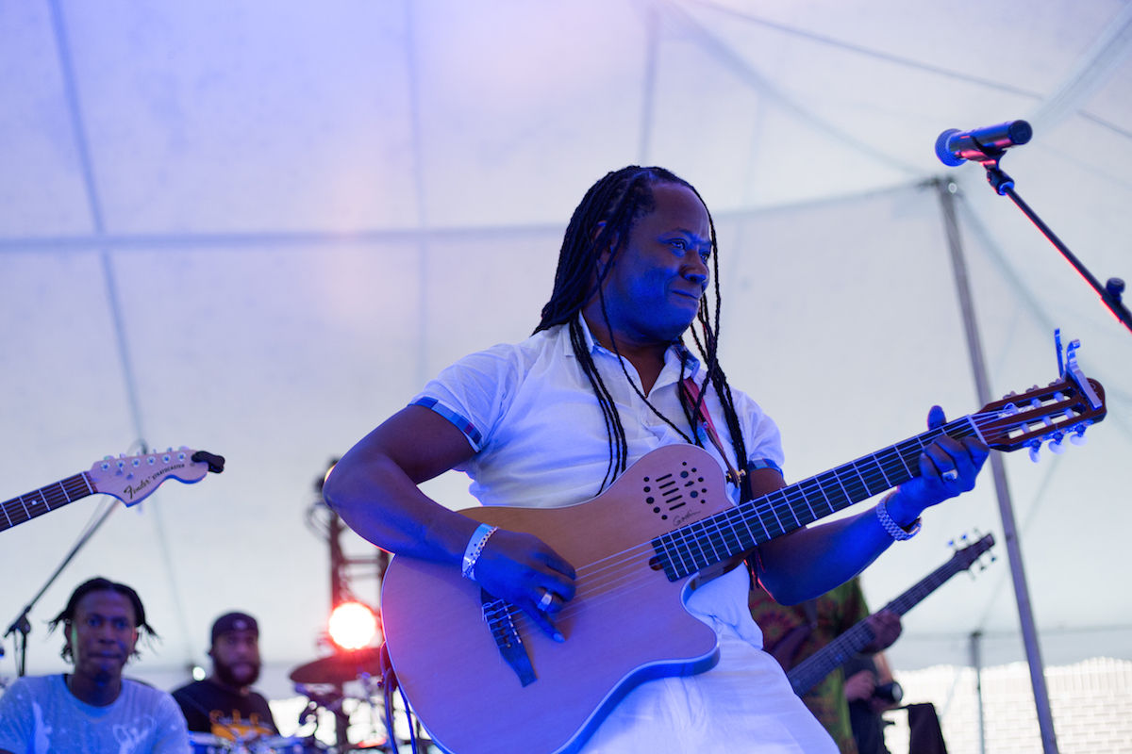Aurelio Martinez at Afro Latino Fest NYC. Photo: Ailyn Robles.
You were playing today with a band made up of Garifunas from the Garifuna community in The Bronx. Are you usually able to find such ensembles in other places where you play?
Yeah. I have a structure in place in Honduras, in Los Angeles, here in New York too. I don’t want to be Aurelio Martínez in front of a project, I want to start a movement of Garifuna music. I want to see Garifuna musicians travelling around the world, bringing our culture abroad, so our children are proud of their identity. Many are playing with me now, and that’s great, because they don’t only carry our music, but also our culture and our history. Today we are the passengers of this project, we are replacement soldiers. Right now maybe I am the captain of this ship, but we must have more sailors and more captains.
And how is that movement going?
Well, I never thought I would be playing in London in front of 40,000 people, I never thought I would see the English, who were the ones who subjected us, singing in our language. That fusion of cultures through art is beautiful. Sometimes we forget about the history of slavery and our enmity when there is music in between. I believe that the most subtle way of entering a human heart is through music, through art.
“I never thought I would be playing in London in front of 40,000 people.”
So what projects are coming up next for you?
Now I’m pushing the development of Garifuna pop. If you had caught my show a few months ago, you would have only seen two drums, maracas, and a clave. Now I added a drum set, so it has a bit more of “punch” and it sounds more pop so it can become more international. Anywhere in the world you can find a drum set, but a Garifuna drum is not so easy to come by. Also, people already connect with the drum set. So my idea is to add the Garifuna drums on top of that. I also want to add some brass now. I’m looking to go beyond the drums and grow so people can grow with us. That’s my project: start at the most traditional and keep going to the most complex of Garifuna music.
Have you been met with any opposition because of this departing from tradition?
Yes. Traditional people are used to traditional chords and to see Garifuna music more as dance than music, it’s more percussion than harmony. But I grew up in the border with Misquito music, the music of an indigenous culture with a lot of influence from the English culture. So their music is connected to gospel, which has a lot of harmonies. I had a Misquito teacher in elementary school, and she taught me how to sing harmonies, which was very different from Garifuna music, where everything is unison. So I began to harmonize, to change notes, to try to give Garifuna music a more international context. I have been bold, but I have always respected the bases of my culture. Some of the older people don’t want any of our rhythms to be harmonized, but I have done it, even if it was forbidden, and people have opened to it.
What do you mean it was forbidden?
For example, the dugu, the rhythm of the Garifuna maternal religion, is very solemn, only to be played in temples. But I know and respect the historical bases of our music… Before I go on stage I pay tribute to my ancestors. So I’m changing things, but I respect what came before me.
Has is it made finding Garifuna musicians willing to play with you difficult because of that?
I think that Garifuna musicians who have studied music beyond our tradition have realized that this is the way to go. So I tell Hondurans and everyone: “Today, the world needs music with an identity.” If you play guitar like the most famous guitar player in the world, what’s the point? You have to find your own style, find your own soul. This is what the Garifuna culture offers, it has its own soul, its own color. Simply put, we are music with identity.
Are there other Garifuna musicians touring and promoting this culture in the same way you are?
This is a still tender project. We used to be two, Andy Palacio and myself. Andy Palacio passed away [in 2008] and I was left alone with this responsibility. There are some young people working on this, so I hope they know their culture, so they can then show it to the world. We are always open to help others, to steer them in the right way to make the movement more robust. We believe in education and solidarity, the success of a project depends on that. We are merely guides.
tags: aurelio martinez, garifuna

