Breaking Gender Barriers
Isabel Kapuya was opportuned to participate in a programme called AIM (Accelerate, Incubate and Mentor) in May which ran in partnership with two other organisations called paNhari and Investor Saint. The AIM project seek to address the primary causes of limited access to opportunities for self-employment by giving the youths leadership skills training, mentoring and networking opportunities. A Youth Entrepreneurship Network Zone was conducted at Young Africa in partnership with paNhari and Investor Saint to select 15 young entrepreneurs for the AIM programme. A total of 175 young men and women participated and went through a tight selection process. Isabel Kapuya became one of the 15 successful participants. The selected youths underwent an intensive 5 week training program in the following areas: leadership development, 21st century non-cognitive soft skills development and entrepreneurship.
Currently Isabel completed the first phase of her vocational training and she is now on attachment for the second and last phase of her training. Her attachment began in July and is expected to end in December 2016 .Isabel’s dream of starting her own company is being inspired at Mr Exhaust Pvt Ltd the company where she is doing her attachment. She has already started her own informal company trading under the name ‘Belltrack Motors’ (see attached business card) where she do some suspension repairs, brakes, engine overhauls and services from home. Isabel is in dire need of capital injection to scale up her business and get a decent workshop to work from.
‘’I am so grateful to EC for the opportunity they gave me to acquire a hand skill, this is now opening up more opportunities for me, already I can see myself being a successful business woman employing other needy youths ’ ’said Isabel

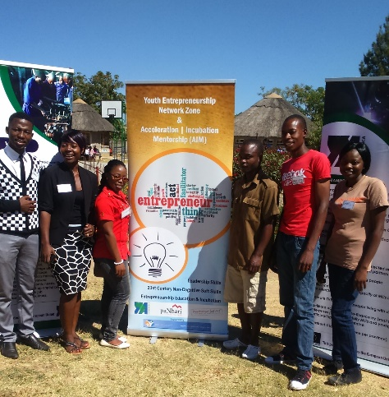
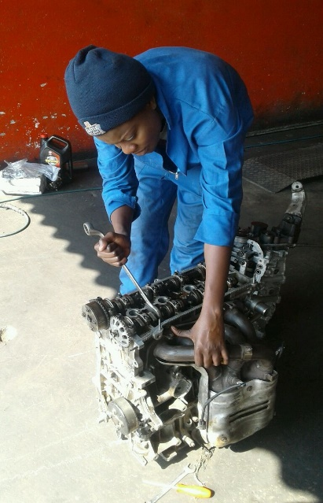
Isabel working on an engine at Mr Exhaust Pvt Ltd during her attachment.

Insert from left to right-YA 6 students under EC funding selected into the AIM project:Ernest Muvunzi (21yrs),Dudzai Paguti (29yrs),Diniwe Mazipatella (23yrs);Ignatius Makunura( 23yrs);Bruce Chidawanyika and Isabel Kapuya

