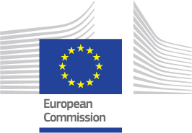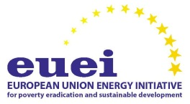
EUEI Advisory Group Meeting, October 2016
05.10.2016, 11:00-17:00
Venue: Berlaymont, room Robert Schuman
at Rond-point Schuman, Brussels
Agenda
Moderation: EUEI Secretariat / European Commission DG DEVCO
11:00 Welcome and Setting-the-Stage
Roberto RIDOLFI, Director- DG DEVCO
11:15 Update from SK Presidency
Alexei JONES
11:30 Presentation from upcoming MT Presidency
Clive GERADA and Robert PORTELLI
11:45 Presentation on COP22
Matthieu BALLU - DG CLIMA
12:00 Update on COP22 energy events organised by DG DEVCO & MS
Mary KOZHAYA - DG DEVCO & MS
12:30 AREI update, reporting from UNGA and way to COP22
Nicolas DASNOIS- France & Felice ZACCHEO, Acting Head of Unit- DG DEVCO
13:15 Networking Lunch Break
14:15 State of play of EU and MS' energy and climate relevant Initiatives
14:40 Update on SE4ALL since SE4All Advisory Board & secondment update
Claudia BOLDRINI- DG DEVCO
15:10 Update on Workshops recently organised:
    - Approach to track energy access - Thierry BERTOUILLE- DG DEVCO
    - Harmonising the Regulatory Frameworks in Africa
Angelika WASIELKE- EUEI Pdf
15:45 Follow up: EUEI presentations – Angelika WASIELKE- EUEI Pdf
    - EUEI PDF mapping – European Portfolio on Energy in international development cooperation
    - Short Report on EUEI PDF on-going activities (Cap4Dev; study; booklet etc.)
16:15 AOB & Upcoming EUEI meetings
16:30 Closing

