Sewing Machine Operator Course Report
The Sewing Machine Operator course by ActionAid and JustRozgar.com seems very popular among the habitants of Shaheen Bagh. With 60 people already trained in three batches from Feburary 10th 2016 to March 25th 2016, around 64 are currently undergoing training at the Rozgar Acadmey. While a lot of people were apprehensive about joining a course which was just 45 days long as the course is usually for 6 months- 1 year long, the level of satisfaction is reflected in the sources they provided to the training program. Out of the 15 students that were interviewed from the previous batches, 10 of them gave a score of 10 out of 10 to the training, other scores being 8 and 9.
Nazia (Mobilizer, Justrojgar) talks about how the mobilization process was carried out. A door to door survey was conducted. A canopy was set up and pamphlets were distributed to the passers-by. Contact numbers of individuals interested was noted down and a follow-up was done to persuade them. Another round of home visits was done in case of failure of the telephonic follow-up as people were not comfortable sharing their personal details. Bonding with the people is the first step in the process of trust formation, says Nazia.
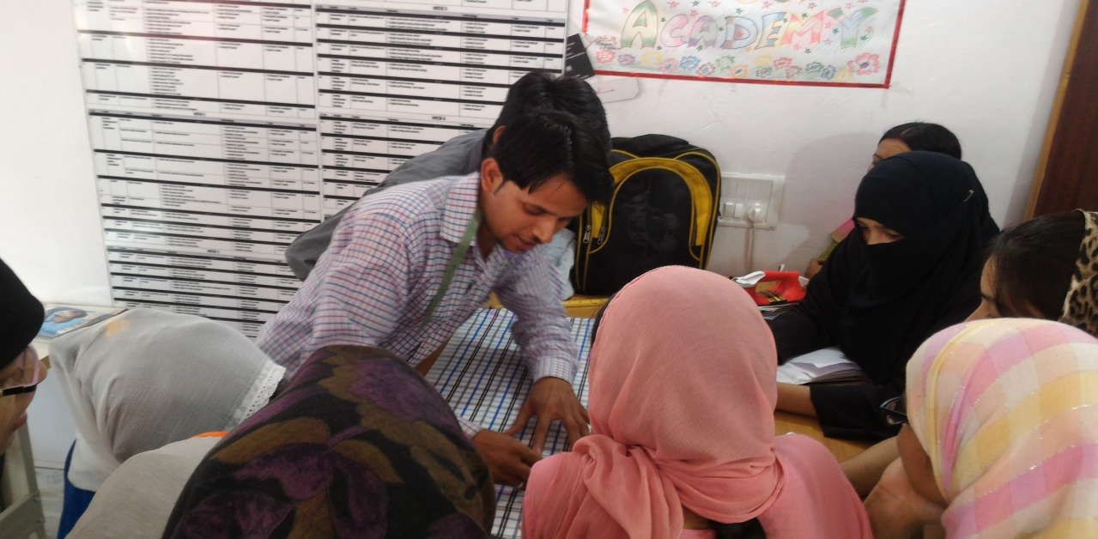
Trainer Kamal teaching the students the intricacies of shirt-making.
Centre Manager Shubham shares his experiences of initial field visit where the feedback he got was challenging. The Muslim community dominating this area doesn’t let it women go out of the house. The localities were unsure about the success of such an initiative as the community is seen as not supportive towards its women. Thus, he strategically chose a centre located on the main road so that the students don’t face any inconvenience. When the guardians of these women were not convinced much, Shubham invited them to the centre so that they can see for themselves and ensure safety. Further, he assured them that if the women were not willing to go for a formal employment, work from home can be an option they can opt for where they can do piece- work as per their comfort. He boasts that these very women later became the part of mobilization that was conducted for the next batch. This, he argues, turned as a source of inspiration for other women who too saw this movement away from their private space as not just their freedom but also liberation for their next generation women.

Feedback from students was also taken using an interview schedule. The students, both men and women, come from the age group 18-40 years. Looking at the educational qualification, we observe that while some of them are still enrolled in school, others are pursuing their bachelors’ degree simultaneously. A lot of them dropped out of school without completing higher secondary. Geographically, the students belonged to Delhi or had migrated from U.P and Bihar. The family size is usually large with one student reported having 8 brothers and a sister.

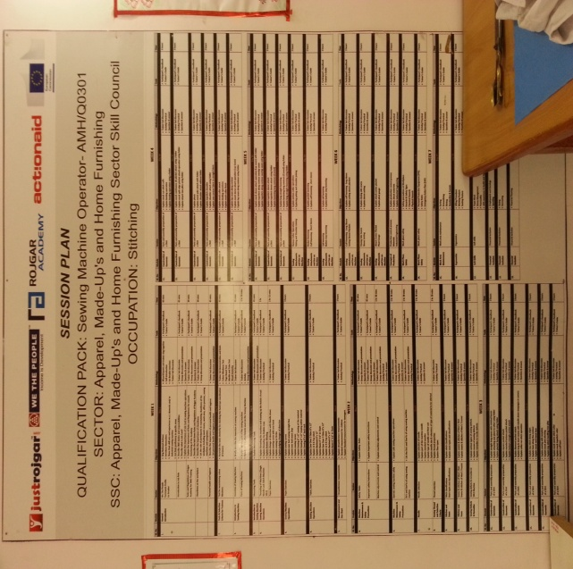

The session Plan being followed at the SMO course
When asked about what they did before joining the training, some of them were already earning a livelihood through tailoring! On being asked the reason for joining the training program as they already knew the skill, the students answered that they needed a government recognized certificate stating the same as only that could provide them with employment opportunities in the formal sector. This highlights the importance of certification of a skill. Today, there are so many skilled individuals looking for a job, but absence of such recognition comes as a challenge to them for getting the right opportunity. Thus, there is a need to introduce mechanisms which ensure that individuals possessing skills get due recognition through government institutions. This will ensure that these students do not have to undergo training for a skill they already excel in. Further, more needy students can be trained instead.

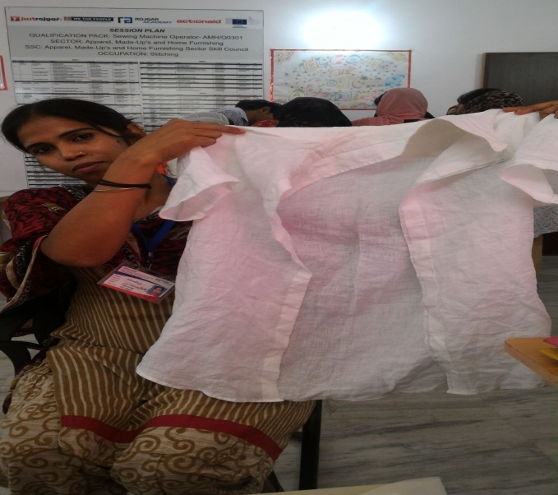
A shirt stitched by Mumtaz who joined the training for the certificate.
The students expressed satisfaction with the time slots of the training as they had three options to choose from. 9 AM to 12 Noon, 12 Noon to 3 PM and 3 PM to 6 PM were the available options. As per their convenience, housewives, students and mothers opted for their batch. The students also expressed satisfaction with the quality of traing provided. They were encouraged to ask questions if they had doubts and the response from the trainer was satisfactory. The size of the group was also satisfactory and individual attention was given to each student.
When asked about the possible changes in the program, students had various suggestions to offer. Increasing the time period of the training was demanded the most. The students wanted that the training program be increased from 45 days to at least 3 months so that they can learn more than the conventional attires. This request was also pointed out by the trainer Ali who believed that his ambitious students wanted to learn much more than was possible in 45 days. Shaheen suggested that the raw material could be sold at the centre itself so that the students don’t have to buy it from the market as it becomes difficult for married women like her to go to the market for the same. Also, when bought in bulk by the training providers, it would be cheaper as well! Power-cuts were another issue the students were facing. Shaheen Bagh not being a very developed area does not have power supply round the clock. Thus, students sometime had to go back home as the electronic machines were of no use without current. Given the already short training period, it thus becomes essential that adequate power back-up systems are in place.
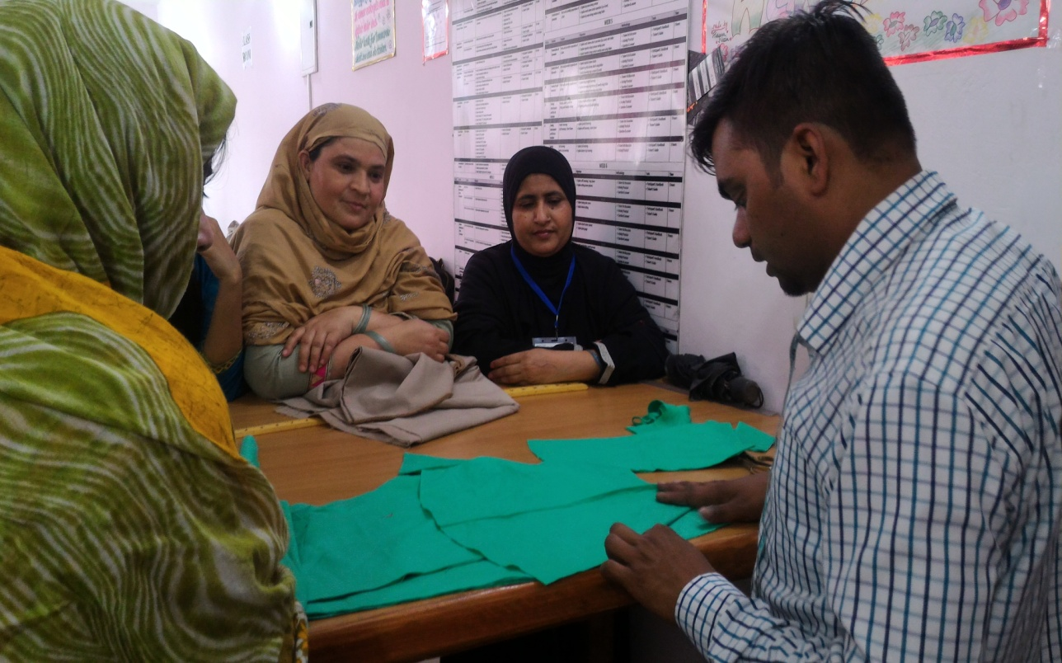
Trainer Ali with the students
Zareen suggested that an inter-lock machine would make things easier for them. Currently, they have to get it done from the market which not only takes a lot of their time but also requires monetary resources.
While Shabnam and Swabha wanted that more time should be spent on Ladies apparels, Saba opined that gents wear should be more perfect and required more focus. The former believed that women would be their prospective clients whereas, the later felt that men’s wear was a complicated process and thus required more efforts. When faced with such extreme opinions, trainer Kamal explains to his students that once they gain perfection at Man’s wear, chances of them getting jobs in the formal sector will increase multi-fold. Women apparel, being relatively simple, was easy to learn in a short time period.
When asked about how the training program will help the women in gaining livelihood opportunities, some said that they’ll start their own enterprise. Some wish to use the skills and work from home. As per the centre manager, 17 out of 60 students have already been placed successfully and the process is on for the rest of them. The added advantage being less effort has to be put in the mobilization process as the success stories are doing the needful. Now, the student’s approach the centre for admission enquires and other details. The team then visits such families and counsels them about the program.
Shubham also shared his experience about the government evaluation exam. For some, it was the first exam they were facing. Nervousness, thus, was obvious. He shared with them his own exam experiences and helped boost their confidence. He recalls how a woman had moist eyes before the assessment. When asked the reason for the same, her reply injected emotional vibes in the class. She explained how she used to send her daughter for school examination all these years. Today, her daughter woke her up and said, “Mumma today is your exam!” Truly, a moment that not only made her more confident, but instilled in her a sense of pride for she was one step away from empowerment and self-dependence.
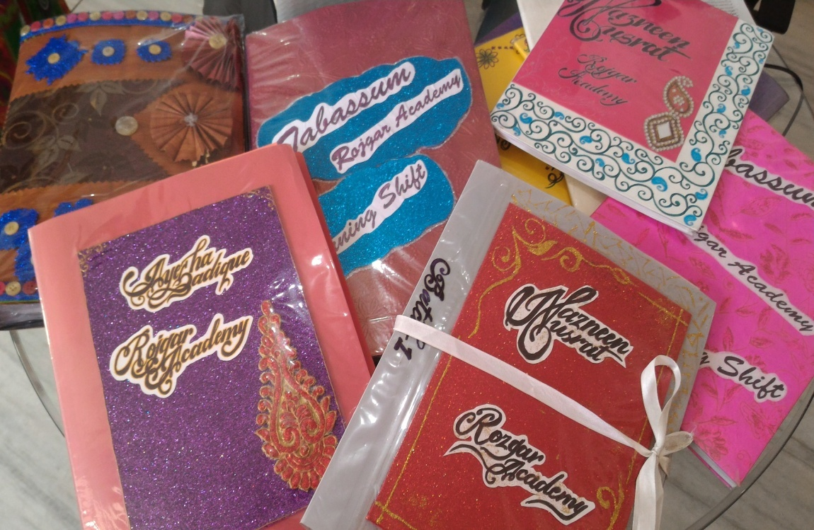
Practical files maintained by the students graded as a part of the evaluation
The other training programs students are interested in include:
- Computer course
- English Speaking classes
- Faishion Designing
- Cooking
- Embroidery
- Mehandi etc.
Those who suggested introducing a beautician course were informed about the training centre run by ActionAid in Shaheen Bagh itself.
Case Study: Firdaus and Rukshana are two sisters undergoing training at the Rozgar Academy. When in school, Firdaus assisted her father who was a tailor by profession. She had to drop out of school after class 10th due to untimely demise of her father in order to support her family. She took tailoring as a full-time job then to earn a living and to support Rukshan’s education. Her 20 year old sister completed her graduation from IGNOU and is now employed as a teacher in a local school while undergoing training simultaneously. The younger one is proud to now know basics of a skill her 33 year old sister excels at! To substantiate her statement, she also shows a picture of the gown stitched by her sister which she wore at a family wedding. She also suggests that a female trainer should be present at the centre so that women do not hesitate in asking doubts or clarifications and can learn better. Rukshana hopes to work with her sister who dreams of owning a boutique once she is an expert like her sibling.
One shortcoming of the course that was observed as a part of this process is the lack of uniformity in the lessons. That is, while some students start when the course begins, some join as late as a week or even more. This leads to different students being at different levels of the course. What was also observed was the lack of discipline in students as they turned up for class with students coming even an hour later than the allotted time. This minor things need to be worked on as they will drastically improve the standards of learning. Not only will there be uniformity in the lessons imparted, but also the efficient use of the limited time available.
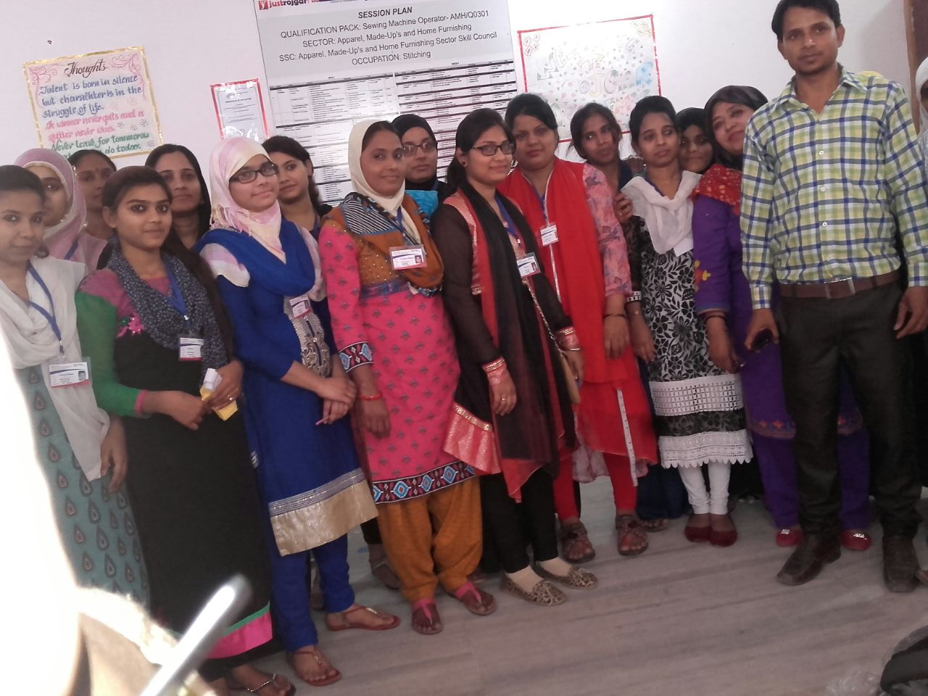
The students at Rozgar Academy with their trainer Mr Kamal.

