|  |  |
| --- | --- |
|  | EUROPEAN COMMISSION  Directorate General for International Cooperation and Development  Operational Information Systems |

Brussels, 25 October 2016

DEVCO.DGA2.05/TM/df   
devco.dga2.05(2016)6702273

REPORT on the OPSYS Delegations Workshop, 10-12 October 2016

**From 10th – 12th October, DG DEVCO , DG NEAR and FPI organised the first OPSYS Delegations workshop, initiating the productive work with pilot Delegations and key HQ stakeholders on the first track to concrete IT solutions and new ways of working in our external relations.**

**Summary:**

The three days OPSYS workshop marked the kick-off of the productive phase of business transformation and related IT solutions for EU external relations (DEVCO, NEAR and EEAS/FPI) in 2020 and beyond. This process, which is being rolled out between now and 2020, is fully driven by the business needs and particularly those coming from our Delegations, as they are at the forefront of aid delivery and policy implementation in the field. Eleven Delegations[1] across the globe are part of the Opsys Program User Committee (PUC) and therefore involved in the piloting phase and participated in the workshop.

Colleagues from Delegations, representing a variety of profiles from different levels (Heads of Cooperation, Heads of Section, Operational and Finance/ Contract Managers) got a first taste of how the new operational system will facilitate and improve their work in the future and brainstormed on more opportunities for increasing impact and transparency across the whole chain of the operations cycle. This first contact with new opportunities created a big momentum and motivation to move ahead with the new system and to make the necessary changes in order to contribute to better ways of doing business at EU external relations in the 21st century.

The workshop was opened by Klaus Rudischhauser, Deputy Director General in DEVCO, and Mark Johnston, Director NEAR R, both highlighting the relevance of the program in terms of bringing EU external relations up high standards in terms of transparency and effectiveness and therefore showing the impact of what we do, as well as looking beyond the IT solutions into new way of working.

OPSYS is a very large program. It was therefore sliced into 6 phases / projects and horizontal project:

* Project 1 : results management and operational entities
* Project 2: operational backbone:
  + Project 2A: Action and level 1 commitment
  + Project 2B: Contract and level 2 commitment
* Project 3: implementation and evaluation
* Project 4: programming process and preparation of actions
* Project 5: tendering

The workshop was focusing on project 1"Results management and operational entities".

Seven Delegations volunteered for the first pilot phase linked to Opsys project 1 with two identified tracks:

* Reviewing the quality of the log-frames of their Project portfolio (11.2016 – 03.2017) and input into the OPSYS system
* Working on a limited number of highly visible breakthrough projects : testing new/ better ways of working on selected projects therefore creating evidence for the further system design and business solutions under OPSYS  (11.2016 – 08.2017)

1. **What is OPSYS and who will use OPSYS?**

OPSYS is a large scale business transformation and IT program aiming at a substantive increase of impact and visibility in our external relations targeting five objectives

* Increase productivity to meet rising expectation on delivery with a shrinking amount of staffs
* Improve transparency of EU aid (Aid Transparency Ranking, EU currently at position fifteen)
* Improve knowledge sharing within the organisation and with other partners
* Improve collaboration within the organisation and with other partners
* Raise effectiveness through strategic result focus and informed decision making

More information can be found on the intranet page of unit DEVCO 05 (<https://myintracomm.ec.europa.eu/dg/devco/resources-procedures/opsys/Pages/index.aspx> ).

OPSYS will be used both in the field and in HQ and will also be open to external partners. An indicative list of future OPSYS users is as follows:

* **The Senior management** (Director general, Depute DG, Geographical director, thematic Director etc.) – to have an helicopter view of results, budgets and disbursements.
* **The middle management staff** (Heads of Units, Heads of Delegations, Heads of Cooperation and their deputee) – to supervise and pilot their units/sections/delegations…)
* **The Operational managers** and related staff (secretaries, assistants etc.) – main users, feeding information on OPSYS daily to manage programmes and projects and monitor the results.
* **The finance & contract staff** (Financial initiating and verifying agents)- to ensure financial follow-up, payments, to follow the procurement planning, etc.
* **The relevant thematic staff** – to provide guidance and support to the field and ensure quality control, including the political section and information and communication teams
* **Staff working on methodology (Budget Support, Results) and cross-cutting functions and issues such as Knowledge Management, Evaluation, aid effectiveness etc… - to ensure appropriate systems and processes for adequate and state of the art business quality**
* **The external staff** including contractors, partners, beneficiary institutions, other donors, member states, external experts, auditors, etc.

1. **Objectives of the workshop**

* Update participants about the OPSYS VISION 2020 « My Workplace » and « Result management » (project 1 scheduled to be rolled out in 2017) and collect their feedback to draw user driven solutions and necessary changes, including larger scope of business process improvement
* agree on a way forward for preparing and launching the first pilot for Project 1 - Results management, which focuses on having online quality logframes

1. **Agenda**

**Day 1** - **Brainstorming** **on Vision 2020 from the perspective of a Program Manager in a Delegation**: what would he/she need as information to be fully effective and productive; and how should results be managed in the future?

**Day 2** - **Reflecting on current and planned methods and processes of developing and monitoring results**:

* Presentations from DEVCO 06/NEAR/ FPI and from Delegations, lessons learnt from DFID
* Consolidation of key issues/drivers and identification of quick wins with OPSYS Program User Committee

**Day 3** - **Reflection on way forward with Delegations**:

* Identification of potential breakthrough pilot-projects for real case test on business transformation
* First brainstorming on options for improving contract management in OPSYS (the next project in the OPSYS pipeline)

1. **Key issues/drivers and quick wins**

* **Lack of relevance of/accountability for results**

**=> Business response options**:

* + introduce monitoring as a standard, decision making linked to results (e.g. bad results = project closure)
  + training of people in PCM has to become a key requirement
  + Upfront exchange and co-drafting at project identification/ formulation stage with thematic/ geographic and 06 colleagues

**=>** **IT response options:**

* + The use of a standardised set of indicators and the possibility to generate results based reports will facilitate these tasks
  + Define a common methodology and terminology
* **Hierarchy of objectives/ results; relations between and higher policy objectives not always clear, lack of visibility for strategic objectives from DG**

**=> Business response options**

* + NEAR/ FPI are setting example of linking results to organisational strategy (not only to SDGs for example) and to develop an objective tree. Clear guidance should be provided on context for result setting  
    => IT response
  + System needs to provide possibility to link projects to DG, country/ regional or sector indicators and objectives
* **Increasing need for comprehensive responses to complex challenges (e.g. migration is cross-sectorial or linking political, security and developmental dimensions)**

**=> Business response options**

* + Establish task force approach within Delegations and with headquarters to develop adequate responses

**=> IT response options**

* + Ad hoc user group, online workspace with interactive templates and chat facilities
* **Necessity to reduce workload related to briefings, update on projects and general follow up**

**=> IT response options**

* + Single entry system for providing and retrieving operational info
  + Progress monitoring by milestones, inputs including reminders and procurement plans, automated correspondence for reminding submission of reports
* **Ensure better capitalisation and knowledge sharing (learning from experience)**

**=> Business response options**

* + Establish regular/ annual monitoring
  + Encourage support through Third party monitoring in delegations
  + Encourage colleagues from other Delegations participate in monitoring missions
  + Additional incentives/ systems to share lessons learnt (peer-to peer coaching, internal benchmarking..)

**=> IT response options**

* + Ensure full access to information
  + Comprehensive database of operations which helps to identify quickly best practices
  + Capability to extract reports (by country sector…) from the system
* **Better access to good quality expertise**

**=> Business response options**

* + Review options on procurement processes: expert facility
  + Use in-house expertise better
  + Learn from Nutrition advisory services

**=> IT response options**

* + Experts pool (internal, external), experience tracking

*Additional comments and ideas expressed during the plenaries are in annex 2*

1. **Next actions with Delegations**

Work on two interlinked tracks for refining /identifying business/IT solutions:

* Immediate IT/Business requirements
  + preparation for pilot: review of log-frames => November 2016 – March 2017
  + training for pilot in Delegations: February 2017
  + running of Pilot: May – August 2017
  + roll out full: September 2017
* Breakthrough projects
  + Prioritisation of projects and formulation of action plans with Delegation/ HQ task forces October/ November 2016 (video-conferences with Delegations)
  + Submission of breakthrough projects and action plans to Program Steering Committee and kick off in Delegations/ HQ
  + first phase of 7-9 projects: November 2016 – August 2017
  + Feeding of key change tracks (business, regulation, IT) into the system – August/ September, part of roll out?
* Getting OPSYS Capacity4 DEV started: everybody connected and user-friendly interface for joint work on pilots and breakthrough projects etc./ October 2017
* Interaction with HoCs, HoDs, HoFC on OPSYS fist lessons and their requirements: during DEVCO days in March 2017
* Giving access to all workshop presentations and materials, as well as sharing agreed documents (comparison between operational entities terminologies)

Contact: Daria Fane, Telephone: +32 229-6139267127, daria.fane@ec.europa.eu

Enclosures:

* Annex 1: Breakthrough projects methodology and first proposals
* Annex 2: governance at a glance
* Annex 3; Feedback from participants
* Annex 4: List of participants

**Annex 1**

**Breakthrough projects methodology and first proposals**



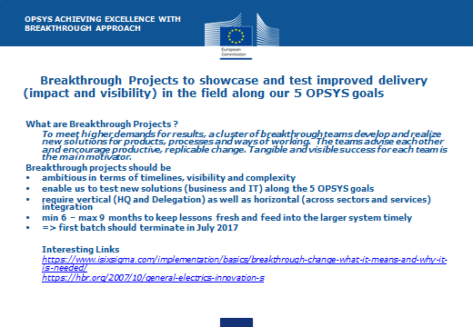

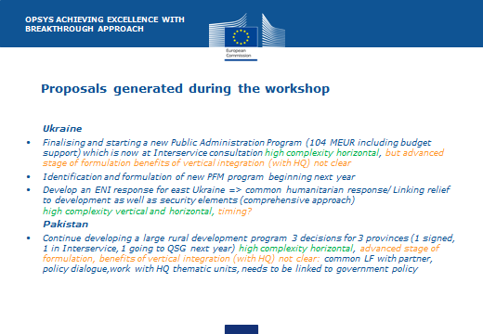

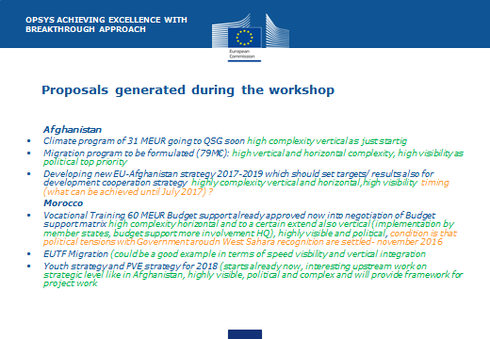



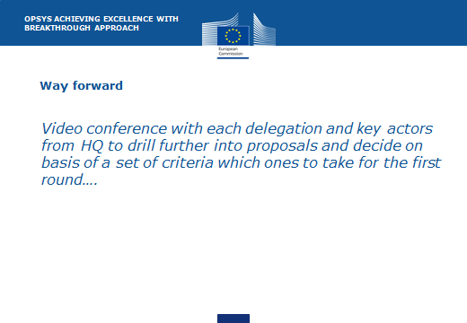

**Annex 2**

**Governance at a glance**



**Annex 3**

**Feedback from participants**

|  |  |  |
| --- | --- | --- |
| **Positive feedback** | **Risks/worries** | **Recommendations/suggestions** |
| Increased **Transparency**   * communication toward external world * direct access to the system * improve image * Internal communication | **Issues on reporting requirements**  How far can we go with results reporting methodology for political issues (ref to the chapter on Ethiopia in the 2015 report)  and/ or what is the level of accuracy/ pertinence test we put in place on choice/ assessment of political indicators to avoid fatal contractions between political assessments and development assessments  How to consider indicators for international requirements (eg climate change) which are not part of the EU RF | Focus on **low hanging fruits**   * search function in CRIS * chat room, collaborative work * DFID: logframe signed at director level, annual monitoring obligatory and informs decision making, participation in monitoring missions in other Delegations part of staff performance assessment * Time for making reporting on results a legal obligation for external partners |
| Increased **collaboration**   * within Delegation (access to Political officer, communications officer etc.) * with sister DUE “Hub” * with partners, MS | **Collaboration** bottlenecks   * no printouts (HoC to use the system) * Unreliable internet access | **Top management support**   * Involve senior management * HoC to promote Opsys * Develop Results orientated culture |
| Improved **Internal & external communication**   * between functions (Ops/F&C) * between DUE (similar programmes) * towards the outside | **Internal communication**   * doubts about buy in from top level * rumours about what OPSYS is * Catalyst for FPI to speak the same language in the different units on results management | **Communication** needs & actions  1) MESSAGES   * OPSYS is not only finance stuff * But FC also involved * More than a replacement of CRIS   2) ACTIONS & SUGGESTIONS   * Intranet to be clarified * Simple message * Show **Quick wins** (attractive) * Name (op system? Or central tool) * A simple presentation for DUE * Posters are powerful * Convince top level (bilaterals) |
| **Positive feedback** | **Risks/worries** | **Recommendations/suggestions** |
| **OPSYS features/interface**   * Single point of entry * User friendly & intuitive, broad vision, ambitious, progressive * Streamlined methods accross DUE * Use of modern & mobile tools (internet, chat, online collaboration) * Strong interest in use with mobile phone * No need for re-encoding (e.g. ARES) | **OPSYS features/ interface risks**   * IT resistant people * Difficult access to internet in some Delegations * Regional delegations: more difficult to track the performance (eg payment delays) * Security for tablet/ mobile * Access management: user profiles and rights * Define of how far we go with EUMS (scope of their encoding) * What is covered for indirect management | **OPSYS features/interface**   * Get architecture right before development * Keep it simple and flexible * Introduce less bureaucracy * Ease access to guidelines, templates * compatibility of data & interfaces * need to keep possibility to make paper bids for e-tendering * Need for multilingual system * Receiving important emails through OPSYS screen * Reports generation * For projects option to register incidents and risk mitigation * Suggest messages for communication purpose * Keep track – log of activities * Access for notifications coming from other systems (e.g. PROSPECT) * Task management for policy dialogue * Work with government counterpart: budget support needs encoding also from their end * Integration with EAMR (their KPIs) * Visualisation DDL for contracts (D+1etc) * Importance of having risk management and procurement planning (see experience of MIS) |
| **Development process**   * participatory * fast moving | **Development process**   * Extra work during the pilot * extra effort to get LF right | **Development Process**   * add progress indicators * Pilot is critical * Involve people from HQ (to ensure simplification) |
| **Content**   * An operational tool (was missing) * Handover easier * information accessible and structured * History & memory of pgm/projects | **Content & migration**   * Risks linked to data transfer * Resistance to abandon existing tool * Extra pressure in case of red indicator | **Content suggestion**   * need realistic & pragmatic indicators * systematic baseline * ensure alignment with procedures & simplification * strong interest in templates |

|  |  |  |
| --- | --- | --- |
| **Positive feedback** | **Risks/worries** | **Recommendations/suggestions** |
| **General questions/ support** | **General questions/ support**   * Opsys will address the issue of current ceiling of 750 k€ for project reporting in EAMR/results management | **General questions/ support**  What is planned as support cf existing USM, deputy USM: we will need focal points in each EU del, and not only for IT aspects |

**Annex 4**

**List of Participants**

|  |  |  |  |  |
| --- | --- | --- | --- | --- |
|  | **Surname** | **Name** | **Position** | **Delegation / Unit** |
| 1 | Vera Lucia | Salomon | FCA | Brazil |
| 2 | Pedro-Xavier | De Miguel Jessel | FCA | Malawi |
| 3 | Berend | de Groot | Ops HoC | Ukraine |
| 4 | Victoria | Brich | Ops Assistant HoC | Ukraine |
| 5 | Dris | Rachik | FCA | Afghanistan |
| 6 | Cecilia | Costa | Ops manager | Afghanistan |
| 7 | Tiruwork | Moges | Ops, asst HoC | Ethiopia |
| 8 | Fasil Genanaw | Tadesse | FCA | Ethiopia |
| 9 | Georges | Dehoux | Ops manager | Pakistan |
| 10 | Denis | Zanotti | FCA HoS | Peru |
| 11 | Philippe | Mikos | Ops HoC | Morocco |
| 12 | Lukas | Melka | FCA | Morocco |
| 13 | Maxime | Montagner | Ops manager | Turkey |
| 14 | Tsvetana | Stoycheva | Ops manager | Turkey |
| 15 | Mikolaj | Bekasiak | Ops manager | Georgia |
| 16 | Aida | Hajrulahovic | Ops asst HoC | Bosnia Herzegovina |
| 17 | Jelena | Gajevic-Perisic | FCA | Bosnia Herzegovina |
| 18 | Elmir | Babovic | FCA (MIS) | Bosnia Herzegovina |
| 19 | Thierry | Fournier | Results management expert | FPI/1 |
| 20 | Andrea | Alfieri | Results management process owner | DEVCO/06 |
| 21 | Odoardo | Como | Operational entities expert | NEAR A3 |
| 22 | Judith or  José Manuel or  Alya | Novak  Pesado Llobat  Gharbi | Opsys NEAR focal point | NEAR/R2 |
| 23 | Simon | Vanden Broeke | Budget support expert | DEVCO/A4 |
| 24 | Frederic | Duvivier | DWH team | DEVCO/R1 |
| 25 | Catherine | Pravin | Deputy HoU | DEVCO/04 |

**Facilitators/Speakers (F) / Observers (O)**

|  |  |
| --- | --- |
| **name** | **Position** |
| Klaus Rudischhauser | DDG |
| Mark Johnston | NEAR R |
| Thierry Mathisse | DEVCO 05 |
| Denis Thieulin | DEVCO 05 |
| Paul Riembault | DEVCO 05 |
| Daria Fane | DEVCO 05 |
| Kay Buring | DEVCO 05 |
| Lucile Petitpierre | DEVCO 05 |
| Giuliano Rosciglione | DEVCO 05 |
| David Romeo | DEVCO R6 |
| Carmelo Infosino | DEVCO R6 |
| Samuel Cansse | DEVCO R6 |
| Roberto Borselli | DEVCO R6 |
| Andrea Alfieri | DEVCO 06 |
| Mehdi El Fadil | DEVCO 06 |
| Thierry Fournier | FPI |
| Georges Dehoux | Del. Pakistan |
| Jelena Gajevic-Perisic | Del Bosnia-H |
| Elmir Babovic | Del Bosnia-H |
| Catherine Peyralbe | Gartner |
| Gaspard Metzger | Gartner |
| Edwin Maaskant | Gartner |
| Ingrid Beauve | Particip |
| Ines Ramos | Particip |
| Nayra Bello O'Shanahan | Particip |
| Veronika Ann Vann | Particip |
| Maria Navarro | Particip |
| Yann Tegin | Coraxone |

1. Afghanistan, Bosnia-Herzegovina, Brasil, Ethiopia, Georgia, Malawi, Morocco, Pakistan, Peru, Turkey, Ukraine