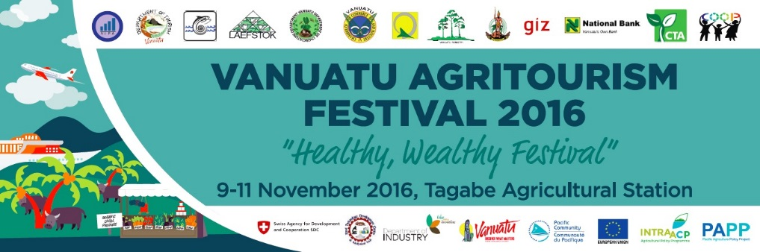`

VANAUTU AGRITOURISM FESTIVAL 2016  
*“Healthy Wealthy Festival”*  
09-11 November   
@ Tagabe Agriculture Complex

|  |  |  |  |  |
| --- | --- | --- | --- | --- |
| **Time Period** | **Wednesday 09November 2016.**  **Main Stage** | **Forestry Conference Room** | **DARD Classroom** | **Field Trips** |
| **0800 -0845** | **Public assemble at the complex and the arrival of the invited guests. Music entertainment by Zadock.** |  |  |  |
| **0845-0850**  **0850-0900**  **0900-0915**  **09:15-0945**  **0945-0955**  **0955-1015** | **Official Opening**  **Welcome by Chairman**  **Opening Prayer**  **Agritourism in Vanuatu – DG Howard**  **Farmer capacity Building-SPC**  **Official Opening Speech – Hon. DPM**  **Official Visit by delegation to stalls, followed by refreshments**  **Cultural dance from SWB Malekula** |  |  |  |
| **1000-1030** | **Donor and Agritoursm – TVET program** | **Agri-Business Principles- Workshop by Toko Mara** | **Linking Energy resources to Tourism (Energy Dept)** |  |
| **1030-1130** | **Display cooking of local produces – Chef Association** |  |  |  |
| **1130-1200** | **Learning from success stories;**   * **Adela Aru** * **Jean Batiste Carlo** | **Strategic decision making by Agriculture Department** |  |  |
| **1200-1230** | **Display of Housekeeping by Tourism School** |  |  |  |
| **1230-1330** | **Lunch break and Zadock entertainment** | **Registration of site visits for day 2 & 3** |  |  |
| **1330-1400** | **Census and statistics – Statistic dept** |  |  |  |
| **1400-1430** | **Display cooking of local produces – Chef Association** |  |  |  |
| **1430-1500** | **Professional catering presentation**   * **David Holiday & Junior Chef** | **Agritourism and rural Cooperatives by department of ORCBD** | **Food Safety – Food Tech** |  |
| **1500-1530** | **NCD/Healthy Diet– Health Department** |  |  |  |
| **1530-1600** | **Business Finance - NBV** | **Department of Industry** |  |  |
| **1600-1700**  **1700-1800**  **1800-1900**  **1900-2000**  **1800-2000** | **Malnaruru String Band**  **TuJah**  **Fire Dance by Wan Small Bag**  **Metoxide & the riddim box**  **Cocktail Function for invited guests** |  |  |  |
| **Time Period** | **Thursday 10November 2016.**  **Main Stage** | **Forestry Conference Room** | **DARD Classroom** | **Field Trips** |
| **0800-0830** | **Public assemble while Zadock entertain** |  |  |  |
| **0830-0900** | **Wan Smol Bag Theatre play on Agriculture, Tourism, Health and Environment** |  |  |  |
| **Quizzes 1 and 2** |
| **0900-1000** | **Seminar: National branding on agri-foods and packaging** | **Tourism in Vanuatu by VTO and Tourism Department** | **Improving livestock market by Livestock department** | **Visit to Tagabe nursery, Fisheries aquaculture site** |
| **Quizzes 3 and 4** |
| **1000-1030** | **Livestock shows and demonstration** | **MALFFB Policy Bank - Outreach** |  | **Visit to Sino-Van factory site** |
| **Quizzes 5 and 6** |
|  |
| **1030-1130** | **Display cooking of local produces – Chef Association** |  |  |  |
| **1130-1230** | **Radio live interview with participants** |  |  |  |
| **Quizzes 7 and 8** |
| **1230-1330** | **Lunch Break. Pentecost custom dance and Zadock entertain** |  |  |  |
| **1330-1400** | **Livestock Competition** | **Culture and Tourism by VanIPO** | **Commercial Forestry for Agritourism by Forestry Dept** |  |
| **Fumigation and certification process- Bio-Security** |
| **Quizzes 9 and 10** |
|  |
| **1400-1500** | **Display cooking of local produces – Chef Association** |  |  | **Field trip**   * **Tagabe nursery/aquaculture** * **ACTIV & Jimmy Nipo Foodie Tour** |
| **Quizzes 11 and 12** |
| **1500-1630** | **Quizzes 13, 14, 15 and 16** |  |  |  |
| **1630-1730**  **1730-1830**  **1830-2000** | **Confliction**  **Krasrut Star**  **Stan and Earth Force** |  |  |  |
| **Time Period** | **Friday 11November 2016.**  **Main Stage** | **Forestry Conference Room** | **DARD Classroom** | **Field Trips** |
| **0830-0900** | **Public assemble while Zadock entertain** |  |  |  |
| **0900-1000** | **Vanuatu Climate Change** | **Showcase of Local rice and Tourism Opportunities** |  | **Visit to Tagabe nursery, Fisheries aquaculture site (Half Day)** |
| **1000-1030** | **Agriculture Competition** |  |  | **Visit to summit Estate** |
| **1030-1130** | **Display cooking of local produces – Chef Association** | **Creativity for tourism by Fisheries** |  |  |
| **1130-1200** | **Forestry Quiz** |  |  |  |
| **1200-1330** | **Lunch break - Entertainment** |  |  |  |
| **1330-1400** | **Display of Housekeeping by Tourism School** |  |  |  |
| **1400-1430** | **Market opportunities to cruise boats-John Toner** |  |  |  |
| **1430-1500** | **Livestock shows and demonstration** | **Considering bio-security for Agritourism – Bio Security dept** | **Agritourism and Finance - BSP** |  |
| **1500-1530** | **Learning from success stories – Alfred Kalontas** |  |  |  |
| **1530-1600** | **Learning from success stories – Jack Loughman** |  |  |  |
| **1600-1630** | **Agriculture display** |  |  |  |
| **1630-1700** | **Feedback from stall owners** |  |  |  |
| **1700-1715**  **1715-1730**  **1730-1735** | **Official Closing**  **Acknowledgement Speech – DG Trade**  **Closing by Minister of Agriculture, Livestock Forestry, Fisheries an Bio-security.**  **Closing Prayer** |  |  |  |
| **1735-1835** | **Small House & KIR** |  |  |  |