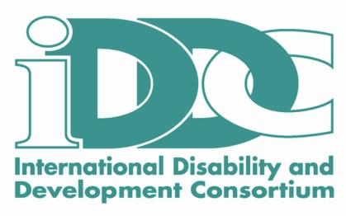

European Disability and Development Week (EDDW)
Together for Inclusion / #EDDW16

The first week of December, IDDC and its partners are organising a week of activities dedicated to disability and international cooperation.

European Disability and Development Week (EDDW) will begin on 3rd of December, the International Day of Persons with Disabilities, and will conclude on 10th of December, Human Rights Day. Framed by these key days in our calendar, activities of various kinds will be organised by IDDC members and partners across Europe.

During #EDDW16 we want to celebrate the 10th anniversary of the UN Convention on the Rights of Persons with Disabilities (UN CRPD) by showcasing positive stories on what has been achieved and to consider how ‘Leave no one behind’ includes people with disabilities in the Sustainable Development Goals (SDGs).

Information on specific activities, events and communication campaigns will be released in the coming month, and will be available on the IDDC website and the IDDC Facebook page.

For more information on the European Disability and Development Week, please contact Ariane Lignier (Ariane.lignier@cbm.org)

Save the date and help us to make Together for Inclusion #EDDW16 a success.

