**Results-based Decision Making IN DEVELOPMENT CO-OPERATION**

***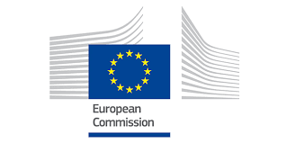*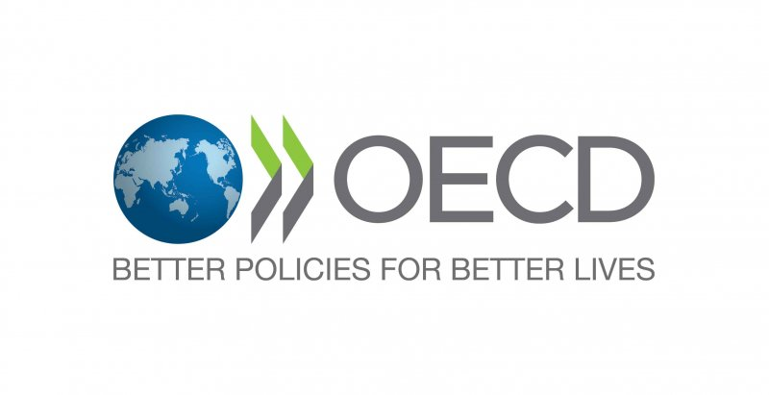**

**Mutual Accountability through Results:**

**Supporting partner countries’ development goals and results frameworks**

***Workshop, co-hosted by the EU and the OECD***

***February 9-10 2017***

***EU Thon Hotel, Brussels***

***Outline, 26 January 2017***

**Purpose**

The results of development co-operation should be found *in* developing countries.[1] Ultimately, we’re all in it for impact on the ground, through country-focused or global programmes. The workshop aims to assess how providers’ and partners’ development goals and results interact and support the results frameworks of developing countries. The storyline should be: 1) the goals and results frameworks of providers and partners are interlinked; 2) providers and partners are mutually accountable through the results achieved; 3) the SDGs offer a common reference-point for goals and results; and 4) country results frameworks are built mainly through their use. Hence, the workshop addresses four themes:

* *Country focus:* how can the *results frameworks of providers and country partners* best be linked, under the leadership of partners?
* *Mutual accountability:* what roles do development results play for accountability, communication, direction and learning of *partners, providers and other stakeholders?*
* *Common goals and results:* how can we assess development co-operation’s contributions to development results, notably within the 2030 Agenda for Sustainable Development?
* *Capacity-building for better results frameworks:* how can partner countries improve their results frameworks, and what tools are effective in capacity-building?

A results framework comprises the tools and information needed to assess whether goals are achieved through demonstrable change. Results cover the outcomes and impacts of policies, programmes or projects, whether or not the results were intentional. Within development co-operation, results frameworks cover goals at three primary levels: 1) Sustainable development and poverty eradication; 2) Development change as affected by development co-operation; and 3) Improvements in the operational and organisational performance of providers and partners in support of development results. The workshop links the results frameworks of development co-operation with the results frameworks of partner countries.[2]

**The workshop**

The OECD has co-hosted a series of workshops for providers of development co-operation to strengthen management for development results, results frameworks and the use of results information. Two recent workshops addressed the possible links between the sustainable development goals (SDGs) and the results of development co-operation (February 2016) and the use of results information for accountability, communication, direction and learning (September 2016). The Brussels workshop in February 2017 engages with developing country partners for results-based management. The expected 90 participants will address the four themes through half day sessions over the two-day workshop. Background information includes:

* OECD-DCD: ‘’Development co-operation results under the 2030 Agenda: Challenges and opportunities in results monitoring’’, January 2017.
* OECD-DCD: “Linking and aligning the results frameworks of providers and country partners. Evidence from the 2016 monitoring round of the Global Partnership for Effective Development Co-operation,” January 2017.
* The UN Development Co-operation Forum (DCF): [*National Mutual Accountability and Transparency in Development Cooperation. Study on the findings of the Fourth DCF Survey*](https://www.un.org/ecosoc/sites/www.un.org.ecosoc/files/files/en/dcf/dcf-accountability-study-v4.pdf)*.* UN-DESA, November 2016.
* OECD/UNDP: [*Global Partnership for Effective Development Co-operation (GPEDC):* *Making Development Co-operation More Effective*](http://www.undp.org/content/undp/en/home/librarypage/development-impact/making-development-co-operation-more-effective--2016-progress-re.html). 2016 Progress Report, Paris, especially two indicators: 1) Use of country-owned results frameworks; and 7) Mutual accountability.
* EU International Cooperation and Development: [*Results Report*](https://ec.europa.eu/europeaid/eu-international-cooperation-and-development-first-report-selected-results-july-2013-june-2014_en), 2016.
* Development Gateway: [*Results Data Initiative*](http://www.developmentgateway.org/expertise/results/)*,* lessons from Ghana, Sri Lanka, and Tanzania.

**Draft AGENDA**

***Thursday 9th of February 2017***

**09.00-09.30: *Welcome breakfast and registration***

**09.30-10.00: *Welcome***

* Deputy Director General Marjeta Jager, DG International Cooperation and Development, the EU
* Director Jorge Moreira da Silva, Development Co-operation Directorate, OECD
* *Introduction to workshop objectives and format*: Poul Engberg-Pedersen, DCD, OECD

***Session 1: Country focus – Linking and aligning the results frameworks of providers and country partners***

**10:00-13.00: *How can country results frameworks contribute to achievement of development results?***

* + *Who uses results frameworks at country level and for what are they used?*
  + *How can providers align to country results frameworks for shared results?*
  + *How is country ownership of results frameworks achieved?*
* **Chair:** Pradeep Itty (Swiss Agency for Development Co-operation). **Panellists:** Seglaro Abel Somé (Burkina Faso Ministry of Economy, Finance and Development), Dickson Chunga, (Office of the President and Cabinet, Malawi), Paula Nolan (Ireland Department of Foreign Affairs), John Egan / Alejandro Guerrero (OECD)
* Group discussions and feedback to plenary
* Conclusions on ways forward for linking and aligning the results frameworks of providers and partners

***13.00-14.30: Lunch break – buffet***

***Session 2: Mutual accountability through development results at country level***

**14.30-16.15:*****Partner country perspectives***

* + *Why is mutual accountability through results at country level important?*
  + *What does mutual accountability through results look like in practice for partner countries?*
  + *What role do country results frameworks play in mutual accountability through results?*
* **Chair:** Nicoletta Merla (European Union). **Panellists:** Angela Bester (consultant on the 4th UNDCF survey), NEPAD (tbc), Timor Leste Ministry of Finance (tbc), Joshua Powell (Development Gateway)
* Group discussions and feedback to plenary
* Conclusions on mutual accountability through results from a partner perspective

***16.15-18:00: Provider perspectives***

* + *What tools are available for building mutual accountability through results at country level?*
  + *How can a balance between partner and provider accountability be achieved?*
  + *What are the benefits of mutual accountability for all stakeholders?*
* **Chair:**René Taus-Hansen, Denmark Ministry of Foreign Affairs. **Panellists:**UNDP (tbc), Myriam Van Parijs (Belgian Development Agency), Sarah Holzapfel (German Development Institute), Joëlline Benefice (OECD)
* Group discussions and feedback to plenary
* Conclusions on mutual accountability through results from a partner perspective

**18:00-20.00: *Drinks reception at the workshop venue***

***Friday 10th of February 2017***

**08.30-09.00: *Breakfast***

***Session 3: Common goals and results – Development co-operation’s contributions to the 2030 Agenda***

**09.00-11.00: *Monitoring the SDGs as development results – The application of SDGs, targets and indicators***

* + *What is the link between the 2030 goals and targets and development results?*
  + *How are partner countries applying SDGs, targets and indicators to their national frameworks?*
  + *How can the SDGs support greater commonality in goals and intended results?*
* **Chair:** Poul Engberg-Pedersen (OECD). **Panellists:** Amèvi Akpoto Komlagan (Government of Togo), Anthony Higney (DFID), Simon Scott (OECD)
* Group discussions and feedback to plenary
* Conclusions on scope and implications of monitoring SDG achievement as development results

**11.00-13.00:** ***Application of SDGs, targets and indicators in providers’ results frameworks***

* + *At what levels of their goals and results frameworks are providers adopting the SDGs / targets?*
  + *How do providers apply / prioritise SDGs, targets and indicators?*
  + *In what ways can development co-operation (including ODA) best be linked to the SDG results?*
* **Chair:** Chiyo Kanda (World Bank).**Panellists:**Nii Moi Thompson (National Development Planning Commission- Ghana), Vaughn Lantz (Global Affairs Canada), Andrea Alfieri (European Commission)
* Group discussions and feedback to plenary
* Conclusions on the scope and implications of incorporating the SDGs in providers’ results frameworks

**13.00-14.30: *Lunch break – buffet***

***Session 4: Capacity-building for results-based management & better results frameworks at country level***

**14.30-16.00: *Building capacity for results based management at country level***

* + *How can country results frameworks best be strengthened and used for mutual accountability?*
  + *How can existing data best be used in country-level results based management?*
  + *What tools are available for effective capacity-building of results-based management?*
* **Chair:** Franco Conzato (European Commision). **Panellists:** Solomon Mhlanga, (Modernisation Department, Zimbabwe), Marie Salomé Ndabahariwe, (Burundi Ministry of Finance, Planning and Economic Development), El Iza Mohamedu (Paris21, OECD), Bill Savedoff (Centre for Global Development), Samuel Blazyk (African Development Bank), Azani Tschabo (German Federal Ministry for Economic Co-operation and Development)
* Conclusions on the scope for joint efforts to strengthen capacities of country-led results frameworks

**16.00-17.00: *Conclusion of the workshop***

* **Chair:** Karen Jorgensen (OECD)
* Summary of next steps agreed under each of the four sessions, including the establishment of task teams to take key issues forward and outline of possible, subsequent workshops

1. Official development assistance (ODA) has ‘’the promotion of the ***economic development and welfare of developing countries*** as its main objective’’.
2. ‘’A country-led results framework is understood as one that is led or originated by the government of the country itself, rather than being provided or imposed by (providers). This can include any form of government-led planning instrument that defines a country’s approach to development, sets out its development priorities and establishes the results expected to be achieved. It also outlines the systems and tools that will be used to monitor and evaluate progress towards these targets, establishes the indicators of progress and determines the baseline against which results will be measured.’’ OECD/UNDP: *Global Partnership for Effective Development Co-operation (GPEDC):* *Making Development Co-operation More Effective*. 2016 Progress Report, Paris, page 44.