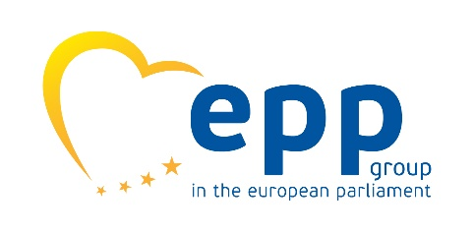


Save the Date

MEP Bogdan Wenta and Light for the World International invite you to save the date for a screening of the award-winning documentary

"Kanthari: change from within"

which will take place on

10 May 2017
18h00
European Parliament, Brussels
ASP 5E2
Deadline for registration with eu@light-for-the-world.org is 1 May 2017

The screening will be followed by a debate discussion with the director and a friendly drink. More detailed information will follow.

You can find more information about the documentary on http://kantharichangefromwithin.com

