DG DEVCO
Task Force Knowledge Performance and Results
Unit 05 Operational Information Systems
Scope of project 1 and First screens (DRAFT)
OPSYS Phase 1: "Results Management and Operational Entities"
Date: 19/04/2017
Doc. Version: <v2.0>

Document Control Information

Settings | Value
Document Title: | Scope of project 1 and First screens
Project Title: | OPSYS Phase 1: "Results Management and Operational Entities"
Document Author: | Lucile Petitpierre (BM DEVCO 05)
Doc. Version: | <v2.0>
Sensitivity: | Public
Date: | 19/04/2017

Document history:
The Document Author is authorized to make the following types of changes to the document without requiring that the document be re-approved:
- Editorial, formatting, and spelling
- Clarification

To request a change to this document, contact the Document Author or Owner.
Changes to this document are summarized in the following table in reverse chronological order (latest version first).
Revision | Date | Created by | Short Description of Changes
V1.0 | 31/03/2017 | Lucile Petitpierre | First draft
V2.0 | 19/04/17 | Lucile Petitpierre | Include last screens, planning and EPICs

TABLE OF CONTENTS
1 Summary 4
1.1 Main Outputs and planning 4
2 MY Workplace 5
2.1 What is my workplace? 5
2.2 What can I see/do from my workplace? 5
2.3 My Workplace Screens 6
3 MY PORTFOLIO 9
3.1 What is my portfolio? 9
3.2 What can I see/do from my portfolio? 9
3.3 My portfolio Screen 10
4 TASK MANAGER 11
4.1 What is my Task manager? 11
4.2 What can I see/do from the Task manager? 11
4.3 Tasks manager screens 12
5 Operational entities 13
5.1 Instrument page 13
5.2 MIP page 13
5.3 Action page 13
5.4 Programme page 14
5.5 Project page 14
5.6 Contract page 14
5.7 Action screen 15
5.8 Programme screen 17
5.9 Project screen 19
6 Logframe 21
6.1 Create a logframe 21
6.2 Add values to a logframe 21
6.3 Validation and quality control 21
6.4 Display aggregated/combined results information 22
6.5 Results screens 23
7 Business needs Draft EPICs co-drafted wit DEVCO Unit 06 - Opsys Project 1 – Updated planning 33

Summary
This document aims at listing the scope of project 1 "Result management and operational entities" that will be implemented for the October 2017 release. It presents the list of features, link to related uses cases and EPICs and whenever available first screens and mock-ups.

Main Outputs and planning
The current project "Result and operational entities" is the first project of Opsys programme and should lead to the achievement of the following key outputs:
- Output 1 - Operational entities (create and retrieve operational entities):
  - All operational entities should be fully implemented for the release 1 pilot in October 2017 (EPIC 01 to EPIC 05)
- Output 2 - Results (manage and monitor results)
  - Project and programme result management should be fully implemented for the release 1 pilot in October 2017 with as a priority the result management under projects and programme at implementation phase. (EPIC 06 to EPIC 12 and EPIC 14 to EPIC 18)
  - The capability to attached document may be implemented in release 2 of Q2-2018. (EPIC 13)
- Output 3 - Monitoring (Further monitoring of activities at implementation phase):
  - Capabilities for monitoring activities and monitoring and evaluation plan will be moved and implemented as part of Project 3 – implementation (EPIC 19 to EPIC 21)
- Output 4 - Integration (integration, migration and interoperability with other systems)
  - For interoperability with document storages should be available (dependency with corporate search) (EPIC 22)
  - For interoperability with other systems (Projects and programmes entities becoming the main entities used for EAMR, ROM, Evaluation, GIS, IATI, etc.) should be fully implemented for the release 2 scheduled in Q2 2018. . This ensures that data structure is properly set and that all operational entities are properly defined by user in the system. (EPIC 23 to EPIC 32)
- Output 5 - Portal and user experience:
  - Security and permission aspects should be fully implemented for the release 1 pilot in October 2017 (EPIC 33 to EPIC 34)
  - At minima the system should be available in English and French should be available as part of release 1 pilot in October 2017 when Spanish and Portuguese should be part of release 2 in Q2-2018 (EPIC 35)
  - Part of non-functional requirements and User experience (UX) interface compliant with eUI should be implemented as part of release 1 pilot in October 2017 (EPIC 36,37,39,40,41,42,45,46,47,48)
  - Non-functional requirements and UX interface should be improved during next release (Q2 2-2018) and other projects (2a – 2b – 3, etc.) (EPIC 38,43,44,49)

- Output 6 - External access (Allow external users to encode or visualize information):
  - Access to external implementing partner as part of release 1 pilot in October 2017. (EPIC 50)
  - Additional access to other external users to be part of release 2 in Q2-2018 (EPIC 51)

MY Workplace
Related EPIC | EP47
Related Use cases | https://webgate.ec.europa.eu/CITnet/confluence/display/OPSYS/02.01.05.02+COMMON+FUNCTIONALITIES+-+Use+case+specifications

What is my workplace?
- The one single entry point for every EC users in Opsys.
- Adapted to the user profile: Operational Manager, Head of Sector , Head of Cooperation, etc.

What can I see/do from my workplace?
- Visualise my portfolio of programmes, projects, contracts, calls I manage with:
  - A direct access to the portfolio page
  - A direct access to programmes, projects, contracts, call I manage
- Visualise the number of tasks I have to manage with
  - A direct access to the task manager page
- Visualise the health of my portfolio:
  - Graphical visualisation of my results
  - Graphical visualisation of my budget
  - Follow-up of corporate indicators I contribute to
- Search through the entire library of operational entities and related documents:

My Workplace Screens
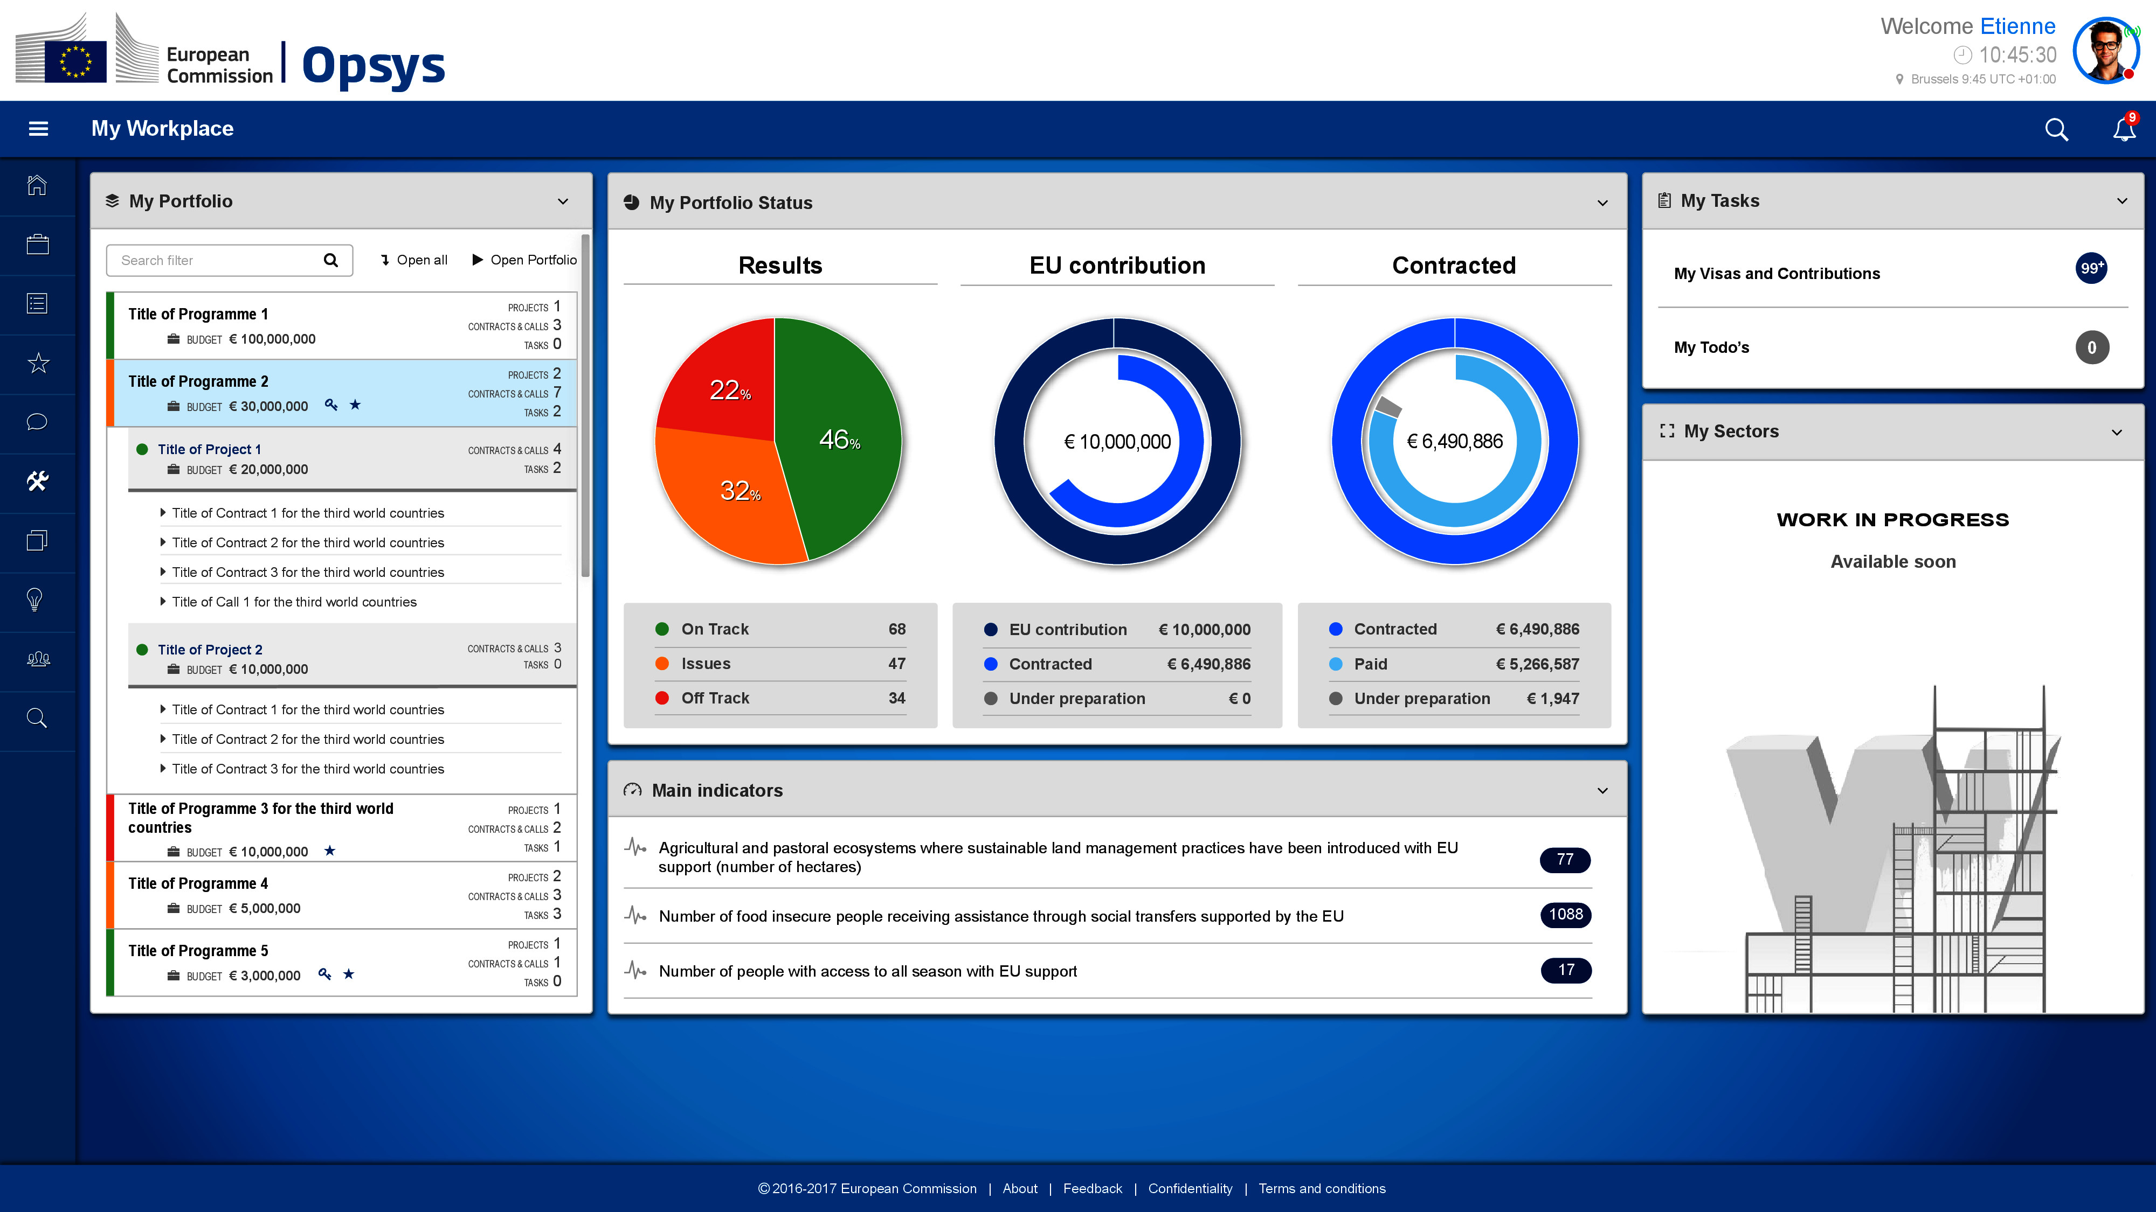
My Portfolio | My tasks
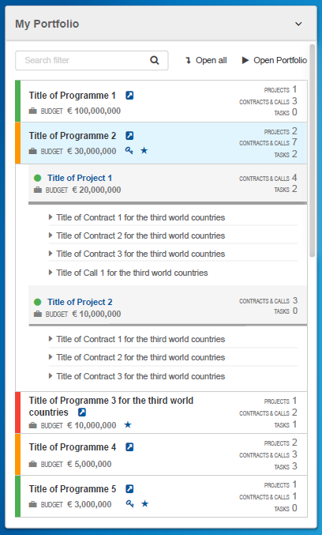 | 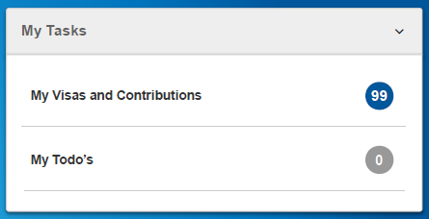
My portfolio status
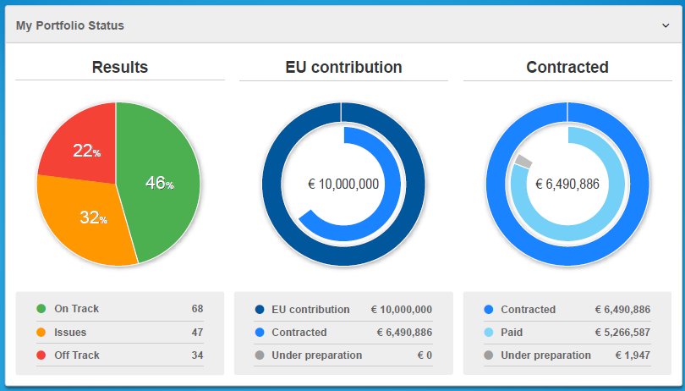
Main indicators
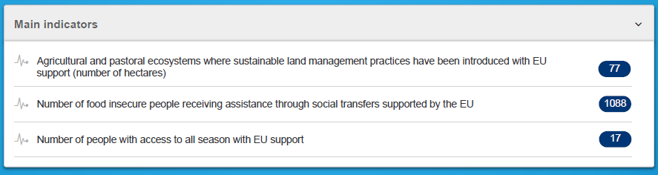

MY PORTFOLIO
Related EPIC | EP47
Related Use cases | https://webgate.ec.europa.eu/CITnet/confluence/display/OPSYS/02.01.05.02+COMMON+FUNCTIONALITIES+-+Use+case+specifications

What is my portfolio?
- The list of operational entities I'm in charge of: Actions, Programmes, projects, contracts, calls
- Access to the portfolio of my Unit/Delegation

What can I see/do from my portfolio?
- Visualise and access to the operational entities pages
- Tree view visualisation: from programme to project to contracts/calls
- Visualise and directly access to the related MIP, instrument when selecting a programme/project/contract/call

My portfolio Screen
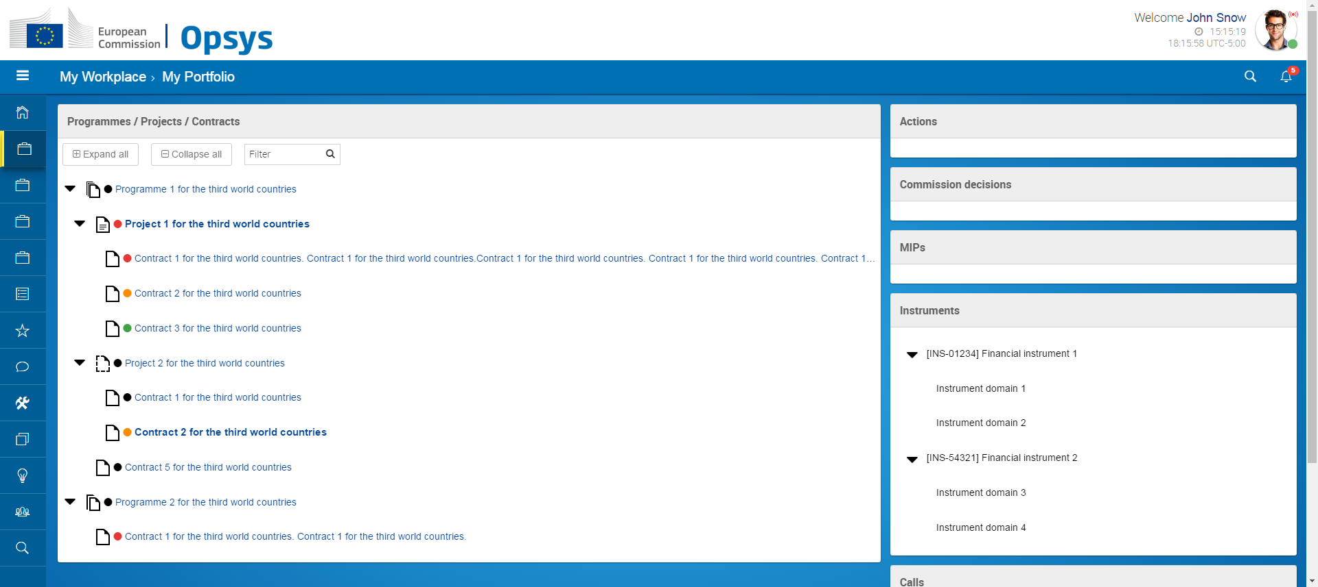

TASK MANAGER

What is my Task manager?
- The lists of Visa and contributions I have to manage in the system (validate logframe, create a programme, launch a call, etc.)
- My own to do list listing ad-hoc tasks I have to manage (draft minutes, send an email, call a colleague, etc.) (Nice to have for October 2017)
- Access to the list of Visa and contributions of my Unit/Delegation

What can I see/do from the Task manager?
- Select a task and be redirected to the relevant page where I can take action
- See the status of tasks I have attributed to another user
- Claim a tasks from another manager from my Unit/Delegation
- Create to do lists for me or for others ) (Nice to have for October)

Tasks manager screens
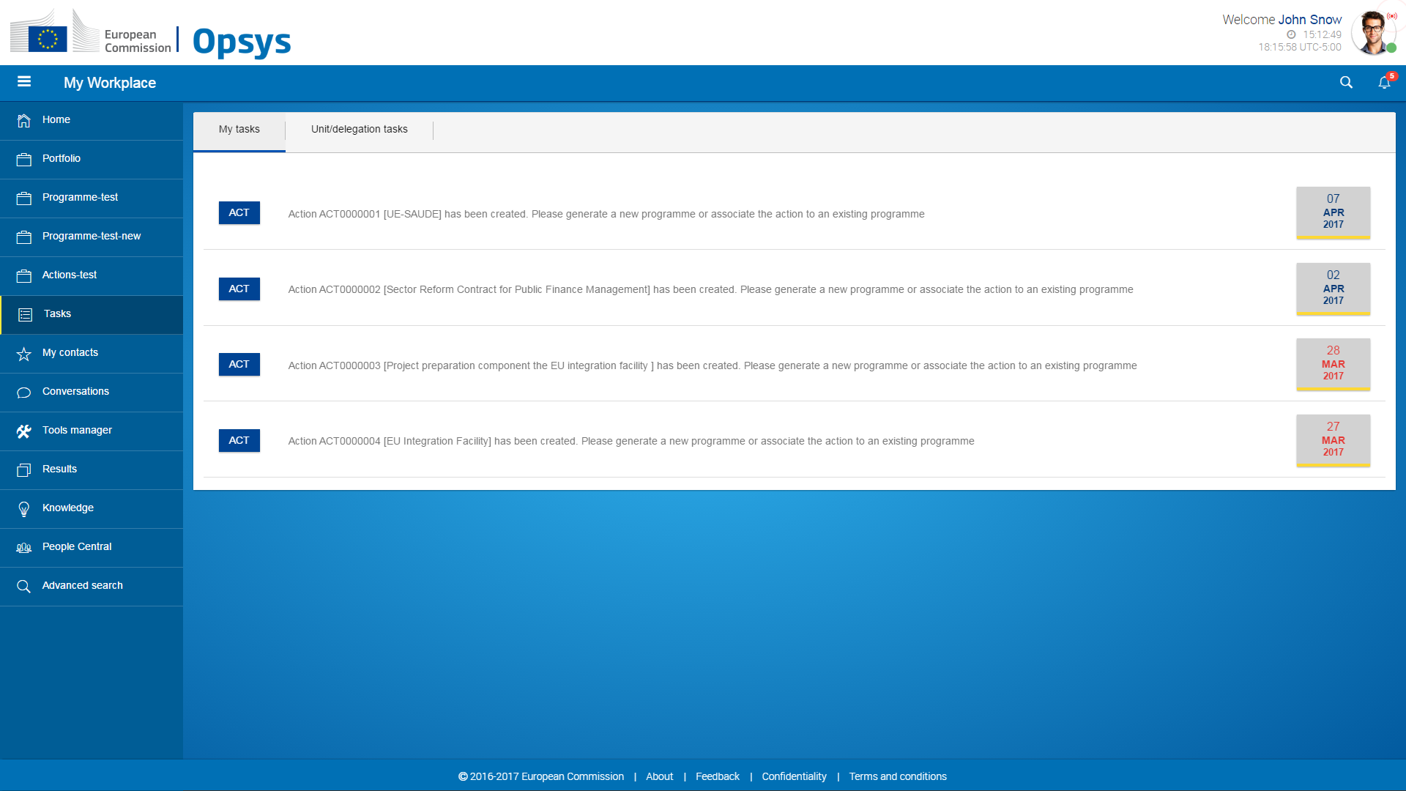

Operational entities
Related EPIC | EP 01, 02, 03; 04, 22, 29, 50
Related Use cases | Instruments: https://webgate.ec.europa.eu/CITnet/confluence/display/OPSYS/02.01.01.02+INSTRUMENT+-+Use+case+specifications  Actions:  https://webgate.ec.europa.eu/CITnet/confluence/display/OPSYS/02.01.02.02+ACTION+-+Use+case+specifications  programmes and projects  https://webgate.ec.europa.eu/CITnet/confluence/display/OPSYS/02.01.03.02+IMPLEMENTATION+-+Use+case+specifications  Contracts  https://webgate.ec.europa.eu/CITnet/confluence/display/OPSYS/02.01.04.02+CONTRACT+-+Use+case+specifications

Instrument page
- Visualise attributes, financial information retrieved from CRIS Domain
- Visualise the MIPs, Actions, Programmes, projects related to the Instrument
- Visualise result information from logframe
- Visualise the list of tasks related to the Instrument
- Create a Logframe as an Operational Manager (OM) (with a role of Instrument manager)
- Add DG sector(s) and benefitting zones as attributes of instrument or domain

MIP page
- Visualise MIP and Sector of Concentration (SoC) /Non Focal Sectors (NfS) attributes (including DAC sectors), financial information retrieved from CRIS MIP
- Visualise the Actions, Programmes, projects related to the MIP and spread by SoC/NFS
- Visualise Instrument parents
- Visualise result information from logframe
- Visualise the list of tasks related to the MIP
- Create a Logframe by sector of concentration as an OM (with a role of MIP manager)
- Add DG sector(s) as attributes from the Sector of Concentration and Non-focal sectors and benefitting zones as attributes of MIP

Action page
- Visualise attributes (including DAC sectors), financial information retrieved from CRIS project/measure
- Visualise the programme, projects, contracts related to the Action
- Visualise Instrument, MIP parents
- Visualise result information from logframe
- Visualise the list of tasks related to the Action
- Generate a new programme from an Action
- Link the Action to an existing Programme
- Create a Logframe as an OM

Programme page
- Visualise and update when needed attributes (including DAC sectors), financial information inherited from the Action(s)
- Visualise the projects, contracts related to the Programme
- Visualise Instrument, MIP, Action parents
- Visualise result information from logframe
- Visualise the list of tasks related to the Programme
- Generate a project from a Programme
- Retrieve and update Action logframe as an OM or an IP
- Provide permission to an implementing partner
- Add DG sector(s) as attributes

Project page
- Visualise and update when needed attributes, financial information inherited from the contract(s)
- Visualise the contracts related to the Project
- Visualise Instrument, MIP, Action, Programme parents
- Visualise result information from logframe
- Visualise the list of tasks related to the Project
- Create a Logframe reusing Programme result information as an OM or an IP
- Provide permission to an implementing partner

Contract page
- Visualise attributes, financial information retrieved from CRIS contract
- Visualise Instrument, MIP, Action, Programme, Project parents
- Visualise the list of tasks related to the Contract
- Generate a new project or horizontal measure from the contract (transitory period)
- Link the contract to an existing Project or programme (transitory period)

Action screen
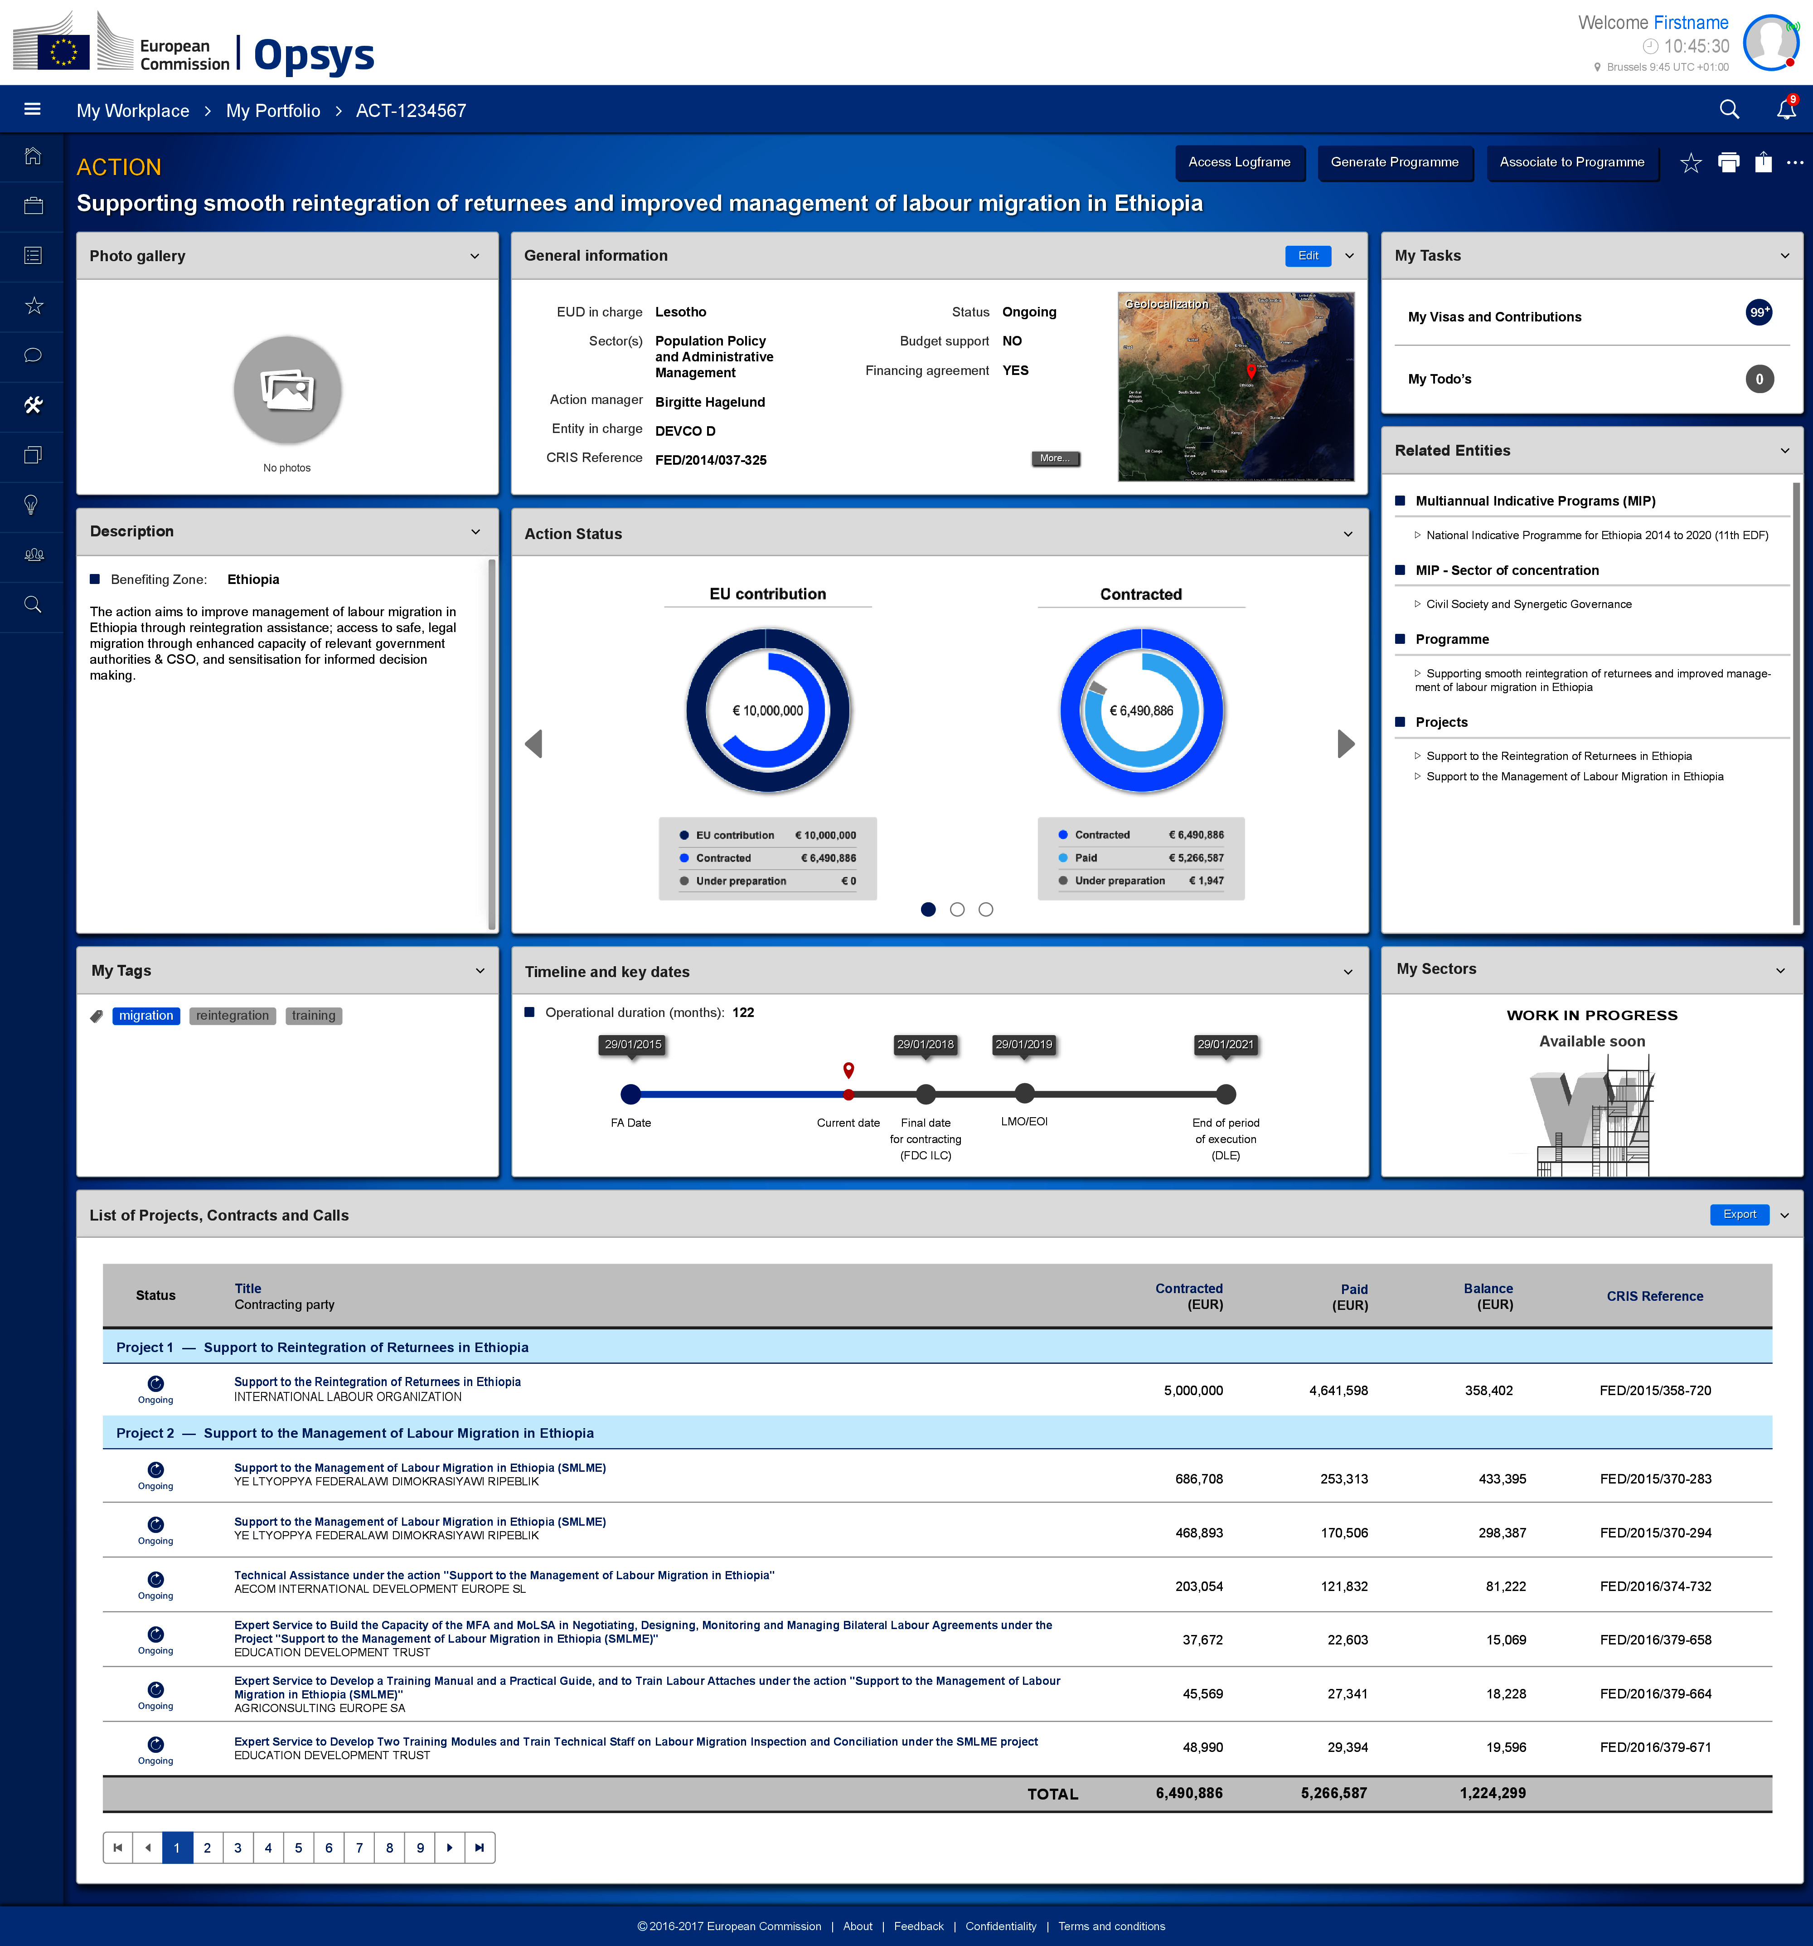

Programme screen
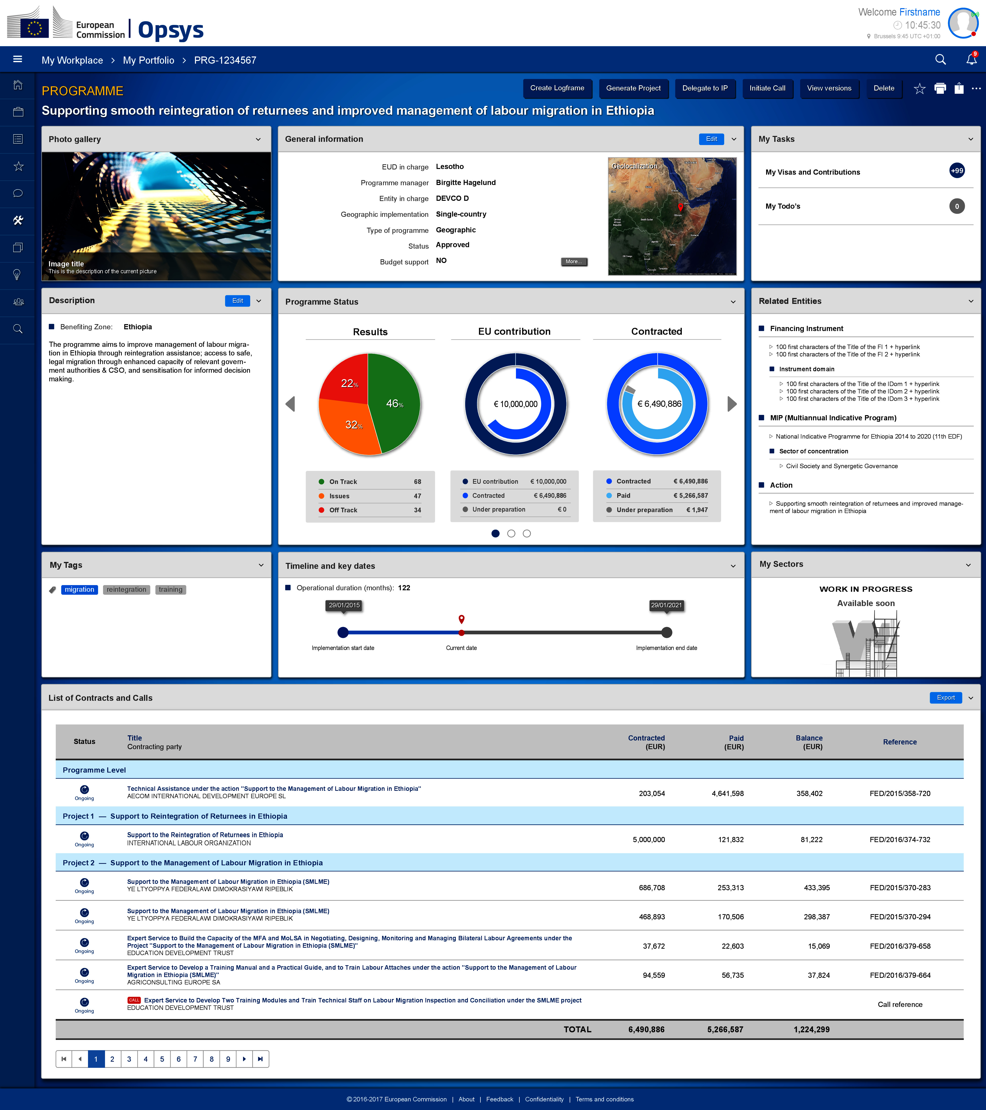

Project screen
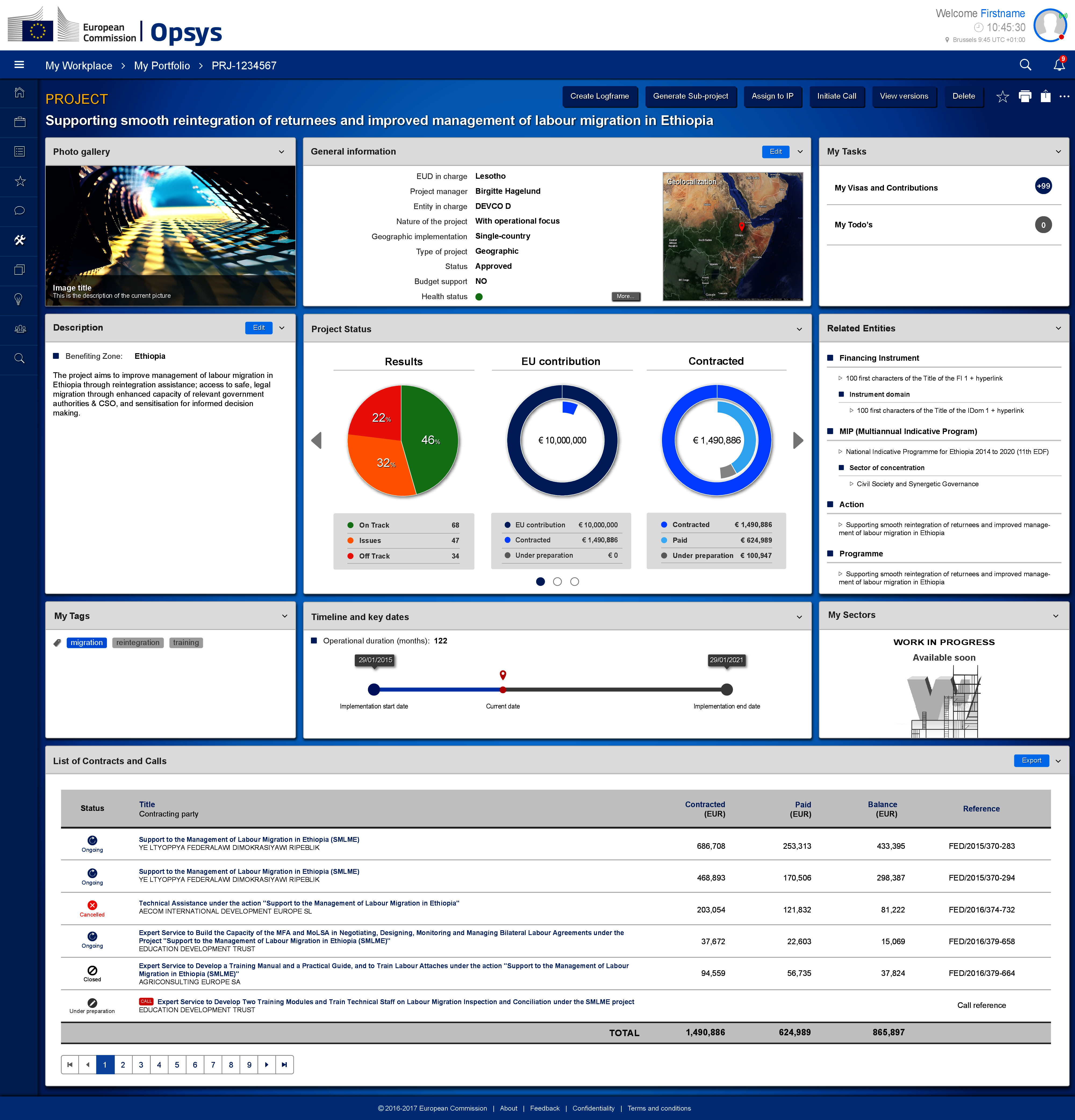

Logframe
Related EPIC | EP06, 07, 10, 11, 12, 14, 15, 16, 17, 18
Related Use cases | Edit Logframe: https://webgate.ec.europa.eu/CITnet/confluence/display/OPSYS/UC_02+Edit+Logframe  Assign Implementing partner:  https://webgate.ec.europa.eu/CITnet/confluence/display/OPSYS/UC_03+Assign+IP  Free indicator value:  https://webgate.ec.europa.eu/CITnet/confluence/display/OPSYS/UC_05.1+Freeze+Indicators+Values  Encode indicators value:  https://webgate.ec.europa.eu/CITnet/confluence/display/OPSYS/UC_05+Encode+Results+Indicators+Values  Review Encoded Results indicators value:  https://webgate.ec.europa.eu/CITnet/confluence/display/OPSYS/UC_06+Review+Encoded+Results+Indicators+Values  Review matching indicator value:  https://webgate.ec.europa.eu/CITnet/confluence/display/OPSYS/UC_13+Review+Matching+Indicator+Values

Create a logframe
- Provide periodicity of reporting
- Reuse results and indicators from parent logframe
- Add result including result name, level, description, assumption
- Add activities
- Add indicator by:
  - Selecting an indicator from the database
  - Define selection criteria
  - Create a new indicator
  - Match indicators with corporate indicators
- Add attribute: source of verification, baseline, targets
- Reorganise indicators inside the logframe
- Reorganise results inside the logframe
- Display logframe

Add values to a logframe
- Add value to an indicator including sex-disaggregation, source of verification, comments
- Add matching value including sex-disaggregation and comments
- Display graphical visualisation of the values across time
- Display traffic lights

Validation and quality control
- A logframe encoded by an implementing partner is validated by an OM
- Any values encoded by an implementing partner is validated by an OM
- Any matching relationship must be validated by an Indicator manager
- Any matching value must be validated by an Indicator manager
- Random/ad-hoc quality control of logframes can be done by indicator manager or quality controller

Display aggregated/combined results information
- Search, display result information in standard presentations of results data by project/programme, EUDs/HQ units, Sector, country, region, year, financing instrument, etc.
- Proper real time assessment of the operational portfolio performance at all levels.
- Corporate indicators aggregated across countries and presented in the same way

Results screens
Logframe display
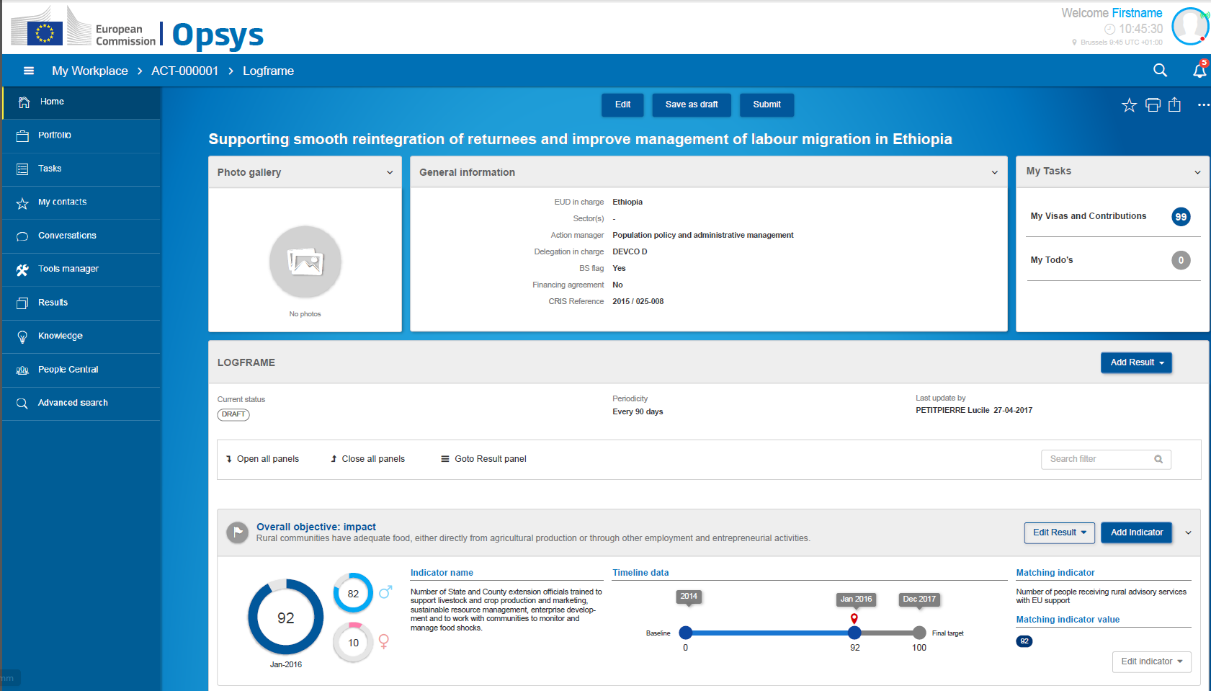
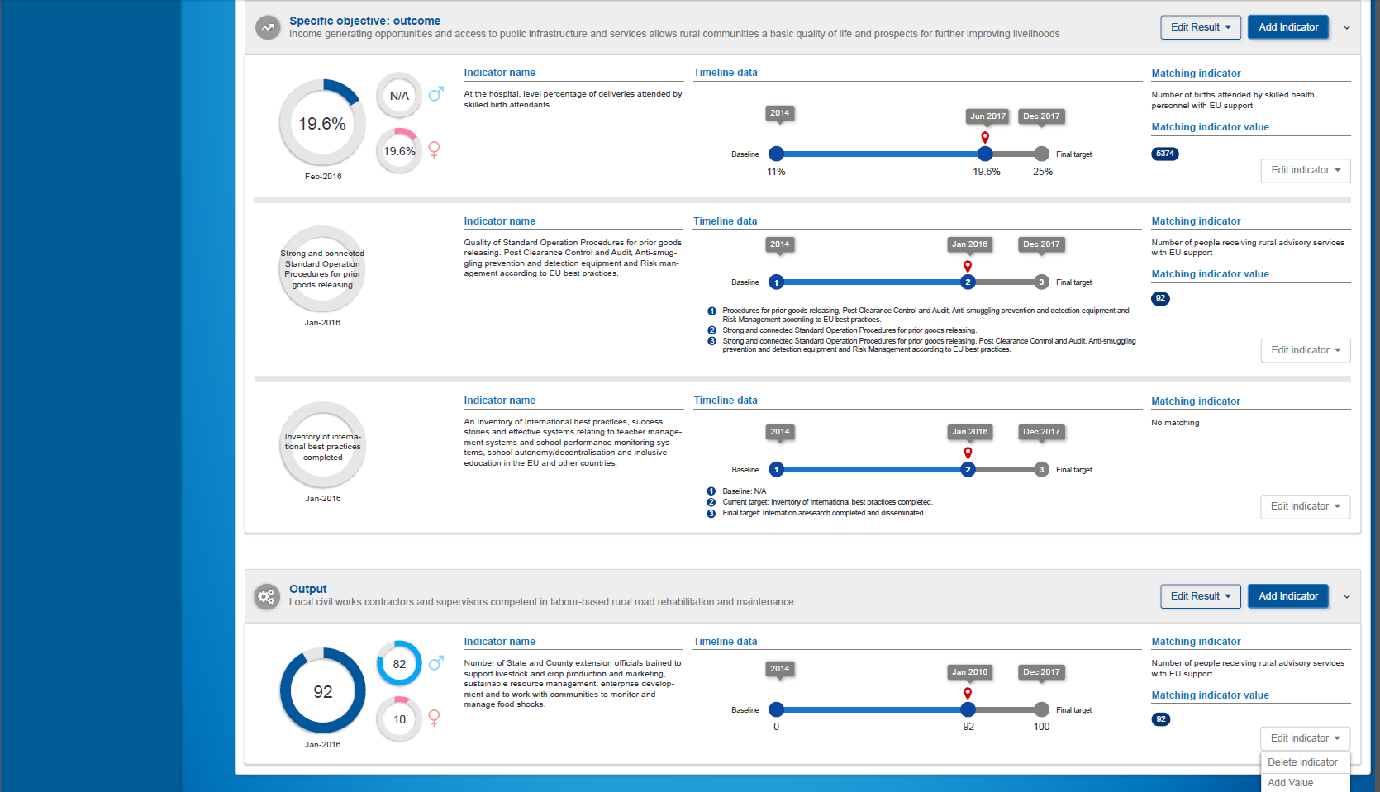

Logframe creation: reuse from MIP and instruments
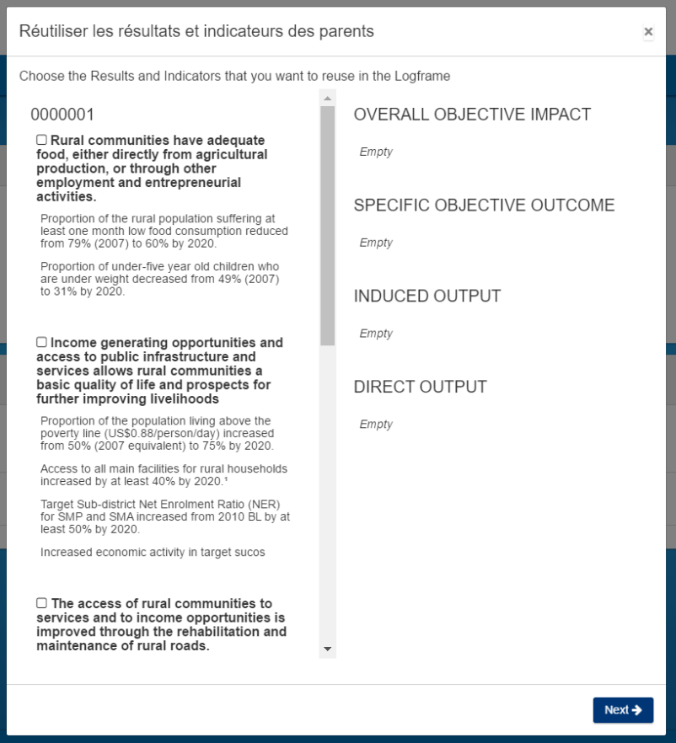 | 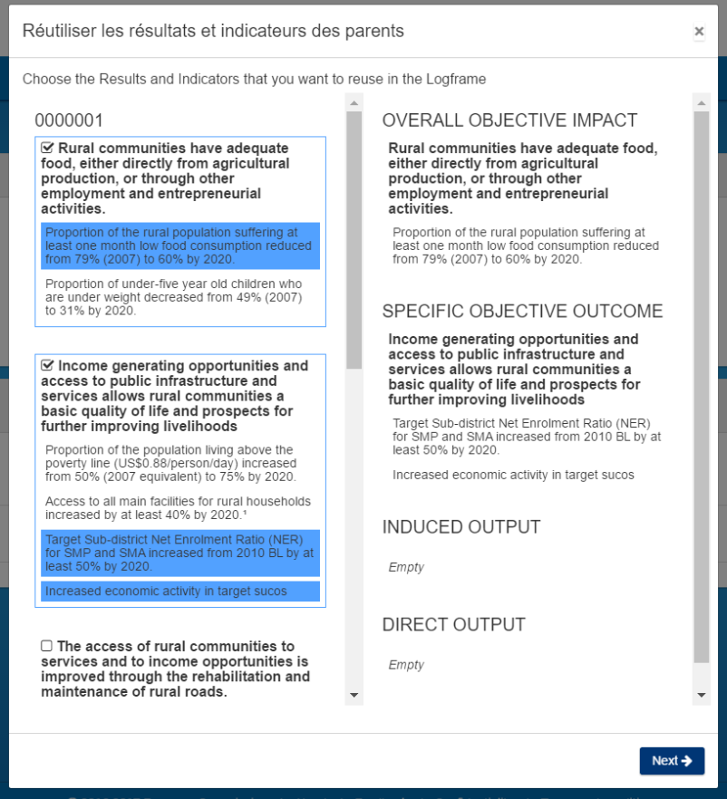
Logframe creation: Add a result | Logframe creation: Search for an existing indicator
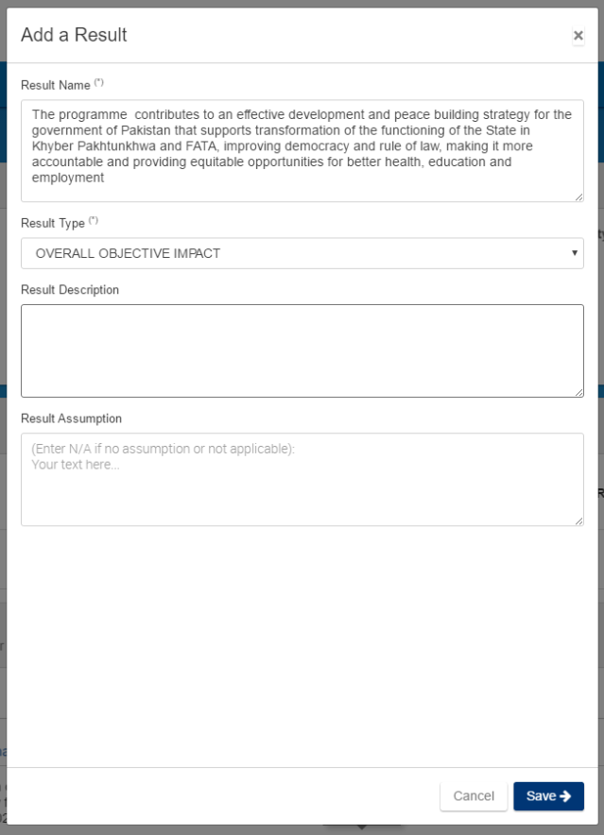 | 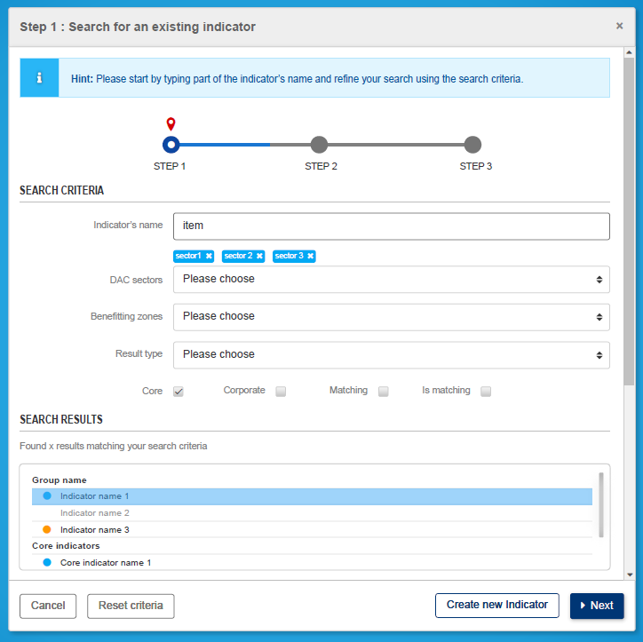
Logframe creation: Select an indicator | Logframe creation: add attributes to an indicator and matching relationship
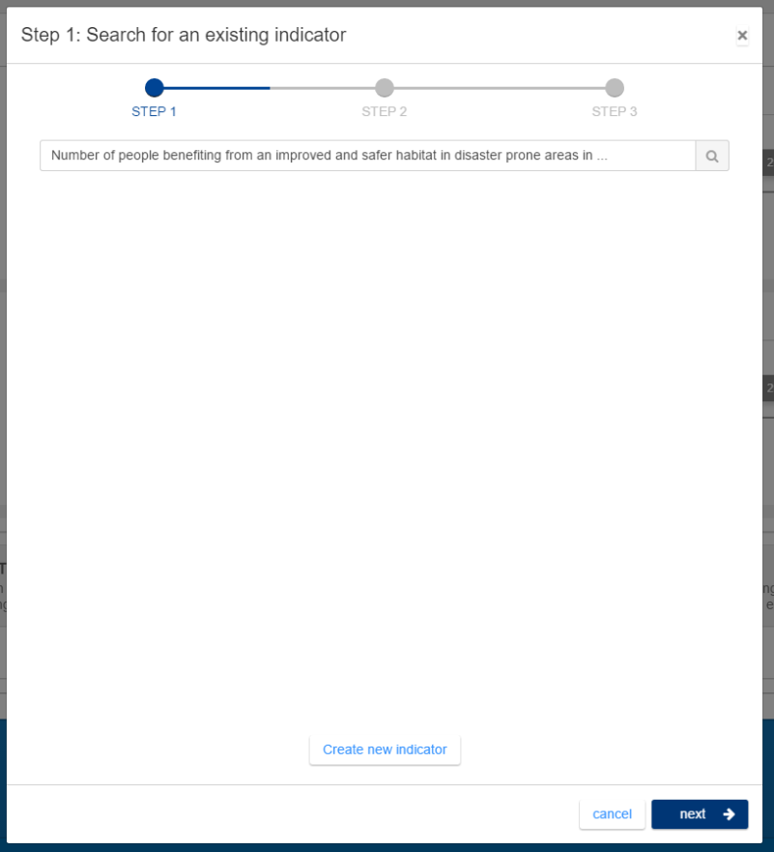 | 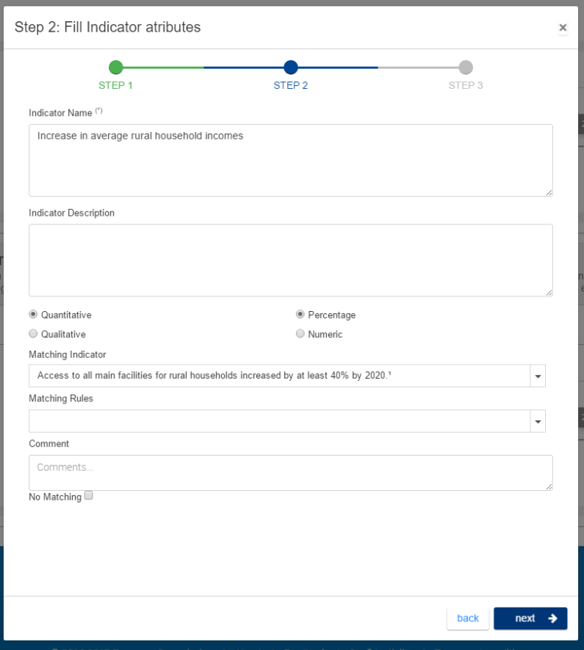
Logframe creation: Add baseline and target | Logframe creation: Generate targets
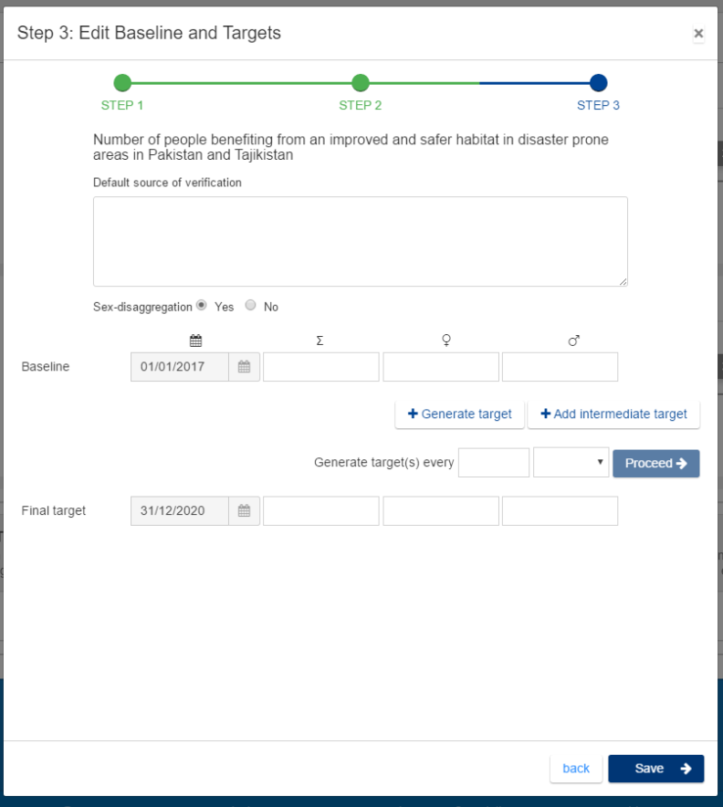 | 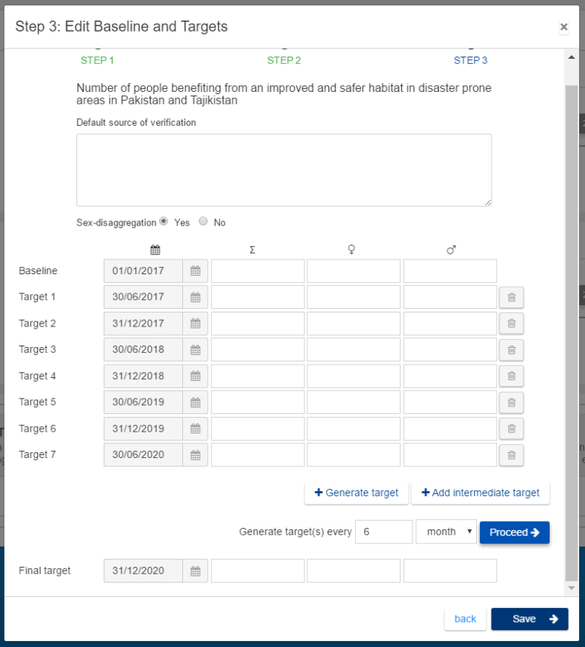
Add values to a logframe (Quantitative – Sex-disaggregation – Percentage) (mock-up
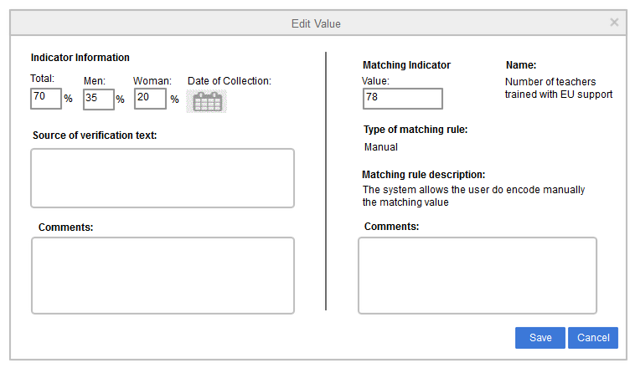
Add values to a logframe (Qualitative - No sex-disaggregation) (mock-up)
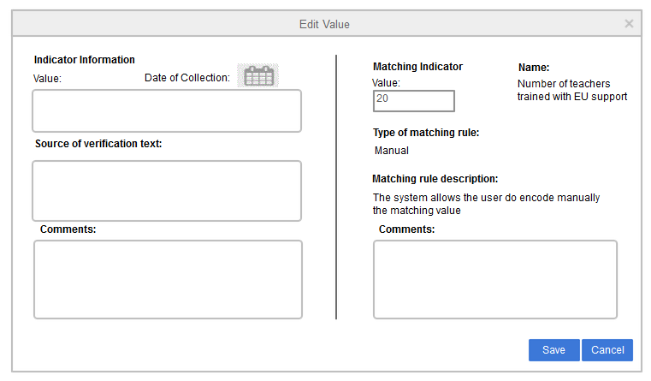
Validation and quality control: Quality Control Comments (mock-up)
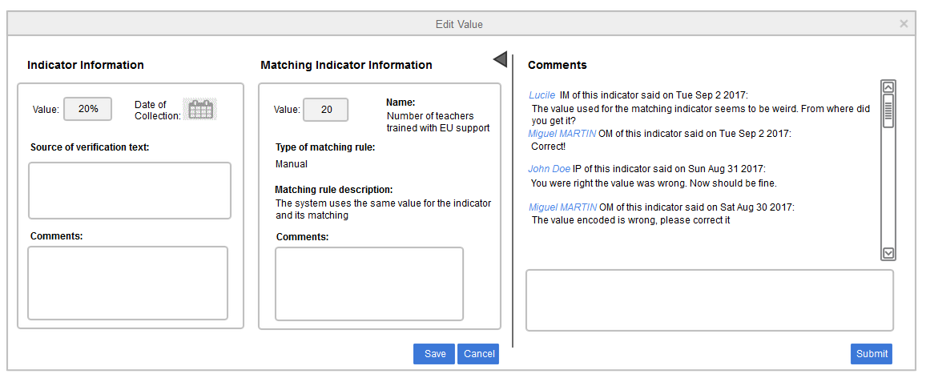

Validation and quality control: Review Indicator’s value by Operational manager (mock-up)
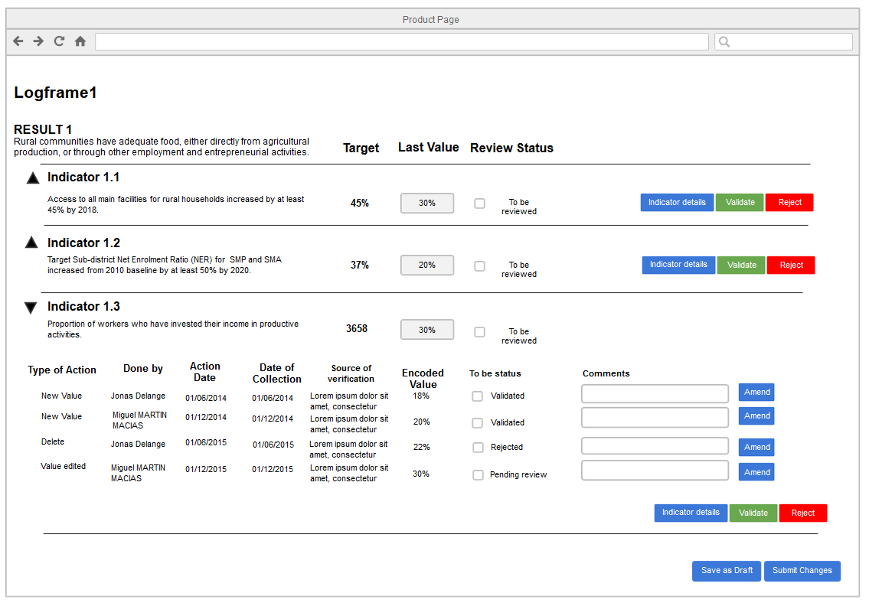

Business needs Draft EPICs co-drafted wit DEVCO Unit 06 - Opsys Project 1 – Updated planning
Output 1 | Operational entities (create and retrieve operational entities) | MoSCoW | Target | Updated target
1.1 | Create/retrieve operational entities
EP01 | As EC Operational manager, I want to manage operational entities all across cycle of operations: MIP (multi-annual indicative programme) at programming level, Action at identification and formulation level (and its underlying commitments), Lead-programmes, Programme, projects and support measures (facility) at implementation level so that I can monitor and report results on them:
EP01 | - As long as CRIS is operating, I want to access/retrieve entities that have been created in CRIS: Programming (MIP), Decision, contract and their underlying commitments as well as associated information. | MUST | 2016 | Oct-17
EP01 | - I want to create operational entities namely: Action, Programme, Lead Programme, projects, Support measure (facility). | MUST | 2016 | Oct-17
1.2 | Link operational entities with financial information
EP02 | As EC Operational manager, as long as CRIS is operating, I want to retrieve from CRIS Financial (commitment level 1 (global commitment), Commitment level 2 (individual commitment), Payment) and Legal entities (Commission financing decision, financing agreement or other types of agreement, Contract), so that I can link them to my operational entities. | MUST | 2016 | Oct-17
1.3 | Add additional information on operational entities
EP03 | As EC Operational manager, I want my operational entities (MIPs, Actions, Projects/Programmes/Lead Programmes and Support measures Facilities) to have at least a title, a brief description, a EUD or HQ Unit in charge, benefiting zone(s), implementation modality, sector(s) (as defined by DAC codes or other sectors), DAC markers, start and end dates and I want to have an overview of the financial situation of the associated decisions and contracts in terms of commitments and payments:
EP03 | - I want to retrieve this information when already encoded in other systems (such as CRIS, MIS), so that I don't have to re-encode it. | MUST | 2016 | Oct-17
EP03 | - I want to be able to enrich entities with additional relevant information (scope/list to be discussed with DUG) | SHOULD | 2016 | Oct-17
1.4 | Link operational entities across the cycle of operation
EP04 | As EC Operational manager, I want that projects, programmes and lead programmes are linked with Instrument, Domain, MIP, Action, Commission Financing Decision, CRIS Decisions and Contracts, so that I can follow, drill down and navigate through them all across the cycle of operations as well as associating operational entities to the underlying financial information. | MUST | 2016 | Oct-17
1.5 | Ensure harmonised terminology
EP05 | As DEVCO-NEAR-FPI manager, I want a harmonised terminology and definition for all operational entities, so that it reduces ambiguity and improve the consistency, clarity and understanding across EC users and other stakeholders. | MUST | 2016 | Oct-17

Output 2 | Results (Result management and monitoring) | MoSCoW | Target | Updated target
2.1 | Create and link result frames across the cycle of operation
EP06 | As EC Operational manager, I want to encode, update, retrieve and display results across the cycle of operation in a seamless way:
EP06 | - (a) At programming stage, I want to create and update for my MIP a structured sector intervention framework including specific objectives by sector of concentration and their related indicators (including type of indicator: qualitative or quantitative) with, when available the baseline and baseline year, the target and target year (both sex-disaggregated when relevant) and the source(s) of verification, so that I can monitor MIP implementation. | SHOULD | 2016 | Oct-17
EP06 | - (b) At identification and formulation phase under project modality I want to create and update for my Action a logframe including overall objective (impact), specific objective(s) (outcome(s)), outputs and their related indicators (including type of indicator: qualitative or quantitative) with baseline and baseline year, target and target year and milestones and intermediary years (all sex-disaggregated when relevant), the source(s) of verification and assumption(s) so that use it as a basis during implementation phase. | MUST | 2016 | Oct-17
EP06 | - (b) At identification and formulation stage under Budget support modality I want to create and update for my Action an indicative list of results indicators including overall objective (impact), specific objective(s) (outcome(s)), induced outputs, direct outputs and their related indicators (including type of indicator: qualitative or quantitative, variable tranches indicator) with baseline and baseline year, target and target year, milestones and intermediary years (all sex-disaggregated when relevant – additional disaggregation will be discussed with the DUG ), source(s) of verification, so that I can use it as a basis during implementation phase | MUST | 2016 | Oct-17
EP06 | - (c) At implementation stage, I want to create or update (based on the one from formulation phase) for my projects and programmes a logframe or an indicative list of results indicators (Support measures:/facilities do not require this.) or ask my implementing partner to do so, so that I can monitor my projects and programmes' results. | MUST | 2016 | Oct-17
EP07 | As EC Operational manager, I want my results to be linked from (a) Programming (MIP) to (b) formulation (Action), and (c) implementation (Programme/Project), so that I can ensure coherence of my results chain across my operation cycle. | MUST | 2016 | Oct-17
2.2 | Be guided in the selection of relevant indicators and possible matching
EP08 | As HQ Result coordinator from DEVCO, NEAR, FPI, I want to be responsible for the list of EU RF indicators (DEVCO), corporate indicators (NEAR or FPI) and potentially OMI, so that I can create, update, delete them when needed. | MUST | 2016 | Oct-17
Ep09 | As EC Operational manager, I want to create OMI in particular when my priorities are not reflected in the (DEVCO) EU result framework indicators (thematic priorities, country priorities) not reflected in the EU RF, so that results can be aggregated by the system according to my needs | MUST | 2016 | Oct-17
EP10 | As EC Operational manager, I want to be guided in the selection of indicators by accessing to a list of indicators: (i) from my previous phase in the cycle of operation programming (MIP)-formulation (Action) –implementation (Programme/ Project) or (ii) indicators included in relevant guidance documents with a clear view on those being used as Other Matching Indicators (OMI) or linked to an EU Result Framework indicator (EU RF) or other corporate indicator (NEAR, FPI). | MUST | 2016 | Oct-17
EP11 | As EC Operational manager, I want to link my indicator to an EU RF indicator or other corporate indicators (NEAR, FPI) or OMI so that I can match results by EU RF indicators or OMI: |  |  | Oct-17
EP11 | - (a) At programming stage, I want to match (when relevant) the indicator(s) of my MIP to one of the EU RF indicator or other corporate indicator (NEAR, FPI) so that this link is already set at identification, formulation and implementation phase. | SHOULD | 2016 | Oct-17
EP11 | - (b) At identification and formulation stage, I want to link (when relevant) the indicator(s) of my Action to an EU RF indicator or other corporate indicator (NEAR, FPI) or an indicator at MIP level (becoming OMI), so that this link is already set at implementation phase. | MUST | 2016 | Oct-17
EP11 | - (c) At implementation stage, I want to link (when relevant) the indicator(s) of my Project or Programme to an EU RF indicator or other corporate indicator (NEAR, FPI) or any other created OMI, so that results can be aggregated by the system by EU RF indicators or OMI. | MUST | 2016 | Oct-17
2.3 | Monitor results across cycle of operation
EP12 | As EC Operational manager, I want that current/latest available values of the indicators included in my sector intervention framework (MIP), logframe and/or indicative list of results (Programme/Project/Lead Programme) can be encoded, while keeping the earlier encoded values visible. The encoded values must be presented in such a way that I can easily compare with baseline, milestones and targets. As EC Operational Manager I also want to be able to update the baselines, milestones and targets.  Data can be inputted by implementing partners, including relevant disaggregation and data sources: | MUST | 2016 | Oct-17
EP12 | - (a) In relation to programming documents, I want to report against MIP implementation. | MUST | 2016 | Oct-17
EP12 | - (b) At implementation stage, I want to be able (or request my implementing partner) to update at least once a year the current/final value of related value of the indicators including relevant disaggregation and data sources – including the management of indicators referring to BS programmes. | MUST | 2016 | Oct-17
EP13 | As EC Operational manager, I want to or allow my implementing partner to upload key documents (such as progress/final reports, studies, site visits, minutes of programme/project steering committee, etc.) related to monitoring, so that I can validate them and easily access it. | MUST | 2016 | Q2-18
EP14 | For results, based on the structure developed under EP06 bullet 4 and EP12, as EC Operational manager, I want the system to generate and display automatic color-codes and percentages or be able to manually encode a scoring (pre-define scoring notation to be further detailed) based on indicator values (including for indicators of BS programmes), progress from baseline towards milestones and targets, and comment on it, so that I can visualize easily the progress of my projects and programmes and I want to be able to support these key performance indicators (KPI) with a narrative report.. | MUST | 2016 | Oct-17
2.4 | Quality control encoded results across cycle of operation
EP15 | As EC Operational manager, I want to quality control any information encoded or document uploaded by an implementing partner (though an approval workflow of one or more steps), so that I can validate, amend, reject and comment on it. | MUST | 2016 | Oct-17
EP16 | As HQ Result coordinator from DEVCO, NEAR, FPI, I want to be able to quality control any link between an indicator and an EU RF indicator or corporate indicators from NEAR or FPI or OMI before it becomes visible to other stakeholders, so that I can validate, amend, reject and comment on it. | MUST | 2016 | Oct-17
EP17 | As HQ Result coordinator from DEVCO, NEAR, FPI, I want to quality control any indicator, so that I can flag them as SMART, amend them or comment on them. Quality control process should foresee interaction with EC Operational managers and eventually between them and the implementing partners as encoded in the form of questions and answers. | MUST | 2016 | Oct-17
2.5 | Display aggregated/combined results information
EP18 | As EC Operational manager, I want to see result information in standard presentations of results data by project/programme/lead programme, EUDs/HQ units, Sector, country, region, year, financing instrument; so that I have a proper real time assessment of the operational portfolio performance at all levels. Indicators matching with EU RF or other corporate indicators (NEAR, FPI) or OMI should be aggregated across countries and presented in the same way. | MUST | 2016 | Oct-17

Output 3 | Monitoring (Further monitoring at implementation phase) | MoSCoW | Target | Updated target
3.1 | Monitoring activities, outputs and outcomes from the implementing partner (including milestones)
EP19 | As EC Operational manager, I want my implementing partner to be able to report/comment on activities related to individual outputs and outcomes as well as on overall project and programme progress as part of its regular progress reporting. | MUST | 2016 | Project 3
3.2 | Plan and monitor key events and activities from the EC Operational manager
EP20 | As EC Operational manager, I want to access a calendar to schedule key events and milestones of my Project or Programme (site visits, steering committees, ROM missions, and other Programme events, such as meetings, commissioning and closing events, evaluation and audit missions..) so that it becomes my monitoring plan. | MUST | 2017 | Project 3
EP21 | As EC Operational manager, I want the monitoring and evaluation plan to be tailored in a flexible way, so that I can adapt it to my specific needs. | SHOULD | 2017 | Project 3

Output 4 | Integration (integration, migration and interoperability with other systems) | MoSCoW | Target | Updated target
4.1 | Interoperability with documents storage systems
EP22 | As EC Operational manager, I want a seamless and immediate access to all documents related to operational entities, regardless of where the documents are stored (CRIS, ARES, etc.) and in accordance with confidentiality rules, so that I don't have to search for them in another system. | MUST | 2016 | Oct-17
4.2 | Migration of Results information from other systems/local tools
EP23 | As EC Operational Manager, I want any results information related to my operational entities currently stored in other system (such as MIS), to be migrated in Opsys, so that I don't have to re-encode them. | MUST | 2017 | Q2-18
EP24 | As EC Operational Manager, I want whenever possible, key results information related to my operational entities currently stored in off-line tools (such as Excel) or documents (Actions), to be migrated in Opsys, so that I don't have to re-encode them. | MUST | 2016 | Q2-18
4.3 | Interoperability for reporting (EAMR)
EP25 | As EC Operational Manager, I want to report at least once a year into Opsys on KPI 5 (implementation progress), KPI 6 (achieving results), KPI 18 (projects visited), KPI 19 (evaluation), Rr (ROM request) and I-4 (Project communication plan) for my Project or Programme, so that they could be reflected in the EAMR report though DWH. | MUST | 2017 | Q2-18
4.4 | Interoperability for ROM and Evaluation (ROM module, Evaluation module)
EP26 | As EC Operational Manager, I want my projects and programmes to be the pivot entities for ROM and my requests for ROM to be automatically displayed in the ROM module workplan, so that I can start scheduling the ROM review | MUST | 2017 | Q2-18
EP27 | As EC Operational Manager, I want my projects and programmes to be the pivot entities used in the evaluation module, so that I can schedule my evaluation based on an operational entities portfolio | MUST | 2017 | Q2-18
4.5 | Interoperability for transparency, communication and knowledge sharing purpose (GIS, IATI, EUDs internet websites, C4dev)
EP28 | As EC Operational Manager I want to be able to flag/authorise which information/fields are going to be used for communication, knowledge sharing and IATI reporting, so that I can control which information is going to the public. By default, Opsys should already flag the information that must be available to the public for legal reasons. | MUST | 2017 | Q2-18
EP29 | As EC Operational Manager, I want my Action, Project, programme or result to be geo-localised, so that I can ensure better communication, increased transparency and easier identification of where ongoing Projects and Programmes take place. | MUST | 2017 | Q2-18
EP30 | As EC Operational Manager, I want that my projects/programmes become the reference entities for IATI reporting and metadata to be compatible with IATI reporting. | MUST | 2017 | Q2-18
EP31 | As EC Operational Manager, I want the system to feed directly DEVCO-NEAR-FPI websites (EC Europa internet) and the corresponding EU delegation website with information on projects and programme (public documents, standard information package on projects and programme: easy to understand title, amount, stakeholders, dates, short description, results, etc.), so that I can better communicate on my project or programme. | MUST | 2017 | Q2-18
EP32 | As EC Operational Manager, I want to be able to use my projects and programme information (public documents, standard information package on projects and programme: easy to understand title, amount, stakeholders, dates, short description, results, etc.) to feed my Capacity4dev project page, so that I can share knowledge on my project or programme. | SHOULD | 2017 | Q2-18

Output 5 | Portal and user experience | MoSCoW | Target | Updated target
5.1 | Security (interface comply with protection rules)
EP33 | As EC user or authorised external user, I want the system to have authentication feature and Single Sign On supported by ECAS and aligned with the user categories defined in the functional requirements | MUST | 2016 | Oct-17
EP34 | As EC user or authorised external user, I want the system to follow corporate data protection rules in collaboration with DEVCO's Data Protection Coordinator, so that data protection is implemented through built-in mechanisms (e.g. confidentiality, application of deletion rules, access rights) or statements (e.g. privacy statement, written consent, and disclaimer). | MUST | 2016 | Oct-17
5.2 | Information (interface has correct, readable and up-to-date content)
EP35 | As EC user or authorised external user, I want the system to support multi-lingual interface with a provision for 4 languages (English, French, Spanish, and Portuguese with English as fall-back solution when a translation is not available), so that it is adapted to my working language (especially useful for external users, like local partners).
EP35 | - As EC user or authorised external user, I want the system to be available in English | MUST | 2016 | Oct-17
EP35 | - As EC user or authorised external user, I want the system to be available in French | MUST | 2016 | Oct-17
EP35 | - As EC user or authorised external user, I want the system to be available in Spanish | SHOULD | 2017 | Q2-18
EP35 | - As EC user or authorised external user, I want the system to be available in Portuguese | SHOULD | 2017 | Q2-18
EP36 | As EC user or authorised external user, I want the system to be always up-to-date and that Data entered in the system are immediately available for further processing or view by the data encoder and related stakeholders (after validation when needed), so that it displays real-time information. | MUST | 2016 | Oct-17
5.3 | Functionality (Interface works and don't break)
EP37 | As EC user or authorised external user, I want the system to have decent response times in Delegations where connectivity is an issue and Internet connection is slow, so that low bandwidth situations do not impact the use of key usability features. Regular auto-saving of the information encoded by any user must be a key feature of the system. | MUST | 2016 | Oct-17
EP38 | As user, I want to work offline for specific tasks or in case of unreliable connectivity, so that I avoid losing data when the connection fails. | MUST | 2016 | Q2-18
EP39 | As EC user or authorised external user, I want the system to be available 24 hours a day, 7 days a week (with an affordable down time of less than 1 day in case of breakdown or a serious issue):, so that I can access it whenever needed | MUST | 2016 | Oct-17
EP40 | As EC user, or authorised external user, I want to see all different versions and modifications of key programmes and projects information (to be further detailed with DUG) | SHOULD | 2016 | Oct-17
5.4 | Usability (Interface allows users to complete tasks quickly and accurately)
EP41 | As EC user or authorised external user, I want to be able to use the system to fully work and tested on Firefox, Internet explorer, Chrome and Safari, so that external stakeholders will not be forced to use a commercial web browser. | MUST | 2016 | Oct-17
EP42 | As EC user or authorised external user, I want the user interface to include key features (such as drag & drop features, auto-complete on searches, responsive UI components use of less click and less change of pages to search for content), so that it is similar to modern dynamic website. | SHOULD | 2017 | Oct-17
EP43 | As EC user or authorised external user, I want the system to be mobile friendly (user interface that is suitable for mobile device (e.g. small form factors and touch screens), or that adapts itself when detecting a user from a mobile system), so I can easily access information and use key features in a secured way with my mobile device. | SHOULD | 2016 | Q2-18
EP44 | As EC user or authorised external user, I want to have Multimedia features of mobile devices (e.g. possibility to take pictures or videos from the mobile devices, so that I can link it to my operational entities in the system. | SHOULD | 2017 | Q2-18
5.5 | Aesthetic (Interface looks unique, friendly and professional)
EP45 | As EC user or authorised external user, I want the user interface to be coherent all over the system (Application of well-known UI design patterns, EC UI guidelines and standardized look-and-feel). | MUST | 2016 | Oct-17
EP46 | As EC user or authorised external user, I want the system to visualize user-friendly and intuitive pages for main entities including up-to-date key data, the related result framework and links with related operational entities at higher and lower levels in the cycle of operations, so that I can easily follow my operation cycle. | MUST | 2016 | Oct-17
5.6 | Customization (personalized dashboard, notifications)
EP47 | As EC Operational Manager, I want my dashboard to be personalised and customisable (allowing configuration of a number of personal settings, typically found in modern information system: start page or favourite pages, frequency of email notifications, UI language, some control on the layout e.g. for local portfolio views or local programme dashboards), so that it is adapted to my needs. | SHOULD | 2017 | Oct-17
EP48 | As EC user or authorised external user, I want to be able to customise the notification system, so that I receive what I am interested about when I need it. | SHOULD | 2016 | Oct-17
EP49 | As EC user or authorised external user, I want the system to use geo-localisation features, so that it can propose me contextual information (allowing for example to show an operational officer visiting a programme data related to his location (local partners, programmes in the area, etc.).) | SHOULD | 2017 | Q2-18

Output 6 | External access (Allow external users to encode or visualize information) | MoSCoW | Target | Updated target
6.1 | Provide permission to external user to provide inputs
EP50 | As EC Operation manager, I want to provide permissions to an external user (Implementing Entity manager, Partner country programme manager) to provide inputs directly in the system (manage results, upload documents), provided that there is an internal DEVCO/NEAR/FPI validation, so that I avoid having to re-encode the information. | MUST | 2016 | Oct-17
6.2 | Provide permission to external user to visualize information
EP51 | As EC Operation manager, I want to provide permissions to an external user ( Partner Country or Regional Organisation Representative, Development partner/Donor Representative, EU Member States Representative) to visualize some information in the system (as validated with the DUG), so that I can ensure transparency. | SHOULD | 2017 | Q2-18

External users will access there portfolio, list of tasks, operational entities pages and logframes from the Participant Portal
For specific cases, not encoded in CRIS, information will be directly retrieved from ABAC
For specific cases, not encoded in CRIS, information will be directly retrieved from ABAC
https://myintracomm.ec.europa.eu/serv/en/dpo/Pages/index.aspx

