 | EUROPEAN COMMISSION  DIRECTORATE-GENERAL FOR HUMANITARIAN AID AND CIVIL PROTECTION - (ECHO)  European Neighbouring Countries, Middle East and Central Asia  ECHO Regional Support Office in Amman – Jordan
  EUROPEAN COMMISSION
  DIRECTORATE-GENERAL FOR HUMANITARIAN AID AND CIVIL PROTECTION - (ECHO)
  European Neighbouring Countries, Middle East and Central Asia
  ECHO Regional Support Office in Amman – Jordan
Mission Report

Subject: WASH Support Mission to Sana’a, Yemen: 4th – 10th June 2017
Mission participants: Christophe Retlien, HoO Yemen (Amman), Kenneth Grant, TA Yemen (Amman), Torben Bruhn, Regional Health Expert (Amman) and Sania Al-Aswadi, PA Yemen (Sana’a)
Author: Monica Ramos, WASH and Shelter Expert
Date: 12/06/2017

EXECUTIVE SUMMARY / HIGHLIGHTS

- Meetings with key Health and WASH actors, such as, WHO, UNICEF, ICRC and ECHO funded partners were held along with field visits to three Cholera Treatment Centres (CTCs) supported by ICRC and WHO confirmed that the current cholera outbreak is serious and still evolving, with several thousand new suspected cases reported daily. Although, there are indications of significant overestimate of caseloads
- The Integrated Response Plan for the cholera outbreak is currently being rolled out by Health and WASH actors, however, is limited by overarching issues related to low capacity of government staff (associated with lack of salary payments for national healthcare staff); low capacity of Health actors to support clinical case management and limited involvement of WASH actors to support preventative actions at the community level
- Health and WASH key stakeholders cited improvements in the coordination between WHO and UNICEF, along with the Health and WASH Clusters, as compared to the ‘first wave’ of the outbreak
- The quality of the response remains a concern at CTCs and Oral Rehydration Treatment Centres (ORTCs), requiring more support and attention to training, supervision, management and monitoring. Of particular concern is the poor quality of Infection Prevention Control (IPC) and WASH practices in CTCs and ORTCs, which requires additional support to ensure adherence to Standard Operating Procedures (SOPs), national and international. WASH actors have and should play a more active role in supporting this aspect of the response
- To date, the response has focused heavily on clinical case management and has lacked coordinated efforts that focus on holistic preventative measures, which balance both Health and WASH interventions to achieve containment. This requires increase focus and support for preventative WASH actions, including, improving access to safe drinking water and hygienic conditions in the catchment areas of CTCs and ORTCs, prioritising locations deemed as ‘hotspots’ for cholera
- The ability of WASH partners to access detailed information to further support and increase the effectiveness of their actions and contributions towards containment of the outbreak requires more follow up and advocacy by the WASH Cluster. Specifically, information regarding caseload by village location is required to be shared and disseminated in order for WASH actors to better design and implement cholera specific WASH programming
- Monitoring of the quality of the response requires a more structured strategy to ensure the effectiveness of the actions taken by Health and WASH actors. This includes the integration of clinical case management and preventive WASH actions to achieve a more balanced approach, as despite cited improvements since the ‘first wave’ of cholera, the response still demonstrates a fragmented approach amongst Health and WASH actors in terms of quality control and adherence to minimum standards
- Follow up mission to be conducted by Regional Health and WASH Experts in August to continue to evaluate the progress of the response and evolution of the cholera outbreak in country

Key Recommendations for ECHO
- ECHO should advocate for improved IPC and WASH in CTCs and ORTCs that adheres to SOPS, national and international, to support a quality response. This should include the more direct and active involvement of WASH actors
- ECHO should prioritise support for preventive WASH actions, as to date, the response has focused heavily on clinical case management, to further complement the integration of a balance approach to contain cholera
- ECHO should continue to advocate for improved information sharing between Health and WASH actors, particularly, in relation to information regarding caseload by village location in order for WASH actors to better design and implement cholera specific WASH programming. This should include increased efforts and dedicated capacity on data analysis and visualisation of prioritised ‘hotspots’, CTCs and ORTCs (operational and planned) and WASH conditions to better understand needs and gaps in terms of coverage and capacity of the response
- ECHO should prioritise support for a structured monitoring framework to address the quality of the response for clinical case management and preventive actions. This should be further detailed as part of the Integrated Response Plan and should focus on quality control and adherence to minimum standards in CTCs, ORTCs and preventive WASH actions

BACKGROUND TO THE EVENT

Since 27th April 2017, a total of 116,772 suspected cases of cholera, with 859 deaths, Case Fatality Rate (CFR) of 0.74% have been reported in 20 of the 22 governorates in the country (90%). Currently, the governorates with the highest caseload of suspected cholera cases are Al Hodeidah with 13,240 cases; Amana with 20,975 cases; Hajjah with 12,519 cases; Sana’a with 10,423 cases and Taiz with 8,351 cases. There are also high rates of acute watery diaherra (AWD) or Other Acute Diaherrea (OAD) being reported, with a total of 169,137 reported cases to date. Health facilities continue to report cases daily, with an estimated 2,000 new cases per day. Annex 1 highlights the accumulated caseload for suspected cases of cholera and AWD or OAD dated 27th April through 4th June 2017 (issued on 12th June 2017).

The Integrated Response Plan for the cholera outbreak has been disseminated as of 23rd May 2017 and outlines the plan for emergency Health, WASH and Communications interventions aimed at containment and prevention. The response plan outlines a funding requirement of 66.7 million USD to support interventions to be implemented for 6 months, from May to October 2017. Key activities include early detection, case management and infection control; preventative WASH. To date, a total of 99 CTCs of the planned 328 CTCs are functional (current capacity of 1,315 out of 6,542 beds) and 166 ORTCs of the planned 1,635 ORTCs are functional. The response is being led in a coordinated effort between the health authorities, including Ministry of Public Health and Population (MoPHP) and Governorate Health Offices (GHO), WHO, UNICEF, Health and WASH Clusters and additional technical staff, under the framework of the national Cholera Taskforce. The taskforce is response for strategy and operational guidance to guide Health and WASH partners in the response, with regular reporting to all relevant stakeholders.

Due to the ensuing ‘second wave’ of the cholera outbreak in the country, a joint technical support mission by the Regional Office Health and WASH Experts was conducted with the aim of reviewing existing capacities and response, to support the possible adaption of ECHO’s programming. This included a detailed briefing with the ECHO country team, highlighting updates of the humanitarian context and Health and WASH cholera-related interventions in country to date. Meetings with key Health and WASH partners were conducted, including UNICEF, ICRC, MSF, ECHO funded partnersError: Reference source not found and Health and WASH Cluster Coordinators, along with a field visit to CTCs supported by ICRC and WHO. The detailed Terms of Reference for the mission is attached in Annex 2. The mission agenda is attached in Annex 3.

ISSUES DISCUSSED / KEY FINDINGS

Meeting with UNICEF
The meeting with UNICEF’s Chief of WASH and Health provided an overview of the current situation in country, in regards to the cholera outbreak, in addition to UNICEF’s response. For WASH, UNICEF is currently partnering with General Authority of Rural Water and Sanitation Project (GARWASP), under the Ministry of Water and Environment (MoWE) to support preventative actions in 19 governorates currently affected by cholera. Large-scale disinfection of water sources is underway, specifically targeting sources used by private vendors and suppliers, as it was found the 60% - 70% of private vendors and suppliers were not adhering to national standards for water quality. To date, 43 of the sources have been closed for disinfection, with 23 being re-opened upon disinfection. UNICEF is working with 3rd party monitors to ensure that adherence to water quality, per the national SOPs. Public water supply systems are also being targeted for support, many are not currently functioning due to lack of operation and maintenance (O & M), along with limited consumables, such as fuel to operate the systems, as electricity is not readily available. Cost recovery of public water systems is also an issue to support functionality. UNICEF is also providing on-going support to sanitation efforts in the country, this includes roll out of Community Led Total Sanitation (CLTS) in the rural areas of the country, along with support to wastewater treatment plants in the urban areas of Aden, Sana’a, Hodeidah and Hajjah. Provision of hygienic materials to the population are also being supplied, including soap, household water treatment chemicals (Aquatabs), water storage containers and jerry cans. Additionally, UNICEF plans to support 56 CTCs and 488 ORTCs with a comprehensive Health and WASH package, along with 188 ORTCs with supplies only, through implementing partners.

In Sana’a city, UNICEF is currently supporting the functionality of the municipal water supply system to ensure 11 hours of water supply to the population per day. The source consists of 41 wells, connected to the network through gravity flow, including water storage and pumping stations. UNICEF has installed chlorine dosing equipment to ensure the disinfection of water supplied to the population. Additionally, UNICEF is supporting the rehabilitation of the wastewater treatment system in Sana’a city for the past three weeks, as it was no longer functioning and has been linked to the spike in the second wave of cholera cases in the urban area.

UNICEF shared insights regarding the causes of the cholera outbreak, highlighting the non-functionality of the wastewater treatment system in Sana’a city, household water storage reserves, low sanitation coverage and poor hygiene practices as key factors in the transmission of the disease. UNICEF shared that the response requires more partners to preventive WASH activities to further support clinical case management. Key activities to be focused on by UNICEF in WASH include water treatment, water quality, sanitation, hygiene promotion and awareness raising / communications.

Meeting with Health and WASH Cluster Coordinators
The meeting with the Health and WASH Cluster Coordinators focused on an update of the current response, along with constraints and challenges faced. The WASH Cluster continues to focus on the mapping of cholera cases, along with access to WASH services, nutritional conditions of the population to support the prioritisation of preventative WASH interventions in hotspots throughout the country. Additionally, the WASH Cluster is currently mapping interventions, by type, of WASH partners in the country, in relation to the hotspots for cholera and shares this regularly with relevant Health stakeholders. Despite the engagement and willingness
of WASH actors to response, the main constraint shared is related to the limited number, coverage and capacity of current partners to support preventative actions to contain the outbreak. This requires an increase in technical expertise, both national and international; to support current WASH partners ability to scale up immediately. The WASH Cluster Coordinator also stressed the need for WASH partners to focus not only on immediate, emergency response activities linked to case management of cholera but to also focus on infrastructural improvements to WASH services in the country to support medium to longer-term containment of the outbreak. A mapping of the current status and condition of water sources in the country was requested to be shared by the WASH Cluster, as highlighted as key piece of work that is currently underway. Additionally, the WASH Cluster Coordinator shared concerns with the current hygiene promotion actions, including key messages used to date by the partners related to cholera containment and prevention. The WASH Cluster has collaborated with UNICEF’s C4D expertise to develop a series of key messages to be shared and harmonised amongst all WASH partners. Beyond the issue of harmonised key messages, another key concern is the availability of community health volunteers to conduct hygiene promotion and awareness raising at the household level in hotspot areas of cholera, as there is a limited number engaged and coverage required is beyond their capacity.

Meeting with ICRC
The meeting with ICRC’s Deputy Head of Delegation provided an overview of ICRC’s response to date for the cholera response. Currently, ICRC supports 13 prisons with Health and WASH interventions, with a particularly focus on IPC as a preventive measure to cholera. In collaboration with UNICEF, ICRC is supporting the rehabilitation of the wastewater system in Sana’a city, along with improving the status of the public water supply system in Hodeida. ICRC is supporting CTCs in the country, providing no incentives to the MoPHP staff, despite the lack of salary payments to the national healthcare staff. ICRC estimates that it is currently treating 15% - 20% of cholera cases in the country, through clinical case management and supply provision. Additionally, ICRC has trained and is currently supporting 100 to 200 community health volunteers to conduct hygiene promotion and awareness raising activities related to containment and prevention of cholera, including cleaning campaigns at the community level. Radio spots are being supported, five times per day, along with distribution of Information, Education and Communication (IEC) materials (50,000 pamphlets, with another 100,000 pamphlets under production), mainly, in the Sana’a and Hodeida.

ICRC cited concerns with WHO’s response which focuses on provision of supply, with limited support for training, supervision, management and monitoring. Additionally, the response still remains heavily focused on clinical case management and is lacking more focus on prevention WASH actions also required to achieve containment of the outbreak. ICRC noted that despite initial tensions and inconsistent coordination during the ‘first wave’ of the cholera, that there has been an improvement in collaboration between WHO and UNICEF, along with the Health and WASH Clusters.

Partner’s Meeting: Health and Nutrition with Integrated WASH and FSL
A meeting was held with some of the ECHO’s Health partners in country, including ACF, IRC, PU and INTERSOS. All partners shared highlights of current intervention and locations, which include both clinical case management in CTCs and ORTCs coupled with some level of preventive WASH actions at the community level. This includes water trucking; hygiene promotion and distribution of key hygiene items, such as, soap, water treatment chemicals (Aquatabs) and training on chlorination. The main observations, challenges and constraints cited by all partners are:

- Cited improvements in the coordination between WHO and UNICEF, along with the Health and WASH Clusters, as compared to the ‘first wave’ of the outbreak
- Increased responsiveness and flexibility by the MoPHP and local health authorities, as compared to the first wave of the outbreak. However, there is still limited acceptance for preventive WASH activities, as not considered as ‘life-saving’ as compared to the clinical case management activities i.e. opening and operating of CTCs and ORTCs
- Despite increased responsiveness, humanitarian access to certain locations is still cited as limited by local authorities, particularly in the south i.e. Taiz governorate
- Limited capacity to respond to the needs in terms of coverage and scale, while maintaining the quality of the response, particularly for that of clinical case management. IPC was cited as a the main concern inside the CTCs and ORTCs, as SOPs are not being rigorously followed
- Issue with the targeting of the potential roll out of the cholera vaccine, as most agree that it would be most relevant and pertinent in the prison system in the country, however, not likely to be prioritised due to political pressure
- Supplies and access to commodities to support clinical case management was not cited as an issue, as most actors are able to locally procure what is required, along with benefit from the stocks and supply lines of WHO
- Funding cycle is considered as ‘too short and fast’ to support the cholera response, as negotiating access takes time in certain locations. Additionally, funding for preventive WASH actions is limited and considered as neglected when compared to the focus on clinic case management activities i.e. opening and operating of CTCs and ORTCs

Partner’s Meeting: WASH, IDP Response
A meeting was held with some of the ECHO’s WASH partners in country, including NRC, CARE and Oxfam. All partners shared highlights of current intervention and locations, which include preventive WASH actions at the community level. This includes: water trucking; disinfection of household water storage and chlorination; rehabilitation of temporary latrines; hygiene promotion and distribution of key hygiene items, such as, soap, water treatment chemicals (Aquatabs) and water storage containers; solid waste collection and disposal. The main observations, challenges and constraints cited by all partners are:

- Cited improvements in the coordination between WHO and UNICEF, along with the Health and WASH Clusters, as compared to the ‘first wave’ of the outbreak
- Limited capacity to respond to the needs in terms of coverage and scale, while maintaining the quality of the response for preventive WASH actions is also a concern. This includes the need for a more strategic approach to the response, that focuses on quality, not just that of quantity
- Cited issues with motivation of local water authorities to support the provision of safe, drinkable water to the population. This relates to lack of salary and funding to the MoWE and GARWASP and the overall collapse of the provision and access to basic services in the country
- While WASH partners are engaged and willing to contribute to the response, there are challenges related to the accessibility of detailed information required, i.e. caseload at village level, in order to design and implement a cholera specific WASH response. This is recognised as a constraint that ultimately limits the effectiveness of WASH actors contributions towards containment of the outbreak
- Barriers related to stigmisation, financial means and dignity amongst the population have been cited as issues raised at the community level, which prevents the population from seeking medical care, further justifying the need for more preventative WASH actions focused at the community level
- WASH actors cite the lack of addressing the ‘root causes’ i.e. high reliance, specifically by rural populations, on unsafe water sources, such as, unprotected wells along with low sanitation coverage in the country, coupled with poor hygiene practices that only further aggravate transmission routes, as the current focus is on providing immediate, emergency response to address cholera (as not considered as ‘life-saving’ as compared to the clinical case management activities i.e. opening and operating of CTCs and ORTCs)
- Hygiene promotion and awareness raising on key messages pertaining to the containment and prevention of cholera also requires more attention. Despite the support of C4D expertise in developing harmonised key messages and IEC materials, a strategy that focuses on urban and rural settings has yet to be developed and agreed upon by the WASH Cluster partners
- Training and capacity building on technical aspects related to WASH are required and should be further focused on by the WASH Cluster
- Supplies and access to commodities to support preventative WASH actions was cited as an issue, particularly for that of chlorination to support bulk water supply. While in in principle, the availability to support WASH actions appears to be in country, in terms of quantity and quality, the challenge is in accessing the supplies that are channelled through UNICEF, as procedures and follow up can be limited at times
- Funding was not specifically mentioned, however, the need for more political presence and lack of donor presence in the country was flagged as a barrier to negotiating with national authorities (broadly, not just focused on the WASH response)

Meeting with MSF
Meeting with the MSF Holland and MSF Spain provided an overview of MSF’s response to date for the cholera response which focuses on clinical case management in CTCs. MSF facilities range in capacity, depending on the location in the country, from 50 to 70 beds, with the capacity up to 100 bed CTCs (as required). Daily caseload ranges from 70 to 200 patients per day, depending on the facility and location. MSF is providing incentives to national healthcare staff to ensure clinical case management. MSF did mention the risk of duplicating resource per the WHO approach of rolling out a high number of CTCs with low bed capacity, as based on the epidemiology of the cholera outbreak in the country, it could potentially be more useful to consolidate efforts to 100 bed CTCs, supported by a strong referral systems from ORTCs. MSF can provide technical capacity and training as required, although, monitoring of the quality of the response outside their areas of intervention could be difficult. MSF did mention awareness of treatment facilities being supported by WHO that only receive supplies, no training or monitoring visits. Currently, MSF is not providing discharge kits at CTCs, although considered as a good practice during a cholera response.

MSF has limited interest in expanding to preventative WASH actions in the catchment areas, however, are well aware of the issues related to the use of unprotected wells along with low sanitation coverage and poor hygiene practices which plagues the population. In particular, households that cannot afford to purchase trucked water are most at risk of accessing unsafe, contaminated water, as only option is to collect water from unprotected wells. There is little to no reports regarding of unreported deaths in the catchment areas where MSF intervenes, limiting the concerns around safe burial practices at the community level. While MSF is able to procure, both locally and internationally, and directly supply their interventions, there are issues of accessing supplies for WASH from UNICEF was raised, particularly related to chlorine.

Field Visit: CTCs supported by ICRC and WHO, 22nd May, Sabin and Azaal
A total of three CTCs were visited, one supported by ICRC and two supported by WHO. The main issues cited and observed during the visit in all CTCs related to the lack of adherence to existing SOPs, national and international, for IPC and WASH, this includes:

- No presence of Free Residual Chlorine (FRC) in the water supply in all CTCs, despite the staff citing that on a daily basis either trucked or piped water supplied to the facilities is dosed upon arrival (in the ICRC supported CTC) and in the storage tank with one tablet of Troclosene Sodium (NaDCC) Aquatab of 1.67gm (refer to Annex 4)
- The water utilised for the preparation of Oral Rehydration Solution (ORS) is purchased by patients, at a cost of 100 Yemeni Rial per 2 litres (0.36 euros). ORS sachets are provided free of charge during admittance
- No preparation or availability of chlorine solutions (i.e. 2%, 1%, 0.2%, 0.1% and 0.05%). Dosing of the hand washing stations and sprayers used for disinfection with carried out using 10 tablets Dichloroisocyanurate Sodium (NaDCC) Aquatabs of 33mg. Cleaning and disinfection was carried using Clorox
- In the ICRC supported CTC, a footbath was present at the entry of the facility, however, during the visit the use was observed to be optional by patients and family members entering and exiting the facility. No footbaths were present in the WHO supported facilities
- In one of the WHO supported CTCs, there was presence of a sprayer at the entry of the facility that was mandatory prior to entering. However, in the other WHO supported CTCs, there was no presence of sprayers nor in the ICRC supported CTC (refer to Annex 4)
- None of the CTCs visited provided staff supporting IPC and WASH in the facilities with Personal Protective Equipment (PPE), including, gloves, boots, overalls etc.
- None of the CTCs visited were treating the cholera effluent and directly disposed of any bodily fluids into the toilets (and eventually the municipal wastewater system), with no pre-disinfection
- None of the CTCs visited followed the protocols for medical waste management, including, segregation, sharps pits and/or incinerators to safely handle and dispose of the waste produced in the facility. There was no spraying or disinfection of medical waste produced from cholera treatment. At one of the WHO supported CTCs, medical waste was collected during the visit by the municipal services, mixing medical waste with mainstream solid waste
- None of the CTCs visited had an on-site morgue to support the safe dead body management. In the case of a fatality, bodies are released directly to the family members for removal and burial
- In the ICRC supported CTC, the Yemeni Red Crescent was providing some level of hygiene promotion within the CTC, however, there were no community based teams to provide disinfection at the household level for patients admitted with cholera, nor hygiene promotion and awareness raising activities at the community level
- In one of the WHO supported CTCs, community health volunteers were providing hygiene promotion at the household level for patients admitted with cholera, along with those living within the immediate vicinity. No disinfection at the household level was being conducted
- No discharge kits are provided to patients, this would normally include hygienic items, such as, soap, water treatment chemicals etc.

Additional issues and observations in the CTCs include:

- In all locations, medical service related to cholera was being provided free of charge, including, medications and ORS
- No barriers were cited for females and males to access treatment. Separate CTCs are established for females and children, usually in the Mother and Child units of existing primary healthcare facilities and in other locations for males. This is essential, as a majority of the reported caseload are adult females. It was not clear if there were any exclusion factors that prevented accessing treatment for any other vulnerable groups
- Lack of incentives was raised during the visit, particularly in the WHO supported CTCs. This trend continues to be the centre of discussion and continues to plague the response

Meeting with Shelter / NFI and Camp Coordination and Camp Management (CCCM) Cluster
The meeting with the Deputy Shelter / NFI / CCCM Cluster Coordinator provided an overview of the shelter and NFI response in country for both in-camp and out-of-camp settings. The Shelter / NFI / CCCM Cluster has 40 to 50 international partners and over 150 national partners that participate regularly in meetings. The Strategic Advisory Group (SAG) consists of three national NGOs, three international NGOs and one UN agency. Technical Working Groups (TWiGs) have been established to support the development of technical guidance on topics, such as, targeting for distributions, cash for rental and rehabilitations etc.

The response supports basic and standard NFIs, including seasonal NFIs, along with shelter kits, such as, emergency, mobile, sealing off, transit. Additionally, the response includes support to collective centres, formal and informal camp settings, cash for rent, upgrading of sub-standard rental units and rehabilitation of damaged or destroyed houses, depending on the region in the country. Issues pertaining to Housing, Land and Property (HLP) are also covered by the cluster, along with CCCM. To date, the Shelter / NFI / CCCM cluster has developed a series of technical documents and guidance on various aspects of the response, including, assessments; targeting; distributions; type of NFIs; rental subsidies; CCCM in IDP hosting sites, HLP, checklists for monitoring of quality, post monitoring distribution. Capacity building and training has been provided both internally to partners and externally to local authorities. Additional focus is on contingency planning for flood response, in case of displacement in preparation for the rainy season. Cited challenges and constraints relate to lack of funding; capacity of partners; humanitarian access to locations and supplies by national and local authorities; and confidentiality regarding sharing of beneficiary lists (requested by the national and local authorities).

EXPERT’S RECOMMENDATIONS

Based on the main findings and observations from the mission, the following recommendations for WASH, specific to ECHO and the WASH Cluster (to be discussed) are:

For ECHO
- ECHO should advocate for improved IPC and WASH in CTCs and ORTCs that adheres to SOPS, national and international, to support a quality response. This should include the more direct and active involvement of WASH actors
- ECHO should prioritise support for preventive WASH actions, as to date, the response has focused heavily on clinical case management, to further complement the integration of a balance approach to contain cholera
  - For water supply, this should focus on interventions for small-scale, rural water supply (at the community level), with consideration for medium to large scale interventions for urban water or wastewater supply only in exceptional cases.
  - For hygiene promotion, this should focus on key messages at household and communal levels regarding transmission and prevention of cholera
- ECHO should continue to advocate for improved information sharing between Health and WASH actors, particularly, in relation to information regarding caseload by village location in order for WASH actors to better design and implement cholera specific WASH programming. This should include increased efforts and dedicated capacity on data analysis and visualisation of prioritised ‘hotspots’, CTCs and ORTCs (operational and planned) and WASH conditions to better understand needs and gaps in terms of coverage and capacity of the response
- ECHO should prioritise support for a structured monitoring framework to address the quality of the response for clinical case management and preventive actions. This should be further detailed as part of the Integrated Response Plan and should focus on quality control and adherence to minimum standards in CTCs, ORTCs and preventive WASH actions

For the WASH Cluster
- Advocate for improved IPC and WASH in CTCs and ORTCs that adheres to SOPS, national and international, to support a quality response. This should include the more direct and active involvement of WASH actors
- Advocate for the revision of national SOPs for CTCs and ORTCs recently disseminated by WHO, in collaboration with MoPHP based on inputs from all Health and WASH partners
- Increase advocacy with the Health Cluster on information sharing regarding caseload by village location in order for WASH actors to better design and implement cholera specific WASH programming. This should include increased efforts and dedicated capacity on data analysis and visualisation of prioritised ‘hotspots’, CTCs and ORTCs (operational and planned) and WASH conditions to better understand needs and gaps in terms of coverage and capacity of the response
- Continue collaboration with the C4D expertise to develop a well-defined hygiene promotion strategy for urban and rural areas, focused on key messages, communication channels and target groups. The existing hygiene promotion messages should be reduced to focus on transmission routes and prevention of cholera
- Continue to analysis potential associated risks with the transmission of cholera which are not currently taken into consideration. This includes availability of water treatment chemicals for turbid water and safe burial practices at the community level
- On the behalf of the WASH partners, should follow up immediately regarding accessing of WASH supplies that are currently in UNICEF’s stock, as appears that procedures and follow up can be limited at times

Annex 1. WHO, Epi Bulletin, Cholera Outbreak, Yemen (27th April – 4th June 2017)

Annex 2. Terms of Reference

ECHO Regional Support Office - Amman
Terms of Reference

Name: Torben Bruhn and Monica Ramos
Place of Mission: YEMEN
Dates of Mission: 04/06/17 – 10/06/17
Mission requested by: YEMEN Office

Context of the mission:
Due to the ensuing cholera outbreak in the country, a technical support mission by the RO Health and WASH Experts is requested to review the existing capacities and response, and possibly adapt ECHO programming. This includes a detailed briefing with the ECHO country team, highlighting updates of the humanitarian context and Health and WASH cholera-related interventions in country to date. If possible, a visit of one Cholera Treatment Center (CTC) in in Sana’a will be arranged. Full description of the mission and the security setting will be provided to BXL Security for clearance, as confirmed details are provided by the office in Sana’a.

Objectives of the mission:
The mission aims review the existing capacities and response, and possibly adapt ECHO programming to the current large cholera outbreak situation through meeting with key Health and WASH stakeholders

Expected Results
- Technical assessment / feedback on meetings with key Health and WASH stakeholders involved in the cholera response, including INGOs, ICRC, UNICEF, WHO, Health and WASH Clusters, along with authorities and officials in Sana’a
- Technical assessment / feedback on bilateral meetings with ECHO funded Health and WASH partners
- Review the existing capacities and response, and possibly adapt ECHO programming for the cholera response

Planned Activities:
- Meetings with key WASH and Health stakeholders involved in the cholera response, including INGOs, ICRC, UNICEF, WHO, Health and WASH Clusters, along with authorities and officials in Sana’a
- Bilateral meetings with ECHO funded Health and WASH partners
- Possible visit to one CTC in in Sana’a to evaluate quality of response
- Discussions with the ECHO country team to review the existing capacities and response, and possibly adapt ECHO programming for the cholera response

Points of contact:
Christophe Reltien, HoO Yemen (Amman)
Kenneth Grant, TA Yemen (Amman)

Annex 3. Mission Agenda

MISSION TO SANA’A 4-10 June 2017
Monica Ramos, Torben Bruhn, Kenneth Grant , Christophe Reltien
Partner’s name | Who | When | Where | contacts
Sunday 4th
UNHAS flight Amman- Sana’a ETA 15h |  |  |  |  | MR, TB, KG, CR
ICRC | HoD | Afternoon | ICRC | Alexandre Faite | CR
Monday 5th June
UNICEF | Rep | 9:00-10:00 | UNICEF | Meritxell RELNO | MR, TB, KG,CR
WHO | Rep | 10:30-11:30 | WHO | Nevio ZAGARIA | MR, TB, KG,CR | cfd
WASH & Health clusters | CC | 11:30-12:30 | WHO | Marije Broekhuijsen W  Dr Alaa Abou Zeid H | MR, TB, KG | cfd
UN | RC/HC | 12:00 -13:00 | UN | Jamie McGoldrick | CR | cfd
ICRC | HoD | 13:30-14:30 | ICRC | Carlos Morazzani Deputy  Johannes Operations Head | MR, TB, KG
MSF | HoM | 14:30-15:30 |  | Ghassan Abou Chaar, | TB, MR,KG
Tuesday 6th June
Partners meeting | CD | 09:00-11:00 | ECHO | ACF IMC IRC RI PUI INTERSOS  health/nutrition programs, some with supporting WASH/FSL | MR, TB, KG, SA | cfd
Partners meeting |  | 13:00-15:00 | ECHO | ACTED CARE NRC OXFAM  IDP response which includes WASH | MR, TB, KG, SA | cfd
UNOCHA | Deputy | 14:00-15:00 | UN | Samir Elhawari | CR | cfd
Wednesday 7th June:

Field visits | Visit CTCs | 08:30-12:30 |  | Visit a CTC with WHO & ICRC in Sana’a city CR back up at office | MR, TB, KG
IOM | Rep | 15:00 | ECHO | Laurent de BŒCK | CR | cfd
Safer Yemen | Dir |  | ECHO | Nabil Alsharafi | CR
Thursday 8th June
WFP | Rep | 10:00-11:00 | WFP | Stephen Anderson | CR | cfd
Logistic cluster | CC | 11:00 | WFP | Christophe Morard | CR | cfd
Friday 9th June
Possible bilaterals
Saturday 10th June
UNHAS return flight to Amm

Annex 4. Photos from the Field Mission
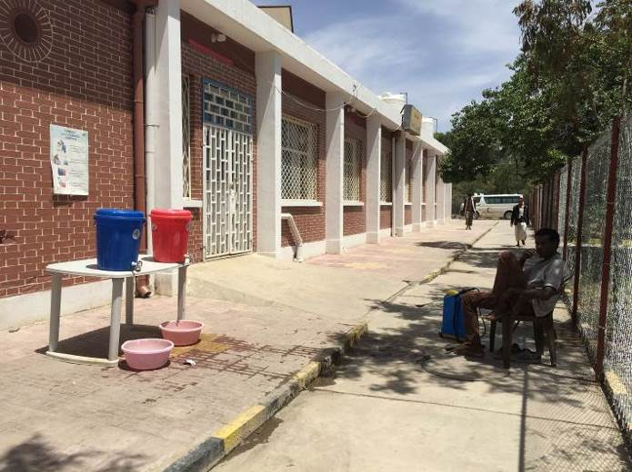
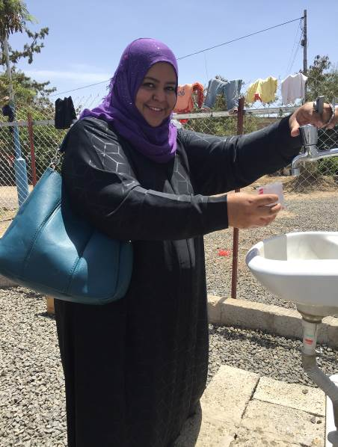
Photo 2. Entry to Sabin CTC (WHO)
Photo 1. ECHO TA, FRC Testing, Sabin CTC (WHO)

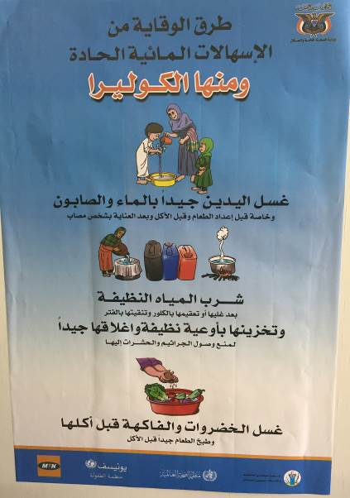
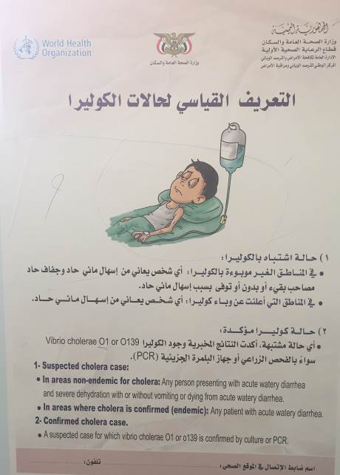
Photo 3. IEC material inside CTCs, Sabin and Azaal (WHO)

Including ACF, IRC, PU, INTERSOS, CARE, Oxfam and NRC
WHO informally confirmed that 55% of the Rapid Diagnostic Tests were negative for cholera, out of the 3,500 suspected cases tested to date. Reporting practice to date is to include any form of diarrheal disease in the line list of the CTC
This is currently available at district / sub-district level
WHO, Yemen. Weekly Epidemiological Bulletin. Electronic Integrated Disease Early Warning and Response System (eIDEWS), Vol. 5, Issue 22, Epi Week 22, 29th May – 4th June 2017 (issued on 12th June 2017)
http://reliefweb.int/report/yemen/yemen-cholera-outbreak-integrated-response-plan-23-may-2017
The wastewater is used for irrigation purposes on agricultural products, due to issues with functionality, the Biochemical Oxygen Demand (BOD) of the effluent discharged was tested to be greater than 1,500 mg/l. The acceptable limit is 20 – 30 mg/l for developed countries,
The WASH Cluster is funding a position from the Pooled funds to support a Technical Advisor, expected to be in post by September / October 2017
This is likely related to the local health authorities vested interested in salary provision due to the lack of salary payments to national healthcare staff, as CTCs and ORTCs are considered as a viable means to salary provision via the use of ‘incentives’
A Technical Working Group (TWiG) has been established to focus on this
WHO standards is a FRC of 0.2 mg/l – 0.5 mg/l for safe drinkable water, 1.0 mg/l in epidemics (such as cholera)
The plan has been developed specifically for Hodeida. UNHCR has 50,000 shelter kits readily available. ACTED, NRC and IOM have received funding from the Pooled Funds to support an emergency NFI and Shelter response
Punctual and timely rehabilitation and sealing off of unprotected water sources are to be prioritised, with limited water trucking to these locations only while works are underway
This includes preparation and availability of chlorine solutions; disinfection of cholera effluent; provision of discharge kits; safe dead body management; household level disinfection and spraying; hygiene promotion and awareness raising at community level etc.

