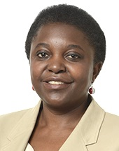
Cécile (Kashetu) Kyenge is a Member of the European Parliament (MEP), from Italy and the Group of the Progressive Alliance of Socialists and Democrats (S&D). Elected MEP in 2014, she is co-President of the EP "Anti-Racism and Diversity Intergroup" (ARDI), Vice-Chair of the Delegation to the ACP-EU, as well as a member of the Delegation for relations with the Pan-African Parliament, and of the Committee on Civil Liberties, Justice and Home Affairs (LIBE). Born in the Democratic Republic of Kongo, Ms Kyenge has lived in Italy since 1983. She became the first Italian Minister of African origin, resulting in numerous personal and racist attacks. She won the Modena municipal elections in 2004 as a member of The Democrats of the Left party. In 2013 she was elected to the Italian Chamber of Deputies, before being nominated Minister for Integration. She has a degree in medicine and surgery from the Catholic University of the Sacred Heart in Rome, and in ophthalmology from the University of Modena and Reggio Emilia. Kyenge is the author of the book “Ho sognato una strada” (I have dreamt a road).

