RETURN TO WORK PLANS (RWP)

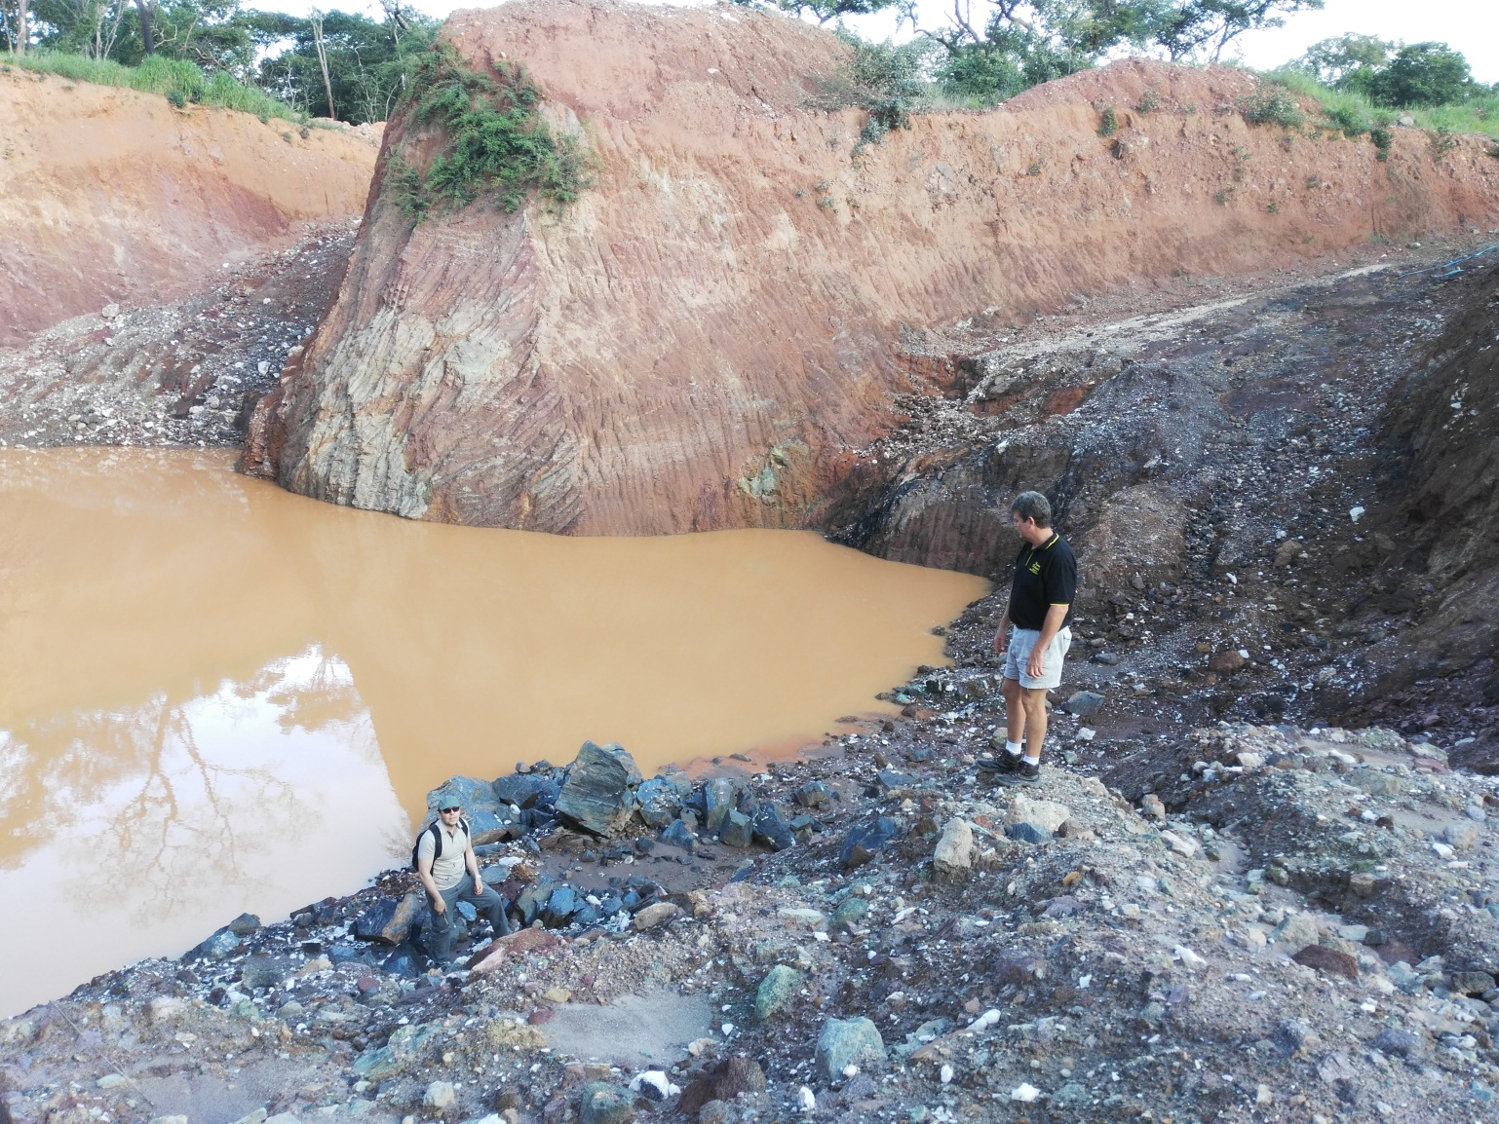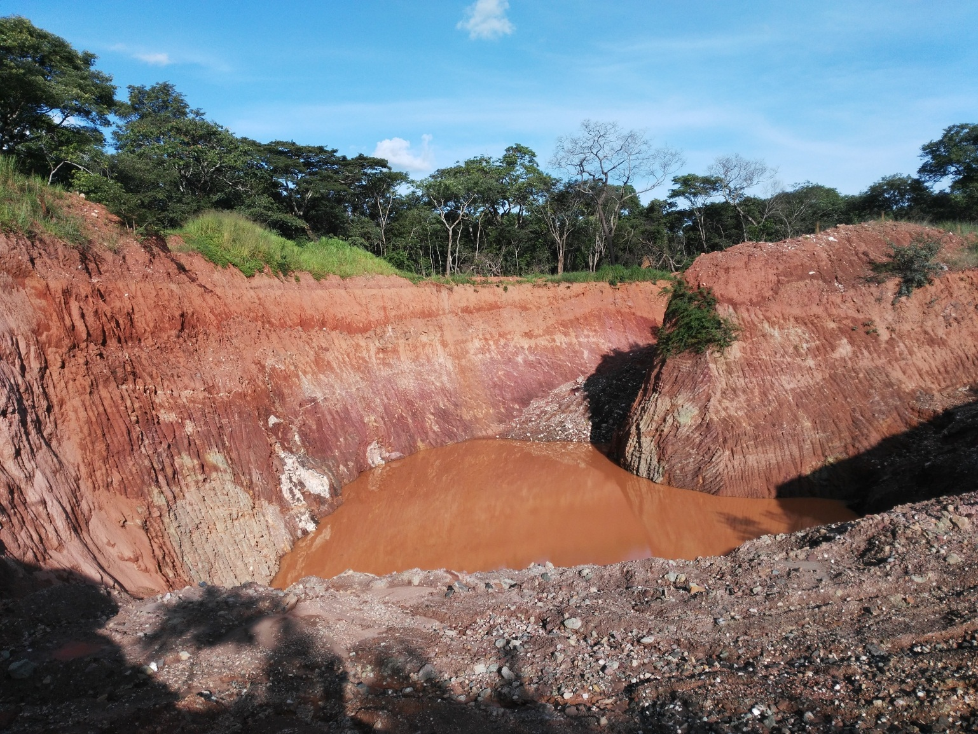

A*n initiative of the African, Caribbean and Pacific Group of States, financed by the European Union and United Nations Development Programme, and implemented by UNDP.*

1. **RETURN-TO-WORK PLANS**

Return to Work projects are a valuable mechanism for workshop participants’ personal and professional development. As part of your sponsorship, you are required to develop a return-to-work plan on a project you will undertake on your return, applying the knowledge and skills gained from workshop to influence change.

Periodic follow-up on the progress of implementation of the plan will be undertaken by UNDP.

1. **REPORTING STRUCTURE FOR RETURN-TO-WORK PLANS**

To facilitate ease of reporting and follow-up on your return to work project, the structure below outlines the key project elements that need to be covered in the reporting. **Please submit a draft Return to Work Project (RWP)** using the structure provided below.

|  |  |  |  |  |  |  |  |
| --- | --- | --- | --- | --- | --- | --- | --- |
| GENERAL INFORMATION | | | | | | | |
| Name(s): MOFFAT MUKWALA  Position: CEO, GERNTINA MINES LTD (EMERALD MINERS IN THE EMERALD RESTRICTED AREA OF LUFWANYAMA, COOPER BELT, ZAMBIA)  Email: moffat.mukwala@gmail.com  Phone no (office + mob): +260 966 948403, +260953 091961, +260 976 863461 | | | | | | | |
| THE FIRST PLACE I WOULD LIKE TO IMPLEMENT THIS WILL BE AT MY WORK PLACE, GERNTINA MINES LIMITED. THIS IS THE EMERALD MINE THAT WE RUN AS A FAMILY. WHILE GERNTINA MINES LIMITED CAN BE CLASSIFIED AS A SMALL SCALE MINING OPERATION, THIS IS A “BILLION US DOLLAR” PROJECT THAT CAN CREAT UP 500 JOBS IN THE EMERALD RESTRICTED AREA OF LUFWANYAMA DISTRICT ON THE COPPER BELT. EMERALD MINING IN LUFWANYAMA DISTRICT OF THE COPPER BELT HAS BEEN GAZETED BY THE ZAMBIAN GOVERNMENT FOR A LONG TIME IN THIS AREA UNDER THE MINING ACT OF THE MINISTRY OF MINES AND MINERAL DEVELOPMENT. THERE ARE OVER 400 EMERALD MINING PLOTS IN THE RESTRICTED AREA. GERNTINA MINES LIMITED IS AMONG THESE MINING RIGHTS HOLDERS. THE MINING RIGHTS ARE GIVEN TO REGISTERED COMPANIES UNDER PACRA, AND RECOGNAZED BY THE REPULIC OF ZAMBIA. THEREFORE, THESE MINING ACTIVITIES ARE LEGAL AND ALL EMERALD MINERS ARE EXPECTED TO BE COMPLIENT TO THE MINISTRY OF MINES, PACRA, ZRA, ZAMBIA ENVIRONMENTAL MANAGEMENT AGENCY (ZEMA) AND OTHER RELEVANT AUTHORITIES IN ZAMBIA. THE IMPLEMENTATION OF THE GERNTINA EMERALD MINING PROJECT IS REALLY IN LINE WITH THE UNITED NATIONS SUSTAINABLE DEVELOPMENT GOALS LIKE GOAL 1: END POVERTY IN ALL ITS FORMS IN ZAMBIA, 2: END HUNGER, ACHIEVE FOOD SECURITY AND IMPROVE NUTRITION AND PROMOTE SUSTAINABLE AGRICULTURE IN ZAMBIA. ON GOAL NUMBER 2, GERNTINA MINES LIMITED’S BIGGER PICTURE IS TO QUICKLY DIVERSIFY INTO SUSTAINABLE AGRICULTURE, SINCE WE REALIZE THAT MINING IS “A WASTING ASSET”. WITH THE “SUPPER PROFITS” WE PROJECT TO MAKE FROM OUR EMERALD MINING ACTIVITIES, WE CAN REINVEST SUCH PROFITS INTO COMMERCIAL FARMING THAT WILL BE SUSTAINABLE. IN THAT WAY, WE WILL BE ACHIEVING GOAL NUMBER 2. UNITED NATIONS SUSTAINABLE DEVELOPMENT GOAL NUMBER 3 AS REGARDS GOOD HEALTH AND WELL-BEING WILL BE ACHIEVED BY GERNTINA MINES LIMITED BY TAKING CARE OF ALL OUR WORKERS AT THE MINE. AS GERNTINA STARTS TO GROW BIG, OTHER UN SUSTAINABLE DEVELOPMENT GOALS WILL JUST FALL IN PLACE.  THEN SECONDLY, I CAN ALSO TARGET THE OTHER GROUPS OF PEOPLE LIKE THE STONE CRASHERS I WILL TALK ABOUT HERE BELLOW.  Brief Description of the project: 1. GERNTINA MINES LIMITED  AS AN EMERALD MINING COMPANY, GERNTINA MINES LIMITED IS INVOLVED IN EMERALD MINING IN ZAMBIA. THE MINING RIGHTS THAT WE OBTAIN FROM THE MINISTRY OF MINES ARE VALID FOR THE PERIOD OF 10 YEARS. AT THE END OF THE TEN YEAR PERIOD, GERNTINA MINES IS ELIGIBLE TO RENEW THE MINING RIGHTS FOR A FURTHER TEN YEAR PERIOD.  THE MINISTRY OF MINES WILL LOOK AT WHAT WE HAVE DONE IN THE PAST TEN YEARS. THEY WOULD LIKE TO SEE WHAT KIND OF INVESTMENT WE HAVE PUT INTO THE MINING OPERATIONS FOR THAT PERIOD AND WHAT THE PLANS FOR THE NEXT TEN YEARS WILL BE. FOR EXAMPLE, OVER THE YEARS, GERNTINA MINES LIMITED HAS INVESTED A LITTLE OVER $5 MILLION US DOLLARS IN THIS PROJECT. MOST OF THAT MONEY HAS GONE TO HIRING OF MACHINERY (EXCAVATORS FOR THE PURPOSE OF EARTH MOVING, DUMP TRUCKS, BULL DOZZARS, COMPRESSORS FOR THE PURPOSE OF DRILLING ACTIVITIES TO BLAST HARD ROCKS AS WE DEVELOP THE PITS IN ORDER TO GET TO PRODUCTION, WATER PUMPS FOR THE PURPOSE OF DEWATERING THE PITS AS WE DO OUR OPEN CUST MINING ACTIVITIES, WAGES FOR WORKERS, AREA CHARGES PAYABLE TO THE MINISTRY OF MINES AND DAY TO DAY RUNNING OF THE MINING OPERATIONS).  WE ARE ALSO CONCERNED ABOUT MANAGING OUR PEOPLE in as far as employee / employer relationship and developing the skills of our staff.  AS REGARDS THE RUNNING OF OUR BUSINESS, WE WOULD LIKE OPERATIONS OF MANAGEMENT TO IMPROVE. WE CAN ACHIEVE THAT BY TRAINING OF OUR EMPLOYEES. WHEN WE ARE IN PRODUCTION, WE WOULD LIKE TO ADD VALUE TO OUR EMERALDS BY CUTTING AND POLISHING THEM. THEN WE CAN DO EXPORTING OF OUR PRODUCTION OUTSIDE THE COUNTRY. AS REGARDS MARKETING OF OUR MINERALS, WE NEED TO TRAIN OUR STAFF IN SALES MARKETING SO THAT THEY CAN HAVE PROFESSIONALISM IN THE WAY THEY MARKET OUR EMERALDS.    THE STONE CRASHERS:  LESA WAMAKA COOPERATIVE, THESE ARE STONE CRASHERS WHO EARN A LIVING BY CRASHING STONES AS A COOPERAVE. THERE ARE 162 MEMBERS WHO ARE DOING THESE ARTISANAL MINING ACTIVITIES IN ONE AREA. THE MAJORITY OF THE MEMBERS ARE WOMEN. THEY ARE DOING THIS IN A GROUP. THEY HAVE APPOINTED PEOPLE AMONG THEMSELVES IN POSITIONS OF LEADERSHIP TO MAKE SURE THAT THEIR STONE CRASHING BUSINESS IS DONE IN AN ORDERLY FASHON. THEY VOICE THEIR CONCERNS AND PROPOSALS THROUGH THEIR CHAIR PERSON…THE NUMBER OF PEOPLE IN THE GROUP IS 162. OF THIS NUMBER, 90 ARE WOMEN AND 72 ARE MEN. THEIR CHAIRMAN IS DAN PHIRI (+260 965 200 102) WE NEED TO PUT THIS PROJECT IN PHASES. PHASE 1. LET 5 PEOPLE OR EVEN 3 PEOPLE RECEIVE TRAINING BY ATTENDING 0NE TRAINING WORKSHOP BY UNDP. PHASE 2. LET THE TRAINED PEOPLE TRAIN OTHERS. PHASE 3. LET THE PEOPLE WHO HAVE RECEIVED TRAINING LEARN HOW TO PUT TO GOOD USE THE TRAINING THEY RECEIVE BY INCREASING THEIR PRODUCTION FROM SMALL TONNAGE OF CRASHED STONES TO HUGE TONNAGE. WITH GOOG MANAGEMENT OF THEIR GROUP , THEY CAN PLAN TO BUY A CRUSHER, A TIPPER TRUCK AND A FRONT END LODDER FOR USE AS A COOPERATIVE. WHEN THEY RECEIVE TRAINING ON ENVIRONMENT, THIS WILL HELP BE A TOOL THAT WILL HELP THE GROUP TO PLAN, IMPLEMENT, CHECK AND IMPROVE ENVIROMENTAL MANAGEMENT. | | | | | | | |
| Expected Outcomes: TO IMPROVE THE WAY THEY DO THEIR BUSINESS BY HELPING THEM INCREASE PRODUCTION, TO HELP THEM FIND A BETTER MARKET FOR THEIR PRODUCT AND TO TRAIN THEM IN SOME SKILLS THEY ARE LACKING LIKE ARTISANAL MINING, SAFETY AND GOOD ENVIRONMENTAL MANAGING SKILLS | | | | | | | |
| Expected Outputs: AFTER THEIR TRAINING, THEY CAN BETTER UNDERSTAND THEIR BUSINESS, THEY WILL HAVE KNOWLEDGE SAFETY, THEY WILL HAVE KNOWLEDGE ON HOW THEY CAN MANAGE TO DO THEIR BUSINESS WHILE TAKING CARE OF THE ENVIRONMENT. THEY WILL ALSO IMPROVE THEIR PRODUCTION | | | | | | | |
| Please describe how you plan to implement the return to work project: (outline key partnerships and collaborations across sectors in your country as well as any joint collaboration with other countries)   I PLAN TO HOLD MEETINGS WITH THEM AND PLAN A TRAINING PROGRAM FOR THEM | | | | | | | |
| What indicators of success will you employ? (include indicators of success that go beyond activity-level implementation)  AFTER THEIR TRAINING, I WILL LOOK FORWARD TO SEEING HOW THEY WILL PUT THE KNOWLEDGE THEY WILL ACQUIRE FROM THE TRAAINING TO GOOD USE. THE INDICATORS OF SUCCESS WILL BE SEEN WHEN THEY WILL IMPLEMENT THE SUGGESTIONS GIVEN TO THEM DURING THEIR TRAINING | | | | | | | |
| What other strategic opportunities have you identified that will contribute to the success and sustainability of your project? (include linkages to sub-regional and regional agenda)   THE CRY FOR JOB CREATION IN OUR COUNTRY IS LOUD AND CLEAR. ALL IN THE COOPERATIVE NEEDS TO SEE AN EXPANSION PROGRAM IN WHAT THEY DO. WAYS TO EXPAND THEIR BUSINESS ARE MANY BECAUSE OF THE BOOMING CONSTRUCTION WORKS AROUND THE COUNTRY AND IN THEIR OWN VICINITY | | | | | | | |
| What aspects of the training will be most useful in implementing your project? Explain   KNOWLEDGE SHARING, COORDINATION BETWEEN THE TRAINERS AND THE END USERS OF THE KNOWLEDGE THEY WILL RECEIVE | | | | | | | |
| What are your future plans? (Include any additional capacity building needs for your professional development that you have identified during the course of the workshop). ON THE EMERALD MINING ACTIVITIES AT GERNTINA MINES, THE FUTURE PLANS ARE TO PUT IN PLACE WORKING CAPITAL TO KICK START THE OPERATIONS THAT WILL LEAD US TO FIRST PRODUCTION. WHEM WE MARKET THE FIRST PRODUCTION, WE CAN PLAN TO MAKE SURE THAT THE MINE HAS CONSTANT PRODUCTION. WHAT IS NOT IN PLACE IS WORKING CAPITAL TO CONTINUE OPERATIONS. UNDP CAN ALSO TRY AND CONNECT US TO BUSINESS HOUSES WHO CAN FUND THE EMERALD MINING ACTIVITIES.  IN THE PHOTO BELOW, ONE PIT HAS BEEN DEVELOPED AND WE ARE PUSHING TO PRODUCTION  C:\Users\Mukwala\Desktop\IMG_20160224_165243.jpg  C:\Users\Mukwala\Desktop\IMG_20160224_171450.jpg  ONE OF THE PITS AT GERNTINA MINES LIMITED, SOME INVESTORS HAVE COME TO VISIT THE SITE AT OUR MINE  STONE CRASHERS: LESA WAMAKA CLUB OF KALULUSHI   THE FUTURE PLANS ARE THAT THE 162 MEMBERS OF THE GROUP CAN BE HELPED TO EXPAND INTO A THRIVING BUSINESS OF STONE CRASHING, MARKETING OF CRASHED STONES TO CONSTRUCTION COMPANIES WHO ARE IN THE BIG CONSTRUCTION INDUSTRY | | | | | | | |
| ACTION PLAN | | | | | | | |
| Period  Activities | Month 1 | Month 2 | Month 3 | Month 4 | Month 5 | Month 6 | Month 7 |
| Activity 1: | TRAINING IN MANAGING PEOPLE | DEVELOPMENT OF STAFF, TEAM WORK SKILLS | TRAINING IN CAPACITY BUILDING | TRAIN STAFF IN EXPORTING SKILLS | TRAIN STAFF IN VALUE ADDITION TO OUR PRODUCT | LEGAL ISSUES HANDLING | **TRANSPORTATION OF EMERALDS TO THE MARKET** |
| Activity 2: |  | PUT THE KNOWLEDGE INTO USE | INSURANCE OF THE PRODUCT |  |  |  |  |
| Activity 3: | SOCIAL SKILLS IN BUSINESS |  | HOW TO INCREASE OUR PRODUCTION |  |  |  |  |
| Activity 4: | TRAIN STAFF TO KNOW THE GEOLOGY OF THE MINE | TO TRAIN STAFF KNOW THE DEPOSIT OF PRODUCT ON THE MINE. AVOID TO DUMP ON THE VEIN |  | LEAD THE GROUP TO BETTER MARKET | SEE HOW THE GROUP CREAT NEW JOBS | SEE HOW EACH MEMBER COMES OUT OF POVERTY |  |
| Activity 5: | STAFF TRAINING |  | BUSINESS ETHICS TRAINING | DEVELOP A BUSINESS PLAN | HELP IN BUSINESS FINANCE | MANAGING DAILY FINANCE |  |
| Etc. |  |  |  |  |  |  |  |

1. **SUBMISSION DATE OF THE DRAFT RETURN-TO-WORK PLAN**

The draft Return to Work plan should be sent to [development.minerals@undp.org](mailto:development.minerals@undp.org)