**Program partners:** **Event partners:**

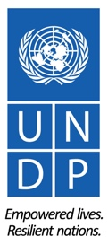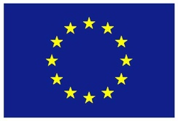

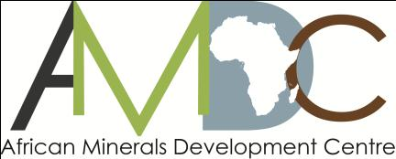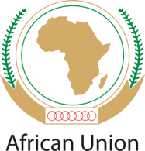

**REGIONAL TRAINING WORKSHOP ON ENVIRONMENT, COMMUNITY, HEALTH & SAFETY IN THE LOW VALUE MINERALS AND MATERIALS (LVMM) SECTOR**

**ADDIS ABABA NOVEMBER 9-12, 2015**

RETURN TO WORK (RTW) PLANS FOR UNDP SPONSORED PARTICIPANTS

1. **RETURN-TO-WORK PLANS**

Return to Work projects are a valuable mechanism for workshop participants’ personal and professional development. As part of your sponsorship, you are required to develop a return-to-work plan on a project you will undertake on your return, applying the knowledge and skills gained from workshop to influence change.

Periodic follow-up on the progress of implementation of the plan will be undertaken by UNDP, with the first update expected at the 2-month mark, in January 2015. A subsequent follow-up in April 2016 will be undertaken and periodic follow-ups thereafter.

1. **REPORTING STRUCTURE FOR RETURN-TO-WORK PLANS**

To facilitate ease of reporting and follow-up on your return to work project, the structure below outlines the key project elements that need to be covered in the reporting. **Please submit a draft Return to Work Project (RWP)** using the structure provided below.

**REPORTING STRUCTURE**

|  |  |
| --- | --- |
| **GENERAL INFORMATION** | |
| **Name(s):** |  |
| **Details:**  Position:  Email:  Phone no (office + mob): | 1. Sori Chalchisa: Sociologist : soribs200@gmail.com 2. Samuel Gobena: Environmentalist: sami8766@gmail.com 3. Tesfaye Kebede : Environmentalist: tesfamom@gmail.com 4. Henock Atnafe: OHS expert: hatnafe@yahoo.com |
| **Brief Description of the project:** | Artisanal miners lack the knowledge and skill to mine low value minerals and materials in socially acceptable, environmental friendly way and in way that does not pose hazard to their health and safety as well as their minerals value chain management. Therefore, conducting awareness raising and capacity building training to artisanal and small scale miners, Woreda Administration officials is essential to reduce the environmental impacts and prevent the potential work related accidents. |
| **Expected Outcomes:** | * Creating and raising awareness on environmental, social safety and health issues of LVMM mining * Awareness creation on mitigation measures and rehabilitation of LVMM mine sites * Creating a conducive environment for the value chain between producers and users. |
| **Expected Outputs:** | * Reduction of the environmental impacts of mining of LVMM * Decrease of mining related health impacts and accidents * Implementation of mitigation measures and /or rehabilitation * Creating of good value chain processes * Creating good community relation between miners and local community |
| **Please describe how you plan to implement the return to work project:** (outline key partnerships and collaborations across sectors in your country as well as any joint collaboration with other countries) | This plan implemented with Relevant Federal Ministries, Regional offices, Zonal and Woreda administration and Non- governmental organizations. |
| **What indicators of success will you employ?** (include indicators of success that go beyond activity-level implementation) | * Safe and unpolluted environment * Socially accepted mining activities & good community relation * number of occurrence of mine- related accidents * Number of trees planted * Hectare of lands rehabilitated * Simple and accepted value chain development on raw materials |
| **What other strategic opportunities have you identified that will contribute to the success and sustainability of your project?**  (include opportunities linked to national level policy, strategies and programmes as well as linkage to sub-regional and regional agenda) | Currently, Ethiopia is building Climate resilient green economy. In this strategy, addressing the environmental, social, health and safety issues of mineral development has been given priority to ensure the sustainable development of the sector. Similarly Ethiopia follow the agriculture led Industry strategy which needs to work on the linkage of LVMM and Industry. Therefore, The implementation of this project has contribution to this strategy. |
| **What aspects of the training will be most useful in implementing your project?** Explain | 1. Impacts to land community: residues/rehabilitation 2. Occupational health and safety 3. Gender and community heath, community relations, dialogue and rights 4. local content and value chain development 5. policy and regulation(impact assessment/management plans/licensing   The above training topics will be useful to assess the gaps of knowledge and skill prevailing on the artisanal and small scale miners being increase the need of OHS, Environment and community relations as well as value chain development during mining. |
| **What are your future plans?** (include any additional capacity building needs for your professional development that you have identified during the course of the workshop). | * Identify the gaps in environmental, Community and occupational health and safety of LVMM * Create awareness on Reduction of the environmental, social and health impacts of mining of LVMM, * Decreasing of mining related accidents * Implementation of different mitigation measures and /or rehabilitation * Creating the conducive value chain development   Additional capacity building needs in detail trainings on First regional training workshop on Environment, Community, Health and safety (09-12 November 2015),for professional development of the sector. |

|  |  |
| --- | --- |
| **Implementation timeline (please detail out timeline for the stated above implementation plan [month/year] )** | Example:   * Output 1: from Dec 15 to march 2016 * Output 2: from Jan 2016-to xxx 2015 |

1. **SUBMISSION DATE OF THE DRAFT RETURN-TO-WORK PROJECT**

The draft Return to Work project is due **by Friday 27 November 2015** and should be sent to: Lacina Pakoun ([lacina.pakoun@undp.org](mailto:lacina.pakoun@undp.org))