Program partners: Event partners:
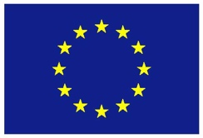

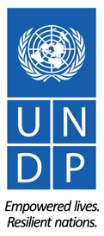
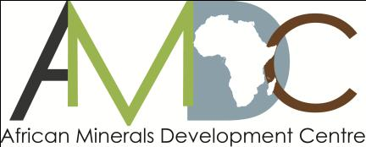
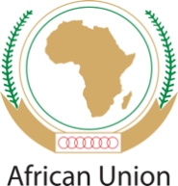

REGIONAL TRAINING WORKSHOP ON ENVIRONMENT, COMMUNITY, HEALTH & SAFETY IN THE LOW VALUE MINERALS AND MATERIALS (LVMM) SECTOR

ADDIS ABABA NOVEMBER 9-12, 2015

RETURN TO WORK (RTW) PLANS FOR UNDP SPONSORED PARTICIPANTS

- RETURN-TO-WORK PLANS
Return to Work projects are a valuable mechanism for workshop participants’ personal and professional development. As part of your sponsorship, you are required to develop a return-to-work plan on a project you will undertake on your return, applying the knowledge and skills gained from workshop to influence change.

Periodic follow-up on the progress of implementation of the plan will be undertaken by UNDP, with the first update expected at the 2-month mark, in January 2015. A subsequent follow-up in April 2016 will be undertaken and periodic follow-ups thereafter.

- REPORTING STRUCTURE FOR RETURN-TO-WORK PLANS
To facilitate ease of reporting and follow-up on your return to work project, the structure below outlines the key project elements that need to be covered in the reporting.Please submit a draft Return to Work Project (RWP) using the structure provided below.
REPORTING STRUCTURE
GENERAL INFORMATION
Name(s): | Davis Osoro
Details:  Position:  Email:  Phone no (office + mob): | Coordinator, Extractive Sector Observatory  osoromm@gmail.com  +25420 /+254721131525
Brief Description of the project: | Desktop mapping of the LVMM sub-sector in Kenya. Since the time given to carry out RWP is limited I will carry out an initial mapping of the areas where LVMM are mined in the country.
Expected Outcomes: | -Increased knowledge on the LVMM sub-sector in Kenya by a range of stakeholders.  -More focused projects within my work circles & collaborations.  -Engagement with the LVMM artisans will be initiated and nurtured
Expected Outputs: | -Informational report containing a comprehensive list of places where LVMM mining activities take place.  -Raw data that will feed into a larger and longer project of mapping the entire extractive industry in Kenya.
Please describe how you plan to implement the return to work project:(outline key partnerships and collaborations across sectors in your country as well as any joint collaboration with other countries) | The process is a simple browsing through all forms of literature that are available in the country such as the web, CSO reports, government records and other libraries such as the World Bank’s and AfDB’s. I will also leverage on the new networks that I created in the LVMM workshop in Addis (three of which were geolosgists from Kenya and one who is a player in the semi-precious gemstones business). I have already made the necessary liaison with them and set the stage for data gathering through their other networks.
What indicators of success will you employ? (include indicators of success that go beyond activity-level implementation) | The immediate activity level success indicator will be the material reports that I will have produced and disseminated to the relevant stakeholders. The longer-term success indicator will be a clear increased focus in terms of policy and guidelines formulation on the LVMM sub-sector by mainly the government agencies.
What other strategic opportunities have you identified that will contribute to the success and sustainability of your project?  (include opportunities linked to national level policy, strategies and programmes as well as linkage to sub-regional and regional agenda) | The Ministry of mining and by extension the government of Kenya wants to collect as much data and to update their databases on the state of the mining industry in the country. Furthermore Kenya is holding multi-stakeholder forums to discuss the Africa Mining Vision and there is already a call to have reliable data on mining in Kenya to work with. This is the data I am preparing to collect and I will thereby piggyback on the goodwill of some of this institutions and initiatives that can help my project in some way.
What aspects of the training will be most useful in implementing your project? Explain | The training gave me insights on how to classify the extractive sector as well as identifying the associated environmental impacts. This knowledge will help me to be able to correctly understand each LVMM mining activity in Kenya and all its characteristics such as the nature of environmental footprint each mining activity has.
What are your future plans? (include any additional capacity building needs for your professional development that you have identified during the course of the workshop). | I plan to engage more effectively in the extractive sector to ensure that Kenya sets the right environment for sustainable exploitation of her minerals. In this regard I will work in any platform or any organizations focusing on this theme. For me to achieve this I believe information gathering is indefinite thereby I will continuously seek to build my personal capacity. For instance I realized that I barely know much about the LVMM subs-sector and I will strive to learn more on this through any means.

Implementation timeline (please detail out timeline for the stated above implementation plan [month/year] ) | Example:  - Outcome 1: from Dec 15 to march 2016  - Outcome 2: from Jan 2016-to xxx 2015

- SUBMISSION DATE OF THE DRAFT RETURN-TO-WORK PROJECT
The draft Return to Work project is due by Friday 27November 2015and should be sent to:LacinaPakoun (lacina.pakoun@undp.org)

