**Program partners:** **Event partners:**

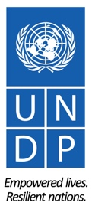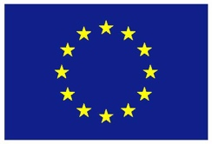

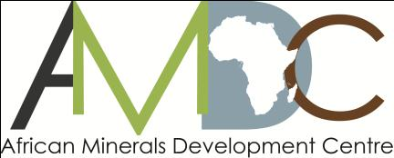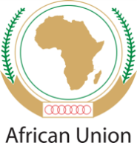

**REGIONAL TRAINING WORKSHOP ON ENVIRONMENT, COMMUNITY, HEALTH & SAFETY IN THE LOW VALUE MINERALS AND MATERIALS (LVMM) SECTOR**

**ADDIS ABABA NOVEMBER 9-12, 2015**

RETURN TO WORK (RTW) PLANS FOR UNDP SPONSORED PARTICIPANTS

1. **RETURN-TO-WORK PLANS**

Return to Work projects are a valuable mechanism for workshop participants’ personal and professional development. As part of your sponsorship, you are required to develop a return-to-work plan on a project you will undertake on your return, applying the knowledge and skills gained from workshop to influence change.

Periodic follow-up on the progress of implementation of the plan will be undertaken by UNDP, with the first update expected at the 2-month mark, in January 2015. A subsequent follow-up in April 2016 will be undertaken and periodic follow-ups thereafter.

1. **REPORTING STRUCTURE FOR RETURN-TO-WORK PLANS**

To facilitate ease of reporting and follow-up on your return to work project, the structure below outlines the key project elements that need to be covered in the reporting. **Please submit a draft Return to Work Project (RWP)** using the structure provided below.

**REPORTING STRUCTURE**

|  |  |
| --- | --- |
| **GENERAL INFORMATION** | |
| **Name(s):** | Gonzaga Mungai |
| **Details:**  Position:  Email:  Phone no (office + mob): | Gold Manager, Fairtrade Africa  [g.mungai@fairtradeafrica.net](mailto:g.mungai@fairtradeafrica.net)  +254 020 272 1930 |
| **Brief Description of the project:** | Building Resilient ASM Communities in East Africa (**Subject for Funding Confirmation in close of 2015**) |
| **Expected Outcomes:** | 1. Increased productivity and safer, cleaner and more responsible workplaces at ASM sites 2. Supportive enabling environment for legitimate ASM businesses |
| **Expected Outputs:** | 1. Create a pioneering investment led model to enable ASMs access finance and invest in capital equipment. 2. Share of leanings & best practices on OHS, Gender, Environment & Community Health shared with wider stakeholders and ASM Communities 3. ASM communities (Gold), trained in OHS and Environmental practices (part of which adopted from Development Mineral Project) |
| **Please describe how you plan to implement the return to work project:** (outline key partnerships and collaborations across sectors in your country as well as any joint collaboration with other countries) | 1. We shall work with selected Local Implementation Partners in Kenya, Uganda and Tanzania to roll out the work with ASMs on the ground. 2. We shall work with other stakeholders such as NGOs, and government representatives with an interest in mining (ASM) to share learnings and contribute to an improved sector. 3. We shall continue to exchange with stakeholders and practitioners in ASM sector to share best practices and increase impact to ASM communities. |
| **What indicators of success will you employ?** (include indicators of success that go beyond activity-level implementation) | 1. Number of ASM Groups actively using enhanced mining equipment 2. Number of ASMs reporting increased production of 20% or more as a result of enhanced mining equipment 3. Number of ASMs with increased net income of 20% or higher |
| **What other strategic opportunities have you identified that will contribute to the success and sustainability of your project?**  (include opportunities linked to national level policy, strategies and programmes as well as linkage to sub-regional and regional agenda) | 1. Opportunity for joint efforts to increase visibility of ASM as a tool for local economic development in National Mining and Development policy agendas (esp in Uganda and Kenya, and other African states where ASM policy is weak) 2. Opportunity to show case viable ASM businesses and demonstrate ASM level organizational development models 3. Opportunity to pilot investment & capital models with mature ASMs beyond our project scope e.g in the Development Minerals sector as a means to commercialize ASM businesses and build sustainable ventures (in consideration of social, environmental and business best practices) |
| **What aspects of the training will be most useful in implementing your project?** Explain | 1. The networks with various stakeholders especially in government and NGOs in East Africa 2. The trainings on OHS, Community Health and environmental considerations 3. The knowledge and understanding of different legal regimes and approaches to the development and regulation of ASM in the region as shared by the participants/ facilitators |
| **What are your future plans?** (include any additional capacity building needs for your professional development that you have identified during the course of the workshop). | 1. Scoping for opportunities to scale impact to ASM communities through the capital investment model and capacity building work across the region |
| **Timeframe** |  |

1. **SUBMISSION DATE OF THE DRAFT RETURN-TO-WORK PROJECT**

The draft Return to Work project is due **by Friday 27 November 2015** and should be sent to: Lacina Pakoun (lacina.pakoun@undp.org)