**Program partners:** **Event partners:**

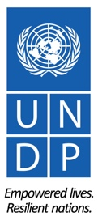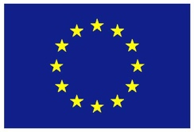

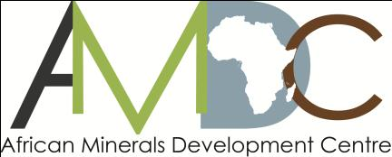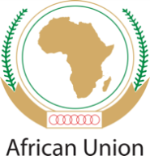

**REGIONAL TRAINING WORKSHOP ON ENVIRONMENT, COMMUNITY, HEALTH & SAFETY IN THE LOW VALUE MINERALS AND MATERIALS (LVMM) SECTOR**

**ADDIS ABABA NOVEMBER 9-12, 2015**

RETURN TO WORK (RTW) PLANS FOR UNDP SPONSORED PARTICIPANTS

1. **RETURN-TO-WORK PLANS**

Return to Work projects are a valuable mechanism for workshop participants’ personal and professional development. As part of your sponsorship, you are required to develop a return-to-work plan on a project you will undertake on your return, applying the knowledge and skills gained from workshop to influence change.

Periodic follow-up on the progress of implementation of the plan will be undertaken by UNDP, with the first update expected at the 2-month mark, in January 2015. A subsequent follow-up in April 2016 will be undertaken and periodic follow-ups thereafter.

1. **REPORTING STRUCTURE FOR RETURN-TO-WORK PLANS**

To facilitate ease of reporting and follow-up on your return to work project, the structure below outlines the key project elements that need to be covered in the reporting. **Please submit a draft Return to Work Project (RWP)** using the structure provided below.

**REPORTING STRUCTURE**

|  |  |
| --- | --- |
| **GENERAL INFORMATION** | |
| **Name(s):** | **LIZUNELA DUNCAN AMBEMBO** |
| **Details:**  Position:  Email:  Phone no (office + mob): | CHIEF SUPERINTENDING GEOLOGIST  dalizunela@yahoo.com  +254722247056 OR +254 734424670 |
| **Brief Description of the project:** | **MAPPING, DATA COLLECTION AND DOCUMENTATION OF ARTISANAL LOW VALUE MINING SITES IN WESTERN REGION** |
| **Expected Outcomes:** | Reconnaissance tour of the western region to identify areas of artisanal mining activities for low value minerals and materials.  Identification of artisanal mining activities requiring attention.  Formation of a team to undertake mapping and data collection on the various types of low value minerals and materials.  Map out areas of artisanal mining areas for various types of stones, stone products and sand harvesting.  Organize seminars and workshops for artisanal miners in the low value minerals sector to sensitize on issues such as environment protection, safety regulations and gender mainstreaming. |
| **Expected Outputs:** | Information about artisanal mining areas for low value minerals and materials.  Geo-data on low value minerals in the region  Data about artisanal mining activities, the number of people involved, types minerals mined.  Geographical locations or distribution of areas with low value minerals artisanal mining activities,  GIS maps of the areas of low value minerals mining,  Essential requirements of artisanal low value miners  Challenges faced by the artisanal miners identified  Miners trained and sensitized through workshops and seminars.  Improvement on the value chain for low value minerals and products. |
| **Please describe how you plan to implement the return to work project:** (outline key partnerships and collaborations across sectors in your country as well as any joint collaboration with other countries) | This will be done through the normal project undertakings of the Ministry of Mining in the western region.  Key partners in the process will include:-  Ministry of Mining,  County governments of the counties concerned (Bungoma, Busia, Kakamega and Vihiga)  Regional NEMA office,  Local administration,  The communities involved or in the affected areas,  Ministry in charge of water,  Contributions from other countries in the region will be welcome. |
| **What indicators of success will you employ?** (include indicators of success that go beyond activity-level implementation) | Team formed to undertake mapping,  Geo-data on artisanal mining of low value minerals available and accessible.  Trainings conducted for the artisanal miners.  Miners formed into groups and registered (for ease of regulation processes)  Distribution map of low value minerals produced.  Report produced |
| **What other strategic opportunities have you identified that will contribute to the success and sustainability of your project?**  (include opportunities linked to national level policy, strategies and programmes as well as linkage to sub-regional and regional agenda) | The good will of the Government through the Ministry of Mining to create employment and reduce poverty for its people. The fast growing construction industry which is the main outlets for the LVMM products.  The opportunities will be in line with policies outlined in the following national documents;  The Constitution of Kenya 2010,  Kenya Vision 2030  The Minerals and Mining Policy of Kenya  The Mining Act Cap 309 and the Mining Bill 2015,  The EMCA Act 2015,  The Water Act 2005,  The various County legislations on environment and development. |
| **What aspects of the training will be most useful in implementing your project?** Explain | The field visits to the Ethiopian Artisanal Mining sites for ash and hardcore stone, the case studies presented and the new ideas learnt from other participants during the training and interactive sessions.  These helped me recognize what needs to be done to assist in promoting and regulating low value minerals activities. |
| **What are your future plans?** (include any additional capacity building needs for your professional development that you have identified during the course of the workshop). | Participate in similar training programmes in future when for knowledge growth  Undertake training in Environmental Impact Assessment and Strategic Environmental Assessment.  Training on uses of GIS for mapping resources  Short courses on community development and conflict resolution mechanisms. |

|  |  |
| --- | --- |
| **Implementation timeline (please detail out timeline for the stated above implementation plan [month/year] )** | Example:   * Outcome 1: from Dec 15 to march 2016 * Outcome 2: from Jan 2016-to xxx 2015 |

1. **SUBMISSION DATE OF THE DRAFT RETURN-TO-WORK PROJECT**

The draft Return to Work project is due **by Friday 27 November 2015** and should be sent to: Lacina Pakoun (lacina.pakoun@undp.org)