**Program partners:** **Event partners:**

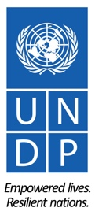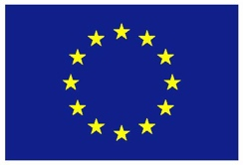

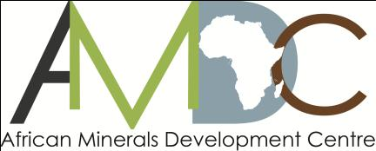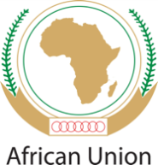

**REGIONAL TRAINING WORKSHOP ON ENVIRONMENT, COMMUNITY, HEALTH & SAFETY IN THE LOW VALUE MINERALS AND MATERIALS (LVMM) SECTOR**

**ADDIS ABABA NOVEMBER 9-12, 2015**

RETURN TO WORK (RTW) PLANS FOR UNDP SPONSORED PARTICIPANTS

1. **RETURN-TO-WORK PLANS**

Returns to Work projects are a valuable mechanism for workshop participants’ personal and professional development. As part of your sponsorship, you are required to develop a return-to-work plan on a project you will undertake on your return, applying the knowledge and skills gained from workshop to influence change.

Periodic follow-up on the progress of implementation of the plan will be undertaken by UNDP, with the first update expected at the 2-month mark, in January 2015. A subsequent follow-up in April 2016 will be undertaken and periodic follow-ups thereafter.

1. **REPORTING STRUCTURE FOR RETURN-TO-WORK PLANS**

To facilitate ease of reporting and follow-up on your return to work project, the structure below outlines the key project elements that need to be covered in the reporting. **Please submit a draft Return to Work Project (RWP)** using the structure provided below.

**REPORTING STRUCTURE**

|  |  |
| --- | --- |
| **GENERAL INFORMATION** | |
| **Name(s):** | MAJALA MLAGUI |
| **Details:**  Position:  Email:  Phone no (office + mob): | Founder, Thamani Group  [majala@thamani.co](mailto:majala@thamani.co)  +254722167067 |
| **Brief Description of the project:** | Research and analysis of marble and limestone rock breaking activities undertaken by Women in Taita Taveta, Kenya |
| **Expected Outputs:** | * Understand their exploitation /extraction techniques and tools used * Quantification of the output of daily/monthly extraction work. * Document the impacts both positive and negative of the activities on the women’s health and safety, the surrounding environment. * Documentation of the supply chain and income generated for the activities that filter into other community activities. * Mobilisation and inclusive participation of women groups in monitoring environmental impacts of the activities for a suitable timeframe e.g. 6 month and recommend better practices that can be implemented by the women miners * Where necessary reengineer the supply chain process and product portfolio assisting in the income generation potential from the marble and limestone materials. |
| **Expected Outcomes:** | * Raise awareness of the involvement of women in the sector and the possible environmental and social impacts of these activities. * Recommend alternative appropriate technologies that would assist in improving the extraction and manufacturing process of the marble ballast * Provide basis for policy inputs both at local and national levels on the management of the construction mineral activities. |
| **Please describe how you plan to implement the return to work project:** (outline key partnerships and collaborations across sectors in your country as well as any joint collaboration with other countries) | * On ground research activity to map out and document the exact areas that women are participating in marble/limestone extraction and processing * Through the community women groups Thamani works with we shall bring together the women community leaders some of whom are involved in these activities to better understand the community impact both of the income generated and the environmental impact. * We shall liaise with the local county government office to understand the management and technical assistance available. * We shall work with the Local National Environmental Management Authority Office to assist in training (where required) of health and safety issues and environmental plan management. |
| **What indicators of success will you employ?** (include indicators of success that go beyond activity-level implementation) | * Documented figures of activities and operators in the sub-sector * Organised women groups gaining access to technical and financial support for their activities * Implementation of health and safety procedures and development of a community led environmental management plan |
| **What other strategic opportunities have you identified that will contribute to the success and sustainability of your project?**  (include opportunities linked to national level policy, strategies and programmes as well as linkage to sub-regional and regional agenda) | * The focus of the SDGs on gender equality and provision of jobs. * The opportunity for the provision of geological information from one of the African Mining Vision Key Initiatives. * The appetite for the National Environment Management Authority to assist ASM operators in assessing and managing environmental impacts within their activities. |
| **What aspects of the training will be most useful in implementing your project?** Explain | * The classification of development minerals * The methods with which to perform analysis of health and safety and environmental impacts |
| **What are your future plans?** (Include any additional capacity building needs for your professional development that you have identified during the course of the workshop). | * Financial management * Business Planning for mine operations * From Mine to Market product value chain development e.g. marble rock to agro input (qualities, quantities etc.) |

1. **SUBMISSION DATE OF THE DRAFT RETURN-TO-WORK PROJECT**

The draft Return to Work project is due **by Friday 27 November 2015** and should be sent to: Lacina Pakoun (lacina.pakoun@undp.org)