Dear all,

It would be good to get some preparation going also so that there is plenty of time for the practical arrangements of:

• Printing and distributing a course folder (including evaluation forms and group work material)
• Arranging for guest speakers (and testing the length and relevancy of their power point presentations)
• Invitations (both for day 1-3 and for day 4)
• Booking and arranging a venue (including daily registration of attendees)
• Planning the more specialized or tailored inputs on day 4: “Developing the partnership” (MoU and CoC)
• Obtaining the key Ghana water documents that people feel should be put in the folder e.g. the draft PP/MoU/CoC and road map etc

I will come back in turn on all of the above. In the meantime there are a couple of things that we should decide on soon: i) title and 2) Agenda.

Once we have done that we can start to prepare the slides and make emails to help with the preparation. A key point here is the identification of a suitable liaison person i.e. the workshop organizer in Ghana.

1) Title:

So far in the correspondence we have had two suggestions:

“Design seminar SPSP Water”
“SWAP and IWRM”

We could also have others e.g.
“ Deepening partnership in the water sector in Ghana”
“From theory to practice – SWAP and IWRM in the water sector in Ghana”

Best that those in Ghana select

2) Main agenda

The basic outline is already agreed: a 3 day course on SWAP with tailoring for water sector and introduction of IWRM; with a 4th day on PP and COC. I put a first version of an agenda below which reflects this.

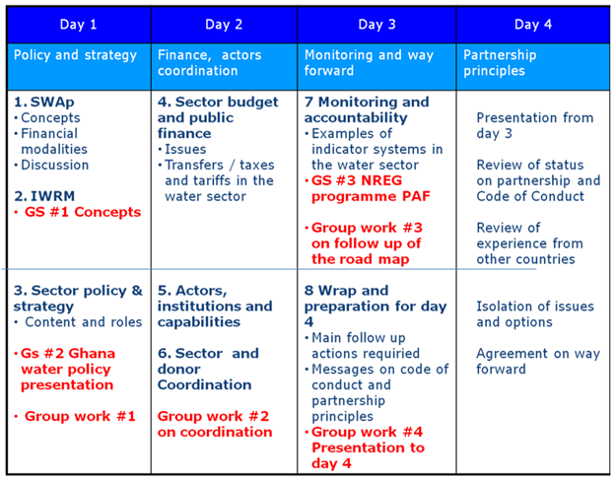

Gs= guest speaker.

Guest speakers – 4 will need to be invited and present their powerpoints quite early on so we can ensure relevance etc
1) Concepts – someone perhaps from GWP office or Ghanan water resources institute to give a 15 min presentation on status / challenges / issues / policy options in Ghana on IWRM
2) Ghana water policy – a policy maker to present perhaps from the Water Directorate in Ministry of Public works
3) NREG, PAF and monitoring set up – someone from that programme which has been going for a long time to present on the Performance Assessment Framework for NREG
4) Road map – someone who has been involved in that work

