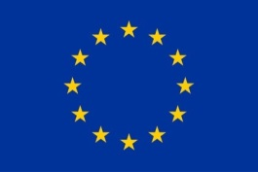
EUROPEAN UNION
CIVIL SOCIETY FORUM
NEIGHBOURHOOD SOUTH
10-12 July 2017, Brussels (Fourth Edition)

SUMMARY and KEY RECOMMENDATIONS

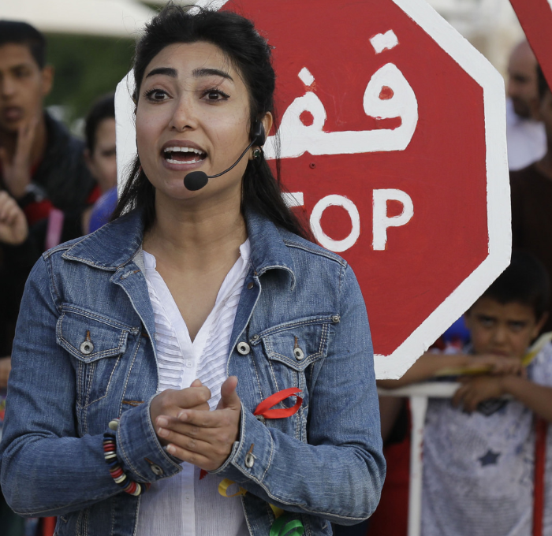

The final report of the Forum is to the published by the end of October 2017.
The present document and the full report will be then translated in French and Arabic, and published online.

This report has been produced with the assistance of the European Union (European Commission: DG NEAR and DEVCO, EEAS, Economic and Social Committee, and Committee of the Regions). The content of this report is the sole responsibility of the experts recruited by the Civil Society Facility South – CSFS (TRANSTEC, Technical Assistance) and cannot be taken to reflect the views of the European Union.

BACKGROUND AND OBJECTIVES

Consistent with the European Neighbourhood Policy (ENP), the EU Consensus on Development and the EU Global Strategy, and building on dialogues and recommendations from previous editions (2014, 2015 and 2016), the 2017 CS Forum Neighbourhood South was shaped under the umbrella theme of “resilience and youth”.
This mechanism for dialogue offers opportunities of exchanging views and debate jointly on regional policy agendas, and enhance partnerships between civil society and key stakeholders from the Southern Neighbourhood (regional bodies, national and local authorities, social actors, media, private sector, academics, etc.) and, the EU institutions.
The objectives of the Forum consist in (i) the development of recommendations by civil society to the EU, and (ii) setting up a plan of action for civil society in the region.
These recommendations and plan of action will set the basis for a renewed structured dialogue from 2018, to be facilitated by a regional civil society hub for structured dialogue to be managed by civil society, in coordination with the EU.

METHODOLOGY

The Forum was organised in two steps: (i) CS preparatory meetings held in the region (for about 120 participants in Tunis in April 2017), and a multi-stakeholders forum in Brussels in July 2017 (that gathered about 160 participants) around four priority themes:
(1) strengthening resilience and promoting stability,
(2) human rights and governance,
(3) migration,
(4) reducing inequalities.

The whole process has been supported by a Steering Group of EU institutions gathering representatives from the European Commission (EC) - DG NEAR and DEVCO - , the European External Action Service (EEAS), the European Committee of the Region (CoR) and the European Economic and Social Committee (EESC). Under the supervision by NEAR B2 (regional programmes Neighbourhood South), these events were organised in coordination with thematic experts, with EU Delegations, and in regular consultation with a South Advisory Group (SAG: 12 CSOs from the South Mediterranean region, designated during the 2016 Forum).

In Brussels, participants had the opportunity to debate EU policy agendas related to the four priority areas with high level EU officials including Federica MOGHERINI, EU High Representative for Foreign Affairs and Security Policy and Vice-President of the European Commission, or, Christian DANIELSSON, DG NEAR Director General. More operational issues were debated in working groups, involving the EC, the EEAS at middle management level and key regional stakeholders.
Sessions were also organised on a number of cross-cutting issues, namely:
- Empowering young voices through education and employment;
- Unlocking the potential of Women in Societies and for resilience;
- How the Media can work better with Civil Society;
- Climate Change and environment; risks and opportunities for Civil Society.

The EU responded to the recommendations by recognising the value of dialogue in this forum and the efforts being made to reach key objectives related to those priorities for the region. The EU reiterated its constant commitment towards civil society, and stressed the importance of working together to reinforce the rule of law, democratic participation, socio-economic stability and resilience through the respect of human rights. Participants have expressed in particular their concerns about the “shrinking space”, and discussed key challenges for civil society to operate in the countries of the region.

KEY POINTS RAISED AND MAIN RECOMMENDATIONS
RESULTING FROM THE DIALOGUE AND WORKING SESSIONS

- STRENGHTENING RESILIENCE AND BUILDING STABILITY

The thematic group on Security and Resilience focused on the role of civil society organisations in working on the ground anticipating risks, identifying strengths and vulnerabilities, and contributing to adaptive strategies to contribute to sustainable stability in the region.

What came across throughout all three workshops was the need for greater engagement by the EU with CSOs in all the sub-themes, and the inclusion of youth in all steps of programming and analysis. This was especially the case regarding youth's vulnerability to be caught up in violent extremism.
There was much discussion regarding the need for improved engagement between CSOs and EU Delegations regarding early warning, preventing/countering violent extremism or conflict prevention. Emphasis was raised on the need for improved early warning related to potential new shocks, such as water and food security problems in the Neighbourhood South and the Middle East. These can lead to domestic instability, violent extremism, migration or conflict. The development of resilience to these shocks requires a multi-disciplinary and 'landscape' approach in order to detect the triggers early on.

The key recommendations and conclusions are as follows:

Security Sector Reform (SSR)
• CSOs need to preserve their advocacy role, but also, as the space is shrinking and they are faced with more complex political conditions, they should try new strategic approaches to develop trust with authorities;
• EU should develop and facilitate a form of dialogue on SSR that involves governments and CSOs in-country.

Preventing/Countering Violent Extremism (PVE/CVE)
• The key is to understand the drivers behind extremism and the context it grows in, rather than dealing with the problem directly. The partnership between the North and South of the Mediterranean in fighting violent extremism should be strengthened, and good practices in that regard should be shared.
• EU should include youth in the development of its programming to combat violent extremism, and stress the importance of early age intervention for PVE and conflict prevention.

Conflict Prevention (CP)
• CSOs should be more involved in early warning, and their capacities in that regard should be increased, they should work to translate early warning into "early action".
• As discussed in all sessions, CSOs would be more effective in influencing EU programming if they approach EU delegations on these issues as groups or networks.
- MIGRATION AND MOBILITY

The thematic group on Migration and Mobility centred its reflection around three issues: (i) Legal migration and mobility, (ii) Humanitarian and protection imperatives on migration, and (iii) Building tools and mechanisms for EU-CSOs monitoring of international responses. The key points and conclusions which resulted from these sessions are as follows:

• CSOs share a positive look on the role and place entrusted to Civil Society in the various frames of dialogue and action designed by the EU to answer the fallout from the migratory crisis since 2015. However, its representatives call for the establishment of an institutional consultation and dialogue framework between the EU and CSOs from the Southern Neighbourhood, in order to associate the latter in the design, implementation and evaluation of the EU programmes and actions. They also called on the EU to ensure that medium and small sized CSOs are eligible for direct funding under regional and multi-sectoral programmes.

• A joint EU/CSOs observatory should be created for shared monitoring and evaluation of the various mechanisms and programmes adopted at the EU/African Union and EU/Turkey summits in the field of migration governance.

• To dissipate the impression of " Fortress Europe " and strengthen the building of a space of dialogue and association between the EU and its Southern Neighbourhood, CSOs called for more opportunities to promote legal migration and mobility between both regions, which should not only benefit elites, but also be open to all categories of society in the South, including the poorer and less qualified. They also call upon the EU to improve coordination with Member States to facilitate the mobility of nationals from South partner countries towards the EU.

• The EU's new approach, intended to handle the underlying causes of migration in the countries of departure and to promote inclusive development for migrants and refugees in the transit and receiving countries was welcomed by the participants. However, CSOs representatives underlined the necessity to protect and respect human rights and fundamental freedoms in all programs, actions and initiatives led by the EU and by the various stakeholders (countries of origin and transit, international organizations).

Finally, for the various sub-themes linked to migration and mobility, the urgent need was raised to set a precise action plan, as well as clear deadlines for the implementation of the Tunis and Brussels recommendations.
- REDUCING INEQUALITIES

The thematic group on Reducing Inequalities focused on employability and inclusive economic growth, and the workshops were around three issues: (i) Linking the job market to education and vocational training (ii) Supporting SMEs and innovation: channelling capacities to innovate and create hubs, and (iii) Social economy and social dialogue; The key points and conclusions which resulted from these sessions are as follows:
Action plan for civil society
- make the transition from the education system to the job market more efficient, while considering gender balance and countries’ specificities.
- bring innovations in the design of curricula, engage in skills anticipations and career guidance; get involved in policy agendas at national level and dialogues with governments, public and private sectors.
- advocate locally and internationally for improving the regulatory framework in the fields of innovation;

- Advocate for developing policies and programmes for providing alternatives and workers' rights from informal to formal economy
- Promote the potential of social economy as a vector of job creation and a tool to address unemployment and inequalities in this region. It should include relevant human rights and environmental standards.
- Reinforce social dialogue to stabilise independent and free trade union and employers' organisations; civil society – including economic and social actors, part of a multipartite dialogue.
Recommendations to the EU:
- Continue supporting access to higher education and VET in coordination with the private sector in particular, bridging the job market to Youth and women in particular.
- Support sustainable solutions for social and economic growth, and Southern innovation in international policy discussions.
- Continue support to SMEs capacities, entrepreneurship and to social economy.
- Promote an enabling environment where Civil Society Organisations - including independent labour organisations and trade unions - can act freely and access resources.
- Promote an inclusive and multi-stakeholders social dialogue and whenever possible, an agenda and action plan for this dialogue.
- Keep on enhancing freedom of assembly and free expression.
- HUMAN RIGHTS AND GOVERNANCE

The confrontation of different views, approaches and perspectives, and the discussions that followed led to the main points listed here below:
Main conclusions/recommendations to EU institutions
- Always prioritise human rights over security;
- Consult and involve CSOs in a more pro-active way in its cooperation policy;
- Support the creation of a Regional Observatory on Violence Against Women in Southern countries, to alert on women abuses, and promote an active involvement of civil society at regional level.

Leverage on human rights and human rights indicators in allocating EU funds and assistance are key question. Whereas the principle of human rights conditionality in the EU partnership agreements with Southern-Mediterranean governments has to be maintained, it should be applied carefully, answering specific needs of each country, particularly in highly volatile political contexts.

Main conclusions/recommendations to CSOs
- Urgent need for a regional forum/ common platform or centre to back up, share best practices and support coordination among CSOs and strengthen networking in the south.
- CSOs should work as monitors and watchdogs of EU cooperation agreements.
- CSOs should engage more in shadow reporting in order to assess human rights situation, and feed into EU reflection in view of programming decisions.
- A regional thematic Forum focusing on LGBT rights in the South Neighbourhood countries should be organised, in order to build solidarity bridges and common strategies between LGBT CSOs and HR activists at national and regional levels, and protect individual victims of discriminations.

Also, the need to further discuss the way EU policy will impact the needed democratization process in view of the deteriorating situation of civic space and the related human rights violations in the region, has been expressed.

- CROSS CUTTING ISSUES

The working groups on cross cutting sessions highlighted some common conclusions/recommendations:
- The importance of acting and creating partnerships at local level; the EU should support and reinforce CSOs/Local Authorities partnership.
- The importance of creating platforms/spaces for dialogue; the EU should continue supporting tripartite dialogue EU/CSOs (including media)/government.
- Culture can play an extremely important role in development processes; it should be included as a cross-cutting issue in the next Forum.

MAIN CONCLUSIONS AND RECOMMENDATIONS FOR THE FUTURE

The different stakeholders present during the Forum agreed on the need to strengthen the regional approach in the Southern Neighbourhood, while considering national and local contexts (ENP differentiated approaches). A regular and genuine political dialogue between the EU and Civil Society remains crucial, as does the promotion and defense of all human rights and fundamental freedoms, and the continuous support of the EU to Civil Society in the region. Given the current challenges faced in the South Neighbourhood, increased efforts in these fields have been called for. The recommendations below were particularly stressed:
Regarding the role of the EU – For Civil Society, the EU should:
- Continue and strengthen all its efforts to support Civil Society, and facilitate and encourage tripartite dialogue: EU/Government/CSOs – Including media and social partners –; partnerships should also be encouraged at local level.
- Keep on promoting an enabling environment, where CSOs – including independent labour organisations and Trade Unions – can act freely and access resources.
- Consult and involve CSOs as well as youth in a more proactive and transparent way in all its cooperation policies, and during all steps of the process. Special care has to be placed on the representativeness of CSOs that are involved, including the new actors among civil society that have emerged since the Arab Spring. At partner country level, EU Delegations should be reinforced to have the capacities to enhance engagement with national and even local CSOs.
- Keep on supporting the capacity building of CSOs, as it remains fundamental in many domains for them to fully play and boots their role as genuine actors of change. A special focus should be placed on strengthening the institutional capacities of small and medium CSOs to allow them to access EU funds.
- Integrate a Human Rights Based Approach in all its operational activities for development, as reiterated in its “Action Plan on Human Rights and Democracy 2015 -2019”.
- Set an action plan for the integrating civil society recommendations where in line with EU mandate.
Regarding the role of CSOs – recommendations to CSOs were:
- Play a greater role in policy-making processes at national and EU levels, and reinforce their capacities, structuration and organisation in networks to do so. At national level, it was recommended they closely monitor EU association agreements.
- Cooperate more with media, and reinforce partnerships with local authorities and religious leaders.
- Strengthen their relations with EU Delegations, including both the political and operation sections.
- Set a regional forum on human rights and vulnerable groups (incl. LGBT) with the EU support.
Regarding both the EU and CSOs (common actions):
The necessity for a regional hub for structured dialogue by and for Civil Society has been reaffirmed while ensuring coordination with EU institutions. A Regional platform will serve civil society from the region to set priorities to contribute to regional policy agendas, reinforce contributions on priority themes, strengthen partnerships, and facilitate the creation of networks to act at regional level (at policy and operational level).
Further, the following structures would also be necessary: (i) a media observatory (as suggested by the Anna Lindh Foundation), (ii) an observatory on violence against women, (iii) a joint EU/CSOs observatory for the M&E of migration governance.

See call for proposals Europeaid/155559/DH/ACT/Multi

