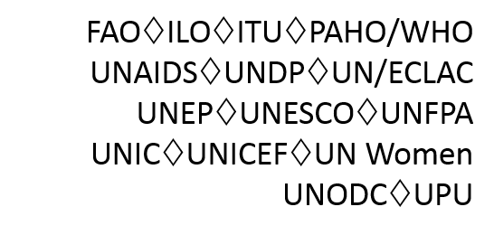
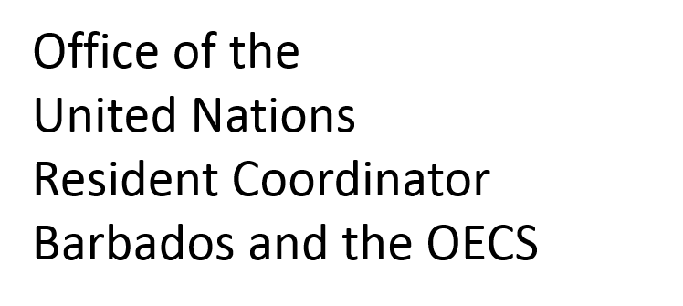

Meeting of the Eastern Caribbean Development Partners Group

Tuesday, 30 January 2018
2:30p.m. – 4:30 p.m.

Glass Conference Room, UN HOUSE
Marine Gardens

- Welcome – Mr. Stephen O’Malley, UNRCO
- Political Forecast for 2018 – Peter Wickham, CADRES
- Hurricane Recovery Planning and Implementation – Mr. Stephen O’Malley, UNRCO
- Caribbean Climate-Smart Coalition – Coalition Representative
- European Development Fund (11th) – Luis Maia, European Union
- Update on ECDPG Working Groups –Shari Inniss-Grant, UNRCO
- Announcements of new initiatives, reviews etc.
- AoB

