ACTIVITY: Result 0 - Management & coordination of TAT, A 0.4.1 Articles inserted in web platform (capacity4dev.eu),

BRIEF INTRODUCTION: This is the second article of a series of 3 to be produced under the Service Contract implemented by SOFRECO under Component 3 of the RED2 programme. Although each article introduces a specific topic they are all interdependent and aim at showing the project’s progress and impact and constraints met over its period of implementation.
The first article has introduced the challenges of Papua New Guinea’s Highlands agriculture sector, the second shall detail the approach proposed by the project and the third will resume its results and impact.

SUBJECT: Article 2 date of January 2018.

TITLE
"Tackling some of the challenges of Papua New Guinea’s Highlands agriculture sector"

The previous article after SOFRECO’s technical assistance intervention under Component 3: Value chain development support services and service delivery capacity of local government, introduced the challenges of Papua New Guinea’s Highlands agriculture sector.
The present article introduces the work carried out by the team of experts mobilized by SOFRECO and the impact achieved by the generalist training sessions to a wide audience including provincial and district government staff, public and private extension service providers, farmers’ associations and community development organisations from throughout the Highlands region.
The generalist round of trainings, of which 2 were delivered in Mt. Hagen (WHP) and Goroka (EHP), was the first step of a 3 stages skills development orientated cycle of trainings which also include the Trainers Inducement Training and Training Replication sessions at pre-selected Farmers Resources Centres.
Let us see how they went and what happened:

The generalist trainings
The ultimate aim of these trainings was to make target groups’ members to think out of the box by taking them into a different notion of an economic world they face every day. This meant introducing them to market economy concepts (individual production management versus market oriented production management) and clarify relevant marketing concepts: market segmentation, market (what is a) and market place, market positioning and impact in business development. It brings to attention the strategic role of distribution / value chains (concept and development) as well as viable agribusiness models: cooperatives, associations, clusters, and marketing groups. Overall, in a pilot case concept, it represents a sequential integrated approach to three subject matters: market oriented farming management, value chain development and realistic agribusiness models which are relevant for the development of the agriculture sector in the Highlands.
The generalist trainings are also a starting point for the target groups above mentioned to develop the following interrelated concepts:
- Value chain as a mean to provide a relevant yet different perspective of how market dynamics can be developed in favour of business opportunities and social development and the roles of all operators involved in the development of a value chain in the fresh produce sector.
- Entrepreneurship and agribusiness models starts by introducing not only the importance of viable businesses and industries but also the relevance of bringing farmers together to overthrow existing market constraints. The introduction of entrepreneurship capacity and agribusiness models give continuity to such endeavours in addition to contributing to the set up of an efficient value chain.
- Farming management is critical as not everyone is ready or prepared to become an entrepreneur and rather focus on ensuring one’s farming productivity and economic viability.
- Gender approach and community development is a cross concept matter. Gender inequality must be mitigated to enable a correct community development, improving a social economic environment and foster equal business opportunities in addition to bringing a different yet strong relevance to traditional values.
Resulting of this all-inclusive approach the Trainees were immerged in technical group activities to acquire a realistic notion and develop fair skills to apply concepts and tools provided as each key subject matter was being introduced.

Value chain in the agriculture sector
Rural development depends on agriculture sector which depends itself on several different actors. The Agriculture “Value Chain” concept can be considered as the interactions between these different actors. The Value Chain concept has been designed first time by the French Agricultural Research Institute (INRA) in the 60’s. It has been popularized in the 80’s. Step by step, this concept become very important for countries, like Papua New Guinea, acting in a globalized world. This concept is not only useful in enhancing export competitiveness, but it is also relevant is a sustainable and local agricultural systems development.

Starting with Market Demand
Understand value chain starts with a simple concept: the “Market Demand”. The market represents all potential customers for a specific product within a specific period. For example, the product “Water” gets the whole humanity as market because everybody need to drink water to live. But, the product “fertilizer” gets only farmers as market because only farmers need to buy fertilizers.
Market Demand is the aggregate of the demands of all potential customers (market participants) for a specific product over a specific period in a specific place.
In Haiti (Caribbean), there is a huge demand for charcoal because 90% of Haitian people are used to cook with this kind of fuel. Farmers have started to cut their trees (even cash crop trees!) to make charcoal and sell it because it generates money quickly. Forest has decreasing and today, the forest covers only 2% of the country creating a dramatic soil erosion; farmers are now losing their most important production unit.
Without any demand for product “A”, there is not any need to produce “A”. The production can start only if there is a significant demand. This “Market Demand” perspective comes from a global concept called “Market Economy”.
Market Economy is an economic system in which there is free competition and prices are determined by the interaction of supply and demand. Of course, market economy is not the only economic approach to development, but it is the most common in the world, including Papua New Guinea. Like any other model has its own advantages and its own constraints. Free competition does not mean “no rules” and it does not mean that all single demand must be supplied if it is not in a reasonable way. Economic pressure can push actors do grow or to produce in wrong conditions leading to a social, financial and environment unsustainability (see box as example).
Market demand should not be considered as a same and unique product request. For instance, the “Water Market Demand” can be split into different categories or sub demand: some people prefer sparkling water, other prefer it with a fruit flavour, other plain, other with a salty hint.
Market segmentation is the process of defining and subdividing a large homogenous market into clearly identifiable segments (and profitable) having similar needs, wants, or demand characteristics. As bellow an example of Lay’s potato chips market segmentation.
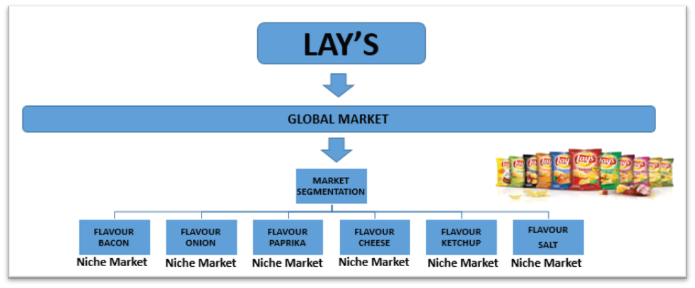
Figure 3: A market segmentation example

What is a Value Chain?
Starting from an existing demand, some entrepreneurs can plan to supply it, producing, transporting, processing, or retailing. The link between these different actions represents the value chain concept.
A value chain is a concept which “describes the full range of activities that are required to bring a product or service from conception, through the production up to the delivery to final consumers”.

The creation of value
This full range of activities can be considered as a chain in which each action will add a value to the product. The added value is generated by different inputs:
- Manpower. e.g. a cooker creates a value mixing different ingredients. This mix (or labour) will create a final product: the main dish of a restaurant for example.
- Knowledge. e.g. an experimented cooker with a strong knowledge will use the different ingredients in such a way that he will create a very famous dish. Even if the ingredients are similar to the ones used by another cooker, the price (and so the added valued) will be higher…this is only possible with the knowledge of this experimented cooker.
- Material adds. e.g. a car with a radio have an added value compared to a car without radio.
- Transport. e.g. the availability of a product near to our living places, creates an added value.
Let’s have an example: there is a market demand for chips potatoes and a unit process company (e.g. Lay’s, a US company) decides to supply this demand. This company is huge and transforms millions of potatoes each year. Lay’s needs to buy a lot of potatoes, but Lay’s managers have not enough time to deal with thousands and thousands of famers, instead, they choose to reduce this time constraint working with farmers association, for instance cooperatives. Then, Lay’s must reaches the consumers around the world. Lay’s will need wholesalers and then retailers to make their chips available for a maximum of people. The value chain can be described as below with supply businesses as INPUT SUPPLY (seeds, fertilizers…), farmers as PRODUCTION, Cooperatives for example as AGGREGATION, Lay’s as PROCESSING and retailers as DISTRIBUTION.
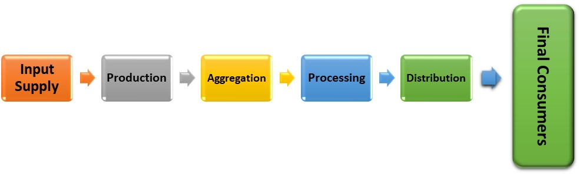
Figure 4: Lays value chain example
These activities can be driven within a single enterprise or divided among different enterprises, as well as within a single geographical location or spread over wider areas. The term ‘value chain’ refers to the fact that value is added to preliminary products through combination with other resources. As the product passes through the stages of the value chain, its value increases. Each key player of a value chain is called stakeholder. The process and the added value starts with the raw product and finish with the final item.
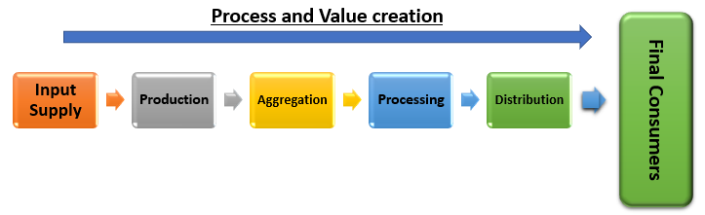
Figure 5: The Product process and the value creation

Transfer of money
Each stakeholder is supposed to earn money according to the value they add to the product, but also according to their negotiation capacity. Money comes always from the final consumers and goes back to each stakeholder as below:
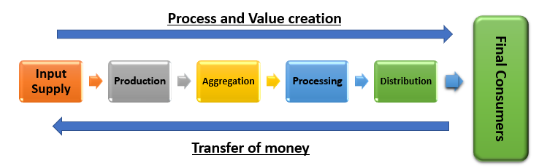
Figure 6: The transfer of money within a Value Chain
The right price is determined by the interaction of the supply with the demand. If there is a lot of potatoes in a small market (like in Mount Hagen), the prices will be low, but if there are very few potatoes in the same market, the price will be higher.
This price fluctuation is a constraint for any stakeholder because it makes difficult to plan financial resources in the future. Without any financial plan, stakeholders will be afraid to invest in a new technology. To implement their business, they might need to borrow money from family, friends, or bank, but since the presence of price fluctuation is a constant, the risk of not being capable to refund exists.
To face this “pricing” challenge, different options exist. The most common one in the world is the AGREEMENT. Between stakeholders, there is an interaction with a financial and product (or service) transfer. To be sure the client will receive supplies on time, quantities, qualities, and fixed price and to be sure the supplier will receive payment on time, quantities, qualities and fixed price, a LEGAL agreement contract must be signed.
Moreover, price must always cover, at least, the production cost. If not, the stakeholder should negotiate again with his clients or find another one or reduce costs of production or reduce his way of life or change of product (switching from potatoes to tomatoes for example). To be sure that the fixed price covers the costs of production, the suppliers need to know these costs of production.

Transfer of information
Finally, there is a last but crucial transfer to make value chains efficient: the transfer of information. First, information should be treated according to the stakeholder needs and capacities. Without the right format, stakeholders will not find the right information.
Moreover, information should be transferred to the right stakeholder in a right format. If the targeted stakeholder does not have any electricity, it will not be efficient to spread information through an electronic support (like CD or flash disk or website).
Information goes to both side of the value chain. In our ‘potato – chips’ example, the buyers need to be sure that they buy the right variety of potatoes to make chips. The consumers need to be sure they buy chips of potatoes and not of any other vegetables. The farmers need to know which kind of variety they should grow, which calibre…
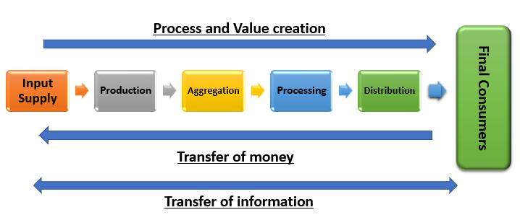
Figure 7: The transfer of information within a value chain

The value chain system
There are several definitions to describe what is a value chain. Each International Organization has its own (FAO, IFAD, WTO, ILO, UNIDO…) but all of them have the same key aspects: stakeholder, transfer of value, process of adding value, transfer of information, rules and supporting functions.
The reader saw before what are the stakeholders, the creation of value, the transfer of money and the transfer of information. Two new concepts appear here: the rule and the supporting functions.
Value Chain system is a model which describes the world in which a value chain takes place.
Considering a value chain with only key actors (farmers, cooperatives, process units, retailers), transfer of product, money and information is not enough to understand reality. The Value Chain is acting within a system which must be considered.
Several external aspects have an impact on the value chains: research, marketing, shipping, roads, packaging, fees, norms, unformal rules, land tenure, climate, ecosystem, transporters....
All these aspects can be sorted within six categories:
- Infrastructure
- Information
- Related Services
- Formal regulations
- Informal rules
- Natural Environment
These six categories can be clustered into two global classes: The Supporting Functions and the Rules:
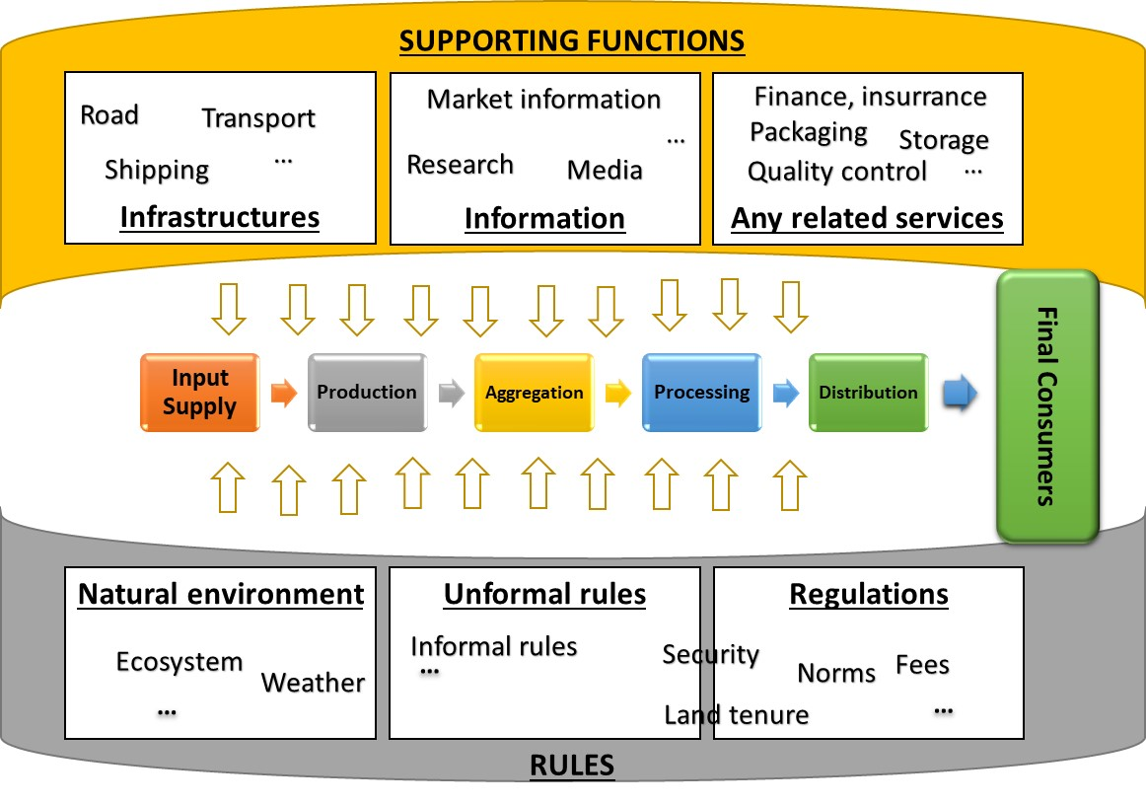
Figure 8: The Value Chain System

Value chain: Going further with analysis and improvement

The value chain analysis
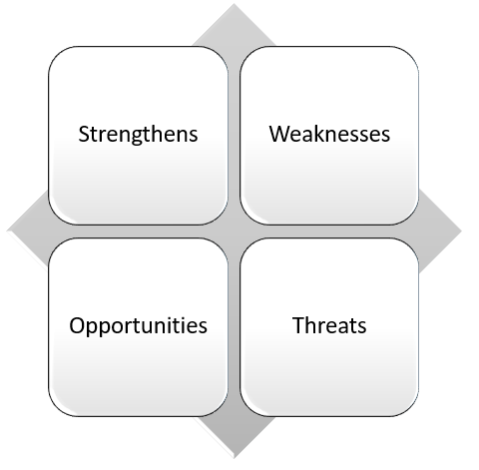
Before to start with any analysis, is it important to set-up the targeted goals. The goals will enable a framework in which the analysis will be conducted. The main goal can be an improvement of the farmers livelihoods, or it could be the agroindustry quality improvement (to match the international export norms). Different approaches can be used for the Value Chain Analysis. Here, the authors would like to introduce a simple but useful tool: the SWOT analysis.
SWOT is the abbreviation for Strengthens, Weaknesses, Opportunities, and Threats. The objective is to identify on which strengthens the value chain can rely, which weaknesses can be mitigated, which opportunities can be used, and which threats should be considered.
To set-up a relevant SWOT, it is crucial to make a clear difference between causes and consequences designing some “Problem Tree”. Confusion can lead to wrong decision-making so let’s have an example:
We can consider that farmers do not earn enough money. To face this issue, we can help farmers to sell more products because we think they do not sell enough. We could decide to focus on the farmers production because we think this is the CAUSE of the problem (here, farmers do not earn enough money which is the consequence).
Figure 9: The SWOT analysis
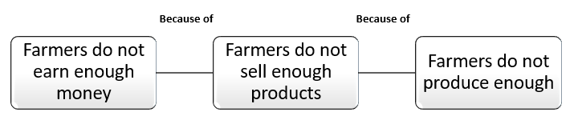
Figure 10: An example of problem tree (a)
In that case, famers might be assisted with new seeds, new practices, new inputs and then, their production will increase and then, they will sell more products and finally earn more money (even if the production cost increase too).
If the CAUSE is not the low farming production of farmers it can only be something else related to market demand as show below:
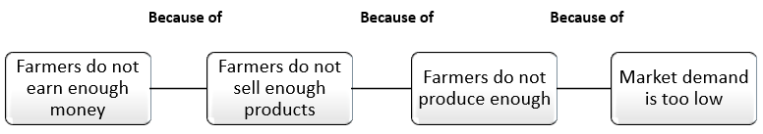
Figure 11: An example of problem tree (b)
In that case, we understand why farmers did not produce enough: it was not because of a lack of inputs or knowledge but because of the low market demand. And in that case, if the famers start to produce more, it will not answer the problem of money for farmers because if they could not sell 100 kg of product yesterday they will not be able to sell 200 kg tomorrow.
It will even lead to a price decreasing (the supply will grow but the demand will remain low) leading to less revenue for the famers and with a cost production increase because of the new practices.
Make confusion between causes and consequences can lead to disaster. It is crucial to identify the actual causes and then start to design an action plan to face them. This identification takes time and specialized assistance might be required.

Improving value chain performance
With the identification of the causes, stakeholders can now decide on which they will focus according to their priorities and capacities. To make relevant choices, the following principals should be respected:
- Ensure there is a link with an existing demand;
- Ensure it allows a realistic action plan;
- Ensure it leads to an added value;
- Ensure it does not result in socially or environmental unacceptable costs.
Once stakeholders agree on an objective, a realistic and clear action plan should be set up. If it is not realistic, the solution will remain only in the paper. If it is not clear, the stakeholder will have problem to implement the solution and the expected results will not be met. The action plan set-up requires specific assistance and it is advisable to seek and invest on reliable extension and/or consultancy services.
Sometimes, the objectives are on a global level, where stakeholder alone will have few impacts. The concertation might be necessary, and the most people share the same objectives, solution and action plan, the most impact it will be, especially if government is involved. In that case, each government level should be considered starting from the local one to the global one. Solutions coming from government might take time. Being pro-active is the first step toward an effective local development. Several and different actions can be taken in a very first level, with few people sharing the same objectives. Within this perspective, entrepreneurship, agribusinesses, and farming management are essential and will be developed in the following parts.

Entrepreneurship and agrobusiness in rural communities
As already explained market economy is a system where the laws of supply and demand direct the production of goods and services. Supply means what we provide and includes natural resources, capital, and labour. Demand means what we want and includes purchases by consumers, businesses and by the government. Businesses sell their goods at the maximum price consumers will pay. At the same time, wholesalers, retailers and consumers search for the lowest prices for the goods and services they want. Workers offer their services at the highest possible salaries that their skills permit. Employers pursue to get the best employees at the lowest possible price.
Resuming, we can say that Market Economy is an economic system in which there is free competition and prices are determined by the interaction of supply and demand. Interaction between supply and demand is probably one of the most fundamental concepts of economics and it is the pillar of a market economy.
Demand refers to how much (quantity) of a product or service is desired by buyers. The quantity demanded is the sum of a product that people are willing to buy at a certain price. The relationship between price and quantity demanded is known as the demand relationship.
Supply represents how much the market can offer. The quantity supplied refers to the sum of a certain good producers are willing to supply when receiving a certain price. The correlation between price and how much of a good or service is supplied to the market is known as the supply relationship.
Figure 12: Price determination from the interaction between supply and demand
Price, consequently, is a reflection of supply and demand.
Hence it´s clear that in order to supply it is required to know the demand, moreover, to know the market demand it is necessary to set up a value chain (all key actors communicate and give information). The value chain is the path to enable businesses to bring a product from farm gate to consumers.
But in the Highlands regions there are missing key actors, there aren’t enough companies that will set in place a proper value chain. The solution must pass through more Micro, Small, and Medium Enterprises (MSMEs), business operators and this means that more entrepreneurs are needed:
- More MSMEs means more business activity;
- More MSMEs means more competitions;
- More MSMEs means more economic growth;
- More MSMEs means more jobs;
- More MSMEs means more life equality.

Entrepreneurship: what is it?
The elementary definition is the act of creating a business, developing and scaling it to generate a profit. However, entrepreneurship is also about changing the world by solving problems. Like starting social change, creating an innovative product or offering a new life changing solution. It can even help lower unemployment rates through job creation and help decrease poverty. Entrepreneurship is what people ensure to take their career and dreams into their hands and top it in the direction of their own choice. It’s about taking a life the way they want. No bosses. No regulatory agendas. Entrepreneurs are able to take the first step into creation the world a better place, for everybody.
An entrepreneur is an individual who, rather than working as an employee, creates and runs a small business, assuming all the risks and recompenses of the project. The entrepreneur is frequently seen as an innovator, a font of new ideas, goods, services and business/or processes.
Entrepreneurs have a central importance in the economy of any country. These are the individuals who have the skills and initiative indispensable to anticipate current and upcoming needs and came with relevant new ideas to market. Entrepreneurs who demonstrate to be successful in taking on the risks of a start-up are pleased with profits, and continued growth opportunities. When they fail, they look at it like a step to success.
But what do we need to become an Entrepreneur?
There are many characteristics and they have a wide range of indicators, depending of the geographic, social, cultural, economic area, still, there are common characteristics between all them. These are:
- Passion and motivation;
- Self-belief, family support, hardworking and a disciplined dedication;
- Entrepreneurs Doubt Themselves – But Not Too Much;
- Adaptability & Flexibility;
- Networking Abilities;
- Risk taking;
- Understand Your Offering – And Its Market;
- Planning (But not Over-planning);
- Money Management;
- Being Prepared to Take the Exit.
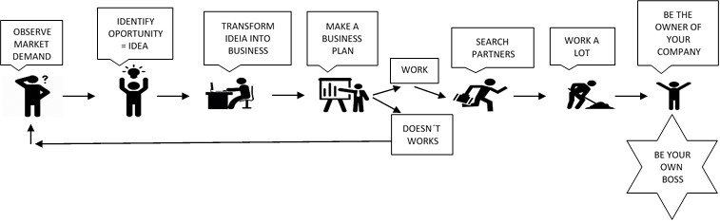
Figure 13: from the idea to the success

Enabling environment to entrepreneurship
Entrepreneurship has been associated with enhanced economic stability and the economic improvement of entire communities to foster job growth and innovation around the world. Creating and enabling environments that incentive, cultivate and sustain entrepreneurs is of extreme importance.
All enterprises run within a political, social and economic context and are subject to regulatory and institutional constraints. Although it is important to support enterprise-specific interventions for businesses to develop, it is equally important to look at the external environment in which they operate. Without addressing the issues associated to the overall business environment, interventions at the enterprise level alone do not produce top results.
Key actions to enable an entrepreneurship environment are:
- Entrepreneurs have more chances to success in a policy and regulatory environment that protects private property, keeps barriers low and rewards innovation;
- Entrepreneurs themselves must be protagonist in creating environments, by generating entrepreneurial communities and providing input into policy;
- The different actors in an entrepreneurship environment must cooperate and network with other stakeholders to make the most of their respective strengths;
- Policymakers should involve in open dialogue with entrepreneurs to find solutions that are suitable to local conditions;
- Educators and community leaders must foster a culture that supports entrepreneurial aspirations and celebrates success stories. Diversity and access to opportunity should be encouraged by empowering women, youth, and informal business owners to pursue entrepreneurial ambition.
Even If the policymakers are not totally engaged in the business enabling environment, entrepreneurs should be pro-active and take the initiative to start the process and take the leading role.
Practical examples to promote and boost entrepreneurship are:
- Business incubator - is a company that helps new and start-up companies to develop by providing services such as management training and/or office space
- Start-up accelerators or seed accelerators - are fixed-term programs that include mentorship and educational components and culminate in a public pitch event or demo day
- Business ideas competitions – Competition usually divided in three phases: the first, is the promotion of the initiative and the selection of best ideas submitted; the second, includes the development of the selected ideas into business plans; the third one includes evaluation and awards to the best business plan developed.
- Co-working spaces - The use of an office or other working environment by people who are self-employed or working for different employers, typically to share equipment, ideas, and knowledge. The whole idea of co-working is to bring bright, creative people together and let the ideas collide.
- Extension services (not just financial support) - should give advice of all sort of information. Regarding to agriculture for example, should give advice for the demand, talk with different actors and put in place strategies to supply that demand. This is also available for advice on the research of the best agriculture practices with the characteristics of the region, but always bearing in mind the market demand.
- Business associations – means any corporation, joint-stock company, investment company, business trust, partnership, limited liability company, cooperative, or association for business purposes of two or more individuals whether or not for profit and together they share information, business opportunities, networking and can give inputs for policymakers.
- Research, advisory centres, University's – These institutions are engaged in knowledge and innovation. They can be key actors giving training, information (market, machines, production…), making studies (feasibility, cultural, marketing…). In PNG these must start now!

Agro-business models: how to select the right one?
This is an important step and decision because, getting into business, means positioning yourself in the value chain and against a given market demand. Therefore, there are a few questions to be asked:
- Where do you see yourself in the value chain?
- How do you see your business growing?
- How do you see your business in 1 year? In 2 years? And so on.
- What are your needs (capacities, networking, information, financial…)?
- Witch business opportunities/possibilities more do you have?
To position yourself properly in the market, you will need to comprehend the value chain and how it suits in your market. A value chain highlights all key participants and how they network to deliver value to customers. It includes the actors with whom you may collaborate or compete with, the products and services these actors provide to customers, and the policies, incentives, and other aspects that outline how actors operate in the market.
To comprehend your value chain and the potential for your position in it, you will need to evaluate the market:
- Market demand for your products and services;
- How the market is already being supplied by other enterprises;
- Existing breaks in the market that your enterprise/cooperative might fill;
- Your enterprise/cooperative strengths and capabilities to supply products and services in the market.
In addition to outlining your market position, you will need to understand and address two other key areas that will support you to find the business model that is more appropriate for your company:
- Outline your vision, mission, and goals. Your vision, mission, and goals provide the predominant direction for your enterprise and should keep the basis of all strategic and tactical decisions related to your strategy.
- Identify partners. You will be obliged to identify strategic partners, undoubtedly outline their parts, and involve them early on to guarantee you shape common understanding and strong sustenance for your business model.
When these firsts steps are made, you have to select or develop your organizational business model (see below). Although business models have shared elements, including, governance structure, financial structure, customer targets and service offerings, they differ widely depending on organization type, revenue sources, and external operating environment.

What is an agro- business model?
A business model is what enables a company to enter the market in a sustainable way and make profit!
A business model is the system by which a business generates and captures value within a market network of producers, suppliers and consumers, resuming, "what a company does and how it makes money from doing it".
A business model is a way in which a company structures its resources, partnerships and customer relationships in order to create and capture value. The degree of inclusiveness is measured by how ownership, voice, risk and reward are shared among the business partners.
A business model defines how any given enterprise - large or small, informal or formal - does business, markets its products and sources inputs and finance. Several types of business models link small farmers to agricultural value chains. These embrace traders, farmer organizations, agri-food processors, retailers, and contract farming arrangements with large buyers.
Resuming, business model aims to add value to a value chain, and in order to achieve that, business model can take multiple forms, depending on the value chain and how they want to position themselves.

What agrobusiness models?
There are many business models in all kind of sectors. For rural areas in PNG the most relevant ones may be:
- Contract Farming;
- Management Contract;
- Tenant Farming and Sharecropping;
- Joint-Venture;
- Farmer-owned Business.
These models describe relationships between smallholders and agri-business and can be seen as a way to generate agricultural productivity advantages without recourse to large-scale land acquisitions.
The aim of a business model is to generate an extra benefit. Moreover, these add value should be shared with all stakeholders of the value chain. This endeavours to establish the way in which the model may share value among the different stake-holders, i.e. between farmers, land owners and agri-business owners. Four indicators can be assumed of as defining how value is shared between these actors.
- Primarily, ownership of the business and key assets including natural resources (forests, land, water) and processing facilities.
- Secondly, the capability to influence decision making, including the mechanisms that are in place to deal with circumstances where actors feel decision making has not been done in accordance with pre-agreed structures.
- Thirdly, how risk is distributed amongst actors.
- Fourthly, how outcomes are shared - costs and profits, including price setting and credit arrangements.
These four characteristics of the value of any business venture are evidently interlaced, this means for example, increased ownership may go hand-in-hand with increased risk exposure. Also, the background (institutional, political, social, and environmental) within which each investment model is assumed will have tangible implications for the practical feasibility of the model and its implementation and application.
It is important to retain that all business models can be interlinked. For example, a farmer-owned business can move in into a joint venture with an agribusiness and this legal partnership can assume a management contract with a specialized provider. Also, the details of how ownership, voice, risks and rewards are shared within the business model can be just as important to partners as whether the model falls within one broad categorization or another.
- Contract farming
It defines pre-agreed supply agreements among farmers and buyers. The agreements frequently specify the purchase price, or how it will relate to predominant market prices, and may also contain terms on delivery dates, volumes and quality (and should have in order to secure both parts). In several cases the buyer, which is generally an agro-processing company, commits to supply upfront inputs, such as credit, seed, fertilizers, pesticides and technical advice, all of which may be charged against the final buying price. Resuming, there is a varied range of contract farming deals, starting in informal verbal purchase agreements finishing in a highly specify out grower schemes.
Contract farming is usually seen in production of labour-intensive, perishable crops where the farmers have insufficient options for the sale of their output, other than the agribusiness, rather than crops that benefit from scale economies.
Guaranteeing that an enabling legal environment exists is imperative in protection the rights of smallholders engaged in contracting arrangements as well as assuring security of the business environment for the agribusiness partner. Governments and rural extension services should support in building capacity in local farmer organizations including providing model contracts.
Contract farming can then be seen as desirable model in comparing to plantation farming for both agribusiness and smallholders. It results in constant supply of crops for the agribusiness without the necessity to invest in land directly. It may result in higher productivity that is possible on large-scale farms (especially for labour-intensive crops). Farmers can benefit from economies of scale in input provision by accessing these through the agribusiness and might also gain access otherwise unavailable to credit and production technologies. Contracts can produce income steadiness as well as enabling access to distant, lucrative markets. Still, these benefits depend on the precise context of each contract, particularly the comparative negotiating power of each party. Where contracts are not easily enforced, or the agribusiness operates as a near monopolist, risks can befall on both sides leading to suboptimal outcomes. For example, agribusiness can face high transactions costs or supply risks where farmers can with no trouble sell their output to alternate buyers. Farmers can find it hard to impose payment on delivery of output or guarantee good quality inputs are provided; they may also risk becoming locked into debt particularly where credit is advanced for long-term investments, for example in tree crops.
- Management contract
It states the diversity of arrangements underneath which a farmer or farm management company work agricultural land belonging to someone else. Management contracts can take the form of a lease or tenancy, but convey the denotation of stewardship, of handling the land on behalf of the owner.
For smallholders, management contracts can take numerous forms, where the management company manage the farms on behalf of the smallholders but does not obtain the land directly.
These can happen as:
- Straight-forward leases, where the company works the farm and pays rental fees to the smallholder;
- Profit-sharing agreements;
- Agricultural output-sharing, where each actor is responsible for their share;
- Blends of these alternatives.
The management company may take scale advantages in input provision, processing and marketing.
These arrangements are predominant in countries with high agricultural potential where ownership and management of land have become detached.
An enabling legal framework is desirable to guarantee equitable outcomes from these arrangements. NGOs, Government and rural extension services can be vital to support local community capacity in the negotiation and assessment of the contracts, particularly where local land owners have narrow capacity for contract negotiation and enforcement.
These may result in positive results for local communities without them having to sacrifice their land-rights entirely, principally because these contracts (parts of it, at least) can be renegotiated periodically. Management contracts can also take outcomes in access to energy or advanced farming techniques that would be otherwise unmanageable for local communities to achieve.
- Tenant farming and crop sharing
There are variations of management contracts in which individual farmers, for example smallholders, work the land of large-scale agribusinesses or other farmers. In tenant farming the typical arrangement is a fixed rental fee whereas in sharecropping the landowner and sharecropper split the crop (or its proceeds) through a pre-agreed percentage. Sharecropping might be chosen to a fixed-rate tenancy because of the sharing of risk and better incentives for the sharecropper. Still, occasionally sharecropping has received a large degree of criticism for presenting exploitative and less efficient business than cash rental contracts. Yet, where working capital and credit access are narrow, sharecropping is a satisfactory option for smallholders and land owners as a way to minimize production risks.
Tenant farming is classically used as an arrangement to manage high-value and multi-use farmland. In developing countries these agreements may be desired where agricultural production requires costly investments, e.g. where the set-up of irrigation infrastructure is undertaken by the land-owner, local communities are responsible to farming of the land and the output is shared with the land-owners.
While restrictive regulations of land rental markets have been in place in many developing countries to avoid manipulation of smallholders, tenancy and sharecropping arrangements are becoming acknowledged as attractive ways for landless groups to access land. At the same time as the importance of undoubtedly recognized land rights and the avoidance of the manipulation must be supported for existing farmers, these arrangements may become increasingly vital in areas of growing population densities.
In practice, sharecropping varies significantly across national and cultural boundaries.
This can embrace the land owner providing food, seeds and other inputs to the share croppers, providing a safety net for the landless. Still, challenges ascend where the land owner himself is poor and cannot provide this support, in which case the land may turn out to be disused. Consequently, these arrangements offer both a probable solution for some landless groups in providing a mean for them to entry land directly, and an imperative way to maximize the intensive management of land and resources. Nevertheless, these arrangements do not solve all the challenges linked with large-scale land ownership and can result in weaker negotiating positions for tenant farmers as contrasting to contract farmers.
- Joint-venture
They require co-ownership of a business venture by two independent market actors, such as an agribusiness, a farmer’s organization or a retailer. A joint venture comprises sharing of financial risks and benefits and, in most but not all cases, decision-making authority in percentage to the financial (these includes cash, land, labour, tools…) participation.
The arrangements might be formal (foundation of a separate legal entity to characterize the venture that safeguards limited liability of the partners) or informal, more malleable arrangements. These arrangements are fundamentally attractive as a means to involve agri-business and smallholders, as smallholders are full business partners granting them both profit sharing and decision-making rights in the process. Nevertheless, as always, the context within which each join-venture is established defines its subsequent success and the challenges that implementation will have.
These models target to maximize the economic benefits to stakeholders by connecting them with established agricultural farm-management companies. However, several of these schemes have been criticized for preserving the status quo, including not moving away from commercial farming practices and not enabling smallholder autonomy, or skill transfers, etc.
In practice, the part of governments in joint ventures is important. Not only they should deliver the basic policy framework for these arrangements, they are also frequently direct joint-equity partners, capacity building, providers of business advice, and underwriters of smallholder business risks, between others. Rural extension services can also take an important role in joint ventures, including capacity building, marketing assistance and facilitating in credit access. Therefore, while these arrangements are theoretically lucrative ways for smallholders to achieve commercial success, successful implementation is challenging, as these arrangements can be intricate and rely on strong business capacity of the smallholders themselves.
These arrangements propose real equality of negotiating power between smallholders and agribusiness. Clear terms of engagements within clear business and legal frameworks reduce political and legal risks, increasing supplier incentives and assisting with branding. Nevertheless, joint ventures are not completely protected from potential exploitation from agri-business. Both down-side and up-side risk exposure to smallholders is high, empowerment can in fact be low, notwithstanding of the intentions of both parties. Initial success can lead to dissipation of equity shares by smallholders where supplementary costly capital requirements see new partners introduced to the scheme. These arrangements consequently require considerable capacity support for smallholders, fully assessed down-side risks to be insurable, possibly through government guaranteeing. Livelihood benefits must be direct, even with long-term crops, this can be enhanced by for example through facilitating subsistence farming alongside commercial agricultural endeavours and all contributions must be reached for and valued.
- Farmers’ owned business
There are properly incorporated business structures for farmers to pool their assets to enter into specific types of business (e.g. processing or marketing), increase access to finance, or limit the liability of individual members. Such businesses are often owned by cooperatives or associations in order to streamline business transactions.
Here farmers move into formal business structures to pool their assets in order to enter an upstream business, or to increase access to finance, or to limit the responsibility of individual members. These businesses are frequently owned by cooperatives. An informal form of this would incorporate cropping zones, where crop production is focused in certain areas producing economies of scale that attract suppliers, buyers and processors.
These arrangements can take several forms, including:
- Associations which represent farmers but are not usually connected to profit-making enterprises;
- Trusts that hold and protect assets for named beneficiaries;
- Enterprises including cooperatives, partnerships, community enterprises and farmer-owned companies;
- Clusters which is a combination of farmers, cooperatives and associations.
Getting into Papua New Guinea Highland reality, we can observe that the majority of the farmers are smallholders, they have small plots, they are no demand oriented and business models are still not in place or adequate.
So, let’s start by defining what a smallholder is.
Smallholder is used as a broad comparable to family farmer, and absorbed the huge diversity of farming systems where agricultural activities are mostly based on family labour. It is worth highlighting the relative nature of the term “smallholder”. The term “smallholder” mentions to their limited resource endowments relative to other farmers in the sector. Thus, the characterization of smallholders differs between countries and between agricultural ecological zones. In auspicious areas with high population densities they often cultivate less than one ha of land, whereas they may cultivate 10 ha or more in semi-arid areas. The term local communities would comprehend not only smallholders, but also rural people not engaged in agriculture.
The next table shows the advantages (For) and the disadvantages (Against) of being/working with smallholder.
For | Against
• Smallholders’ comparative advantages (premium quality, access to land, etc) | • Costs and risks in organising supply from dispersed producers:
• Securing supply in volatile markets, spreading portfolio geographically, reducing risk of undersupply as well as localised pest and disease problems | • quantity
• New business, clients for other products and services (Base of Pyramid) | • quality
• New technologies available (efficient low scale processing equipment, information technologies for coordination and lower cost traceability) | • consistency
• Capacity to ramp up or ramp down production without incurring fixed costs (contract farming) | • safety
• Access to donor assistance | • traceability
• Corporate Responsibility | • compliance with rising standards
• Community goodwill | • packaging
• Political capital | • loyalty and fulfilment of commitments by farmers
 | • negotiation time and costs
 | • political opposition to commercialisation of peasant agriculture
Figure 14: The strengthens and constraints of the being/working with smallholders
- Cooperatives
Cooperatives result of the need to solve pressing farming constraints identified by several farmers and the decision to seek the most suitable solutions (the mission). Cooperatives are an autonomous association of persons united voluntarily to meet their common economic, social and cultural needs and ambitions through a jointly owned and democratically controlled enterprise.
Agricultural cooperatives empower producers to realize economic benefits that they could not otherwise achieve by themselves. Groups of agricultural producers increase their bargaining power in the marketplace, reduce costs by assembling capital and resources through cooperative enterprises, and provide services, such as marketing, that are unavailable to just one smallholder. Through cooperatives, farmers can achieve economies of scale, by dropping the unit costs of inputs and services, enabling farmers to focus on producing goods instead of searching and finding buyers and suppliers. Cooperatives also enable farmers to improve product and service quality and reduce risks. Agricultural cooperatives usually allow farmers to address common problems, develop new market opportunities or expand existing markets but also demand a loss of democratic process. Agricultural cooperatives empower farmers and improve their position in the marketplace.
Cooperatives for these organizations are as diverse as the reasons for which they are established. Common types are:
- marketing agencies or marketing boards, to promote and manage collective sales;
- processing companies, to provide farmers with improved sales prices and added value distribution agencies to manage collection and transport of produce;
- service-provision companies, to allow members to go into new areas of business such as management consultancy;
It is important to bear in mind that a Cooperative can integrate only one of the above specifications, a few, or even all the features. It only depends of the position that the farmers take once the foundation of the cooperative and how they position themselves. The cooperative starts with the needs of its members and it should answer to that needs, still, they can change and/or grow, and the cooperative must compose in order to facilitate response. This means that Cooperatives must adapt and be flexible in the services that they provide.
- Clusters
A cluster can be defined as a geographical location where enough resources and competences gathered reach a critical point, giving it a key position in a given economic branch of activity, and with a decisive sustainable competitive advantage over other places.
A cluster approach, helps in scaling up to the industry level, and promotes regional innovation systems. A government may choose to follow cluster initiatives along with simultaneous policy reforms, because the two approaches may generate positive externalities and help government develop a better case for policy reform. The most essential factors in the success of a cluster program or initiative it’s demanding markets, positive joint action, and institutions proficient on moderating and focusing power disparities, complemented by the impulsion factors of education. Perhaps most important from a policy standpoint is the ability to adopt flexible and coevolving policies intended to foster cluster development, which reflect the development of institutions, technologies, and companies in a vibrant and self-organizing process. It is critical to find an equilibrium between carrying capacities, the institutional outfit, and the individual incentive strategy.
Cluster-based policy aims to enable companies’ system to function more efficiently and avoid coordination failures. A cluster-based approach is a sharp way to identify the policy and institutional impediments to competitiveness and innovation. When a critical mass of enterprises moves simultaneously to function as an initial cluster, they represent an effective vehicle for catalysing reform (for example, individual farmers, cooperatives, associations…). Through dialogues at the cluster level, new partnerships will be set up between cluster leaders and various public organizations (such as those working on industrial and infrastructure development, research, innovation, and training) to formulate, put in place, and create policy reforms.
In a cluster there is no prerequisite agreement required between the cluster and the market (they can sell to anyone they want). A cluster can work for 1 product or a range of similar products (e.g. fresh agriculture products).

Agro-business success factors
The following factors have been identified as success factors for strengthening the role of smallholder organizational models and their overall position in the value chain:
- Non-politically aligned organizations: There is a political stigma associated with farmer organizations and cooperative terminology, with groups preferring to disassociate themselves from past connotations of politically aligned organizations in order to be viewed as practical and market oriented service providers for their members.
- High quality service provision: In order to retain and recruit farmers, members must understand that their membership they will have access to quality services, some of which may be outsourced, such as: the identification of market research, training, technical assistance and advice.
- Social and enterprise strategies: In the absence of local social services, farmer organizations are often requested to overcome the needs and the priorities of the community. These activities should be managed separately from agribusiness related activities, which should take precedence as they are directly linked to poverty education and the financial sustainability of the organization.
- Network membership: The organizations must be integrated in a wider network that links members to information on new ideas, markets and funding opportunities outsider of their community (for example a federation of associations).
- Focus on core business: Farmer organizations need to, first, priorate their core function of supporting members to improve productivity, production planning and marketing, then they should diversify activities and resources into additional enterprises such as capital-intensive value adding agro-processing technologies.
- Add value through efficient and low-cost innovations: If compatible with their core business, farmer organizations can undertake an important action in adding value to their members produce through organizational innovations and support with activities, such as sorting, grading, production planning and logistics, which do not require high cost capital investments.
- There is no “one-size-fits-all”: Farmers organization models can range from traditional marketing cooperatives and farmer bargaining associations to informal groups. The models are targeted as the most likely to succeed are those that are formed on the based on local culture, social context and the needs of members.
- Understanding the needs and risks of agribusiness companies: There are some risks that agro-enterprises face when buying from smallholders – from inconsistent quality and quantity of supply to side-selling and reputational risk based on public perception of smallholder exploitation. To reduce these risks, a key action of farmers organizations is to remain in constant dialogue with buyers and guide smallholders in responding to market requirements.
So, let’s focus in adding value. If it is often linked to investments in high-value processing the resulting advantages are significant by the improvements brought to the raw produce. The introduction of cleaning, grading or labelling processes do not change the physical shape of fresh produce but immediately increase its market value. One can also introduce add value by putting in place logistics, marketing and quality control systems through cooperation with value-chain partners. Nevertheless, the first step is always the harvest and the post-harvest, and if it is not done correctly the rest of the value chain will not work properly.

Farming management in a value chain perspective
A value chain describes the full range of activities which are required to bring a product or service from conception, through the different phases of production, delivery to final consumers, and final disposal after use.
In a value chain perspective, the agricultural activity is a likely business activity driven by profit and inserted in a market economy system. The farmers, as business manager, must be linked to the market and they must create the most possible value with their own activity. Creation of value and the earning of a higher income is linked to the right farming management and the skills of the farmer.
In the farming management, there are 4 main stages to create value:
- Identification of the markets opportunity and the customers’ requirements;
- Decision making;
- Reduction of losses;
- Creation of partnership.

Identification of markets opportunity and customers’ requirements
Usually in agriculture there is big misunderstanding between “selling what it can be produced” and “producing what it can be sold”. In a market perspective agricultural, production must adapt to the market needs and requirements. To select a product and to sell it effectively, farmers must understand not only their immediate market situation, but also how the complete value chain works. By doing it, it enables them a range of new options: use the collected information to negotiate for better prices, find a different buyer, grow a different product, package it in a different way, or process it before selling it. That will enable them to add value and, eventually, generate more profit.
Furthermore, value chain approach orients farmers to the market by focusing on what consumers recognize as add value in the product, as well as, what the final supplier, such as a retailer or food service operator, requires to step in the market. In some value chains, the requirements of the processor/retailer and consumers differ and may even conflict. Value chain analysis can support stakeholders to identify these inconsistencies and provide a framework for resolving them.
During the process of market identification, farmers must understand the customers requirement and how to meet, wondering the following questions:
- Who are my customers?
- Which are the customers priorities?
- How can I meet their requirements?
- How and when do I have to deliver?
The market potential for sweet potato in PNG, has improved significantly in recent years due to a vibrant existing informal value chain system from the increasing demand in urban centres, especially Lae, Madang and Port Moresby. High prices for rice, flour and other cereal products also influence consumer demand for sweet potato because of a lower price. The pathogen-tested technology offers huge opportunities for farmers to improve tuber yield and quality. This enables access to clean sweet potato planting materials from NARI and Fresh Product Development Agency (FPDA). Market diversification and processing opportunities make sweet potato a staple food, animal feed (leaves/tops/roots), dried chips and starch production. Sweet potato also has a huge potential for industrial uses - jam, flour, noodles, pickles and brewing of soft drinks.
Like sweet potato, the market potential for Irish potato in PNG is vibrant at the informal sector and has improved significantly in recent years due to the mining boom and increased urbanization demand as a result of consumer trends which favour potato based fast-foods and snacks. It sets a great opportunity for the farmers and the players along the potato supply/value chain. In many urban areas, potato fries/chips are replacing traditional and staple foods like sweet potato, taro and bananas, even rice, especially among the children and youths. Potato may be cooked in many ways - boiled, steamed, baked or roasted, and fried; as well as being a satisfactory component in stews, soups, and in mixtures with meats and other vegetables. Demand for potato from coastal cities, especially Lae and Port Moresby, has increased because of these factors.
The value chain of potato has the potential in PNG to further develop into chips or mash potato in formal marketing systems and crispy chips for food processing companies. In addition, it can be a valuable starch ingredient in other food products, beverages and sweets. With the opportunities available for the clean seed system and fungicide use, the use of high-quality seeds of robust and
market-preferred varieties are obvious. The potential to increase and optimize potato productivity, simultaneously improving the livelihood of smallholder in potato-growing regions of PNG is evident. An opportunity exists for NARI and FDPA as partners in the potato industry to increase the number of certified seed growers and improve seed supplies. In addition, it enables the provision of training and dissemination of information on production techniques, harvesting maturity, curing and packaging/handling in transit.
Like sweet potato and potato, the bulb onion demand throughout PNG has increased as a result of urbanization and economic growth from markets in major towns and cities, including mining industries. The crop has great potential to generate income for farmers and other players along the supply/value chain. Bulb onion has a low perished ability hence quality is maintained, whilst wastage is low and returns are optimized. The demand for catering has prompted fast-food outlets, hotels, shops, institution and restaurants to buy more bulb onion. As in value addition, dried or fresh, raw or cooked onions are an essential part of in a variety of soups, salads and stews. Onion also has an important role as a medicinal herb, and is claimed to minimize high blood pressure and other heart diseases due to its favourable action on the elasticity of the blood vessel. (Source: NARI)

Decision making in farming management
Below the guiding question for decision making in farming management:
- What the key criteria are for select one market or value chain?
- How can these criteria be classiﬁed according to their relative importance?
- Which one/ones is/are more important than the others, and why?
The following criteria may be useful but do not represent an exhaustive list and they should be modified according to the criteria of the organization of farmers/single farmer. However, in most cases, the following principles are a useful guide:
- Market demand: How much demand is there for the market chain product? Is the market for this product growing rapidly or slowly? Is it stable or diminishing?
- Feasibility of a crop: Even though market demand exists for a product, it is crucial to be sure that it is possible to produce this product in the area given, existing social, economic, and environmental conditions with the quality that the market demands. Moreover, is the production system for this product consistent with sustainable natural resource management?
- Existing business organization: Traditional rural extension services workers often look for problems and then set programs to overcome them. A business approach is different: it seeks opportunities and then evaluates business options, investment, cash flow, and profit to make decisions. The farmers organizations should assess aspects such as:
- What are the business organizations in the market chain like?
- Are there formal or informal groups of producers, processors, or traders in this market chain?
- How strong or weak are they in business terms?
- Is there coordination among them now, or was there in the past?
- Support agencies: How many support organizations are associated with this market chain? What services do they or could they offer to the market chain? Are they willing to facilitate or participate in the design of a strategy to increase competitiveness?
- Risk assessment: One of the more difficult criteria to assess is an appropriate level of risk that a farmer group/single farmer entrepreneur should take on. Risk management is based on having sufficient information to make an informed decision.
- Environmental sustainability: An important criterion that must be addressed is the sustainability and environmental impact of the new business. The farmer should ask if there are any hazards or risk of pollution in his business activity. If there are hazards, it’s crucial to know if long or short-term and what are the measures that are being taken to address these hazards.
- Financial characterization (profit): Assessing the profitability of a market option is one of the most important selection criteria for comparing products for smallholder rural producers. This selection process provides a standard way to compare different types of products and to evaluate risk. Economic characterization reveals (a) conventional financial parameters such as investment level and profitability, and (b) financial ratios which can be chosen and designed according to client needs. Although smallholder producers may have different rationale or perspectives to that of a typical businessman, they are undoubtedly interested in increasing their income. Income generation is considered a key strategy for improving both well-being and food security of farm families. In addition, the promise of profitability is a great motivator for collective action among smallholder producers, involving the creation of economic organizations and marketing activities. Evaluating the profitability of small agro-enterprises is probably the most demanding criteria in a decision-making process. The simplest method to evaluate and compare profitability of different product within an enterprise is by using a basic profit/margin analysis method such as gross margin analysis, net margin, or cost—benefit analysis. “Gross margin” (Fig 15) is the final income paid to the producer after all production costs have been subtracted from the sales income. These methods require some practice to get accurate figures and it should be noted that in many cases farmers, who do not have records of their production costs, are likely to guess and often overestimate costs and underestimate incomes. In many cases, smallholders do not cost their labour or that of family labour. One of the limitations of the gross margin analysis is that it only provides profit over one season and is therefore of most use for annual crops. The evaluation of profitability over a longer period will require more complicated forms of profit analysis, like multiyear financial models.
Cost of Production | $
Seed tubers | 988
Land Preparation | 25
Fertilizer-NPK (100:60:80) | 192
Irrigation | 56
Labour | 278
Agrochemicals | 185
Gunny bags | 79
Organic manure-FYM (1 ton) | 62
Total cost of cultivation per hectare | 1 864.33
Yield (tonnes) | 25-30
Yield for crisp grade (tons) | 20-25
Market price | 0.1-0.16
Value of output (yield 25 tones and crisp grade 20 tons) | 2350 - 3850
Value of output | 2850 - 4650
(yield 30 tones and crisp grade 25 tons)
Gross margin (yield 25 tons) | 486 - 1986
Gross margin (yield 30 tons) | 986 - 2786

Figure 15: Example of Gross margin analysis

Reducing losses
In an agricultural value chain, what are the sources of waste? Losses can occur along all the value chain, but in the farming/production phase can be avoided if the farmers are able to identify causes and deploy the right interventions or prevention actions.
Mapping the losses in preproduction, production and post harvesting, as well as, identifying the right interventions, means higher income and reduced costs, that is translated in creation of value. Indeed, waste and losses mean that the product can be sold for a lower price giving an advantage in price competition, improved quality and a reduction of unnecessary/excessive inputs or activities and unnecessary activities. Waste reduction might involve: matching the timing, volume and quality of supply with demand to prevent losses downstream, especially of more-perishable products, reducing postharvest deterioration, or improving transport, packaging and storage. The reduction of loss leads farmers to ask:
- Where does waste occur on farming?
- How can avoid the on-farm losses and downstream?
- Which is the most appropriate post harvesting practice to avoid waste?

IRISH POTATO: RIGHT POST HARVESTING PRACTICES
FOR MEETING MARKET DEMAND AND AVOID WASTE
The crucial post-harvest activities include: curing, storage, packaging, handling and transportation. These activities are very important as they help preserve the crop and add value to the end product. The buyers prefer potato in good condition. Therefore, if the farmer wants to sell potato and get money from them, he must meet the market requirements. It is important the growers must know this quality requirement and produce quality potato in order to obtain a better price. The requirements can be:
- Tubers must be dry with a strong outer skin;
- Tubers must be free of soil or dirt;
- Tubers must have no insect or disease damage;
- Tubers must not be green in colour;
- Tubers must be the size of an adult fist.
Curing:
The skin of the potato becomes resistant to skinning damage. How?
- Reducing ventilation to allow an increase in temperature;
- Build-up humidity is needed to ensure curing;
- The higher the temperature (in the given range), the shorter the time needed for curing;
- Keep tuber at temperatures from 16°C to 21°C with 90 percent relative humidity during approximately 10 to 15 days.
Storage:
The storage requirement for ware potato are:
- Ware potatoes for food or for processing must be kept in the dark to prevent greening at a temperature of about 6 to 8°C, in a well-ventilated environment with high relative humidity (85 to 90 percent);
- The storehouse can be constructed from local materials or permanent materials;
- The building must be dry, cool and well ventilated;
Transportation:
- DO NOT throw the bags of potatoes during loading and unloading, but lift them carefully and put them down carefully;
- DO NOT allow anyone to sit on top of the bags of potatoes or place any heavy on top of the packed bags;
- DO Transport potatoes in the early morning, late afternoon or night when it is cool. It is a good idea to use cool containers for long-distance market transportation.
Source NARI: Irish Potato training manual.

SWEET POTATO: RIGHT POST HARVESTING PRACTICES
FOR MEETING MARKET DEMAND AND AVOID WASTE
A large portion of sweet potatoes in PNG is still marketed as ‘fresh” meaning it is usually harvested and packed within a few hours or days of digging and shipped immediately to buyers without curing. When roads, storage and marketing facilities are inadequate, sweet potato will suffer some form of injury and show, especially non-cured sweet potato, lacks the visual appeal, shelf-life, and taste character.
Curing:
Sweet potatoes should be cured before storing to heal wounds and improve flavour. It is during the curing process that starch is converted to sugar. In the absence of better facilities, they can be cured in a fire house or near your furnace. If the curing area’s temperature is between 18-23°C, the curing period should last 2-3 weeks. To maintain the required high humidity (85-90% R.H.), stack storage crates or boxes and cover them with paper or heavy cloth. Packing in perforated plastic bags will also keep humidity high.
Storage:
Once sweet potato is cured, move them to a dark location where a temperature of about 12-16°C can be maintained. Select only whole roots that are free from disease and insect damage for long-term storage. Use cut pieces and damaged roots soon after digging. Sweet potatoes are subject to chilling injury at or below 10°C. Good results can be obtained by merely wrapping cured sweet potatoes in newspaper and storing them in a closet in which the temperature is 12-16°C. Outdoor pits are not recommended for storage because the dampness encourages decay. It is essential to note that proper storage facilities will help maintain the temperature and humidity required for curing. The storage house should be designed to provide the temperature, humidity, and ventilation recommended for proper curing and storing of sweet potatoes throughout the season in the location selected.
Storage without temperature control or the assumption of temperature adequacy given the local environment, especially in the highlands, will not maintain sweet potato quality.
Transportation:
It is estimated that a good number of packed sweet potatoes are lost annually during transportation to market. Much of the loss is a direct result of mishandling during dropping of heavy sweet potato bags on the ground and sitting on top of the bags during transporting. To reduce losses, shippers, truckers, and receivers should be well acquainted with the specific handling requirements of sweet potatoes. Production must be regular and transport must be scheduled correctly. Sweet potato transport to the market should not be delayed as delays leads to rotten sweet potato, especially if the bags get wet. Keep harvested sweet potato dry (out of the rain) always after harvest. Wet sweet potato rot during the long travel times to distant markets, especially during hot weather.
Source NARI: Sweet potato training manual

BULB ONION: RIGHT POST HARVESTING PRACTICES
FOR MEETING MARKET DEMAND AND AVOID WASTE
The aim of post-harvest quality control of bulb onion or any other fresh produce for that matter is to extend its storage and shelf life. To achieve this, it is important to harvest the bulbs at their correct time of maturity and more importantly under dry conditions. Onions should be planted during wet weather and harvested during dry season or if irrigated, water should be withheld in the last two to three weeks prior to harvest. After harvest, in order to maintain quality, the rates of respiration and disease infection should be minimized.
Farmers must pay attention to:
Harvesting:
Bulb onions are usually harvested when the weather is dry as harvesting after rainfall, or when humidity is high increases crop susceptibility to post-harvest diseases. At harvest, bulbs must be firm, with mature necks and scales, and must be of good sizes. Defective onions (i.e. sprouted, insect damage, sun-scalded, green, bruised) should be discarded.
In Field and Indoor Curing:
Once the onions have fallen they are lifted and left to dry in windrows or heaps until cured. The curing process allows for development of scale leaf colour and firming of the bulbs. Curing generally takes 3 – 5 days under local conditions. If onions cannot be dried in the field, they can be collected in trays or buckets, and cured indoors. Move the onions to a shaded, warm, dry, and well-ventilated area to complete the drying and curing process. Spread them out in a thin layer on wire screens, wooden shelves or on the floor of the curing room. Allow to bulbs to remain undisturbed for 14-21 days. Onions can also be cured by tying the tops of the bulbs in bunches and hanging them on horizontal poles in well-ventilated shades. Curing in shade improves bulb colour and reduces losses significantly during storage.
Packaging and Storage:
To ensure bulb onions get the best price it is critical to sort and grade them according to market specifications. Market requirements will determine whether onions need to be size graded or not. Retailers in markets will normally do their own grading when making up lots for sale. The good quality requirements for market are:
- Bulbs must be of a uniformed shape and size (45-60 mm in diameter);
- Bulbs must have a strong, dry outer skin layer with no signs of blemish or rot;
- Bulbs must not be growing shoots and their appearances should be attractive.
The key to effective storage of cured bulb onions is to choose the right seed variety to plant. Onions that have a long dormancy period and be able to form a strong outer skin when dry are suitable for long-term storage. Bulb onions can also absorb odours and moisture from other fresh produce which may lead to sprouting and rotting therefore must be stored separately.
Onions are normally stored in cool, dry and well-ventilated rooms. Produce from peak production periods can be stored in that manner and sold during periods of low production. The optimum storage temperatures are between 25°c-30°c; outside this range the onion bulbs will sprout and develop roots if the storage room is damp. Effective storage requires a good product that is harvested at the right stage of maturity and is free of disease and other mechanical and handling injury.
Proper storage conditions are important to prevent and control Botrytis neck rot, the most common disease affecting onion in post-harvesting storage. Botrytis neck rotis caused by the fungi “Botrytis allii” and “Botrytis aclada”. The fungi cause neck rot in stored onions and typical symptoms show collapse of the neck tissue and the presence of black sclerotia. Internal symptoms consist of a water decay that can move down from the neck and affect the entire bulb. Any conditions that provide rapid and proper curing will help prevent this problem. Storage conditions should be such that no moisture condensation occurs on the bulbs, and temperatures should be just above freezing for long-term storage.
The source of this infection is usually from seed, volunteer plants, and crop debris. Infections occur in the field mainly through uncured necks, but the pathogen remains inactive until 4-8 weeks later when bulbs starts rotting after they go into storage.
Transportation:
The produce must be handled with care during transportation as the bulb onion flesh can be easily damaged. Bags should be lifted and placed gently during loading and unloading. Transportation of bulb onions should be arranged in the early morning, late afternoon or night when it is cooler. Cool containers should be used for long distance market transportation.
Source NARI: Bulb onion training manual

Developing partnerships
The success or failure of a market chain intervention depends principally on the partnerships that are built between actors and business organizations that participate in the chain. Therefore, it needs that market chain actors are clearly identiﬁed and existing relations understood. This information enables the group of farmers or single farmer to develop strategies built on trust and recognition rather than only focusing on opportunities and balance sheets. Eventually, who are the people involved in the producing, selling and buying of your product? They are our market value chain actors (e.g. farmers, extension services, brokers, retailers, wholesalers, processors, and consumers). If all the actors are committed to a reach common goal, there will be a trust and willingness to share information, risk and rewards. The first step is to find suppliers and customers willing to work cooperatively and then: agree to focus on consumers and service, not just price and volume, learn about each other’s businesses, and so see how to work better together, identify and solve problems together, reward commitment, quality, reliability and reducing waste.

Gender approach and community development
There is a need to address gender inequality prevalence in roles of men and women in PNG. The change of gendered roles from subsistence agriculture to semi-commercial or commercial agriculture is a huge challenge for development workers to play an active role in this transformation of mindset. Gendered approach refers to roles of men and women having distinct roles and specific roles. Men do not use women’s tools and vice versa. This has various effects on the family benefits from their resource investments during this time when PNG is going through development changes influenced by monetary systems and westernization.
Obviously, families need to change and help each other in daily household chores and other farming practices. This is so that they can use their time wisely and do more farming so that their production is increased thus the income that can support their family needs.

Goal at family units and communities at large
All family members respect the values of men, women and all people in their communities and are committed to promoting equal opportunity and participation within their networks and across the fresh produce value chain in PNG and ultimately improve their living standards.

What is Gender?
In order to understand the term gender, it is important to know the difference between gender and sex. Sex refers to biological characteristics which make a person male or female. It is fixed at birth. It is universal for all women and men throughout the world.
Examples of biological difference between women and men are:
- Woman get pregnant, man makes women pregnant
- Women give birth, man does not
- Woman menstruate, man does not
- Woman has vagina and men has penis
Gender is the social differences or roles that are allotted to women and men or boys and girls. They are the roles that are learned and unlearned from the society as we are growing up when we talk about gender, we are referring to characteristics and attributes that society (family culture, church, school, politics etc) expects a person to have based on their sex. Its society defines what behaviour is appropriate for a man or woman and it becomes norm or part of life to practice. Women do perform tasks which man is not allowed to do or like wise men do certain work which women are not allowed to do. Some Example of gender differences are:
- Boys wear trousers while girls wear skirt. It was decided by your family.
- Men build house, women do the cooking. It was the custom of certain culture.
- Mechanic is men’s job, typist is women job. The school decided it.
Gender is not fixed and varied from time to time and from one society to another. Gender is changeable and can be changed by individuals or the society that practices.

Gendering process
This process is often determined before the child is conceived and continues to learn and unlearned as the child grows. The future of the child is already decided by the parents and continues to reinforce it during childhood. Quiet often in most male dominated society the parents prefer male child more than the female child. This results in unequal treatment between the male child and female child. Because of preference for male child, the future of male child is often bright while the female child is often gloomy and shaky.

Gender relation
Gender relation is relationship of men and women based on their roles and activities decided by society. In our society at present, gender relation favours men. Our society tells us that women must subordinate to men, that they should have less power, less opportunities, and less excess to resources then men.
In most PNG society, it is about power relationship based on the belief that men are superior and women are inferior (weak), men should lead and women should follow. These relationships are reinforced at home, in church, in school, in work place, in public life etc. These lead to different access to resource and opportunities between women and men, which in turn contribute to lower women’s status.
Traditional perception about gender relations are slowly changing in PNG because we want to give women or girls equal opportunity. These changes provide women allot of opportunities for change. That is why we have women police, women defence force officer, women doctor, women pilot etc. The table below illustrates changes in varies society in the country what PNG was in the past and today.
Society | Changes | Yesterday | Today
Family | Dressing  Build house  Food serving | Trousers boys/Dress for girls.  Men or boys deserves the best food and in quantity | Both boys and girls wear trousers  Girls build house too.  Women / Girls have equal share
Community | Kill pigs  Tribal Fights  Make fence  Driving cars | Only women kill pigs  Only men fight  Only men make fence  Only men hunt for animal  Only men drive | Women can kill pigs  Women can fight.  Women make fence  Women can hunt for animal  Women can drive
Church/ Institutions | Preaching  Priest  Deacon/Deaconess | Only men preached in the church.  Only men become priest  Only men or women does deacon /deaconess duty | Both man and women can preach and become priest  Both Men and women can do deacon/deaconess job.
School/ Institutions | Subject selection  Separate Class  Separate School | Boys take practical skills, Girls Home Economic.  Only boys take carpentry/Mechanic.  Only girls take sewing/cooking  Some class reserved for boys only  Some mission school reserve for single sex only | Both boys and girls can take both subjects.  Girls take carpentry/mechanic  Boys take sewing/Cooking  Both boys and girls in same class  Both girls and boys in same school
Employers | Employment | Typist for girls’ work  Pilot for boys  Police and Defence force for boys. | Men can type. Women become pilot and women join army
Politics | Politicians  Decision Making | Only men were elected to parliament.  Only men elected for councillors  Only men make major decisions. | Both men and women elected to parliament.  Women become councillors  Women make major decisions too.

Community development: Why a community (family) approach in agriculture?
85% of the population which is around 5-6 million people who rely on subsistence farming. This population can switch to commercial agriculture when the right approaches are taken in development. Many countries have now realized the importance of zooming down on families for development. It is now a new change in basic assumptions for development in most developing nations. Family as a social unit is considered as the centre of all development efforts.
Development starts from needs and needs create motivation. Motivation is the basis of development but firstly the families must be aware of their needs. There are sector wide issues that need solutions and therefore not all the issues can be solved by a single family but would need coordinated efforts from the established government authorities and external support organizations. Family members look at immediate needs and therefore all the members of the family become the stakeholders. The family members collectively make plans and execute their plans. Where families understood their development needs, building a collective farmer groups/associations/cooperative to consolidate volumes of crops with coordinated market is possible. Moreover, families can also meet their financial needs and diversify into other non-agriculture businesses as long as they work to meet the market requirements of the crops they cultivate.
The more the development motivates the families, the more they want to be trained on various tools and skills to achieve their goals. In doing so, they increase production of various crops and try to adopt to the commercial way of farming.

Family development workshops and trainings
Focusing more on family members or better the spouses in training and development approaches is more important now than in the past where trainings have been delivered to communities without much attention on the spouse’s attendance. For the reasons above, government institutions and technical people need to do more family empowerment trainings in all sectors. In the trainings, they can use some development tools to identify the family needs and then assist the families to do their plans of short-term, medium-term, and long-term. They can also look at the ways of supervising and monitoring the family projects. The families can later form associations to address community issues.
Experience has shown that it is important to have spouse attending gender and family development trainings at community settings so that the family members equally understand the training so that they understand the individual roles and respect each other. Also, the family members will have to do their actual plans together in the training sessions, so the plans become their take-home deliverables to ponder.
The notion of moving away from subsistence agriculture to commercial production really is development idea that needs to be harnessed by both spouses and even passed onto their children. The gendered role practice in subsistence agriculture should change in a such a way that spouses can use all tools without cultural restrictions. To increase yield, families should alternatively use available production means. If the wife can do the job, she should not wait for the husband to do the task. And to achieve this cultural change, both spouses should attend all trainings that are conducted, not just Gender and Family Development Trainings. Many new technologies and innovations are introduced to communities and that would need all the family members to understand the functions and use them effectively. Some are too costly, and can make a family lose finance if the members do not understand how a machine operates.
In PNG culture, men attend many development trainings. Unfortunately, women are left in the villages to do household or garden activities. Therefore, development is lacking because when the men try to implement their learning/technologies in the gardens, the women refute the technologies and hold fast to the cultural practices used in subsistence agriculture. In any training, if a trainer wants to see effective uptake by the participants, both spouses will have to be present.

Training uptake success is high with family development approach
This is because motivation is there, and family members practically implement the trainings well. The members share the technical knowledge on the field when one of the members does not understand a subject matter well. The family members take ownership and the crops in the fields grow better than other communities where families do not plan to meet their needs. It has been seen in some communities where implementation is very good as opposed to trainings where only one partner attended. The IRRM and KGWan community based organizations in Gembogl area of Simbu province in PNG are two communities that have seen success through “spouse’s trainings”.

Conclusions
The impact of the generalist training is clearly reflected on the feedback provided by almost 200 Participants at the end of each session. About 98% of trainees expressed satisfaction while between 78% and 98% of them considered they understood market economy dynamics and ensuing concepts, such as: value chain, market demand, marketing segmentation, farming financial and environmental sustainability, entrepreneurship and agri-business models, business planning and gender and family development approach for Papua New Guinea agriculture systems. To be noted that, during or after the trainings, most of the participants confessed their knowledge and application of the provided concepts was non-existent or very limited.
According to comments from the questionnaires, most of Trainees would have preferred an extended period of training to better understand and further consolidate skills on some specific subjects such as value chain development and entrepreneurship. This being a normal reaction / request as most of them have hands-on farming experience or a very limited notion of businesses activities.
Nevertheless, a total of 83 potential trainers have been identified according to their performance and commitment at the generalist trainings and feedback provided through the profiling questionnaires. Identified pre-selected trainers come from the following target groups:
- 8 from private providers of extension and advisory support services,
- 32 from private sector operators (intermediate traders/buyers and main buyers/storage and processing facilities), commodity organisations, Farmers' associations/cooperatives and Women groups and FRC managing associations,
- 43 from public entities administration extension services, such as: DAL, NARI, FPDA and PDPI and their participation at the ToT and replication sessions very much depend on the agreement of their institutional employers.
The pre-identified trainers cover the 7 provinces and come from organisations / rural communities close to FRCs. Moreover, 27.7 % of these pre-selected candidates are women. The final selection of ToT candidates will take place as part of the preparation of the ToT rounds and the replication sessions.

See handbook annexes 34 and 35.

