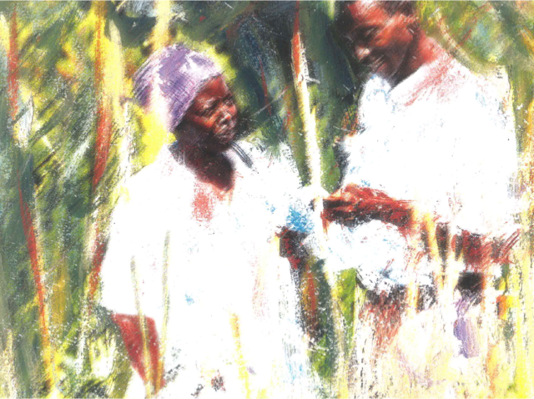
Nutrition Seminar: The European Commission's Action Plan on Nutrition – Ensuring Quality Implementation

Monday 19th March |  | Tuesday 20th March |  | Wednesday 21st March
Registration: 8:30 for 09:00 start |  | Registration: 8:30 for 09:00 start |  | Registration: 8:30 for 09:00 start
What | Who | What | Who | What | Who
9:00-9:15  Opening Welcome  9:15-9:45 Introductions | Commissioner  Neven Mimica  Facilitator | 9:00-9:10  Opening Day 2  9:10-9:45 Introductions & reflections from yesterday | Madeleine Onclin, DEVCO/C1 Head of Section, Nutrition  Facilitator  Resident Artist | 9:00-9:45  Introductions & reflections from yesterday | Facilitator  Resident artist
9:45-11:00 Session 1.1  A Global Overview:  - Malnutrition in All its Forms  - Economic Consequences of Malnutrition  Q+A / Discussion / Exchange | Francesco Branca, WHO  Bruno Declercq, DEVCO/C1 | 9:45-11:00 Session 2.1  Monitoring multi-sectoral efforts  Discussion/ Exchange | Patrizia Fracassi, SUN Movement Secretariat  Veronique Girard DEVCO/05 | 9:45-10:15 Session 3.1  Q+A with DEVCO & ECHO management  Unit C1 | - Leonard Mizzi, Head, DEVCO/C1;  - Philippe Thomas, C1/ Head of Section, Resilience to Food Crisis;  - Madeleine Onclin, C1/ Head of Section, Nutrition
 |  |  |  | Geographic | - Stephane Devaux, DEVCO/E2, Geographical coordination for Western Africa Regional Programmes;  - Michel Arrion, Head, DEVCO/D4, Regional Sector Policy Analysis (tbc)
 |  |  |  | ECHO | - ECHO Management (tbc)
 |  |  |  | 10:15-11:00 Session 3.2  Nutrition in the European External Investment Plan  Q+A / Discussion / Exchange | Matthew Brooke, DEVCO/ C1  Phoxay Chandavone, SUN Focal Point, Laos;  Chris Osa Isokpunwu SUN Focal Point, Nigeria
Break: 11:00-11:30 |  | Break: 11:00-11:30 |  | Break: 11:00-11:30
11:30-12:30 Session 1.2  Coherence between international positions & national actions  Q+A / Discussion / Exchange | Patrizia Fracassi,  SUN Movement Secretariat | 11:30-13:00  Session 2.1 continued  Capturing learning from multi-sectoral monitoring: Insights from SUN countries  An overview of what can be achieved with a range of evaluation tools.  Discussion/ Exchange | David Pelletier, Cornell University  Jef Leroy, IFPRI | 11:30-13:00  Session 3.3  Nutrition in Budget Support  Q+A / Discussion / Exchange | Agnes Duband, EU Delegation to Niger;  Andrea Massarelli, EU delegation to Honduras;  Assunta Testa, EU Delegation to Bangladesh;  Xavier Le Mounier, DEVCO/A4

Lunch: 12:30-14:00 |  | Lunch: 13:00-14:00 |  | Lunch: 12:30-14:00 - Informal reminders of EC guidance on the linkages between various thematic areas & nutrition (Health, Education, WASH, Gender, Agriculture, Social transfers)
14:00-15:30  Session 1.3  Donor Co-ordination: A focus on EU Joint Programming for Nutrition  Q+A / Discussion / Exchange | Koen Eveaert, EU Delegation to Laos  Pierre-Luc Van Haeverbeke, EU Delegation to Ethiopia  Fiona Ramsey DEVCO/A2 | 14:00-15:25  Session 2.1 continued  Strengthening skills & capability for learning in nutrition  Discussion / Exchange | David Pelletier, Cornell University | 14:00-15:30  Session 3.4  Nutrition in the Humanitarian-Development Nexus  Q+A / Discussion / Exchange | Cosimo Lamberti Fossati, EU Delegation to Sudan;  Sarah Bernhardt, EU Delegation to Chad;  Gaëlle Zeegers-Nizery, ECHO & Abi Masefield, NAS, for Myanmar;  Anthony Ayeke, EU Delegation to Nigeria  Gaëlle Zeegers-Nizery, ECHO
 |  | 15:25-15:35  Pre-break announcements  A new funding opportunity: Food Systems in Arica, A Horizon 2020 topic for collaboration  A new call for proposals on research / nutrition / food systems as part of the DCI project AU Research Grants | Hans-Joererg Lutzeyer,  DG Research & Innovation  Christophe Larose, DEVCO/C1 Head of Section, Sustainable Agriculture
Break 15:30-16:00 |  | Break: 15:35-16:00 |  | Break: 15:30-16:00
16:00-17:15  Session 1.4  Experiences of multi-sectoral planning & effective donor coordination.  Q+A / Discussion / Exchange | Sarah Bernhardt, EU Delegation to Chad  Maren, Lieberum,  GIZ, Germany; Abdoulaye Ka, SUN Focal Point, Senegal | 16:00-17:30  Session 2.2  Building the EC research agenda for food fortification  Workshop discussions building on InfoPoint session (15/02/18) | EC Food Fortification Advisory Service.  Facilitator:  Saskia Osendarp, Wageningen University.  Expert contributors:  Lieven Bauwens, Smarter Futures;  Peg Willingham, HarvestPlus;  Saskia Osendarp. | 16:00- 17:15 Session 3.5  Agreeing an Outcome Document - What have we learned? What next? | Facilitation team
17:15-17:30 Lessons/ Inputs to Outcome Document/ Evaluation | Reflections on the day  Facilitation team | 17:30-18:00 Lessons/ Inputs to Outcome Document/ Evaluation | Reflections on the day  Facilitation team | 17:15-17:30  Evaluation/ Close | Leonard Mizzi, Head of Unit C1
Finish time: 17:30 |  | Finish time: 18:00 |  | Finish time: 17:30
19:00 Evening meal |  |  |  | 17:30 Evening reception

