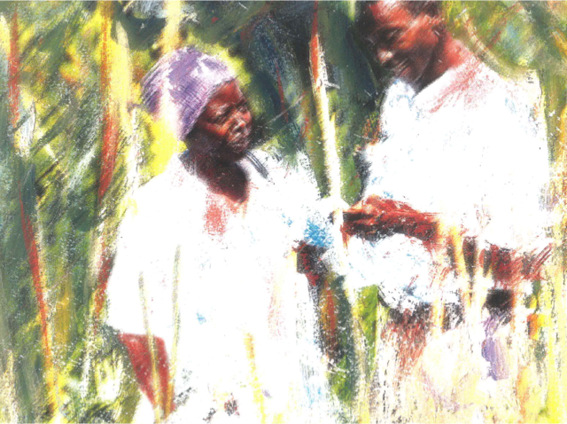**Seminar: The European Commission's Action Plan on Nutrition – Ensuring Quality Implementation**

**The Outcome Document, 22 March 2018**

|  |
| --- |
| *The European Commission needs to broaden the focus of its nutrition priorities beyond stunting and wasting, to consider all forms of malnutrition. The human and economic consequences of not doing so are severe: health and longevity are undermined; and the earning potential of individuals is diminished. Globally, malnutrition in all its forms costs nations an average of US $500 per citizen per year (or US$3.5 trillion).* |

**Introduction**

The EU Nutrition Seminar took place in Brussels 19-21 March 2018. It provided a forum for the exchange and mutual learning across 39 countries from Africa, Asia, Central and South America, including 35 of the 42 EU nutrition focal countries. Alongside EU Delegation staff were Scaling Up Nutrition (SUN) Focal Points from 16 countries; EU Member States; and technical experts from partner institutions. The seminar was opened by Mr N. Mimica, EU Commissioner for Development, and a member of the SUN Lead Group. The closing comments were provided by Mr L. Mizzi, Acting Director Planet & Prosperity, and a member of the SUN Senior Official Group. This Outcome Document highlights the principal messages that emerged; a full report of the discussions will be available in April.

**1. Considering all forms of malnutrition**

* The importance and advantages of tackling all forms of malnutrition are very clear
* There is a need to better understand the practical implications of this: what needs to be done and how, so as to ensure quality implementation
* Besides stunting and wasting there is a call to play greater attention to low-birth weight and anaemia where there is little progress towards achieving the World Health Assembly (WHA) targets; exclusive breastfeeding, complementary feeding and individual dietary quality because of its significance to all forms of malnutrition; and greater attention to overweight and obesity which contribute significantly to the rise in non-communicable diseases (NCDs)
* The current Nutrition Policy and Action plans focus on wasting and stunting. A move towards tackling all forms of malnutrition, increasing attention to the role of food systems and the endorsement of the new Consensus for Development, will require a revision of these documents.

**2. Coordinated efforts towards building multi-sectoral nutrition systems**

EU+ Joint Programming

* Joint programming offers a country-tailored, flexible and voluntary approach that is aligned behind national planning frameworks and synchronised with country cycle.
* Relevant to nutrition since it ensures a louder voice and increased transparency to raise the burden of malnutrition and measures to tackle all forms
* There are potential efficiency gains to joint programming, but these can only be attained through the long-term commitment of all partners from planning through to implementation, monitoring and evaluation
* There are challenges in contexts where there are few EU+ member states or the political commitment to nutrition is low
* Government’s willingness to bring coherence to the donor arena is a facilitating factor for joint programming
* It is a time-consuming process for EU Delegations and Member States alike
* Joint Programming should take account of other existing planning and programming mechanisms especially those instigated by national authorities within the framework of the SUN movement; Joint Programming should not contribute further to the congestion of coordination mechanisms

SUN coordination mechanisms

* Assuming the SUN donor convenor role at the level of EU Ambassador is powerful and influential to the nutrition agenda in country
* Lack of appropriate leadership on nutrition diminishes the SUN donor convenor function and effectiveness (attributing time to this function then becomes very challenging)
* Networking between SUN donor convenors from EU Delegations and other donor convenors is valued and participation at the SUN donor convenor meeting in Malawi 6-8 June is supported
* The EU should consider being co-chair of the global SUN Donor Network
* Donor mapping for nutrition can generate a useful planning tool to promote nutrition-sensitive interventions, but the exercise requires significant resources and commitment across all parties to achieve
* A Civil Society Alliance that grows from a grass-roots movement tends to be more representative of its constituencies than umbrella organisations simply established for the purpose

Building national multi-sectoral systems for nutrition

* The political leadership from the highest level of government is critical
* Recognition of the role of civil society to raise awareness and promote behaviour change at community level, to engage in policy dialogue at national level, to maintain momentum and to hold governments accountable
* A prerequisite is for building the capacity of the Secretariat for multi-sectoral approach at all levels so that this facilitates support across government sectors
* Multi-sectoral nutrition system needs to be built and to be made functional
* Capacities have to be built within relevant sectors to ensure awareness and commitment to achieve the multi-sectoral dialogue and action on nutrition

Nutrition within the Humanitarian-Development Nexus

* Adopting a more holistic approach to undernutrition in situations where wasting and stunting are inextricably linked, often affecting the same children
* Ensuring both humanitarian and development partners are working towards effective and sustainable solutions

Coherence between national and international levels

* Global targets (SDGs/WHA) are influential in promoting and identifying national level objectives and goals
* The commitment to achieving those national goals depends heavily on the political leadership of the country, civil society mobilisation and the importance attributed to nutrition in the development agenda
* Achieving those goals depends significantly on national and sub-national level capacities to plan, deliver and monitor interventions designed to achieve those objectives (this is a particularly critical issue to Africa)

**3. Information, knowledge and learning about nutrition**

* Despite some limitations to the data and modelling of the economic consequences and benefits of malnutrition/improved nutrition, there is recognition that the findings provide compelling arguments on the potential return of investment in nutrition that could be very influential at higher political levels
* More consistent and quality data at sub-national and national level is critical
* Significant gaps remain on measuring individual quality of diet, on diet-related NCDs and other forms of micro-nutrient deficiencies (in addition to iron-deficiency anaemia)
* Need to build capacities at national and sub-national level to deliver on data collection, analysis and then utilisation of this information for planning and programming purposes
* the MEAL dashboard needs to be better adapted to meet country needs
* Nutrition-sensitive interventions must clearly define the impact pathway through which they aim to achieve their objectives to ensure more effective monitoring, learning and assessment of impact
* Generate documented evidence of the impact that nutrition-sensitive interventions can achieve to demonstrate relevance and effectiveness in different contexts
* There is a need to draw on appropriate local and international expertise to achieve quality results

**4. Looking to the Future**

* The meeting helps to begin paving a nutrition roadmap for the Commission’s work in years to come – particularly to frame efforts for the next programming cycle from 2020. This will be elaborated in close cooperation with the EC’s partners; and it will be informed by a mid-term review of the Action Plan on Nutrition which will be launched later this year.
* This roadmap may require a review of the EU’s policy framework for nutrition, to ensure that it provides a solid cornerstone for the EC’s cooperation and development agenda post 2020. This will necessitate the close involvement of colleagues in delegations, counterparts in partner countries, and the voice of civil society. It will need to be a global exercise, founded on local experiences.