FORM TECH-4
DESCRIPTION OF APPROACH, METHODOLOGY, AND WORK PLAN IN RESPONDING TO THE TERMS OF REFERENCE

Table of contents
a)Technical Approach and Methodology. 4
a 1) Background 5
a 2) Objectives of the Assignement 6
a 3) Methodology 7
a 4) Technical approach 10
T0] Inception phase 11
T1a] The TCP training design 12
T1b] The TAT training design 14
2] The TCP training 16
3a] The TAT training 16
3b] The first study visit of the TAT training 17
3c] The second study visit of the TAT training 17
4] Delivery of promotional material and workbooks 20
b) Work Plan 21
c)Organization and Staffing. 24

a) Technical Approach and Methodology.

a 1) Background
In view of reaching the overall objective of the KARDP project, that is, to support the Government to implement appropriate measures of its National Agriculture and Rural Development Plan, the MAFRD wants to expand and re-organize the services of rural advisors.
An effective advisory service in the primary sector requires many actors, since the number of farms and of potential rural firms is large and they are distributed throughout the territory. With regard to this, the MAFRD has not enough staff to ensure a widespread impact.
In order to promote the access to basic knowledge and technical information of rural people, the Law No. 04/L-074 approved on the 15/2/2012, established the Agriculture and Rural Development Advisory Service and the MAFRD created the Advisory and Technical Service Department.
The human resources available to the Advisory Service are made up of ministry personnel, municipal staff and potentially private technicians, also organized in consulting companies.
The concerned staff must take part in training courses, in order to ensure an approach that is homogeneous and consistent with the priorities defined by the Rural Development Plan. Moreover, a certification and registration process is put in place to ensure that its technical capacity is kept up to date. This process is designed by the Administrative Instruction (MAFRD) Nr. 07/2015 that rules on the procedures regarding the training, the compulsory exam, the certification and the registration of Rural Development Advisors.
According to Article 11 points 1 and 8 of this Administrative Instruction, the Ministry hires professional companies to carry out this process in collaboration with the other stakeholders and in support of its Advisory and Technical Service Department and the Commission for Assessment and Certification of Advisors (Art 7, from now on, the Commission).
This Consultant understands that the Kosovo National Agriculture Extension Service (AES) is thus composed of the following entities:
- the Municipality Agents /advisors
- the Advisory and Technical Services Department of MAFRD
- the group of certificated private consultants (natural persons) and of licensed legal persons
training activities conducted in Kosovo.
The overall organization is summarized in the chart below:

a 2) Objectives of the Assignement
It is usually a good starting point to state clearly what are the objectives and which tasks are defined to reach them. Objectives are summarized here, while tasks are listed and discussed in a4) below.
1a] Develop training design for training of MAFRD extension personnel, of municipal advisory agents and of private extension personnel based on the need and requests of the Agriculture Extension Service of MAFRD: The Training Certification program for Advisors (TCP)
1b] Develop training design for training and candidates for advisory services on advanced technologies in agriculture and rural development (TAT)
2] Implement the Training Certification program for Advisors (TCP)
3a] Implement the training for advisory services on advanced technologies in agriculture and rural development (TAT)
3b] Study visit for a subset of selected trainees in one EU country to establish contacts and to exchange experiences with the extension staff
3c] Study visit for another subset of selected trainees in one EU country to enhance the technical knowledge about the production level of the primary sector
4] Delivery of promotional material and workbooks for each module of both training courses
This Consultant chooses to underline here one underestimated objective -that becomes also a consequence- of an efficient extension service in agriculture: in countries where extension services are inadequate, they are substituted by "independent" professionals that work in close collaboration with producers of agricultural inputs. Since their main source of revenues is a function of the sales of those inputs, distortions appears in the efficient choice of the adopted technology. The mix of generally adopted inputs, be they pesticides, seeds or fertilizers, may become a hindrance or delay the introduction of advanced technologies because the new ones have less marketing power. Two good examples to prove this statement are the following:
- the delay and the relative difficulties of the diffusion of technologies that minimize the environmental impact of agriculture.
- the relative absence of technologies adapted to increase production efficiency in marginal areas

a 3) Methodology
In all cases of on-the-job training the OJT Plan regards people that are already involved in the activities that are the object of the teaching and learning process. This case in not quite an OJT, since trainings take place off-the-job: however, all potential trainee already have a good knowledge of the object: the application of agricultural policies with the goal to advance the development of the rural sector.
Civil servants working for the Municipalities and for the Ministry clearly possess the basic knowledge at least because they work on the primary sector. Private professionals that are interested to participate already have a pertinent university degree if they want to take part into the certification programme, and even those that want to take part into the training in advanced technologies in agriculture and rural development clearly have a background knowledge of both the rural field and the extension activities.
In this particular case we see two main aspects worth of consideration:
- The first one belongs to the training teachers. Their capacity is made of their cultural and professional background, their knowledge of the evolution of the European agriculture as it is influenced by the European agricultural policies -that set the long term strategies. Their capacity is also given by the experiences that they have in their own countries about the extension activities.
- the second one is the knowledge that trainees (the future advisors) have about the real rural situation in Kosovo and the expectations they have concerning the possible path of development
The key of the success of such a training program lays in the interaction between these two main aspects, in the working relations that will be established among trainers and trainees. This working relation will crucially depend on communication skills from both sides. This prompt us to consider the problem of the language. It can be approached in three ways:
- The expert trainers speak in English or Italian using short statements or subjects and then they wait for the interpreters to translate them first in Albanian and then in Serbian
- The expert trainers speak in English or Italian and simultaneous interpreters send their translation to the trainees equipped with headphones.
- The experts trainers produce workbooks for each module that are translated and distributed to trainees. They also meet local experts in several occasions to ensure the consistency of the information they want to deliver and they are present at training sessions. Local experts deliver the training in their own language.
The first option is time consuming and absolutely boring for the trainees. The second option has at least two drawbacks: it is very expensive and cannot be implemented with the available budget; secondly, it is extremely difficult to find interpreters that know the specific terminology of agriculture.
This consultant's experience of training in Kosovo strongly suggest the adoption of the third option. This is not only justified by the fact that many local trainers were formed in the past during similar projects and most of them demonstrated a fine knowledge of the matter and a good capacity as trainers: they represent a public investiment in human resources that belongs to Kosovo and that would be unreasonable to waste. It is also justified by the fact that the expert local trainers that we employed before, be they academician or researcher, proved to be perfectly able to interact with foreign experts and to enrich their knowledge and capacities to deliver top-notch training.
During the inception phase the team leader, the experts and the stakeholder will decide whether or not to implement the Consultant' suggestion.
Concerning the training itself, our experience advises us to propose a methodology based on the following points:
- Interactive lecturing
- Active learning
- Using case-studies
- Sustain small group work and team research
- Teaching style
Interactive lecturing is a method based on both forward and backward flow of information.
Active learning is a process whereby trainees engage in activities, such as reading, writing, discussion, or problem solving that promote analysis, synthesis, and evaluation of class content. Cooperative learning, problem-based learning, and the use of case methods and simulations are some approaches that promote active learning.
Case studies are examples that allow for the theoretical aspects to be applied in a practical way. In this case, to apply the theory of investment evaluation, the required topics like livestock, fruit and vegetables and greenhouses are excellent models. Even when the average number of trainees per session is large, it is easy to create smaller groups working on particular subjects.
Regarding teaching styles, it is clear that different instructors perceive the classroom environment in different ways: however, our consultants are all briefed and followed by the team leader and the backstopping committee that will give and receive information about the different situations and ensure a homogeneous approach.
Both teaching styles and teaching strategies are often based on an approach that helps trainees appreciate the value of the learning goals in the course. Usual actions taken by trainers are the following:
- connect the material to trainees' interests
- show trainees the relevance of the course to their professional lives or to their job
- share the teacher’s enthusiasm and passion about the subject
- give trainees authentic, real-world tasks to facilitate and assess their learning
It is easy to see that all these conditions are already incorporated in the set up of the proposed work, since public officers and private consultants have a real interest in the topics of the course. Moreover, our experts share the approach based on these actions.
We will also make use of a mix of theoretical teaching and case-based teaching: theoretical teaching provides the foundation for analyzing general cases and cases different from those discussed during group work. It allows the trainees to learn a method that can be applied in most real cases.
A number of examples of our topics discussed during modules is given below in paragraph 4b]: this is because they can constitute, together with the technical topics, the base of the required workbooks, specifically for TCP Modules 2,3 and 4.
Concerning the curriculum design aspect, we believe that it should include the goals for learning people, the contents and their sequence, the instructional methods, the evaluation and grading approaches, and how adjustments to the plan will be made according to experience and to assessment data.
Our standard off-the-job training design consists of the specific definition of each module of the subjects to be covered (the curriculum), the number of hours given to each of them, the teachers, a calendar, and the methods by which the trainees and the training are evaluated. The last one is an adapted version of quality control.
The definitive methodology of the training design will be approved during the inception phase. On the base of the inception report, the first task of the implementation phase is the training design with all its components. After completion of deliverable D-2 1) and the approval of the training design by the Client (step D-2 2)) the implementation will begin.
An important point of our methodology is the forming and the work of the backstopping committee: all our involved experts, local and foreigners, constitute a pool of resources available to the team leader that will call upon them to perform single tasks. The team leader coordinates their work with the stakeholders, mostly in the inception phase and during the designing of the trainings, and with the trainees during the rest of the implementation phase. Particular answers can be promptly given, changes in the modules' subjects can be done according to the needs arising from the trainees. Members of the backstopping committee will also guide the groups during the study visits.

a 4) Technical approach
In order to attain the objectives outlined above (a 2) this Consultant plans to execute the following activities. They will be assigned as tasks to the staff composing the team. During the inception phase and with regard to the designing tasks, the main working unit is composed by the team leader and the appropriate components of the backstopping committee. The backstopping committee is formed by all experts listed in section c) below. They will work in close collaboration with the stakeholders, in particular with the extension department staff at MAFRD and with the Commission.
The consultant assigns the following activities to its staff:
T0] Inception phase
T1a] A training design is to be developed for objective 1: the curriculum, that is the specific definition of each module of the subjects to be covered, the number of hours given to each of them, the teachers, the calendar, the trainees evaluation method and the quality control plan.
T1b] A training design is to be developed for objective 2: the curriculum, that is the specific definition of each module of the subjects to be covered, the number of hours given to each of them, the teachers, the calendar, the trainees evaluation method and the quality control plan.
T2] Implementation of the Training Certification Program, TCP
T3a] Implementation of the training in advanced technologies in agriculture and rural development, TAT
T3b] Conducting the study visit for a subset of selected trainees in one EU country to establish contacts and to exchange experiences with the extension staff
T3c] Conducting the study visit for another subset of selected trainees in one EU country to enhance the technical knowledge about the production level of the primary sector
4] delivery of promotional material and workbooks for each module of both training courses
Each task is described below.

T0] Inception phase
At the beginning of the project an inception phase will be carried out by the team leader, by the relevant members of the backstopping committee and by local partners and experts.
The main tasks of the inception phase are:
- To set up logistics: the office, computers, a printer and communication facilities
- Mobilize specialists and local experts on training design and preparation
- Organize a workshop of the backstopping committee and the main stakeholders for presenting activities and orienting training packages design
- Check, edit and confirm the work plan
- Submit the draft of the inception report, edit the possible comments and submit the final version

A further important subject to be discussed during the inception phase is the composition of the set of trainees for both activities 2] and 3]: we refer here to the cultural profile and the professional background of the trainees. Being them the main target of the training, the overall results of the training itself also depend on their characteristics, capacities and expectations. This consultant understands that the Client is going to set up the list of participants and it underlines the need to have it ready for the inception phase. In this way it will be possible to involve some of them in the test of the training package.
Common features of tasks T1a] and T1b] are:
Trainings will include a theoretical part and a practical part. In particular, during the practical section, some cases study which occurred in Italy and appear to be relevant for Kosovo will be discussed. This trainings are professional trainings and they aim to improve advisors’ capacity building.
The subjects that will be considered during the design include at least the following:
- Main stakeholders involved directly or indirectly in agriculture who need training and access to information;
- Issues arising from the assessments of the situation, which affect the main stakeholders;
- Assessment of training needs to farmers and advisors for agriculture;
- Features of the training according to the Law No. 04/L-074 on Advisory Services for Agriculture and Rural Development and the sub legal acts established by this Law.

The development of trainings design will start in the inception phase but its realization is due at the beginning of the implementation phase with the following steps:
The team leader and the Curriculum design specialist (CDS) will employ part of their time during the inception phase to set up a general assessment of the situation. This will enable the latter to prepare the guidelines for experts during the first week of the implementation phase.
Getting training contents proposals by the selected training topic specialists: each expert will provide a first draft of his/her contribution on his/her area of expertise, based on the information given by the Guidelines.
Analysis of the proposals and feedback process: the CDS sends his comments and requests of adjustments to the experts. He receives the final draft from each of them in about a week. Then, he will design an ad hoc curriculum proposal and discuss it with the stakeholders.
Discussion of the curriculum proposal in the 2-days workshop with concerned stakeholders, foreign experts and local trainers who will implement trainings. The Commission will be a relevant subject in thsi process. The consolidate draft of the proposal is sent to the agricultural extension department of MAFRD for approval.
After approval of the Training Packages, training topic specialists and local experts will be engaged on Training Packages finalization, under the coordination of the Training Designers specialists and Team Leader. This process consists of the detailing the subjects presented in each module, assigning durations, the trainers, the schedule and so on.
In what follows, regarding training designs, we give two example of the tasks based on our experience. Of course, the actual tasks will be implemented according to the result and the work on site.

T1a] The TCP training design
It is composed of: the curriculum, that is the specific definition of each module of the subjects to be covered, the number of hours given to each of them, the teachers, the calendar, the trainees evaluation method, the certification method, and the quality control plan.
Regarding the TCP, the design will be finalized as follows:
- Training material preparation by specialists and local trainers: at this stage training topic specialists and local trainers will jointly work to prepare training structures and materials, detailing methodologies and specific needs from training delivery. Each module will have the support of an 8/10 pages document translated in both Albanian and Serbian languages, presenting modules objectives, delivery methodology, practical activities, contents.
- Training packages test and adaptation: foreign experts and local trainers will work together to test their training packages, by also requiring the involvement of selected potential trainees.
- Training packages adaptation: accordingly to the previous step outputs, needed changes and adaptation will be internalized in the training package
- Designing of the certification methodology in accordance with the Administrative Instruction (MAFRD) Nr. 07/2015 and with the Commission

The table below summarizes one possible training curriculum, with its modules and the main learning subjects.
Module | Duration | Learning focuses
Module 1: Basic knowledge | 2 days | - Concepts of agriculture and rural development  - Principles and story of extension in agriculture  - Typologies of extension  - Extension in Kosovo
Module 2: Time management | 1 day | - Categorization of typical activities  - Determining importance and urgency of activities and tasks.  - Planning and implementation processes
Module 3: Methodology and Inter – personal skills | 2 days | - Top-down versus bottom up approaches  - Typologies: Training&Visit systems, groups extension approaches (Farmers field schools, farmers extension groups, participatory technology developments, etc.)  - Agent skills: public speaking and presentation skills, reporting, extension material preparation, farmers mobilization and involvement, sensitiveness to cultural and social issues, group techniques, managing group discussion
Module 4: Methods of advice giving | 2 days | - Face to face communication  - Mass Extension: Village meetings Field days Extension through Media  - Farmer-to-Farmer Extension  - Cross-visits  - ICT technologies helping in growing the profit from agriculture and non-agriculture activities  - Proctices on sustainable agriculture  - Group Extension Methods
Module 5 Farm management | 3 days | - Planning farm activities  - Agricultural Operations  - Farm Economics  - Creation of farmers’ cooperatives  - Marketing  - Norms and rules (EU)
The editor of the TCP design will be the Curriculum Training Specialist. Each module will be jointly developed by an international expert on the subject and a local trainer: after approval of the training design the content of each module will be edited and delivered as a workbook and it will be the base of the training activities.

T1b] The TAT training design
It is composed of: the curriculum, that is the specific definition of each module of the subjects to be covered, the number of hours given to each of them, the teachers, the calendar, the trainees evaluation method and the quality control plan.
Regarding the TAT, the design will be finalized as follows:
- Training material preparation by specialists and local trainers: at this stage training topic specialists and local trainers will jointly work to prepare training structures and materials, detailing methodologies and specific needs from training delivery. Each module will have the support of an 8/10 pages document translated in both Albanian and Serbian languages, presenting modules objectives, delivery methodology, practical activities, contents.
- Training packages test and adaptation: foreign experts and local trainers will work together to test their training packages, by also requiring the involvement of selected potential trainees.
- Training packages adaptation: accordingly, to the previous step outputs, needed changes and adaptation will be internalized in the training package

The table below summarizes one possible training curriculum, with its modules and the main learning subjects.

Primary crops production and Primary livestock production | 2 days | - Focus on 2/3 primary crops (crops selected according to the results of the preliminary mission) and on 2/3 primary livestock (livestock selected according to the results of the preliminary mission)  - Presentation of issues related to the use of advanced technologies: inputs, sustainable practices, control of pest and diseases, livestock provision, nutrition, vet services, reproduction, etc.  - Field visits for on-farm analysis
Farm Planning, Management and Analysis | 2 days | - Planning  - Operations  - Finances  - Marketing  - Field practice
Post-harvest Handling and Agricultural Marketing | 2 days | - Products quality and perishability  - Postharvest technologies  - Food norms and rules  - Products brokers, intermediaries, buyers
Agro-processing and Rural diversification | 2 days | - Agro-processing technologies  - On-farm and off-farm agro-processing  - beekeeping  - new and alternative crops  - hospitality and tourism
Agricultural Produce Transport and Agricultural Trade | 2 days | - Products Markets  - Costs of transport  - Technologies for transporting food  - Transport actors and buyers
Information and communication technology in agriculture (ICT in agriculture) – a tool for access to knowledge and transfer of information, and innovation in agriculture and rural development | 2 days | - Mobile use  - E-platforms for data access  - ITC for certification and traceability

Each training will be structured in 2 main sessions. The first to present and update trainees on specific advanced technologies and practices. The second to analyze farms/firms and to interview stakeholders and to discuss on real cases.
The editor of the TCP design will be the Curriculum Training Specialist. Each module will be jointly developed by an international expert on the subject and a local trainer: after approval of the training design the content of each module will be edited and delivered as a workbook and it will be the base of the training activities.

2] The TCP training
Basic data for the organization of the TCP are:
# of trainees concerned |  | 40
# of groups |  | 2
# of trainees per group |  | 20
# of modules of 7 hours |  | 5
# of days per group |  | 2+1+2+2+3=10
total days of training |  | 10 x 2 = 20
total man days of training |  | 20 x 10 x 2 = 400

The task consists in the delivery of the TCP to approximately 40 new advisor agents.
The TCP training will last for 20 training days. It is composed by 5 main modules, each one repeated for the first and the second group. It will be delivered in 2 times for training and certificate 40 new advisor agents.
Trainees will be organized in 2 groups, thus the 10 days TCP will be delivered 2 times. The course will provide 400 man days of training and it will require at least 20 trainer man days.

3a] The TAT training
Basic data for the organization of the TAT are:

# of trainees concerned |  | 70
# of groups |  | 5
# of trainees per group |  | 14
# of modules of 7 hours |  | 6
# of days per group |  | 2*6=12
total days of training |  | 12 x 5 = 60
total man days of training |  | 14 x 12 x 5 = 840

The 5 training courses on advanced technologies -the same one is replicated 5 times on 5 groups of trainees- will be delivered in such a way to facilitate the participation of different advisory services communities. Approximately 70 advisory agents in total, from MAFRD and municipalities, will benefit of the courses. The courses delivery will start in July and last up to November. Each module will last for 2 days or 14 hours.
The course will provide 840 man days of training and it will require at least 60 trainer man days.

3b] The first study visit of the TAT training
Where, When, Who, How many, the local Guest, member of the team involved, main subjects of meetings

The 1st study visit will be in Rome, Italy, Apulia Region, and will allow participants to establish contacts and exchange experiences with extension staff in Italy.

3c] The second study visit of the TAT training
The 2nd study visit will be in Bari, Italy, and it will allow participants to see and understand the latest applications of innovative production processes in different areas of the primary sector: e.g. the functioning of the agricultural value chain in horticulture, fruit production, olive oil, husbandry.
CIHEAM-Bari is the Italian institute of the International Center for Advanced Studies on Mediterranean Agriculture, whose headquarter is in Paris. CIHEAM Bari has the mandate to implement programs on research, education and cooperation, aimed at developing a sustainable agriculture and rural development in the Mediterranean Basin. Nowadays its activity is centered on education program attended by students coming from Mediterranean countries and on several regional and country projects. In the last years CIHEAM Bari was engaged on important projects for strengthening Institutional capacities of MoA of Kosovo.
CIHEAM Bari has a consolidated experience on the organization of study tours for agricultural officers and practitioners form a wide range of countries.
During the study tours participants will be hosted at the CIHEAM Bari premises, that may provide accommodation, restaurant services, logistics for education activities and seminars.
The study visits' programs
Here we explain 2 indicative examples of programs that are designed for providing advisory agents from Kosovo with innovative and good practices for a sustainable agriculture and rural development framed within EU and Regional policies and programs.
The 1st example is about “Horticultural in Apulia Region: actors and services”
In Apulia region horticulture is an intensive and modern sector on which many farmers rely on. Important public and private actors do exist that are playing key and innovative roles, providing important support to farmers. These include research and extension services, water management consortiums, seed suppliers. Mechanisms are in place for ensuring to farmers access to knowledge, technologies, markets, through processes that protect human and environmental health and respect social and cultural values.
The study tour will have the objective to transfer to participants basic notions on Apulian horticultural value chain and innovation systems, in particular presenting policies, programs and actors that perform innovative roles. The study tour will include interaction and discussion with key actors and field visits to significant sites. Specific emphasis will be on actors delivering assistance and services in horticulture. The study tour program will be as follow.

Day
1 | Arrival to IAMB  Presentation of the study tour  Seminar on EU LEADER Program and application in Apulia  Meeting with CIHEAM Bari staff
2 | Visit to the Local Action Group of Ostuni  Visit to agritourism  Visit to didactic farm
3 | Visit to Cooperative Cellar of Alberobello,  Visit to Tocchi di Puglia, family firm led by woman for agro-processing of horticultural products
4 | Visit to small scale mills  Visit to pasta makers family led firm  Debriefing at CIHEAM Bari
5 | Departure to Kosovo

The 2nd example is about “Rural economy diversification and development"
The objective is to present to participants important programs of Apulia Region that build on agricultural and rural communities values. Participants will have the chance to meet important actors who govern rural development in Apulia, managing programs on local development processes (e.g LEADER and other multi-stakeholder platform) or private firms receiving support (such as agritourism and agro-processors firms).
The program will be as follow:
Day
1 | Arrival to IAMB  Presentation of the study tour  Seminar on: Extension services, Regional programs for Agriculture development (Integrated and Organic Agriculture, typical products, diversification of rural economies and leader program)  Visit to horticultural farm under integrated agriculture regime
2 | Visit to University of Bari and CNR on research and demonstration activities in horticulture  Visit to La Noria farm, demonstrative farm on innovative technologies in Horticulture, in particular on greenhouses and no soil cultivation technologies
3 | Visit to Locorotondo CRSA Basile Caramia delivering services on multiplication and certification of propagating material for continental fruit crops and on soil and product quality analysis  Visit on products traceability to Fasano Market place (managed by a farmers’ consortium)
4 | Visit to Consorzio della Capitanata on water basin and irrigation schemes management in horticulture  Debriefing in Bari
5 | Departure to Kosovo

The study tour includes the visits to the following farms and research centres:
-Experimental Farm "La Noria" is located in the suburban area of Mola di Bari, 20 Km south of Bari. This Experimental Farm is the result of a joint-effort between Mola di Bari Municipality, Puglia Region and CNR (National Research Council -Italy) and it is constituted by the headquarters and three greenhouses (around 1600 m2) aimed to conduct and research on soilless systems. The headquarters is constituted by offices, labs ( Physical and chemical analysis of substrates, Chemical analysis of nutrient solutions and biometrical samplings) and a small library (containing the most important Italian Horticultural Journals and hundreds of specialized books). The whole area is almost 7000 m². The main greenhouse is an iron-structure covered by wavy methyl polymethacrylate (Ondex) and divided into two independent sub-climatic sections. Internally, this greenhouse has a shadow-thermic facility, top and lateral ventilation windows automatized and a main-computer guided facility to keep track of all the climatic events (DGT Volmatic). During the first phase of activity (this Experimental Center was inaugurated on 20 April 1998), the research group constituted by 3 researchers, 2 scholarship holders, technicians and co-workers of the CNR and the Agricultural Faculty of the University of Bari has conducted several researches under different regional, national and international projects. A special role has been played as Extension Center and particularly acted to the Agricultural Development Service of Puglia Region, which also see on this kind of research center a main function to introduce, adopt and extend technological innovations for producing high-quality vegetables respecting the surrounding environment. The Experimental Farm is also an organization where formative and practical stages are conducted by undergraduate students of the Agricultural Sciences and Technology Program of the University of Bari; besides other students have conducted experimental trials in order to develop their undergraduate research-based thesis. Since 2000, the Experimental Farm "La Noria" is also an institution where several research projects of the Ph.D program in Mediterranean Agronomy (University of Bari) have been carried out.

“La Noria Farm” (Azienda La Noria (http://noria.ba.cnr.it/farm.phtml)

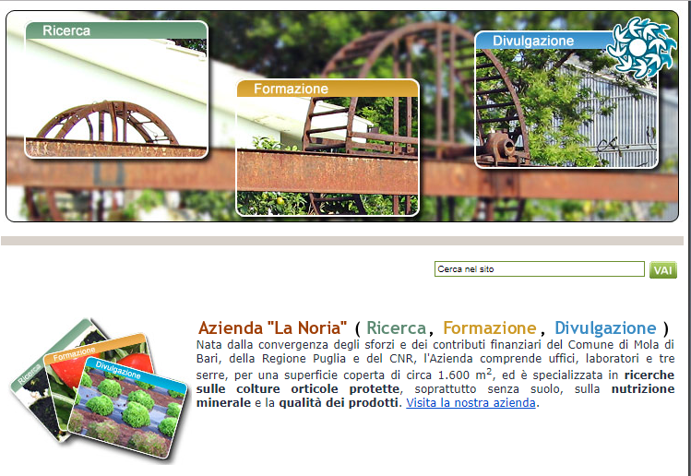

- CRSFA Agricultural Research Centre is an ONG created in 1987 with the aim:
- to put in connection farmers with agricultural research centers
- to improve fruit and vegetables production
- to improve farmers’ knowledge
- to provide support on agricultural subsidies
- to train Agricultural College students coming from Locorotondo (Bari, Italy).
This research Centre provides different services: research, training, technical assistance in the agricultural sector. One of the main target is the improvement of plant nursery industry and the safeguard of the biodiversity through the implementation of projects aimed at the recovery, conservation and enhancement of ecotypes of the native Apulian species (citrus, fig, stone fruit, olive, pear, grape, etc.).

CRSFA Agricultural Research Centre (CRSFA Locorotondo (www.crsfa.it)

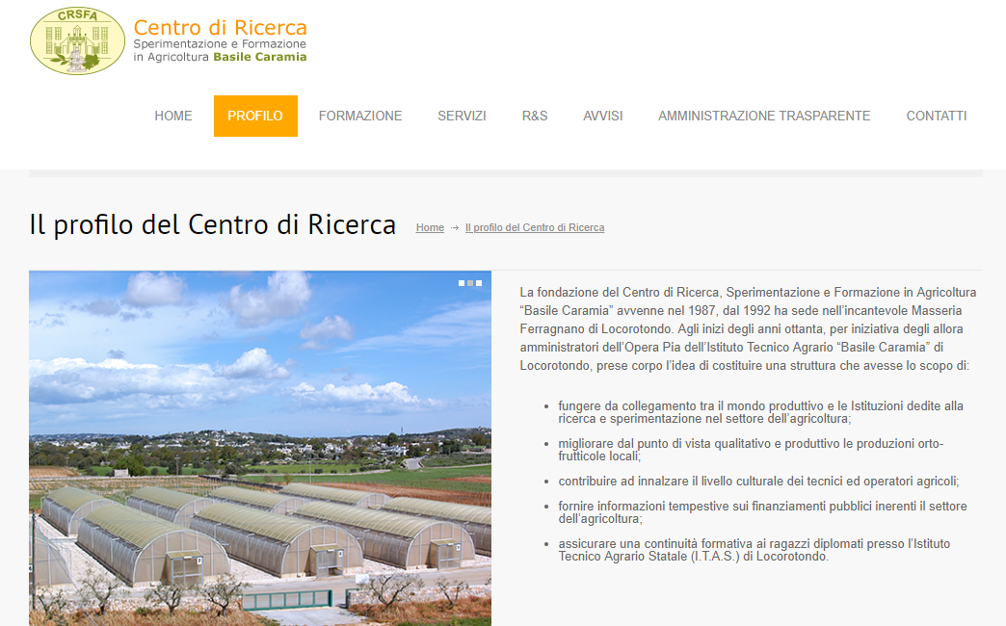

- Capitanata land reclamation Consortia was created in 1965 to guarantee hydraulic safety, land management, to manage water resources, to guarantee land protection and preservation and to promote environmental and rural development.

Capitanata, Foggia Italy, land reclamation consortia (Consorzio per la bonifica della Capitanata http://consorzio.fg.it/)

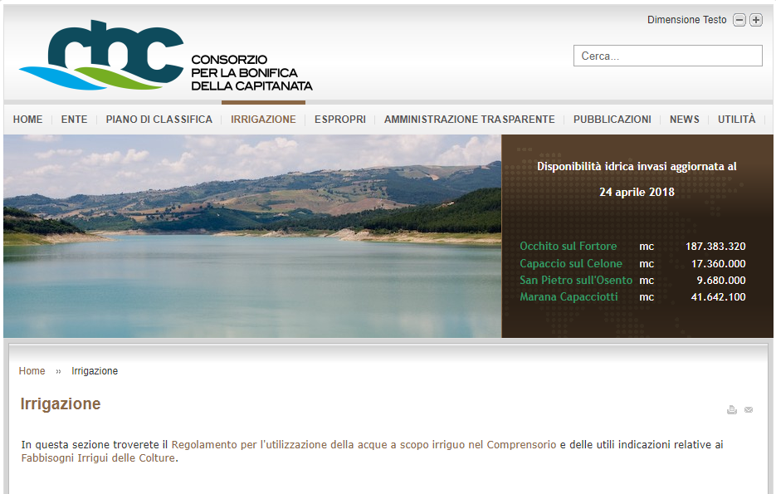

- Fasano Mediterranean Fruit and vegetables market is one of the most important Italian fruit and vegetables market. The modern structure of the market was created in 2001 by the Fasano’s Municipality in cooperation with farmers, producers and operators. Over the years the market gets bigger, at the beginning was 1.239.000 q.li and in 2014 was 1.600.000 q.li. It means that the fruit and vegetable market represents an important driving force for the economy of the Brindisi area (Apulia Region). The Center has started incisive initiatives in recent years which contribute to develop and to publicise the typical products of the territory. And this fits perfectly in the guidelines of the EU that sees in the agri-food chain a strong tool for the identification, qualification, valorisation of typical products and therefore of the territory's economy.

Fasano MediterraneanFruit and Vegetables Market (Mercato Orto-frutticolo di Fasano)



4] Delivery of promotional material and workbooks
Promotional material of firms providing inputs and services to the primary sector has a long tradition of a positive mixing of practical and useful advices with the advertisement of products. In European and less developed countries the practice of major firms to openly support the diffusion of technical brochures, also edited by public extension services, is a widespread custom.
This Consultant is not a priori against this custom, but it expresses the view that it must be followed with much care: essentially, there need to be a control of the public extension service on two aspects:
- the consistency of the recommended practices with the agricultural measures set locally by the agricultural policy
- the fact that no particular firm gain a dominant position in the market due to the advertisement contained in the materials
If this is the meaning of Promotional Material, as it is mentioned in the ToR, the Consultant will instruct the team to work with the stakeholders in providing guidance to realize this aim.
On the other hand, we propose to edit a brochure about the Extension Service in Kosovo to be used during trainings and distributed to trainees.
4b] Workbook
The consultant will prepare classroom material (approx. 8 pages/topic) with all topics of organized trainings on both certification program and technical trainings for extension staff.
With its experience in professional training, the Consultant owns a large library of materials that has been edited and adjusted during the years. Technical subjects like those regarding the TAT or the last Module of TCP constitute the first part of this library. Modules and materials concerning best practices in training are the second part.
Training material for technical topics are less standardized than the others, since, although based on general principles of agronomy, veterinary and engineering, they usually face different sources of variation: the country, its climate, the general practices of the primary sector, its social and economic conditions etc. These materials are more dependant on the particular audience and expert trainers, that have a larger degree of freedom in answering the clients' needs. As a matter of fact, this project considers the design of the course curriculum not as a given item but as something that constitute a specific task based on the desiderata of the client and on the local conditions.
We have given two examples of curriculum with topics in the paragraphs above: during the designing phase they will be tailored as needed by the team of experts and written material will be edited and translated for each module. This papers will constitute the base of the training and will help trainees to keep track of the development of the discussion, as well as for getting ready to take the exams.
The second part of our library of topics concerns directly the "art of training": it is formed by modules that leverage on psycological and social sciences to enhance the efficiency of training and the effectiveness of working relations. We believe they are quite adapted to the TCP and its final curriculum will greatly benefit from them. Of course, the choice of the single examples / subjects will be taken during the designing phase. The chosen subjects will constitute the workbooks given to trainees. A sample of this kind of training material is given in the following list, which provides subjects and time duration.

1 Acts of Recognition, 30 minutes, purposes:
• To help participants recognise how their behaviour/communication is experienced by others.
• To encourage participants to increase the positive acts of recognition they give to others, and to create a working atmosphere in which people feel accepted and recognised

2 Making Meetings Effective, 60 minutes, purposes:
• To encourage participants to think about what causes meetings to be ineffective.
• To identify what can be done to make meetings effective.
• To introduce the acronym APPLE and explain how focusing on five simple themes will help participants ensure meetings are effective.

3 Testing Communication Between Teams, 75 minutes, purposes:
• To help participants develop their communication skills and in particular their listening skills, their ability to share information effectively and their ability to explore problems objectively.
• To illustrate the importance of teamwork and develop the skills needed to work effectively with other teams – particularly where teams are small and geographically diverse.
• To understand that effective teamwork involves identifying and capitalising on all of the unique skills and talents of individuals within the team.

4 Getting the Questions Right, 30 minutes, purposes:
• To demonstrate the importance of asking a mix of open and closed questions to gain a clear and accurate understanding of a situation

5 Body Language and Mirroring, 30 minutes, purposes:
• To show participants how we tend to mirror the body language of others when rapport is established.
• To discuss what happens to body language when rapport is absent.

6 Feelings Towards Change, 45 minutes, purposes:
• To recognise the impact of imposed change on people.
• To remind participants how easy it is for progress to be lost and for things to slip back to the way they were before

7 Barriers to Communication, 60 minutes, purposes:
• To enable participants to test their communication skills.
• To test participants’ abilities to get their point across effectively whilst building an understanding of others’ feeling

8 An Exercise in Customer Service, 30 minutes, purposes:
• To demonstrate the importance of exploring customers' needs through questioning, listening and checking understanding

9 Presentation Skills, 60 minutes, purposes:
• To examine common problems/conundrums associated with giving presentations and discuss ways of overcoming these.
• To highlight and share best practices and tips for making presentations successful.

10 What Listeners Pay Attention To, 20 minutes, purposes:
• To help participants understand what listeners actually pay attention to when someone is speaking.
• To provide participants with a self-generated list of the essences of powerful communication.

11 Common values and experiences, 30 minutes, purposes:
• To encourage participants to find things they have in common.
• To consider the impact on relationships of finding common ground.
12 The Importance of Summary and Clarification, 30 minutes, purposes:
• To demonstrate the importance of summary and clarification in effective communication.
• To test participants' ability to listen effectively, check understanding and summarise key points back to the person delivering information to them.
• To briefly consider some of the barriers to effective listening and techniques for minimising these.

13 Designing Practical Objectives, 60 minutes, purposes:
• To communicate the skills needed to design and write effective training aims, objectives and outcomes.
• To encourage participants to apply the principles to all the sessions which they design and deliver.

14 Leading a Discussion, 20 minutes, purposes:
• To consider the advantages and risks of using facilitated discussion within training interventions.
• To explore how to manage the risks and tips for successful discussions.
• To provide an opportunity for participants to practise leading and participating in discussions.

15 Training Practice for farmers, 120 minutes, purposes:
• To give participants an opportunity to practice training delivery to farmers; including debriefing exercises.
• To explore the importance of using relevant icebreakers and energisers to change energy levels in the training room. The importance of using well known local examples
4c] Tools
One dossier containing a notebook, a pen, the classroom material and the calendar, will be given to each trainee.
Given the relatively small size of the groups, there is no need for the trainer to use a microphone, amplifier and loudspeakers. During the trainings, each classroom will be provided with a white board, a screen and a projector: each trainer will deliver the training following a presentation projected on the screen. Trainers will preferably use files transferred to the available computer in each classroom, to avoid technical glitches with the projector.

b) Work Plan

Qui inserire il work plan colorato con le stelline e commentarlo con note tipo quelle sotto
what follows is moved to the workplan section: queste sono note di Lamberto, credo, che forse possono essere utili.
- Selection of candidates: between August and September will be collected applications to TCP (40), and formed 2 groups (20 trainees each) that will attend the TCP.
- Commission appointment: in September a 3/5 member commission for Assessment and Certification of Advisors, formed by Kosovo MAFRD and other key institutions, will be appointed for Assessing and certificating advisors trained by TCP
- Trainings delivery: during October and November the training will be delivered two times for the 2 selected groups of candidates. Each training will last 10 days, with the participation of different specialists according to modules.
- Preparation of assessment test for the advisors: the contractor will prepare and compile the assessment test and it will submit it to the Commission
- Certification: at the end of each training the appointed commission will assess and certificate advisors through individual interviews.
Io credo ancora che il work plan con le stelline debba andare qui per primo con i suoi commenti.
Poi segue il comm TECH 5 che riguarda i deliverable e poi infine i due calendari a modo di esempio che ho appena fatto con il testo che segue.

We already made it clear that the design of both courses, the TCP and the TAT, needs to be defined during the implementation phase. This is a requirement of the ToR and it appears to be a logical one: the knowledge of the profile of the candidates, of the desiderata of the Extension Department and of the needs in terms of employment of time by the candidates and the stakeholders, are all data input to any realistic calendar. The team leader will employ part of his time during the inception phase to ensure that these information will be available at the beginning of the implementation phase.
Notwhidstanding these caveat, it seems appropriate to check that the available time of 8 months can accommodate the courses, considering three main requirements:
- the trainees will be splitted in 2 groups (TCP) and in 5 groups (TAT)
- the courses have to be spread out over as many weeks as possible
- two periods are taken by the study visits
The Consultant provides in the following table a provisional calendar of the training activities until December 2018. Each month is divided in weeks and only working days are shown. For both trainings a two digit symbol indicates the group and the module: for example, in the line of TAT, Group 4 the two symbols 41 show that on Tuesday 28 and on Wednesday 29 of August, the Group 4 will work two days on the Module 1 concerning Primary Crop and Livestock Production. The symbol E indicates the days of the final examination for TCP. There will be a final examination also for the TAT, not indicated here, that can possibly be carried out in the first two weeks of December, assuming that no trainees for TAT are concerned by the study visit. The study visit days are denoted by SV and can be carried out in the most suitable period: as it was said before, this is an example of the actual calendar.

c) Organization and Staffing.
{Please describe the structure and composition of your team, including the list of the Key Experts, Non-Key Experts and relevant technical and administrative support staff.}

