**Towards a Sustainable Garment Sector**

**Make sure to participate in all sustainable garment activities that are taking place during EDD**

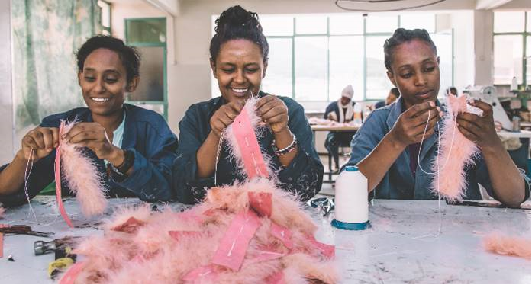

**5th at 9.15-10.30, High Level Panel, Auditorium 3. Towards a Sustainable Garment Sector: Ethical is Fabulous. How to create jobs and growth and enhance social and environmental sustainability in garment value chains** The global garment industry generates 1.3 trillion EUR of business each year, and employs 75 million people worldwide. The garment value chain is one of the most complex production models globally as well as an important value chain in economic terms, both within the EU and in partner countries, providing employment opportunities to millions of workers, especially women. However, the industry faces a wide area of sustainability challenges such as lack of enforcement of labour rights, unhealthy and unsafe working environments, use of hazardous chemicals, poor working conditions and low wages, water pollution and unsustainable use of resources.

This session will bring together different stakeholders and offer a platform to highlight country-specific, regional and global initiatives. The objective will be to facilitate dialogue and encourage collaborative actions in view of tackling social and environmental challenges in global garment value chain. Organized by DEVCO.

<https://eudevdays.eu/community/sessions/1360/ethical-is-fabulous>

**5th at 16.15-17.30, Lab Debate, D2. Do you know where your clothes come from? How to achieve more transparency and traceability in garment value chains**

Increased traceability and transparency are now recognised by many stakeholders an essential step for companies in performing due diligence throughout their global supply chains. However, achieving progress in this area is a major challenge, in particular due to the fragmented production and the prevalent practice of illegitimate subcontracting and undeclared informal work in this sector. This session will debate if and how increased transparency and traceability can turn challenges into new opportunities to developing a reliable garment industry. The session will draw learnings from the experience of stakeholders in the sector and of different initiatives and debate the challenges and opportunities to reducing risks and supporting stakeholders' efforts in this area. Organized by DEVCO, in partnership with ITC and UNECE.

<https://eudevdays.eu/community/sessions/354/do-you-know-where-your-clothes-come-from>

**6th at 14.45-16.00, Project Lab, S3. Empowerment of Women workers in the garment industry in Myanmar: Reaching out and educating women workers in the garment industry of Myanmar about their rights via APPs and Sunday Cafes**

Since 2013 sequa runs the SMART Myanmar project which promotes sustainable consumption & production of garments. Compliance with social and environmental standards and improving working conditions are the main activities, which is done with both management and workers as well as international brands. SMART Myanmar, which is funded under the EU SWITCH Asia Programme, developed in cooperation with other donors like giz and C&A Foundation APPs to inform women workers about their legal rights and occupational health and safety issues, one is called SHWE Job. Another important tool of women empowerment is the establishment of Sunday Cafes in collaboration with local NGOs. In this safe place female workers have a chance to relax, stay, inform themselves about their rights and seek legal counsel. Organized by Sequa.

<https://eudevdays.eu/community/sessions/631/empowerment-of-women-workers-in-the-garment-industry-in-myanmar>

**5th and 6th in the EDD Village, Stand 33: Valued, Respected, Paid! Towards dignified work in the garment sector unifying and strengthening women’s voices to realize labour rights and to demand fair, gender equal and dignified garment production**

The garment industry dominates the Bangladesh economy. Women workers are disproportionately represented in the most marginalised & impoverished forms of work in the industry, falling short of a living wage, facing a gender pay gap & living in poverty. Gender-based violence remains a largely hidden issue. This is exacerbated through power differences between a female workforce and male management & social norms. CARE and Südwind strengthen the capacity of labour rights actors & increase the voice of female garment workers. Südwind connects them with European consumers for decent working conditions. Organized by Care.

<https://eudevdays.eu/community/sessions/487/valued-respected-paid-towards-dignified-work-in-the-garment-sector>