ANNEX-A

Terms of Reference
PREPARATION AND PACKAGING OF THE WESTERN CORRIDOR INFRASTRUCTURE PROJECT

Abbreviations and definitions

BOST Bulk Oil Storage and Transportation Company

CBS Central Bureau of Statistics
Cedi National currency unit of Ghana
COCOBOD Ghana Cocoa Board

DSGS Development study of Ghana seaports, Feb 2002, the Takoradi Masterplan

ECOWAS Economic Community of West African States
EDF European Development Fund
EIA Environmental impact assessment
EITI Extractive Industries Transparency Initiative
EMP Environmental management plan
EPA Environmental protection agency
EC European Commission
Euro European currency unit

FLEGT Forest Law Enforcement, Governance and Trade

GASCO Ghana Association of Stevedoring Companies
GBC Ghana Bauxite Company Ltd
GHACEM Ghana Cement Co
GMC Ghana Manganese Company Ltd (from 1995)
GPHA Ghana Ports and Harbours Authority
GRC Ghana Railway Company
GSC Ghana Shippers Council

JICA Japan international cooperation agency

MC Minerals Commission of Ghana
MFEP Ministry of Finance and Economic Planning
MLFM Ministry of Lands, Forestry and Mines
MPR Ministry of Ports and Railways (formerly Ministry of Ports, Harbours and Railways)
MRT Ministry of Road Transport (formerly Ministry of Roads and Transportation)
MSSP Mining sector support programme
MSSP/PMU MSSP/ Programme management unit

NDPC National Development Planning Commission

TOR Terms of reference

WLDS Western Line Development Study (DE-Consult, 1996)

The Western Corridor is composed of the GRC railway line from Takoradi to Kumasi, with branches to Nsuta and Awaso, and the new inland port of Boankra (under development), of the attached railway spurs (present and proposed) and of the Port of Takoradi. Under this definition, roads are not included.

The Assignment is: ''to carry out the feasibility study of the project for the rehabilitation of the Western Transport Corridor as a whole and of its components''.

The Contracting Authority is the Government of Ghana, represented by the National Authorizing Officer for the EDF, Ministry of Finance and Economic Planning.

The Consultant is the consulting firm which has been selected to carry out the Assignment.

The Project is the object of the feasibility study. It is composed of various components (railway investment programme, port investment programme, environmental mitigation programme, financial engineering, etc).

A Component is a part of the Project to be defined by the Consultant. It may be physical, institutional or financial. A Component may be dealt with individually in establishing the feasibility of the Project, provided that its participation to the Project is relevant and is explicitly stated. The port and the railway are two distinct entities which will be dealt with as distinct components, though those components are to be consolidated in a transport chain vision.

The Supervisor of the Mining Sector Support Programme is the Minerals Commission.

The Supervisor of this study is the Ministry of Ports and Railways.

The Monitoring Committee is the Committee in charge of monitoring and evaluating the Consultant's work and organising ad hoc donors’ round tables. It is composed of representatives of relevant administrations and entities: MFEP, MPR, GPHA, Minerals Commission, MSSP/PMU, and the Delegation of the EC as an observer.

1. BACKGROUND

1.1 Study Background

The Financing Agreement for the Mining Support Programme between the Republic of Ghana and the European Commission was signed in December 2002, within the framework of the Lomé IV Convention and the 8th European Development Fund. Under the Agreement, the European Commission is financing through a grant a support programme in the Mining Sector of Ghana (project 8 ACP GH 027).

Among the main areas of focus are feasibility studies to upgrade the Western Corridor mining supportive infrastructure (in short: the Western Corridor), composed of the railway line from Kumasi to Takoradi, the railway feeder lines (actual and projected) and the Port of Takoradi. Road infrastructure and transport are outside the scope of the assignment. Upgrading the Western Corridor is the Project.

Within the framework of this Programme and on the basis of the findings of a pre-feasibility study, the European Commission has received a request from the Ministry of Ports and Railways through the National Authorizing Officer, being the Minister of Finance and Economic Planning, to conduct the said full feasibility study of the Project.

A copy of the pre-feasibility study report is attached to the Tender Document.

The present feasibility study shall cover seven main topics which are listed below and detailed in Sections 4 hereafter.

Demand for transportation on the corridor: present and future distribution of goods transported by the railway and the road.

Railway rehabilitation and development programme (infrastructure, rolling stock, etc). Long-term develop costs.

  - Railway commercial reforms. Mid and long term development perspectives.

  - Port operations and development programme.

  - Institutional streamlining in view of possible public-private partnerships: port and railways. Institutional and financial framework for financing railway development.

Mid- (10 years) and long term (20 years) development perspectives, particularly in a regional framework (ECOWAS).

  - Environmental protection.

1.2 Sector background

The Ministry of Transportation (MoT, formerly Ministry of Roads and Transport) is in charge of road Infrastructure (Ghana Highway Authority, Department of Urban Roads, Department of Feeder roads), road transport services (Metro Mass Transit Company, Intercity STC) and regulatory and other agencies (Driver and Vehicle Licensing Authority, National Road Safety Commission, Ghana Road Fund Board).

In the road sector, there are a number of challenges: funding for road maintenance and transport needs, axle load control, labour-based technology for maintenance, decentralisation. Cost recovery for the impact of heavy vehicles is an issue of growing importance.

The Ministry of Ports and Railway (MPR, formerly Ministry of Ports, Harbours and Railway, MPHR) is to ensure the provision of multi-modal, integrated, sustainable and environmentally responsible infrastructure and services that respond to national, expanding global market needs and international standard through. Effective and efficient services encompasses promoting partnership with the Private Sector, promoting strategic investment in the sector, streamlining unnecessary or inefficient regulatory requirements and procedures that affect the flow of transportation goods and services, and promoting international transport in a multi-modal manner. It has oversight responsibility over the Ghana Railway Company Ltd. (GRC) and the Ghana Ports and Harbours Authority (GPHA).

The Ghana Maritime Authority (GMA) operates under the supervisory role of the Ministry of Ports and Railways and acts as the sole regulatory body for the country's maritime affairs. It is also the agency tasked to further develop and promote Ghana's maritime services. It works closely with its maritime industry partners, facilitates their needs and nurtures their businesses by providing a conducive maritime operating environment in Ghana. The role of the GMA is principally to ensure safe, secure and efficient provision of shipping and related services in a harmonious and clean maritime environment in Ghana.

The Ghana Railway Company Limited is a public sector body with responsibility for the efficient management of the national rail system so as to enhance the smooth movement of goods and passengers. A rehabilitation programme aimed at removing physical bottlenecks was initiated in the eighties. With the support of donor agencies, operating assets have been acquired and tracks refurbished. However, the situation has not improved significantly.

The Ghana Ports and Harbours Authority is the national organization which manages the ports of Tema and Takoradi, as well as the fishing harbours. It is presently undergoing re-structuring exercise which will progressively transform it into the Maritime hub of the sub-region. Then, GPHA will act as the regulator of port activities instead of its present role as an operator.
The National Transport Policy, which is currently under development with participation by all the stakeholders responsible for the other transport modes and should be adopted by the end of 2006. It will inform, regulate and give strategic direction and focus to the transport needs of the nation. Based on the policy, the Transport Sector Integration Plan will be prepared, setting planning priorities for the different sub-modes, suiting the national development agenda and sub-regional strategic objectives. It will form a basis for the Transport Sector Development Programme 2008-2013 and will seek to harness the synergies of the transport sector as a whole.
Boankra Inland Port (under development) is an inter-modal road-rail terminal at Boankra (close to Kumasi, to its East) to facilitate import and export trade, especially for the hinterland countries of Burkina Faso, Niger and Mali.

It is Government’s desire to establish the Boankra Inland Port on a Build, Operate and Transfer basis. The main operators at the moment are the GPHA and the Ghana Shippers’ Council. The MRT is co-ordinating the activities of interested parties at the moment. The inland port would involve an inland Port Estate and inland Container Deport as an integral part of the long-term development of the ports of Tema and Takoradi. As part of the programme, a hundred-container carrying wagons and associated handling equipment should be procured to enable Ghana Rail move containers up country.

The regional framework is to guide the development of the railway network, present and future. In that sense, the Western Line should not be considered as a single vector (a mining railway) but as a pillar of a major structuring mode for the south of the country and as a means to establish possible connections with neighbouring countries (in the ECOWAS framework) in the future.

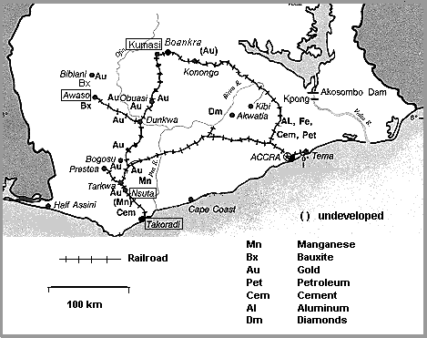
Map of Southern Ghana showing the railway network

Recent Initiatives
In 2006, the Ghana government took several initiatives concerning the western corridor rail and port infrastructure:

- On Thursday 22 June 2006, Alcan and the President of Ghana announced to build a 2 billion US dollars Alumina refinery, with 51%/49% participation in the investment by Alcan and GoG respectively (source (B&FT, 26 June 2006).

- CEO of Kampac Oil and Ministers of Ports and Railways and Lands, Forestry and Mines signed a MoU for the rehabilitation of the western railway, with an estimated investment of 1.5 billion US dollars.

- Maersk is planning an investment in Takoradi port for modernization and expansion of the container port, including breakwater, deepening of port for sea vessels, etc.

- During the President of Ghana last visit to the USA, a MOU for the conduct of feasibility studies on the rehabilitation o railway lines and the rail system of the Western and Eastern Lines was signed between Ghana and SNC Lavalin, a Canadian construction and engineering company.

- JICA has been requested by the Government of Ghana to update the Master plan of Takoradi port.

And recently, although not directly related to the Western Corridor:

Ghana/Korea Holder Company has received the green light to begin a feasibility study on the Accra/Kumasi Line.

2. OBJECTIVES

2.1 Overall Objectives

The overall objectives of the Project are as follows:

- To ensure sustainable and environmentally sound mobility of goods and persons on the railway, taking into account the comparative advantages of rail transport over road transport if relevant, and facilitate a smooth movement of goods and passengers between the mainland, the coast and overseas destinations through the Port.

- To have optimum combination and integration of the modes (rail and port; coordination between road transport and rail transport), within the framework of the National Transport Policy,

- To improve safety and reliability,

- To ensure sustainable development of the Western Region and an increased integration in the national economy.

- To provide the potential financiers with a clear picture of the investments and actions which are needed to reach these objectives, including an overview of the relationships (formal and informal) necessary for coordination, cooperation and partnerships.

The aim of the feasibility study is to develop the different aspects of the Project, possibly with variants and adequate phasing, and to establish its feasibility. It will provide the decision makers within the Government and the European Commission with sufficient information to justify acceptance, modification or rejection of the proposed programmes defined under the Project, including the documentation necessary for further implementation and financing.

2.2 Specific Objectives

With respect to the Railway:

- The Western Line should be rehabilitated and upgraded in order to cope adequately with the identified demand, for goods as well as for passengers.

- This rehabilitation should not be isolated from the rehabilitation of the railway network as a whole: at no time, should the Western Line be considered as a single vector (a mining railway) because of the status of the railway as a major structuring mode for the south of the country and as a means to establish possible connections with neighbouring countries (ECOWAS framework) in the future.

- Ultimately, the railway company should become a commercially driven entity and this will be better achieved if more than mining issues are dealt with. The Consultant is required to propose structural and institutional changes for the Railway as a whole; this may include public-private partnership(s).

With respect to the Port of Takoradi:

1) The port storage area for bulk minerals should be well demarcated, expanded and improved to enable more minerals to be stored to meet international orders.

- Port handling equipment for bulk minerals be modernized to increase efficiency in the handling of the minerals.

- Berthing area for ships be improved to allow for bigger ships to call at the port to load more minerals.

3. RESULTS TO BE ACHIEVED BY THE CONSULTANT

The study will deliver the following:

- An assessment of the relevance of the proposed Project and its components to address the problems identified in the economic and social sectors and any additional problems arising in the transport and demand sectors. The time horizon is 20 years; adequate scenarios on transport demand will be used.

- A detailed analysis of the technical, economic and financial, institutional and management, environmental and socio-cultural feasibility of the proposed Project and its components.

- A detailed analysis of the potential sustainability of the Project results.

- A detailed plan which specifies indicators for project objectives, results and activities and incorporates required resources, the institutional structure required for the implementation of the Project and its components, and stipulates the responsibilities of various bodies, including public-private partnership(s), Project timing/phasing, estimated costs and a logical framework planning matrix. The time horizon is 5 years (five year programmes).

- A Preliminary design of those components which are backed by the selected scenario and details of next steps to be taken from this preliminary design stage to implementation for each of the components, including tender dossiers for the engineering, procurement and construction (EPC) package.

- A draft financing plan, by component.

- Recommendations for the following steps and any further actions to secure project financing This shall include procurement advice on how to attract financing and preparation of draft contract packages which would govern the relationship between the concession authority and the potential private partners: delegation, concession and supply commitments, financing agreements, loan syndication, etc. Relationships with Development Partners and International Financing Institutions may be considered as well.

- Initial promotional activities such as production of a full-colour brochure and organisation of a workshop to attract potential investors from private and public domain, including development partners.

See the Workplan in Section 5 for the desired study results at intermediate stages.

4. SCOPE OF WORK

4.1 Main issues to be studied

The main issues to be studied are outlined below. The different headers of the study are presented in Appendix I: Content of the Feasibility Study Report. The Consultant shall use the draft feasibility report carried out by SNC Lavalin as primary basis for assessing the feasibility of the project. Since mining interests are expected to be the main thrust of the SNC Lavalin report, Consultant shall where necessary widen the scope, so as to comply with below main issues to be studied.

In addition to the carrying out the feasibility study, the Consultants shall be expected to assist the supervisor, Ministry of Ports and Railways, in acting out its lead role for coordination between, and if necessary negotiation with, parties involved (such as Maersk, private banks, financing institutions, etc.) for the purpose of assessing their role as possible partners and/or future investors.

a - Demand for transportation on the railway

It must be noted that almost all goods which are transported on the railway pass through the port.

Transport forecasts were prepared in the past (DE Consult study, Takoradi Masterplan). They need to be revised in relation with past developments and new perspectives, including the national development agenda as formulated in the Growth and Poverty Reduction Strategy II (GPRS II). Some new research is needed, which will imply commitments of the major stake holders: the mines, the cocoa traders, logging industry, the gasoline trade, etc.

The Consultant may submit questionnaires to the users of the rail and port facilities, have direct contact with professionals, household interviews, etc. in order to document properly its hypotheses and the future level of demand.

Road checks and interviews should provide a suitable reference of road traffic alongside the railway corridor (passengers, ore trucks, log trucks, etc.)

The following categories should be explored:

Passengers demand

Bulk transport:

Bauxite, manganese ore: perspectives of present mines (GMC; CBC), potentialities of new mining.

Oil and petroleum products (imports): GPHA; BOST, etc.

Clinker (Ghana Cement Company)

Ballast, etc.

Cocoa.

Timber.

Containerized goods (imports and exports)

Others, including equipment for the present and future mines

Transit goods from and to landlocked countries

Tourism development

b - Railway rehabilitation and development programme

The rehabilitation and realignment proposed in the technical evaluation of 1996 (DE Consult, scenarios S3 and S4), which was soundly conducted, should be used as a reference. It must be actualised though, taking into account what has been done on the lines during the past ten years.

Base costs are to be calculated anew. Reference to long term development costs for the railway is a must.

This should be done on the basis of the definition of a five-year railway rehabilitation and development programme (see above) and of an evaluation of the production of railway services. It should also consider the need and viability of changing gauge width, in particular in context of sub-regional strategic framework.

This will examine the rationale behind fixing a fee for use by the operator of the infrastructure (in this case: ore trains) and define a suitable level for that fee.

This will also consider a possible split of ownership of rolling stock between the operator and major clients (GBC and GMC owning ore wagons and possibly shunting locomotives).

c - Railway reforms; commercial and institutional framework for financing railway development

The feasibility study will review what has been proposed and would adjust the railway action plan (or the concessionaire's action plan) to the new commercial and institutional framework: a business oriented marketing structure including profit centres, a capacity to conduct market research in all market sectors, a capacity to hold discussions with GBC and GMC to determine the required scale of investment in new facilities and the extent to which each party is prepared to contribute financially, etc.

Then, options should be explored to consider various possible financing mechanisms, including private sources and development partners/International Financing Institutions.

Recommendations for a new institutional structure should be made. Examples in the sub-region, with their successes and drawbacks, may be used as a reference. An overall objective should be the creation of proper and fair public-private partnership(s), bearing in mind the need for a sustainable activity which may associate efficiency with fairness.

The problem of passenger traffic should be addressed properly.

Suitable procurement rules must be drafted, bearing in mind the Public Procurement Act recently adopted in Ghana. The Consultant should advice on how to package the different project components: what should be tendered/ outsourced and what should remain in public domain (either funded by the Government of Ghana or Development Partners)

d - Port operations

GPHA uses its adopted Masterplan for Takoradi as a basis for its actions. Its Projects Office in Tema keeps all relevant documents. In addition, Consultant shall coordinate closely with plans for construction of a container terminal in port of Takoradi (Maersk).

The role of the Consultant is to define with precision what a five-year investment programme could be.

Loading mineral ships with the present system is not optimal. It may become less and less optimal as the tonnage grows. The Consultant shall check this technical issue with the perspectives for traffic, and determine when specialised berths become an absolute must.

Another key issue is the transport and export of cocoa. The Consultant is expected to give a clear view of the actions to be taken by the stakeholders in that trade. This concerns the railway, as well as the port.

More generally, the Consultant will define in which way his proposed investment programme for the port may assist the railway in attracting traffics which need mass land transportation.

Any relevant commercial reform in the port operations as well as in the railway-port coordination should be mentioned and properly addressed.

e - Mid- and long term development perspectives

For the grander scheme of extending it to the North, examine the perspectives of development activities with the Northern Regions and with the neighbouring landlocked States and their possible translation into railway traffic on the Western Line. The horizon will be 20 years.

The development of the railway system in Ghana for both goods and passengers will not be complete if the central and eastern lines are also not rehabilitated in the long term. The study should develop a scenario which will indicate how the various rail systems can be developed in the long run with forecasts of economic indicators – population growth rates, sector employment figures, GDP, etc. and estimated costs and others. The study should also take into account the future plans of linking the country’s rail system with that of other West Africa countries and it implications.

f - Environmental issues

Consultant shall cary out an Environmental Impact Assessment of the proposed project. The first issue to be considered is the damaging effect of road transport on the environment: lives, corporal damages, motor pollution, road destruction, dust, noise, etc. By comparison, a railway is more environmental friendly, which does not mean it is harmless.

The Consultant will explore the potential of attracting more cargo to the train with the view to minimising the detrimental effects of haulage on the environment. This will be based on proper assumptions on the cost and the price of transportation on both modes, as well as issues like the unit size of the cargo and the waiting time. Corresponding investments (in storage, parking spaces, container handling facilities, etc) will be included in the railway development programme.

The Consultant will make a case for the enforcement of all traffic and safety regulations in road transportation in order to avoid disregard of signals at level crossings. Bridges may have to be envisaged at some strategic intersections in order to separate rail and road transport.

Upstream, issues on environmental protection should be addressed: logging and the timber industry (a reference to FLEGT about illegal logging is a must), mining industry, oil products storage and transport, etc. For the mining industry, the EITI programme, which deals with institutional and financial transparency, is also relevant.

4.2 General Considerations

In general terms, the Consultant will bear in mind that he must conduct his work with four main preoccupations:

- Relevance
The Consultant will assess the extent to which the proposed Project (and its components) is coherent with the country’s macro-economic environment, and addresses the economic or social demands. This will involve verifying the analysis presented in the pre-feasibility study with regard to:
- the nature and number of beneficiaries potentially affected by the proposed Project;
- all organizations and agencies affected by or involved in the proposed Project;
- all major problems related to the proposed Project, experienced by the beneficiaries and other parties involved, the causal inter-relationships of these problems, and the inter sectoral linkages;
- other interventions or priorities of ministries, agencies and donors which may affect or be affected by the proposed Project;
- information from previous studies and evaluations relevant to the proposed Project.

- Feasibility

The Consultant will determine the feasibility of the Project (and its components) by analysing the alternative technical solutions, taking into account various aspects: economic and financial, institutional and management, environmental and socio-cultural, regulatory and operational standards and practices.

This analysis shall be presented in technical appendix IV of the feasibility study report.

The Consultant will develop a detailed recommendation for the Project to be structured as follows:

- Overall objectives: why is the Project important to the users and beneficiaries, the region and the government? What are the desired economic and social benefits?
- Project purpose: why do the users and beneficiaries need the Project?
- Project results: what services will the Project deliver to the users and beneficiaries? What services external to the Project (classified as assumptions) are required to achieve the Project purpose?
- Project activities: what has to be done to achieve the Project results? What activities external to the Project (classified as assumptions) have to be carried out to ensure the Project results?

The Project purpose and results should be specified by indicators, and the Project activities should be quantified as closely as possible.

This information, which updates the pre-feasibility study, will form chapter 3 (intervention) and chapter 4 (assumptions) of the feasibility study report (see Appendix I).

(iii) Risks and assumptions

The Consultant will identify risks and formulate assumptions and determine any preconditions necessary for the start of Project activities.

The Consultant is required to propose an efficient project organisation and any phasing of project activities considered necessary. Cost estimates shall be provided for all project activities.

This information, which updates the pre-feasibility study, shall be presented in chapter 5 (implementation) of the feasibility study report (see Appendix I).

(iv) Sustainability

The Consultant will assess the sustainability of the proposed Project and its components using the key sustainability factors which are:

- policy and coordination ;
- demand and economic sustainability ;
- financial sustainability ;
- institutional and management sustainability ;
- environmental and socio-cultural sustainability ;
- regulatory and operational sustainability.

This information shall be presented in chapter 6 (factors ensuring sustainability) of the feasibility study report.

These lists of issues are not exhaustive. The Consultant is required to use his professional judgement and experience to review all relevant factors and to bring these to the attention of the Government of Ghana and the Delegation of the European Commission.

5. WORKPLAN

On the basis of the proposed time schedule outlined in this Terms of Reference, the Consultant will prepare and submit a detailed work plan based on the activities to be performed under the study.

The work plan should set out the Consultant’s approach to the following activities:

- fact finding/data collection/surveys omitted in the pre-feasibility study or requiring updating;
- identification of alternative solutions for the proposed Project ;
- analysis of alternative technical solutions ;
- a brief report summarizing the analysis of the alternative solutions;
- consultation meetings with decision makers/stakeholders to identify the preferred technical solution;
- preparation of preliminary design documents and draft EPC tender and financing packages;
- preparation of the draft and final feasibility study report.

An inception report (end of month 1) will detail the preliminary findings of the Consultant as well as adjustments in the work plan.

At the intermediate stage of the first progress report (end of month 3), various scenarios for the development of the corridor will be presented, reflecting the results of the demand study (by commodity, and as a whole) as well as the preliminary findings on the capacity of the railway and the port, and on the means to increase them.

The Evaluation Committee will comment on the said scenarios and indicate which ones would be kept as a base for the subsequent works.

From months 4 to 6, the Consultant will propose relevant technical options in relation to the development scenario which has been selected. Cost estimates for these options (and each of its components) will be prepared with a +/- 30% margin of accuracy. Options will include various financing mechanisms; financial engineering will be started at this stage.

At the intermediate stage of the second progress report (end of month 6), the Consultant will propose various technical options as well as various phasing of investments based on the selected scenario. This proposal will come along with a screening by objective criteria within the framework of the national transport policy, possibly through multi-criteria analyses.

The evaluation of options shall be done in consultation with stakeholders. The coordination workshop with potential financiers may be organised at the end of this stage, so that their inputs can be considered in the preliminary design stage.

From month 7 to month 10, the Consultant will proceed with the development of the selected option to the preliminary design stage. Revised costs for the selected option will be done with +/- 10% margin of accuracy. Sub-components will be priced.

The Environmental Impact Assessment is to be carried out during this period.

The final report (end of month 10 in its preliminary version) has to give an overview of the general progress and major problems encountered. It includes all the consultant's findings, analysis, conclusions and recommendations.

6. EXPERTISE REQUIRED AND STAFFING

Indicative staffing requirements of key personnel, in man-months, are given in the table below:

In man-months | Inception phase and  up to 1st progress report | From 1st  to 2d progress report | Final phase and presentation | Total
Team leader | 3 | 3 | 5 | 11
Transport economist | 3 | 3 | 3 | 9
Financial analyst |  | 3 | 3 | 6
Railway track design engineer | 2 | 1 | 2 | 5
Railway rolling stock expert | 1 | 1 | 2 | 4
Railway operation analyst | 2 | 1 | 1 | 4
Railway traffic control expert |  |  | 1 | 1
Port infrastructure expert | 1 | 1 | 2 | 4
Port handling & operations expert | 1 | 1 | 2 | 4
Containerization expert | 1 | 1 | 1 | 3
Project Finance / Public-Private Partnership expert | 1 |  | 2 | 3
Environmental expert | 1 | 1 | 2 | 4
Key experts, total | 16 | 16 | 26 | 58

The Consultant must specify the qualifications and experience of each key expert to be assigned to the study. For each specialist proposed, a CV must be provided of no more than four pages setting out the relevant experience.

Some specific expertise may be needed, involving local consulting. For that purpose, the breakdown of price includes a pool of local specialist to be used on an ad-hoc basis upon approval of the candidates CVs by the Contracting Authority. This specific expertise could be used to mirror the expertise of the short-term international inputs.

Note that civil servants and other staff of the public administration of the beneficiary country cannot be recruited as experts.

The profiles of the key experts for this contract shall be as follows:

- Project Manager - Team Leader

Qualifications and skills
He/she should be at least holders of MSc degree or equivalent experience in his fields of specialisation.
Proven strong skills in communication and project management
Experience of EDF Procedures is advantageous
Fluent in English

General professional experience
Minimum of 15 years post qualification experience in the transport sector of which at least 10 years international experience in developing countries.

Specific professional experience
Experience must include feasibility studies for rehabilitation of major transport infrastructure, preferably in Sub-Saharan Africa. Experience as a team leader on a similar assignment is essential. Experience in Ghana would be an advantage.

- Transport economist

Qualifications and skills
He/she should be at least holders of BSc degree or equivalent in his fields of specialisation.
Experience of EDF Procedures is advantageous.
Fluent in English

General professional experience
Minimum of 15 years post qualification experience in the transport sector of which at least 10 years international experience in developing countries.

Specific professional experience
Experience must include feasibility studies for rehabilitation of major transport infrastructure, preferably in Sub-Saharan Africa. Experience in Ghana would be an advantage.

- Financial analyst

Qualifications and skills
He/she should be at least holders of BSc degree or equivalent in his fields of specialisation.
Fluent in English

General professional experience
Minimum of 8 years working experience of which 5 years in an international context.

- Pool of Railway experts

This pool of experts includes a Railway track design engineer, a Railway rolling stock expert, a Railway operation analyst and a Railway traffic control expert.

Qualifications and skills
All experts shall be at least holders of BSc degree or equivalent in their fields of specialisation.
Fluent in English

General professional experience
Minimum of 8 years working experience of which 3 years in an international context.

- Pool of Ports infrastructure Specialists

This pool of experts includes a Port infrastructure expert, a Port handling & operations expert, and a Containerization expert.

Qualifications and skills
All experts shall be at least holders of BSc degree or equivalent in their fields of specialisation.
Fluent in English

General professional experience
All experts shall demonstrate a Minimum of 8 years working experience of which 3 years in an international context.

- Project Finance / Public-Private Partnership Expert

Qualifications and skills
He/she should be at least holders of BSc degree or equivalent in his fields of specialisation.
Fluent in English

General professional experience
All experts shall demonstrate a Minimum of 8 years working experience of which 3 years in an international context.

- Environmental Expert

Qualifications and skills
He/she should be at least holders of BSc degree or equivalent in his fields of specialisation.
Fluent in English

General professional experience
All experts shall demonstrate a Minimum of 8 years working experience of which 3 years in an international context.

7. REPORTING

The following reports shall be submitted:

An inception report shall be submitted to the Contracting Authority for approval by the end of week 4;

The inception report has to:

  - Define clearly the aims and the objectives of the assignment;
  - Detail the methodology;
  - Set out the organisation of the Consultant's work and experts' detailed work programme,
  - Identify the constraints and risks, assumptions and problems arising in the initial period of services and propose solutions to deal with them.

A progress report n°1 shall be submitted to the Contracting Authority for approval by the end of month 3;

This report will include various development scenarios for the corridor.

This report will include the environmental scoping report and draft TOR for EIA.

A progress report n°2 shall be submitted to the Contracting Authority for approval by the end of week 6;

Reports 1 and 2 on the progress of the services have to address the following issues:

- Progress on individual tasks and the finalization of individual tasks as well as whole, assignment, detailed comparison and analysis between the work programme and activities realized,
- Summaries of results achieved under individual tasks including working papers,
- Any delays encountered / foreseen,
- Any other problem encountered / foreseen and suggestions for overcoming these problems ;
- Visualisation, drawings, photos.

The monitoring committee will review all reports received and comment on them within 15 days. If required, the Consultant shall revise the report and resubmit for approval within 15 days.

A draft of the final report shall be submitted to the Contracting Authority for approval by the end of month 10.

The final report has to give an overview of the general progress and major problems encountered. It shall include all the Consultant's findings, analysis, conclusions and recommendations.

The study conclusions will be presented in the format given in Appendix 1. The underlying analysis shall be presented in appendices to the report.

The report will include a draft of the Environmental Impact Assessment report.

The Monitoring Committee will review it and deliver its full comments within 15 days.

The Consultant will submit the final report, including the EIA, not later than a month after he has received the said comments. Final approval will be given within 15 days.

Workshops

The Consultant will organise two workshops and a presentation meeting:

- A kick-off meeting workshop to provide an opportunity to present the team to the Authorities and the major stakeholders.

- A one-day high-level coordination workshop at intermediate stage to consult the authorities, potential financiers, and stakeholders for the evaluation of options.

- A Monitoring Committee presentation meeting when delivering the draft of the final report. The aim of this meeting will be to present the main results of the study and the strategy proposed.

The Consultant is responsible for the organisation of the workshops and the meeting and the venue. He will meet all pertaining costs.

Study reports will be delivered in seven paper copies plus one copy in an electronic form.

8. TIME SCHEDULE

The Consultant will organise his work in such a way that the reports listed in Section 7 above shall be in conformity with the requirements.

Phase 1 | Inception | End month 1
Phase 2 | Study of various scenarios | End month 3
Phase 3 | Basic study of the selected option (30% accuracy) | End month 6
Phase 4 | Detailed study of the selected option (10% accuracy) | End month 10
Phase 5 | Final Report | End month 12
 | Total | 12 months

The Consultant shall propose a detailed time schedule in his offer.

9. OBLIGATIONS OF THE CONTRACTING AUTHORITY

The Contracting Authority shall provide all possible support to the Contractor, in particular:
- The Contractor shall have free access to basic information, maps and documents relating to the mineral sector infrastructure of Ghana.
- The Contracting Authority shall facilitate custom clearance and acquisition of visas and residence permits for the experts with the local authorities, but any cost arising thereof shall be borne by the Contractor.

Facilities to be provided by the Consultant

The Contractor shall ensure that experts are adequately supported and equipped. In particular it shall ensure that there is sufficient administrative, secretarial and interpreting provision to enable experts to concentrate on their primary responsibilities. It must also transfer funds as necessary to support its activities under the contract and to ensure that its employees are paid regularly and in a timely fashion.

The Contractor will be responsible for the procurement five (3) 3 desktop computers and a laser printer, for use in the project and handing over to the Supervisor (MoPR) at end of project life. Additionally needed computers should be provided by consultant and costs should be included in the fees.

Local travels (in Accra and in country) are included in the direct cost as per Annex D of the contract. No car is to be purchased under this contract. The Contractor will be responsible for providing his own means of transportation.

The contract does not include payment of per-diems for local experts or long-term international experts for trips/field visits outside Accra. The corresponding amounts are deemed included in the fees of the concerned experts.

APPENDIX 1: Content of the Feasibility Report

The Feasibility Report shall contain at least the following headers (not exhaustive):

1. Summary

2. Background

2.1 Government/sectoral policy

2.2 Features of the sector

2.3 Beneficiaries and parties involved

2.4 Problems to be addressed

2.5 Other interventions

2.6 Documentation available

3. Intervention

In this section of the report, the Consultant is required to outline the proposed Project and its components, making reference to their analysis presented in technical appendix IV.

3.1 Overall objectives

3.2 Project purpose

3.3 Project results

3.4 Project activities

4. Assumptions

4.1 Assumptions at different levels

4.2 Risks and flexibility

5. Implementation

5.1 Physical and non-physical means

5.2 Organization and implementation procedures

5.3 Time schedule

5.4 Cost estimate and financing plan

5.5 Institutional issues, public-private partnership

6. Factors ensuring sustainability

6.1 Policy support and coordination

6.2 Regulatory and operational, including appropriate technology

6.3 Environmental protection

6.4 Socio-cultural aspects/gender issues

6.5 Institutional and management capacity, public and private

6.6 Demand, economic and financial analysis

7. Monitoring and evaluation

7.1 Monitoring indicators

7.2 Reviews/evaluations

8. Conclusions and proposals

Technical appendices

- Draft financing proposal including a logical framework planning matrix of the proposed Project/programme design - intervention logic, indicators, assumptions and preconditions.
- Map of the Project area.
- Analysis of the relevance of the preferred solution (the Project) with the final conclusions also presented in chapter 2.
- Detailed analysis of the technical and institutional alternative solutions of the Project/programme design, incorporating feasibility and sustainability, with the preferred solution presented in chapters 3, 4 & 6.
- Preliminary engineering designs for the proposed Project and its components (selected option), including draft EPC tender dossiers
- Financing Plan of project and its components, including draft contracts/financing packages.
- Other technical information and data, as required.

Appendix 2
The Port of Takoradi

Source : GPHA

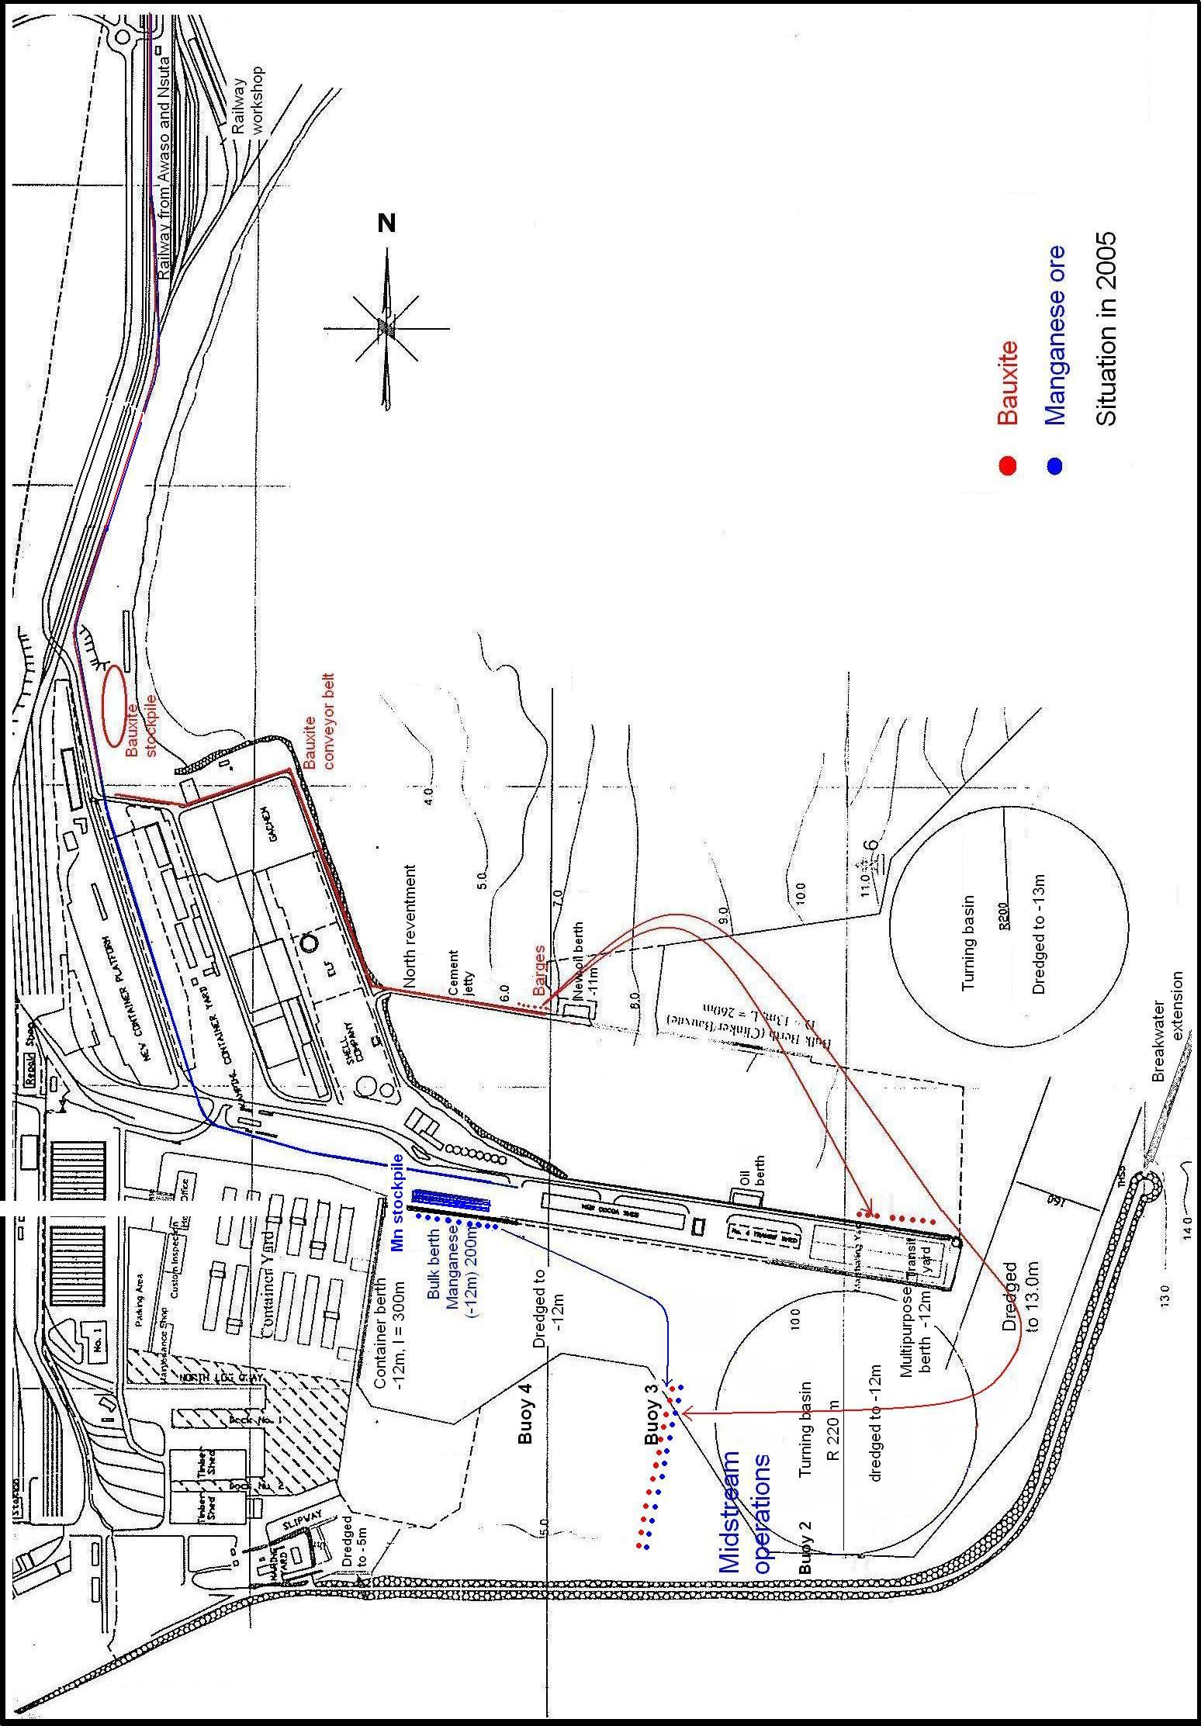
Appendix 3
The railway Network

Source : GRC

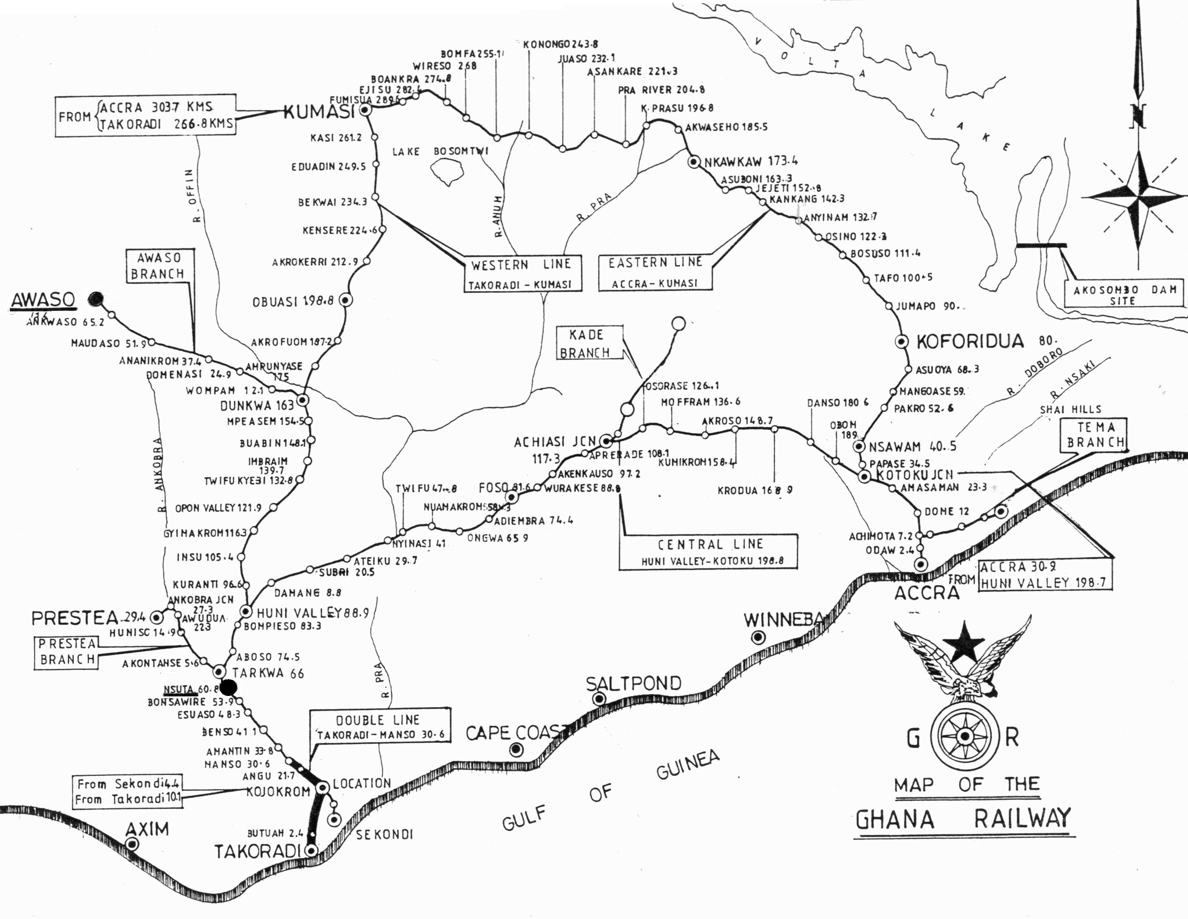
Appendix 4
Reference Documents

Major reference documents are:

- The pre-feasibility study by Tec Ingénierie (Jean-Pierre Diehl, October 2005) “Western Corridor pre-feasibility transport study”: an attachment to the present TOR. This report contains a number of relevant reference documents.
- The ‘’Western Line Development Study’’ was conducted in 1996 by the German consultant DE-Consult, on an IDA loan. A paper copy of that report may be obtained from the printed document in the Headquarters of the GRC in Takoradi.
- The Development study of Ghana seaports (DSGS), Volume 2, ‘’Development guidelines and Masterplan, Feb 2002, the Overseas coastal area development institute of Japan & Nippon Koei Co Ltd, on a JICA grant ; Volume 3, ‘’Short term development plan for Takoradi’’.
- The National Transport Policy and the Transport Sector Development Program, in their end-of-2006 version.

Apart form the above, during the assignment, all relevant literature on road transport may be collected from the Ministry of Transportation, particularly with respect to truck transport (roads and road network, road deterioration, enforcement of axle load regulations, weather-related deterioration, users’ charges, international transport and transit, facilitations, etc.)

