 | EUROPEAN COMMISSION  Directorate-General for European Civil Protection and Humanitarian Aid Operations (ECHO)  ECHO.C4 - Asia, Latin America, Caribbean and Pacific  Mission Report
Subject: Shelter Support Mission, Haiti, 20th – 25th May 2018
Author: Denis Heidebroek, WASH and Shelter GTC (C1/C4)
Mission participants: Denis Heidebroek, WASH & Shelter GTC, Jean-Marie Zephirin, PA, ECHO PaP/Haiti Office
Date: 28/06/2017
Objective of the mission: To monitor and provide technical support to the ongoing ECHO funded shelter grants in the aftermath of Hurricane Matthew (2017) and to provide advice for future ECHO shelter grants (2018/19).
Places visited & interlocutors: The mission was conducted over a period of 6 days. It consisted in a number of meetings in PaP and field visits to 4 ECHO funded projects in the department of Grand´Anse (GA).
- Sunday 20/05: Arrival in PaP
- Monday 21/05: Briefing ECHO PaP + Meeting with national shelter coordination co-lead IOM (Head of Mission and Shelter Co-lead) + Meeting ECHO shelter partners (ACTED, CESVI/HfH, IOM, PUI)
- Tuesday 22/05: Flight PAP-Jeremie. Visit ACTED project in Dame Marie.
- Wednesday 23/05: Travel to Dame Marie. Visit shelter project - IOM.
Visit of IOM project in Chambellan + Moron
Visit of Cesvi/HfH project in Corail
- Thursday 24/05: Visit of PUI project in Beaumont
- Friday 25:05: Return to PaP

EXECUTIVE SUMMARY / HIGHLIGHTS
- The bulk of the ongoing shelter reconstruction response following hurricane Matthew is led by the affected population through self-recovery. Due to the scale of the disaster this response has been marginally supported by the national and international communities. Unfortunately, the self-recovery process is poorly understood and monitored, and urgently requires attention so it can be better supported.
- Regrettably, ECHO´s contribution in support of the shelter sector was reduced from 4.2 to 1.08 M EUR from 2017 to 2018.
- It is recommended that ECHO´s ongoing and future shelter grants in response to Matthew focus on the following actions:
- Address implementation delays in the construction of core shelters of the 2017 grants.
- Correct observed design and construction flaws (particularly structural ones) of the core shelters being built and reinforce the partners´ quality assurance system to monitor the related construction process.
- Develop and roll out a Participatory Approach for Safe Shelter Awareness and Mobilization strategy at community level to complement the prevalent focus of the past and current shelter actions (construction, decentralized technical training, DPC & HRC BBS/DRR campaign)
- Introduce multiple layers of shelter reconstruction approaches (closed/open) rather than a ´one size fits all´ core shelter approach/solution for the 2018/19 shelter grants. This including monitoring, supporting and scaling up broader and spontaneous shelter self-recovery for increased impact/coverage in communities supported by ECHO.
- Reinforce shelter coordination and harmonize ECHO partners’ core shelter solutions to increase consistency and cost-efficiency across ECHO shelter projects.

BACKGROUND TO THE EVENT
Overview of the shelter situation post Matthew: The scale and magnitude of the shelter needs post-Matthew remains very high. According to the related PDNA, 104,000 houses were totally destroyed by the hurricane (+- 520.000 pers.), other 100,000 were severely damaged (+-500.000 pers.), 11,500 were slightly damaged (57.500 pers.) and 21,500 flooded (107.500 pers.) plus an additional 10,700 additional houses (58.500 pers.) due to heavy rains in April 2017. This represents more than 1.0 million persons needing support for total reconstruction and/or substantial repair of their houses. In November 2017, the Haiti Shelter/NFI Working Group (SWG) drew the following conclusions on the shelter response:
- The emergency response has achieved a wide coverage and was coordinated. Immediate basic needs were answered.
- The response to ensure more sustainable shelters allowing households to live in dignified conditions and according to minimum humanitarian standards has been limited due to a lack of resources.
- The shelter response focused on supporting self-reconstruction but it benefited a limited number of households in relation to needs.
- The build back safer reconstruction approach has been promoted and implemented
In practical terms, only 61,326 households (24% of the total caseload of affected houses) received some form of shelter support (CGI kits for roofing repairing, core shelters, permanent houses or rental subsidy cash grants among other shelter assistance modalities), which means that thousands of households remain unattended and severely exposed to further risks. In the department of Grand’Anse where ECHO´s shelter actions are located, 13,655 houses (+- 70.000 pers.) have (or are still) benefiting from some form of shelter repair support, representing 68% of the needs identified in the PDNA. It is however unlikely that this assistance resulted in repairs that provide safe and resilient shelter solutions against future disasters. Moreover, in terms of shelter reconstruction, the response has been marginal, benefitting 3,660 houses (completed and ongoing) or barely 4 % of PDNA needs. An additional 585 new core-houses are planned for 2018 and a further 100 houses (planned by UNDP). According to the SWG, 675 individuals (226 household) are still living in 19 temporary collective shelters or camps. All of them are located in the Grand’Anse and South departments. The limited shelter response significantly undermines the resilience of the local population.
HRP 2018 – Shelter / NFI sector: 3 main priorities have been defined by the SWG. These are:
- Shelter (core-house) assistance for households (HH) that have lost everything
- Shelter repair (directed at the ´poorest´ excluding houses which suffered superficial damages)
- Strengthening Shelter/NFI stocks
The 2018 targets for the shelter sector are as follow: Construction of core house = 15,000 HH (75,000 pers.); House repairs = 9,000 HH (45,000 pers.); and NFI procurement = 40,000 HH. In other words 120.000 beneficiaries have been targeted for shelter repair and/or construction (priorities 1 and 2), a fraction of the population still in need of shelter solutions. The above priorities and targets were reportedly agreed between SWG partners in Oct/Nov 2017 and the shelter strategy presented in Nov. 2017 at the HRP inter-sectoral workshop organized by OCHA. Meanwhile 16 shelter projects were validated by the national shelter coordination (UCLBP).
Funding of the shelter sector: The response has been largely underfunded ever since its onset. Out of the 26.8 M USD requested for the sector in the 2017 HRP only 5.5 M USD (or 20%) worth of contributions were received (equivalent to 7.2% of the total HRP 2017 funding contribution). The lack of funding for the sector worsened in 2018. HRP funding appeal was 103.8 M USD of which the shelter sector represents almost 40%. However only 2.8M USD (2.7 %) of the amount required by the 2018 HRP for the sector has been raised.
ECHO shelter projects:
HIP 2017: 4 shelter related grants/partners (IOM, ACTED, CESVI/HfH, PUI) were implemented in 2017 totalling a shelter budget of around 4.2 M EUR. All grants are running behind in terms of their initial implementation schedule with many core shelter unfinished. This is of particular concern to the PaP team. ECHO has granted partners NCE ranging from 2 to 6 months. The main reasons cited for these delays include:
- Difficulties faced by partners to get approval from UCLBP on the size and design of the proposed shelters and the UCLBP demand to include a toilet as part of the implementing agencies ´core shelter´ delivery package(to be strictly enforced in 2018).
- The limited capacity and/or willingness of beneficiaries to actively contribute to the construction of their shelter (excavation of foundation trenches, provision of sand/ stone, labour (up to 36 man/days ) to complete the shelter (i.e. filling of the walls).
- Difficulties with the supply chain (i.e. sourcing of wood), logistics/transport and access (PUI).
- The lack of water in places such as Pestel (CESVI/UNHCR) which hampers the construction process.
- Changes of the initial focus of the grants (at ECHO request) to move from roof repairs to full shelter reconstruction.
- The possibility to use cash for rent for a full 12 month (IOM, ACTED) following the ECHO contract signature.
HIP 2018: 2 shelter related grants are being implemented in 2018 (Consortium ACTED, CESVI/HfH and IOM) totalling a shelter budget of 1.08 M EUR (only 25% of the shelter budget of 2017) from ECHO´s DP budget line. The main focus of the IOM grant is on Shelter/NFI coordination, BBS capacity building, core house training, roof construction training and BBS/DRR sensitization campaign, whereas that the ACTED led consortium grant is on community preparedness (training of RC volunteers and DPC brigades on correct use of tarpaulins and on improving the local knowledge of construction techniques with a limited number – around 13 - construction of core houses).

ISSUES DISCUSSED / KEY FINDINGS

Assessing and monitoring shelter needs: The prevailing shelter needs in GA (but also in other parts of the South such as Nippes) are still overwhelming in light of the scale of the disaster and the limited response to date. Yet, these needs haven´t been updated since the PDNA took place (Nov. 2016). As was the case for 2017, the 2018 HNO/HRP was based on the outdated PDNA figures (minus the 2017 shelter response of the humanitarian community). The 2018 needs assessment process fails to take into account the shelter repair and reconstruction activities that have been carried out spontaneously by the affected populations through self-recovery. As a result, it is doubtful whether the new target HRP population (120.000 pers.) for the shelter sector – as calculated below by the SWG - makes sense in relation to the prevailing needs. The field visits allowed the witnessing of a significant amount of owner-driven shelter re-building/repair activities which is not being monitored nor sufficiently supported by the humanitarian community including ECHO´s partners. In fact, ECHO projects are fairly unaware and disconnected from the broader and ongoing reconstruction process in the communities where these are implemented.
Recommendations: Monitoring of the overall shelter self-recovery process in areas where partners intervene in this sector in 2018 should be considered. For this purpose it is recommended to include a shelter needs assessment and monitoring activity in the 2018 ECHO shelter grants, supported by the sector coordination and based on a common methodology. In that regard, it is also recommended that the profile of the IOM “IM” position function (proposed in grant 2018/00466) be combined with a “shelter assessment” capacity.

Focus on primary shelter needs: ECHO´s priority should be to promote resilient and people centred solutions by first and foremost ensuring the structural integrity of shelters, hence their protective function against future natural disasters. This is normally done through retrofitting of existing houses (i.e. repair of roofs or structure) or the construction of core shelters. Additional demands for extensions of core shelters and the construction of other structures or services (latrines, rainwater catchment systems) may be legitimate but should not undermine this prime focus. These additional demands carry a cost that needs to be carefully analysed on a case by case basis rather than implemented indiscriminately. In some communities of the ´mornes´ (highlands) such as Pestel, the added value of HH rain water catchment system is undeniable given the chronic water scarcity situation. On the other hand the systematic construction of toilets as part of the core shelter package is a requirement of the Haitian government, and not one that necessarily responds to the primary focus of ECHO´s shelter interventions.
Recommendation: ECHO should maintain a focus on the primary objective of the shelter intervention as described above. Given the current funding constraints imposed on the sector, the IOM shelter co-lead should advocate the prioritization of this objective rather than yield to UCLBP demands. This said efforts for identifying alternative sources of funding to complement ECHO´s actions for the same core-shelter beneficiary case load should be pursued (i.e. IDB funding for latrine construction which ECHO is already exploring).

Repair and/or core-shelter construction: ECHO´s shelter´s approach in Haiti has gradually evolved from an “open design” (i.e. roof repairs) to “closed design” (i.e. construction of core shelter) approach, as explained in the table below:
Closed Design | Open Design
- Full construction on our outside existing foundation  - Expensive turnkey project to support extremely vulnerable families (limited mobility, elderly, protection cases)  - Long-term perspective safeguard for families who may not be able to make adjustments at a later stage | - Structural repairs  - Larger scope of intervention (requires work on a larger foundation)  - Enables families to carry out further repairs after initial humanitarian intervention  - Linkages to early recovery
In order to enhance the potential for coverage and impact of ECHO´s shelter actions, a balance needs to be achieved, allowing these approaches to co-exist and be implemented in a complementary way. The choice for the most adapted approach will be dependent on the beneficiary profile and related technical and socio-economic selection criteria (see annex 2).
The fact that the 4 ECHO shelter grants focus mostly on the (re)construction of core shelter (full package) rather than the repair of roofs (as initially foreseen in 2017) or other structural damages should allow ECHO to deliver fairly integral housing solutions to some of the most vulnerable beneficiaries, which in principle is a positive outcome. However, an unfortunate side-effect is that many other people with very similar degree of vulnerability were not selected. In some communities it is estimated that this ´ignored´ case load is about 10 times the amount of people who directly benefited from the ECHO grant. In addition the difference of criteria for selecting beneficiaries is minimal, hence fairly subjective. In order to avoid this type of situation it is crucial to devise a strategy that extends some benefits of ECHO´s shelter´s actions to a broader segment of the highly vulnerable population. Such strategy would promote a greater impact in the communities than is presently the case.
Recommendations: Differentiated approaches are proposed for the 2017 and 2018/19 shelter grants.
2017: Complete the projects using a mostly closed design approach (turnkey core shelters). A mostly “agency driven” construction mode will be required to ensure nearly completed housing solutions for a very limited number of beneficiaries.
2018/2019: In line with the 3 HRP 2018 sector priorities (Construction, repair, NFI), adopt a multilayer approach that includes open (repair) and closed (construction) designs. This means (re)engaging in structural repairs of shelter (not only core shelter construction) to support the broader self-recovery process at the communitywide level, in addition to core-house constructions and other support activities (BBS, training, PASSA and on-site Technical Assistance). In other words, ECHO should consider introducing a ´basic shelter reconstruction package´ (in addition to a limited number of ´full reconstruction packages of core houses´ - as done presently - for very few beneficiaries). The limited number of core shelters resulting from the full package will serve as demonstrative models in the immediate vicinity of their community. The households not eligible for a full package, but for a basic package, would receive a limited amount of tools, materials, messages and technical assistance (from a ´boss´ working on a nearby ´chantiers école´) for the reconstruction of their own core shelter (exact package TBD).
Proposed ECHO shelter supports for 2018/2018
Typology of affected population | Type of shelter support provided
Typology of affected population | BBS Campaign (IOM) | Training bosses (IOM) | PASSA or equivalent (to be added) | On site Technical Assistance –(to be added) | Repair kits: Tools & materials (To be added) | Demonstrative core shelters (to be reduced to allow other form of supports )
Non vulnerable population with shelter needs | X | X
Vulnerable population with shelter needs (repair or reconstruction) | X | X
Highly vulnerable population with both shelter repair and reconstruction needs | X | X | X | X | X
Highly vulnerable population with shelter reconstruction needs (sub-group of the one above as in current projects) | X | X | X | X |  | X

Disseminating BBS messages and creating community awareness to increase safe shelter demand: Most of the spontaneous shelter reconstruction observed during the field visits did not integrate basic BBS practices. In fact there is little evidence that the core BBS messages disseminated to date are effectively reaching the bulk of the intended beneficiaries at community level. In addition, none of the current shelter projects pay sufficient attention to the broader reconstruction process beyond the construction of the ECHO core shelters. The projects mostly focus on the training of local builders and the physical construction of individual core shelter but do not sufficiently exploit the potential for grass-root community led initiatives in support of shelter self-recovery. The 2018 IOM BBS/DRR sensitization campaign (which will essentially consists in the mass dissemination of key messages through the BPC and HRC volunteers) is unlikely to be sufficient and should be complemented by more community based outreach activities focusing on safe shelter awareness creation activities in communities where ECHO shelter projects are implemented. The mission could observe how a stack of ECHO funded posters including BBS messages laid on top of the desk of the mayor of a municipality but could not be found (let alone posted) anywhere else.
Recommendations:
Develop (with the support of the SWG) a shelter community mobilization strategy that seeks to create greater community awareness, solidarity and demand for core shelters, hence an enabling environment for better informed self-(re)construction of (core) shelters. This strategy will need to be articulated with the other projects activities, including the physical construction component of core houses and repairs. The PASSA methodology (or similar) could be introduced (as recommended in my June 2017 mission report) at least in highly vulnerable communities that will benefit from some form of shelter construction or repair activity supported by ECHO (note that PASSA should not be implemented as a ‘stand-alone’ initiative, or in the absence of other shelter-related activities that can enable construction and shelter improvements).
Adopt a more effective approach to beneficiary contribution as the current one is clearly insufficient. This contribution which precedes (exaction of foundation) and run parallel to the construction process (i.e. accumulating raw material for filling the walls, building doors/shutters) must be promoted by dedicated outreach workers operating in addition to the construction crews and falling under the construction supervisors.
Develop an outreach strategy capable of promoting (not just disseminating) key BBS messaged to the most isolated corners of the affected communities where ECHO shelter partners intervenes.

Building core shelters: The shelters built by ECHO´s partners are based on the UCLBP TCLA model. This model has been defined by the Haitian government as the ´lesser´ option for rural areas in the scope of its 2017 strategical framework for shelter reconstruction (Cadre conceptuel pour le relèvement poste Mathieu – Secteur Logement). This TCLA model is a broad technical concept based on the findings of the CRAterre institute research rather than a strict shelter design. While ECHO´s shelter partners have adopted the TCLA model, the practicalities to build it on a massive scale (including through self-recovery) has not been sufficiently tested and guided. This has led to significant differences and a lack of consistency in the way ECHO partners understand, design and build these shelters. For example while some partners allow for a future shelter extension to be connected to the foundation of the core house, other don´t. Equally, some partners build toilet (mostly VIP latrines) as part of their core house package while others don´t. Differences in what is requested from the beneficiaries is also quite apparent. For example some partners will provide a concrete floor while others won´t. The same applies to doors, shutters, inside wall partitions but also front porches (galleries). While some differences may be justified based on the local context, others are more difficult to justify and may be questioned by the beneficiaries and authorities. This also profoundly impacts unit cost, with core shelter cost ranging from 2000 to 3000 USD depending on the partner (without the cost of the latrines estimated at 600 USD) and salaries to build a single shelter unit ranging from 300 (OUI) to 1000 USD (IOM). Furthermore, the TCLA model promoted by UCLBP is encountering its own limits in terms of localized implementation and scaling up potential. The notion of “locally appropriate” does not fully hold to reality in many of the contexts where the ECHO´s core shelters are built. While the TCLA models provide an ideal solution to be aspired to, a large segment of the population, particularly the most vulnerable, is not in a position to construct it on its own or even with partial support from humanitarian agencies mostly for reasons related to the beneficiaries own ability, willingness and/or capacity. The size of the ECHO core shelter varies between 22 and 25 m2, although the UCLBP model is intended to expand to 54 m2. However, the size of the ECHO funded shelter does not take into account the number of intended inhabitants. The quality of the construction depends mostly on the following factors: the type and quality of the material used, agency specific adaptations in the design and the skills and workmanship of the bosses. Many recurrent technical issues related to the above factors were observed on-site. A summary of these observations and recommendations is included in annex 1 of this report. On-site supervision of the construction is usually carried out by construction/civil engineers. Worth mentioning is the fact that IOM´s project has adopted a gender sensitive by recruited 2 trained female supervisors. However, the presence of supervisors does not guarantee well-built shelters, as could be observed during the field visits.
Recommendations:
- Quickly address the main shelter design and construction flaws (as discussed on-site and/or highlighted in annex 1): Pay particular attention to those that directly undermine the structural integrity of the shelters to withstand storms or earthquakes (i.e. banding/bracing of walls, tying of walls, trusses and roof).
- Engage IOM and UCLBP to challenge the notion that the current TCLA model is 100% locally appropriate (if it can´t be completed - let alone built - by at least 50% of the intended beneficiaries – on their own - it shouldn´t be called locally appropriate). This could contribute to lower the pressure from UCLBP to require more from the implementing agencies, including latrines, etc.). The focus of the TCLA strategy should be on promoting and scaling up ´shelter self-recovery´ at a wider scale – even if it means adjusting the TCLA approach - rather than creating unrealistic expectations and a dependence on external (non-community) stakeholders to a lead a very limited shelter reconstruction outcome. Joint field visits and practical LL of the ongoing core shelter projects should be drawn collectively to adjust the current government sector policy in order to enable and scale up reconstruction through self-recovery.
- Standardize shelter core models across ECHO´s partners, while keeping some flexibility to introduce contextual modifications based on objective and verifiable criteria (rather than institutional preferences or practices).
- Explore and introduce diverse options for modular extensions of core shelters which are adjustable to diverse plot contexts (i.e., size, topography, risk factors, land tenure) rather than adopting a ´one-type fits all´ option as is currently the case.
- Where possible consider the prefabrication of carpentry component (i.e. wall panels and roof trusses) in order to speed up the construction process and upgrade the quality of the shelters.
- Promote and reintroduce local and more adapted materials (thatched roofs, intertwined bamboo strips walls or ´clissage´) and techniques (earth/clay mix mortars) wherever possible and educate authorities and construction staff accordingly.
- Consider adapting the size of the core shelter to the actual number of family members. Whereas a 22-25 m2 shelter may be adapted for a family of 4 or 5 individuals, building smaller (but extendable) core houses (14-21 m2) may be sufficient for families of 1 to 3 members, allowing for increased coverage with the same amount of funds.
- Revise the partner´s ´quality assurance and monitoring processes´ for shelter construction: This issue needs to be stepped up in all projects. It will require: a) reinforcement of the supervision of the construction workers (or bosses), including more frequent spot checks. Monitoring reports for each shelter unit need to be filled in on a daily basis and discussed with the bosses so that common and recurring problems are identified and corrected in time. If necessary payment of the bosses should be withheld until these problems are solved. b) improving sourcing and treatment of materials particularly lumber and strapping materials and c) reinforcing capacity and skills of construction staff.

Adjusting the timeline: Completing core shelter construction within ECHO standard projects timelines (typically 12 months) is possible but challenging. Unlike emergency shelter and or shelter repair, shelter reconstruction stands at the limit of what ECHO is able to implement. While distribution, training and broad based sensitization activities usually fit within such time frame, the nature of reconstruction activities will often require more time, even more so if these activities are in beneficiary centred rather than agency driven. This means that partners must rigorously plan their activities and ECHO needs to monitor that these are implemented in a timely way. That being said, ECHO should be mindful that shelter is a process not a product, therefore it is expected that the reconstruction process will outlive the ECHO project time frame. While the question of whether all physical (hence visible) components (particularly walling, doors, shutters) of the ECHO funded core shelters should be completed by the end of the project is an important one (not least from a contractual perspective) but it is no less crucial for resilience building than other (often less tangible measures) such as broadly promoting community awareness, demand and mobilization for shelter repair and/or reconstruction.
Recommendation: Plan and monitor the implementation of core shelter activities more frequently to avoid delays. However, where justified, consider granting no cost extensions for a period of 6 months (rather than successive extensions of 2 months) given the length required to implement core shelter construction.

Coordination and information management: At national level, Shelter/CCCM coordination is held by the UCLBP and co-lead by IOM since 2016. The regional shelter coordination positions in GA and Les Cayes haven´t been covered for many months although these positions and that of the national co-lead were funded by ECHO in 2017. An IM (expat) officer was employed by IOM until March 2018 but the position is now vacant. In 2018, IOM requested ECHO to continue funding the IM and Shelter co-lead at national level. Despite an obvious need for continued sector coordination, the added value of this service, as provided by IOM, is questionable. Monthly shelter coordination meetings are held at national level but less so at the departmental levels (GA/South). Minutes of these meetings can be found on the Haiti SWG web site although the last one was posted in Feb. 18. There seems to be no formal email list for technical exchanges or active Technical Working group (TWIG) on pressing shelter issues. A very brief outline of the sector priorities has been produced for the 2018 HRP but has not been unpacked in more technical and programmatic terms. Few of the technical documents posted on the web site are actually related to the project´s period. Technical designs (not sketches) and BoQ of core houses have not been posted. Nor was it possible to find the roof repair or core house training packages that have been rolled out to date. As far as could be investigated there is no contingency plan for the sector. Information Management (IM) is mostly limited to regular updates of 4 W´s (and related maps) although the last update was posted in Feb. 2018. Of the 452 reported in IOM MR on the Haiti web site, most dates back to the 2010-2016. By now IM capacity (production of tools and 4 W´s) should have been mainstreamed within UCLBP as the government´s organization in charge of the sector. At field/departmental level the coordination seems to be even patchier. Many of the individuals attending the SWG meetings in PaP are not the ones implementing shelter projects in the field and the information does seem to be systematically transmitted to field operatives. Some ECHO partners, particularly field operatives implementing shelter projects in GA do not know each other although they have been at the helm of shelter projects for 12 months or more. In any case, few exchanges amongst field operatives seem to take place, let alone field visits of each other projects. Some of the project reported the IOM shelter co-lead or UCLBP never visited their project.
Recommendation:
- ECHO should only continue funding coordination if there´s real commitment from IOM to improve it, both at national and departmental (GA) level. In practice this means that the “Minimum Requirements for National Humanitarian Shelter Coordination Platforms” should be fulfilled (see annex 3).
- Improvement in IM should be promoted with a focus on assessing and updating needs rather than just 4W´s. One of the responsibilities of the new IM officer (requested by IOM to support shelter coordination) should be to build up this capacity (in addition to supporting partners in updating needs assessment in the communities where they work).
- Devise a full contingency plan for the sector.

Various:
Resistance to the introduction of local and ancestral techniques and materials: Despite the fact that some of these materials are locally abundant and the vernacular construction techniques are perfectly safe, there seems to be resistance in the use of these latest (i.e. thatched roofs, ´clissage´ for outside walls, use of a mix of clay rather than cement masonry) as it is considered as ‘going backward in time´.
Recommendation: Where safe, abundant and relevant, ECHO (and the shelter coordination) should not promote the use of these techniques and materials as these are a critical elements for scaling up the shelter self-recovery process in the communities (especially in isolated rural areas).
Supply/logistic: A number of constraints were reported regarding the supply chain of construction materials. Some partners experienced difficulties in sourcing certain type of materials (4x4 timber post) while other did not. On some occasions the quality and thickness of the CGI sheets was much better (IOM) than other (PUI).
Recommendation: Short of setting up a single pipeline for material sourcing, partners should be encouraged to share information on material suppliers (type of material, quality, and prices) and transport options. This information should be centralized by the shelter coordination and updated on a regular basis. The type of CGI sheets and hurricane straps vary according to partner. These choices should be standardized and agreed by the SWG and concrete steps should be taken by the sector coordination / UCLBP to ensure a constant chain of supply of these materials (in terms of quality, availability and cost) for ongoing projects, but also in case of response to new disasters.
Cash & markets: The shelter sector has yet to explore and test the potential for the use of cash & markets in the current shelter response but also in the scope of future shelter (or multi-sectoral) responses as part of the sector contingency plan.
Recommendation: Explore a number of possible market-based options to better prepare for future shocks. This could include mapping out key suppliers of building and roofing and other construction materials, pre-selecting and drawing up pre-agreements with local suppliers, pre-positioning key shelter material (locally sourced where possible). PCMA could be complemented by other more technical surveys, including mapping out the availability of qualified laborers (carpenters, masons), identifying and building up capacity and partnerships with local shelter partners/NGOs, or identifying critical repairs of community shelters in order to advocating/promote solutions at corresponding levels (local/departmental/national).
Shelter trainings: Shelter trainings have been conducted in 2017 and are planned for 2018 (IOM BBS training for 50 bosses, ACTED RC training on plastic sheeting, etc.). While it is expected that the training of bosses directly benefits the other shelter construction projects in GA, in part because of the immersion of ´chantiers école´ in the affected communities, this outcome is far from guaranteed.
Recommendation: Ensure mechanisms to encourage the insertion of the trained bosses in support of the broader reconstruction process in the affected communities beyond their ´training´ time on the ´chantiers école´.

List of Annexes:

ANNEX 1: Main Technical Observations on core shelter design & construction (In French)
ANNEX 2: Technical and socio-economic selection criteria for selecting an open or closed approach to shelter reconstruction.
ANNEX 3: Minimum Requirements for National Humanitarian Shelter Coordination Platforms:
ANNEX 4: Core shelter pictures
ANNEX 5: Core shelter designs
Further resources: https://www.humanitarianresponse.info/en/operations/haiti/shelternfi
https://www.sheltercluster.org/americas/haiti

ANNEX 1:

Main Technical Observations on core shelter design & construction (In French)

- Implantation: Socialiser et accorder le choix de l´implantation avec le bénéficiaire et s´assurer que ce choix permet une éventuelle extension du core shelter comme cela est préconisé par l´UCLBP. Pour les zones qui ne sont pas couvertes par la cartographie multirisque du PNUD, important de s’assurer avec la mairie que les zones proposées par les bénéficiaires sont constructibles.
- Fouille: Veillez à couvrir les fouilles avec du plastic sheeting quand les fondations ne sont pas posées directement, ceci afin d´éviter des risques d´éboulement de ces dernières lors des pluies.
- Fondation: Le type de mortiers d´appareillage des fondations en maçonnerie de pierres varient d´un partenaire à l´autre. Certaines fondations sont en béton cyclopéen, d´autre font usage d´un mortier de terre fibré et ou de chaux. Bien que la logique de la construction de logement localement adaptées exige l´utilisation de matériaux localement disponible dans la communauté, il semblerait que la pression de certaines autorités oblige l´utilisation généralisée du ciment chez certains partenaires (Cesvi/HfH). Pour surmonter cet obstacle, il y a besoin d´un travail approfondi d´éducation des autorités de la part de la coordination sectorielle. Ceci afin de diminuer les couts des constructions des core shelters, promouvoir un plus grand potentiel de reproduction de ces derniers sans (ou avec peu) d´assistance externe. Inclure une extension de la fondation de manière à pouvoir la solidariser avec l´extension du shelter (voir modèle Cesvi/HfH).
- Soubassement: Plusieurs types de soubassement ont été observés. La plupart sont en maçonnerie de pierre, mais certains d´entre eux présentent un muret entre le soubassement principal et la lisse basse en bois. Ce muret en béton permet une meilleure protection de la lisse basse.
- Ossature en bois: La section des bois de l´ossature varient selon les projets. Une certaine difficulté à s´approvisionner en bois 4x4 (ACTED/PUI) ne permet pas d´obtenir une structure idéale, notamment au niveau de la lisse basse et des poteaux d´angles. Des assemblages et des entailles qui fragilisent les bois (au niveau de la lisse basse pour pouvoir laisser passer les fers à bétons) ont été observés. La couple des bois laisse parfois à désirer notamment au niveau des angles des différentes composantes de la charpente de la toiture mais aussi de celles des croix ´saint-andré´. Ceci fragilise la résistance structurelle du bâtiment. Il faudrait encourager les partenaires à avoir un fournisseur commun afin que les avantages dont bénéficie un partenaire puissent être partagés entre eux . Cela favoriserait la standardisation des travaux (ex : en évitant pour certains de devoir coller deux 2*4 pour avoir un 4*4 alors que d’autres partenaires n’ont pas ce problème). A noter qu’à la base, l’idée du consortium était de permettre à tous les partenaires d’ECHO de bénéficier des contacts et avantages dont Habitat for Humanity dispose en ce sens.
- Ligatures: De nombreux problèmes ont été observés y compris l´utilisation de fil non galvanisés ou non/mal traités contre la rouille), ainsi qu´une mauvaise utilisation des fils de ligatures notamment au niveau de la charpente (fils non torsadés/dédoublés), des feuillards (straps) mal placés, mal cloués, etc. et fers à béton insuffisants ou mal repliés pour l´ancrage de l´ossature au niveau de la lisse basse. Ancrage aussi insuffisant sur plots béton (2 straps plutôt que 4) des galeries et l´utilisation de straps de différentes épaisseurs.
- Parois : L´utilisation de croix saint-andré sur tous les pans des murs n´est pas justifié (seulement sur les panneaux d´angle) car cela rend la construction plus chère et plus compliquée/retarder le remplissage des panneaux par les bénéficiaires. L´habillage en clissage (avec lattis de palmis ou bambous) est préférée là où la maçonnerie en pierre n´est pas une option pour les bénéficiaires. Le contreventement et notamment l´installation des 4 renforts d´angles horizontaux est à revoir chez certains partenaires (longueur mais aussi position par-dessus la lisse haute) (IOM, PUI).
- Accessoires parois: Les dimensions et le choix des matériaux pour les portes et volets mais aussi de leurs ouvertures sont à soigner (notamment en termes de niveaux). Un encadrement assistance technique plus rapprochés des superviseurs des chantiers aux bénéficiaires dans cette démarche est souhaitable.
- Charpente: Le nombre de ferme et l´espacement entre ces fermes varient selon les partenaires mais ne suit pas tjrs des critères techniques (type de couverture et section des lattes). Une entaille devrait être systématiquement dégagée au bout de chaque entrait pour mieux retenir les chevrons des fermes (avec straps en plus). L´utilisation de pièce de contreplaqués pour renforcer les connections au niveau de la charpente ne fait pas l´unanimité. Un consensus devrait être dégagé au niveau du SWG. De même en ce qui concerne l´utilisation d´une ou plusieurs traverses longitudinale (sur toute la longueur du shelter), certaines entières et d´autres en morceaux.
- Toiture: La pente de la toiture des galeries du modèle shelter de Cesvi/HfH et d´OIM est trop faible (elle devrait être d´au moins 25°). L´entablement ou le plafonnement du débord de toiture à l´extérieur (pour limiter la prise au vent) est recommandée ; ce plafonnement facilite aussi la juxtaposition de gouttières pour capter les eaux de pluie.
- Drainage: Certains shelters ne disposent pas d´un drain d´évacuation des eaux de pluies ruisselantes en amont
- Sensibilisation : Il est important de sensibiliser les bénéficiaires continuellement sur le timing et leur engagement surtout en ce qui concerne le niveau de contribution qu’ils doivent apporter. Les rôles et responsabilités doivent être mieux définis. Pour un partenaire (PUI) étant donné le niveau important de contribution attendue par les bénéficiaires, il s’avère important qu’un staff soit dédié uniquement à la sensibilisation des bénéficiaires pour garantir leur contribution dans les temps impartis.

ANNEX 2:

Technical and socio-economic selection criteria

for selecting an open or closed approach to shelter reconstruction.

Structural repairs with open design:
- Living in premises, proven return or confirmed intention of return.
- Able body family with willingness to rebuild or repair their own plot demonstrating potential for active participation and involvement (example of kind of beneficiaries: young able-bodied family who will need extra space when more children are born)
- Not owning another permanent shelter solution somewhere else.
- Land owner of the previous plot
- Wall and load bearing structure partially reusable.
- Interventions should focus on preserving the core house function

Reconstruction with closed design:
- Living in premises, proven return or confirmed intention of return
- Beneficiary is vulnerable and requires extra accommodation or protection due to circumstances following the natural disaster or socio-economic situation
- Not having another permanent shelter solution somewhere else.
- Landownership to be clear; this type of project is possible for beneficiaries not owning land (relocation and resettlement cases)
- Closed concept
- Turnkey project with no involvement of beneficiaries

ANNEX 3:

Minimum Requirements for National Humanitarian Shelter Coordination Platforms:

Core Function 1: To support service delivery by:
− Providing a platform that ensures service delivery is driven by the Humanitarian Response Plan and strategic priorities.
− Developing mechanisms to eliminate duplication of service delivery. s
− Cluster/sector at national level is adequately staffed and is proportional to the size of the needs for coordination
− Cluster/sector at national level has a ToR outlining the structure, architecture, roles and responsibilities and minimum participating requirements of the platform
− Cluster/sector meetings organized with minutes and action points and frequency and structure of meetings is in-line with needs for coordination
− Strategic decisions for the cluster / sector are taken by a group of partners representing the interest of all the Shelter Stakeholders involved in the response (for instance, a Strategic Advisory Group (SAG))
− When Sub-national clusters/sector platforms are established, there are clear focal points or sub-national coordinators in place
− Information sharing platform established (website, file sharing or humanitarianresponse.info)
− Activity reporting form is established (4W or something similar)
− Information management capacity exists to produce mapping/information products for operational presence and activities of partners

Core Function 2: To inform the HC/HCT’s strategic decision-making by:
− Preparing needs assessments and analysis of gaps (across and within clusters, using IM tools as needed) to inform the setting of priorities.
− Identifying and finding solutions for (emerging) gaps, obstacles, duplication and cross-cutting issues.
− Formulating priorities on the basis of analysis.equirements
− Standard Shelter indicators have been agreed by cluster/sector partners and have been integrated into various multi-sector data collection initiatives (DTM, CCCM tracking, SMART Surveys)
− There is a cluster/sector mechanism or protocol in place to collect assessment data from partners.
− Cluster/sector partners are regularly submitting activities data (4Ws)
− Analysis highlighting geographic/programmatic gaps is regularly updated, easily accessible, and discussed in coordination meetings

Core Function 3: To plan and implement cluster strategies by:
− Developing sectoral plans, objectives and indicators that directly support realization of the overall response’s strategic objectives.
− Applying and adhering to common standards and guidelines.
− Clarifying funding requirements,helping to set priorities, and agreeing cluster contributions to the HC’s overall humanitarian
funding proposals.um Requirements
A Shelter response plan has been jointly agreed addressing priority needs identified during data review. At a minimum the response plan includes;
− priorities (geographic, activity, etc.),
− key strategic indicators and
− funding requirements
− Shelter standards and guidelines for humanitarian response have been developed and agreed by partners and are based
on national standards where applicable (or global otherwise) with consideration made for the local context

Core Function 4: To monitor and evaluate performance by:
− Monitoring and reporting on activities and needs.
− Measuring progress against the cluster strategy and agreed results.
− Recommending corrective action where necessary
− Regular communication / information product are distributed
covering:
− tracking of progress against strategic plan / indicators
− tracking of funding status of overall cluster / sector
− Mechanism in place to monitor the quality of Shelter services delivered to the affected population against
established standards (relevance, quantity, quality, etc. )

Core Function 5: To build national capacity in preparedness and contingency planning
− Emergency response preparedness (ERP) is dependent on country level coordination structure and risk levelm Requirements
− Hazard identification, risk Assessment and risk monitoring is undertaken as part of the HPC on a needs basis.
− Contingency plans exists for high risk or recurring disasters

Core Function 6: To support robust advocacy by:
− Identifying concerns, and contributing key information and messages to HC and HCT messaging and action.
− Undertaking advocacy on behalf of the cluster, cluster members, and affected people.m Requirements
− Critical Shelter issues are identified and brought to the attention of the relevant stakeholder
− Advocacy initiatives are undertaken when required to communicate these Shelter issues to key stakeholders (HCT, Donors, CLA, Government etc.)

Accountability to Affected Populations:
Ensuring that women, men, girls and boys of all ages and diversity backgrounds, affected by a crisis have equitable and meaningful access to:
− Appropriate, relevant and timely information
− Two-way communications channels that facilitate feedback and complaints and provide redress for complaints.
− Means to participate in decisions that affect them, including fair and transparent systems of representation; and
− Active involvement in the design,monitoring and evaluation of the goals and objectives or programmes.
− Shelter cluster/sector has conducted a training or workshop on AAP within the past year or AAP is a standing agenda item during coordination meetings.
− Shelter cluster/sector specific policy or guidance for the minimum level and means of communication with affected communities
− When relevant and feasible, cluster/sector reporting data is disaggregated by sex, age, geographical areas or ethnic groups
− Specific cluster/sector focal points for cross-cutting issues have been identified

ANNEX 4: Core Shelter Pictures

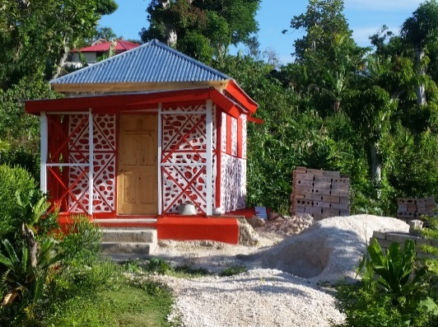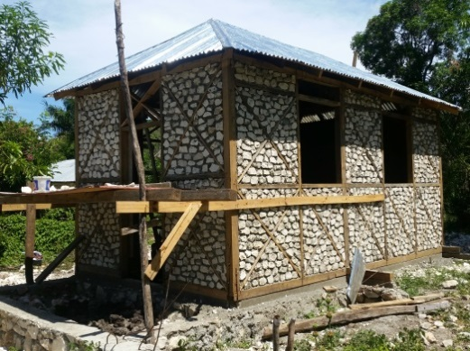
Example of Cesvi/HfH core shelter
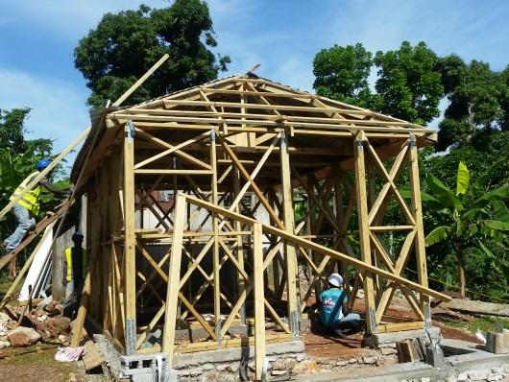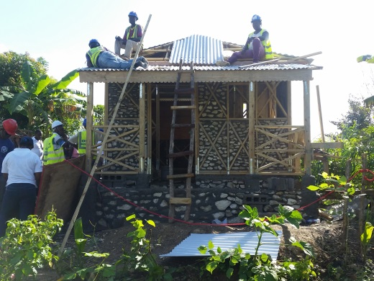
Example of IOM core shelters
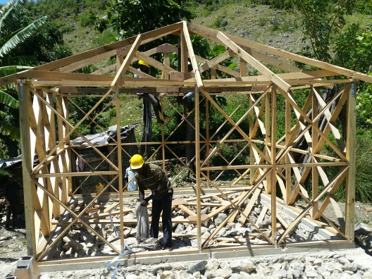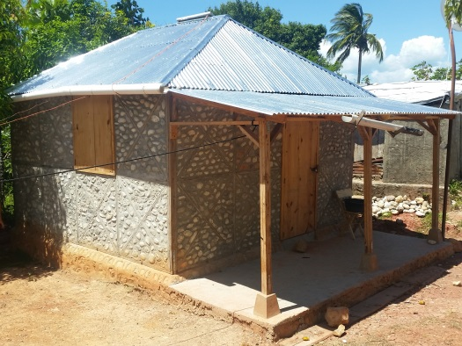
Example of PUI core shelter
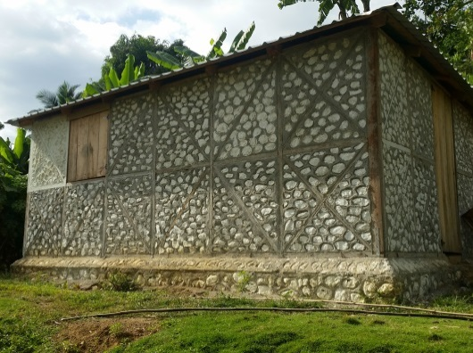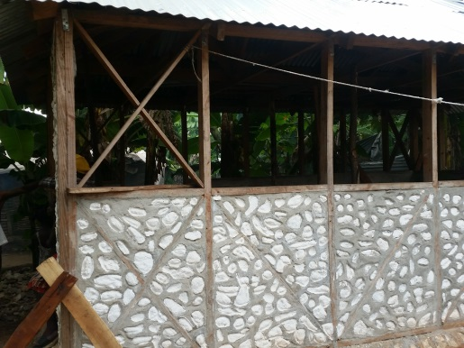
Example of ACTED shelters

ANNEX 5: Core Shelter Designs

Dans la situation la plus optimiste c’est-à-dire considérant le scenario 80% et face au besoin initial du PDNA, environ 79,464 maisons restent à réparer sur le plan national et 11,694 dans les départements de GA et du sud seulement. Considérant uniquement le département de la GA, environ 5425 maisons restent à réparer et 6,269 à réparer pour le département du Sud (extract of minutes of SWG meeting, Nov. 2017)
Department of Civil Protection & Haitian Red Cross
According to the SWG
The construction of 100 houses is planned at Grand'Anse department at Dame Marie by UNDP for the relocation of households in the locality of Lahaie, on land made available by the Haitian Government, taking into account the multiple natural risks. All houses will have access to water and energy, and will be equipped with adequate sanitary facilities. The project will build on good practices in housing construction, in line with the Gov. conceptual framework for post-Matthew reconstruction (ECHO April 18 report)
See slide #11 document “Haiti: 1 an Après Matthew Apercu - Nov-17” - https://www.sheltercluster.org/node/13500
A new partnership is under discussion with the IADB, ECHO, DINEPA and UCLBP to find an agreement on the co-financing of latrines in newly built core-houses.
When designing a shelter program focusing on structural repairs, two forms of structural repairs can be implemented depending on the type of beneficiaries and the type of work being implemented. Closed design interventions are done for vulnerable and immobile beneficiaries as turnkey projects, while open design projects can be linked with early recovery interventions, enabling active involvement of beneficiaries
Barring the current constraints linked to the expected contribution of the beneficiaries to finish the shelter (i.e. filling of walls)
hurricane straps and/or 16 gauge galvanized wire, nails and basic tools but also a pack of 8 to 10 BBS simple outreach messages (of the type distributed on poster to some municipalities)
Participatory Approach for Safe Shelter Awareness (PASSA) is a participatory method of disaster risk reduction (DRR) related to shelter safety. The aim of PASSA is to develop local capacity to reduce shelter related risk by raising awareness and developing skills in joint analysis, learning and decision-making at community level. PASSA is a process, facilitated by volunteers, that guides community groups (called PASSA groups in this manual) through 8 participatory activities which enable the participants to do the following progressively: 1) Develop their awareness of shelter safety issues in their community; 2) Identify hazards and vulnerabilities that create risk related to shelter; 3) Recognize and analyse causes of shelter vulnerability; 4) Identify and prioritize potential strategies to improve shelter safety; 5) Make a plan to put those shelter safety strategies into place, based on local capacities; 6) Monitor and evaluate progress. For more information on the PASSA methodology refer to http://www.ifrc.org/PageFiles/95526/publications/305400-PASSA%20manual-EN-LR.pdf
Technique Appropriée de Construction Locale
After significant lobbying from the humanitarian shelter agencies
https://www.sheltercluster.org/haiti-hurricane-matthew-2016/meetings-material

