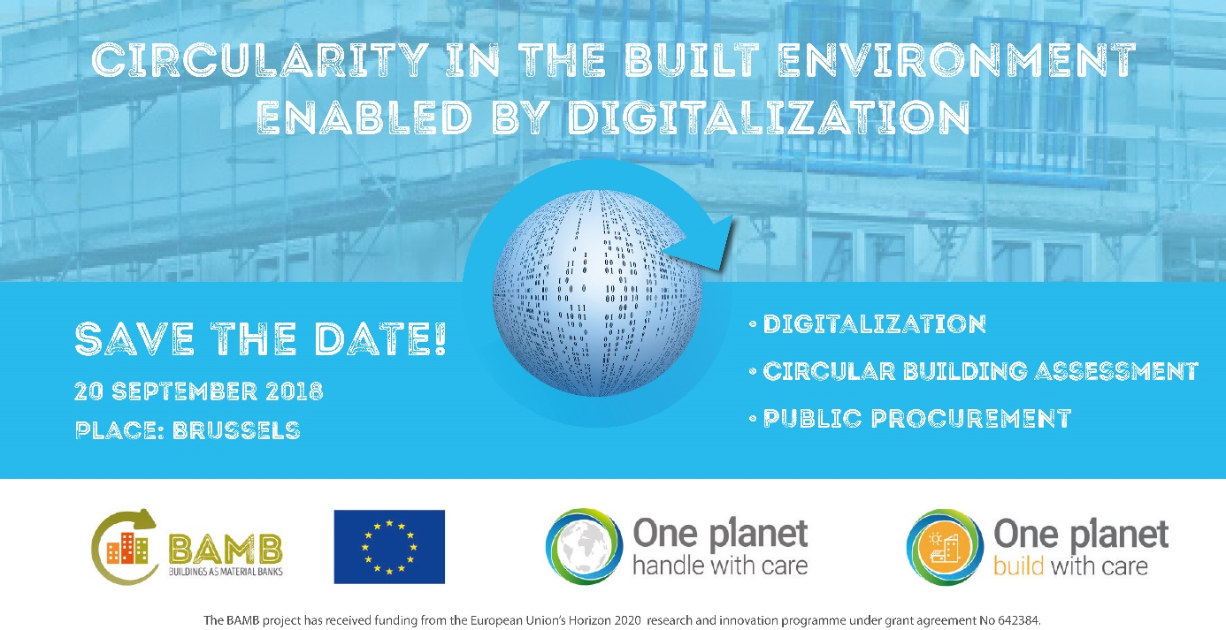
Press release for immediate release
BAMB and the One Planet Network join forces to boost circularity in the built environment
The EU H2020 project BAMB (Buildings as Material Banks) and the One Planet Network are joining forces for a full-day event to boost circularity in the built environment. Key areas that will facilitate this systemic shift will be focused on: digitalization, circular building assessment and public procurement.
During the day the participant will be able to learn from ongoing exemplary initiatives and debate how currently available tools are supporting a systemic shift towards circularity in the built environment. The BAMB team will present their core results and share experiences from pilot projects in order to demonstrate how BAMB tools can help you take significant steps on the path towards a circular future. One Planet Network will introduce the approach of and good circular practices from three global programmes on buildings, procurement and tourism that are committed to accelerate the shift towards sustainable consumption and production in both developed and developing countries.
This event aims at sharing knowledge and showcasing tools that are already available for circular construction. – “The objective is to learn from different approaches and build a road towards a circular construction sector that can provide climate positive solutions in a resource positive way.” says Molly Steinlage, BAMB Project Coordinator. – “To achieve this, awareness must still be further raised amongst all stakeholders in the built environment world-wide and the whole value network must be committed to developing processes that will take us closer to our goal of circularity.” continues Pekka Huovila, coordinator of the Sustainable Buildings and Construction Programme of the One Planet Network. He continues, - “A lot has already been achieved, but to succeed, we need everyone’s active participation”.
The day will be split into key note speaker, panel and parallel sessions. The event will be held in Brussels, Belgium on the 20th of September 2018.
Find out more:
www.bamb2020.eu www.oneplanetnetwork.org
https://www.eventbrite.co.uk/e/circularity-in-the-built-environment-enabled-by-digitalization-registration-47159479272

Contact information:
BAMB Project Coordinator SBC Programme Coordinator
BAMB – Buildings As Material Banks Green Building Council Finland
Molly Steinlage Pekka Huovila
info@bamb2020.eu pekka.huovila@figbc.fi
Phone: +32 2 5634201 Phone: +358 40 546 0855

The BAMB Project– Buildings as Material Banks
Imagine a world where buildings are seen as material banks! Whether an industry becomes circular or not depends on the value of the materials within it, worthless materials are waste while valuable materials are recovered. A building that is being renovated or demolished should not be seen as a cost, but rather as an asset and source of valuable materials. In order to change this, the BAMB innovation project has developed tools such as Materials Passports, Reversible Building Design tools and Circular Building Assessment methodologies. These tools are tested in 6 pilot projects to show that a circular construction industry is really possible! BAMB – Buildings As Material Banks, is part of the EU Horizon 2020 Framework Programme bringing 15 partners from 7 European countries together for one mission – to move the building industry towards a circular economy.
Participating partners BAMB
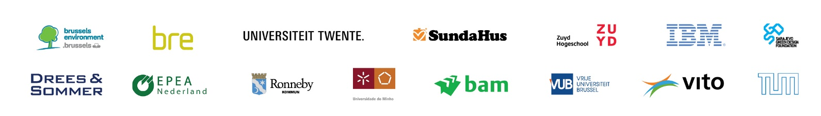

The One Planet Network
According to World Economy Forum adopting circular economy principles could significantly enhance global construction industry productivity, saving at least US$ 100 billion a year. The One Planet Network is a multi-stakeholder partnership for sustainable development, generating collective impact through its six programmes: Public Procurement, Buildings and Construction, Tourism, Food Systems, Consumer Information, and Lifestyles and Education. The One Planet Network has chosen circular economy as a focus area for collaboration among its six Programmes to pursue more sustainable production and consumption patterns. The Sustainable Buildings and Construction Programme aims to set up a platform for a worldwide network of experts to support and maximise the benefits of circular economy in the built environment globally.
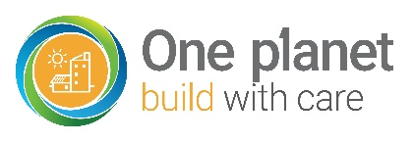

Circular Economy is looking beyond the current take-make-dispose extractive industrial model. A circular economy aims to redefine growth, focusing on positive society-wide benefits. It entails gradually decoupling economic activity from the consumption of finite resources, and designing waste out of the system. Underpinned by a transition to renewable energy sources, the circular model builds economic, natural, and social capital.
Circular Building Assessment is an assessment approach and method that aims to provide a holistic evaluation and interpretation of multiple sustainability aspects of buildings and their parts. Circular Building Assessment is facilitated through data extraction from Building Information Modelling and Material Passports where available. Consequently, from a certain level of detail, an evaluation of the transformation capacity and reuse potential of the building and its key parts can affect the assessment outcomes for all aspects.
Building Information Management or BIM is the process of designing, constructing and operating a building with the use of electronic object-orientated information, i.e. Building Information Models. Building Information Management should not be confused with BIM software. BIM software are digital tools to set up a Building Information Management process and create BIM models. It is therefore advised to make explicitly clear if the acronym BIM relates to the process, the software or the model of building information.
Materials Passports are electronic and interoperable data sets that collect characteristics of materials and assemblies, enabling suppliers, designers and users to give them the highest possible value and guide all towards material loops.
Material loops are flows wherein materials or larger parts are recovered from buildings and reclaimed, recycled or biodegraded through natural or technological processes.
Reversible Building is the design and construction strategy that has the ambition to realise buildings whose parts follow material loops and facilitate building alterations and support changing user needs. It includes a spatial dimension, in which the building can be efficiently refurbished, as well as a technical dimension, wherein the building’s components can be disassembled and used again or deconstructed and recycled or biodegraded.
glossary
- The construction industry is one of the largest industry sectors (10% of the GDP of the EU and 20 million jobs (CEN 2015))
  - Responsible for 40% of greenhouse gas emissions in Europe and uses more than 50% of the materials taken from the earth’s crust.
  - C&D waste and building manufacturers generate more than 45% of the total controlled waste (EIB, 2015; EEA, 2001; Eurostat 2006, McCormick, 2016)
  - Cement and steel production – two pillars of the European building industry – are responsible for half of GHG emissions.
- Most emission reductions from manufacturing industries were achieved by 1993, due to efficiency improvements and a fuel shift from carbon intensive solid fuels to less carbon intensive gaseous fuels. (EEA, 2006; Debacker 2009)
- Based on studies of the IPCC (2007), the building sector has the biggest potential to mitigate GHG emissions at the lowest cost; over 80% of the building’s potential can be described as 'negative cost'.
  - According to IPCC (2007), about 30% of the projected CO2 emissions could be avoided by 2030 with net economic benefits, by means of energy efficiency options for new and existing buildings. However, with increasing population growth and wealth, energy efficiency measures alone will not be enough.
Basic facts
why a systemic shift in the building industry is needed:

The One Planet Network is the network of the 10 Year Framework of Programmes on Sustainable Consumption and Production which is a global commitment to accelerate the shift towards sustainable consumption and production in both developed and developing countries.

