Connection Guide for Internal EC Users
How can I access the session?
In order to access the session please follow the instructions on how to connect from page 2 of this document.
Test your session!
Please test your access to the session as soon as possible to mitigate the risks of connectivity issues.
Technical issues?
For technical issues, please refer to the instructions guidance from page 2 onward. Should the issues persist, please contact your local technical support and show them this document.
Blackboard Collaborates technical requirements can be found on this webpage
Should I subscribe to the webinar in EU-Learn?
Subscription to the EU-learn course is not mandatory, and Blackboard Collaborate will not prevent you from accessing the webinar if you did not subscribe.
On the day of the webinar
We recommend that you connect at least ½ hour before the start of the session in order to settle any technical problems in due time.
You will be able to interact with the speakers using the chat (but not by microphone).
In case you will not be able to participate, a recording of the webinar will be published on YouTube. The link to the video will be posted in the OPSYS group in Capacity4Dev.
Help!!
For any further questions, please feel free to contact us via e-mail:
EuropeAid-OPSYS-USER-SUPPORT-COMMUNICATION@ec.europa.eu

How to connect to the Blackboard Collaborate™ session
User guide for internal EC users connecting from the EU internal network

Important!
We recommend that you try to connect to the session some days in advance to ensure that your computer is configured correctly.

To test your connection, follow the instructions below.

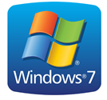 | If you are using Windows 7 page 3 (STEP 1)  page 5 (STEP 2)
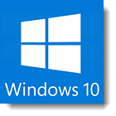 | If you are using Windows 10 page 8 (STEP 1)  page 10 (STEP 2)

Windows 7

Before you start please make sure you have the required software installed (in this case Java version 7 or higher).
1) If Java is not installed, please go to STEP 1 (below)
2) If Java is installed, please proceed to STEP 2 (page 5)

STEP 1 – Installing and configuring Java
1.1 Use Mozilla Firefox or Internet Explorer to open the session link:
https://eu1.bbcollab.com/m.jnlp?sid=2014023&password=M.EB37D8BBE0A3C6639B76D3E9D176A6
1.2 Add your internet credentials in the "proxy internet" prompt
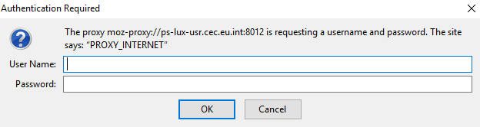
1.3 Select your operating system (MAC or WINDOWS) and click on "Get Required Software":
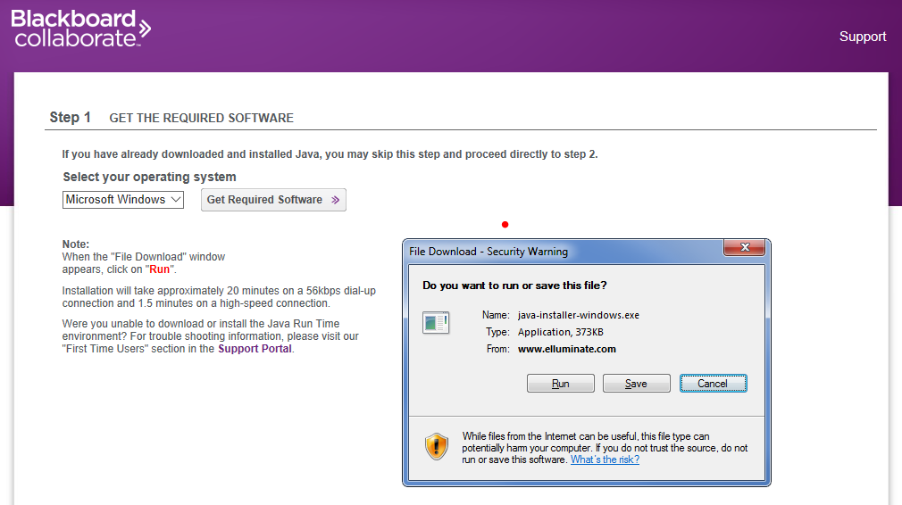
1.4 Download, SAVE and RUN java-installer-windows.exe file
1.5 Install the java file
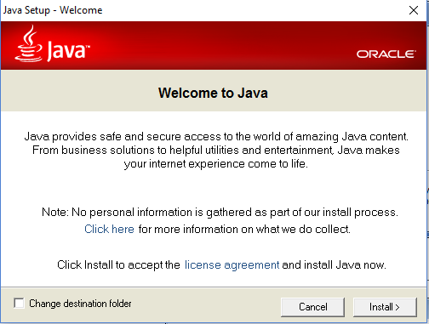

STEP 2: RUN Blackboard Collaborate™:

2.1 Start session via Firefox or Internet Explorer
Please check "always trust content from this publisher" and click "RUN"
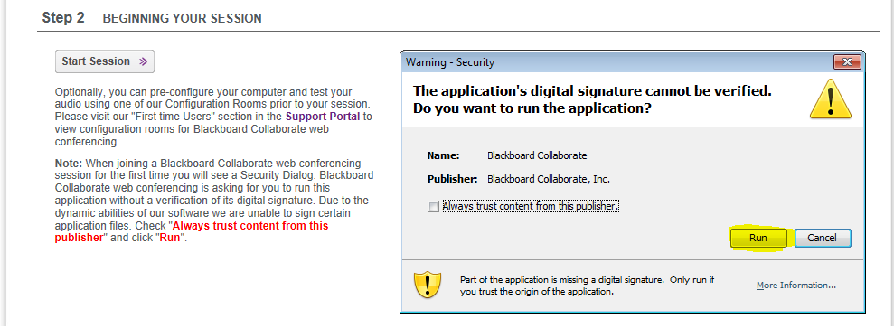

2.2 Enter your first name and LAST NAME, and the name of your unit/delegation. Then click on “Log In”
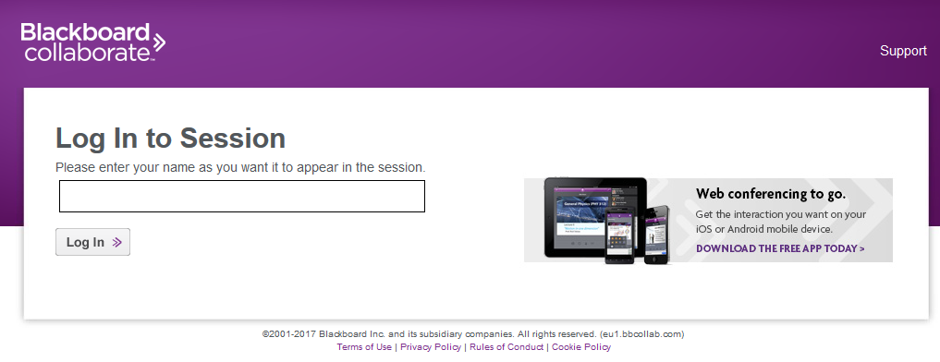

Please remember to add both your full name and your delegation or unit, as this is the only name anyone will see during the session. If your full name and delegation/unit are not present, you will not be recognisable in the system.

2.3 Blackboard Collaborate™ is launched by opening Java™ Web Start Launcher (default). Choose "Open with" and click on "OK" to download and run the meeting.jnlp file:
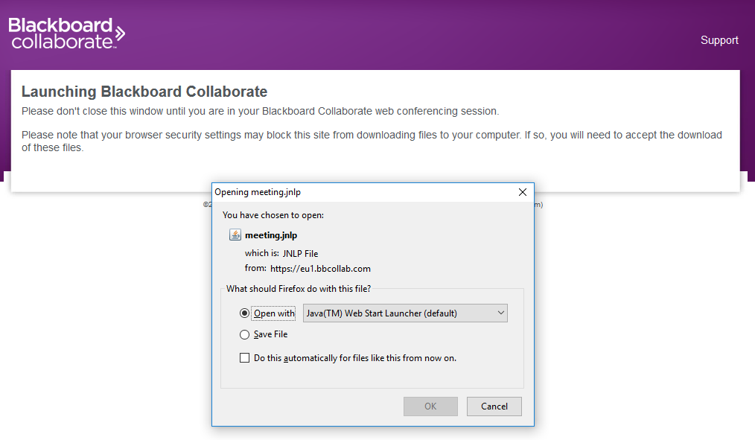
2.4 Enter your internet credentials again in the Java prompt
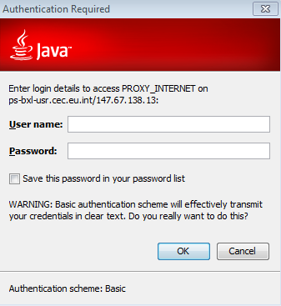
2.5 Do you want to run this application? Click on RUN and “Accept” the conditions of use of Blackboard Collaborate
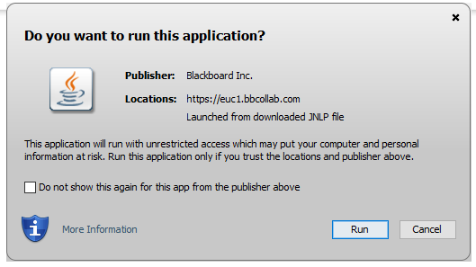
2.6 Choose connection speed => Cable/DSL and click "OK"
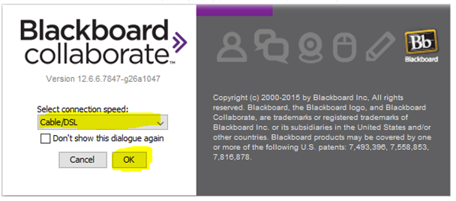
2.7 Add your internet credentials one last time
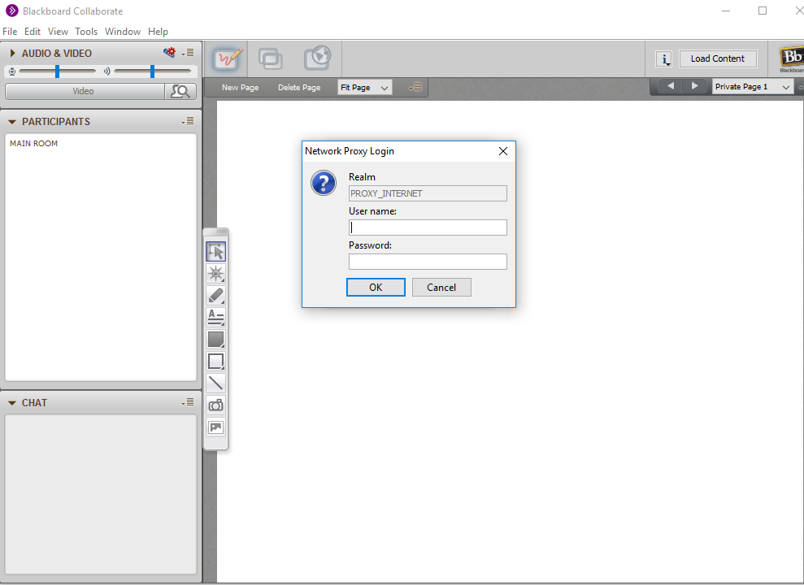
2.8 Welcome to the Blackboard Collaborate™ session!
For any questions or assistance concerning the use of the Blackboard Collaborate application we kindly refer to the Technical Guide on Blackboard in attachment to the email. For other information please do not hesitate to contact us by mail at EuropeAid-OPSYS-USER-SUPPORT-COMMUNICATION@ec.europa.eu.
***********************************************

Windows 10
Before you start please make sure you have the required software installed (in this case Mozilla Firefox [V5] [Java 8.162]).
Important!
Mozilla Firefox [V5] [Java 8.162] is the only supported browser version for Blackboard Collaborate under Windows 10 in the EC internal network.
Please do not use any other browser, or even other versions of Firefox, as they are not guaranteed to work.

1) If Mozilla Firefox [V5] [Java 8.162] is not installed, please go to STEP 1 (below)
2) If Mozilla Firefox [V5] [Java 8.162] is installed, please go to STEP 2 (page 13)

STEP 1 – Installing Mozilla Firefox [V5] [Java 8.162]
1.1 Open the EC Store from the start Menu
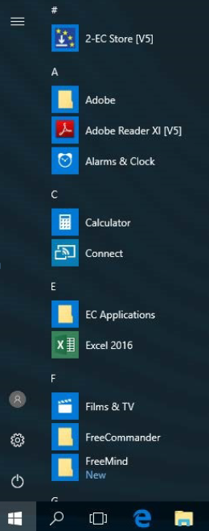

1.2 Search for "Java for Browsers"
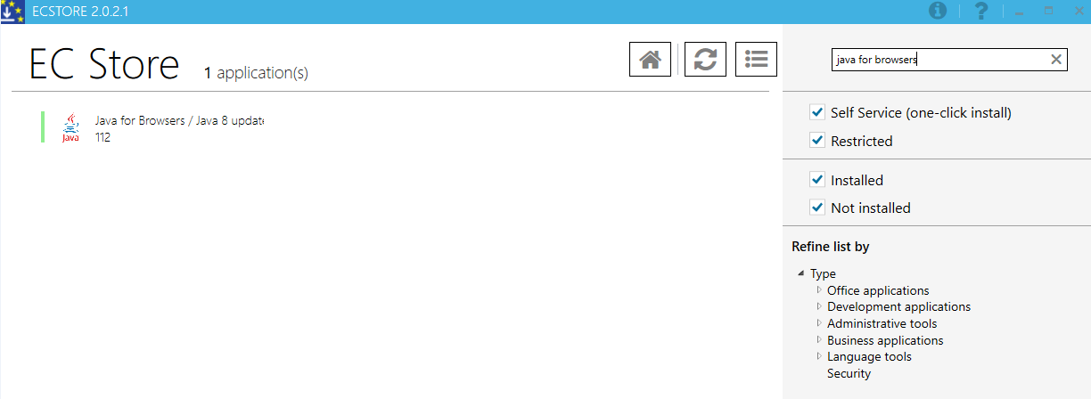

1.3 The package "Java for Browsers/ Java 8 Update 112" shows up in the list. Click on the "Java for Browsers/ Java 8 Update 112":
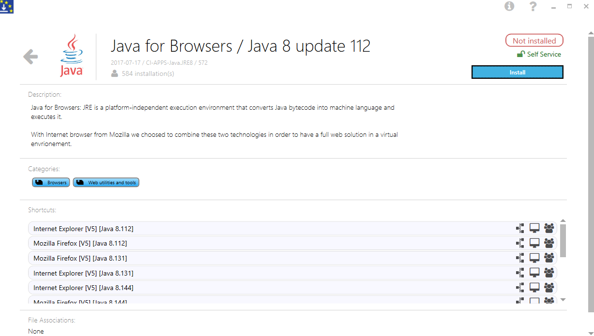
1.4 Click on the "Install" button
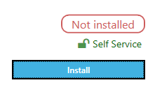
1.5 Logoff/logon from your Windows session
STEP 2: RUN Blackboard Collaborate™:
Important!
Mozilla Firefox [V5] [Java 8.162] is the only supported browser version for Blackboard Collaborate under Windows 10.
Please do not use any other browser, or even other versions of Firefox, as they are not guaranteed to work.

2.1 Open Mozilla Firefox [V5] [8.162]
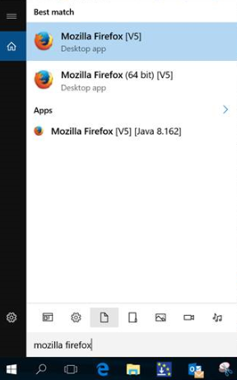
2.2 Copy/paste the session link in the address bar
https://eu1.bbcollab.com/m.jnlp?sid=2014023&password=M.EB37D8BBE0A3C6639B76D3E9D176A6
2.3 Add your internet credentials in the "proxy internet" prompt
2.4 Enter your first name and LAST NAME, and the name of your unit/delegation. Then click on “Log In”
Please remember to add both your full name and your delegation or unit, as this is the only name anyone will see during the session. If your full name and delegation/unit are not present, you will not be recognisable in the system.
2.5 Blackboard Collaborate™ is launched by opening Java™ Web Start Launcher (default). Choose "Open with" and click on "OK" to download and run the meeting.jnlp file:
2.6 Enter your internet credentials again in the Java prompt
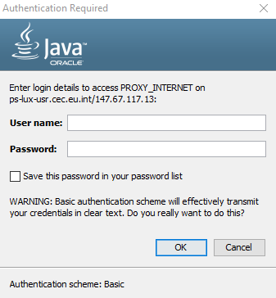
2.7 Do you want to run this application? Click on "RUN"and “Accept” the conditions of use of Blackboard Collaborate
2.8 Choose connection speed => Cable/DSL and click "OK"
2.9 Add your internet credentials one last time
2.10 Welcome to the Blackboard Collaborate™ session!
For any questions or assistance concerning the use of the Blackboard Collaborate application we kindly refer to the Technical Guide on Blackboard in attachment to the email. For other information please do not hesitate to contact us by mail at EuropeAid-OPSYS-USER-SUPPORT-COMMUNICATION@ec.europa.eu.

