Towards national and global public health models based on the ethics of equity: seven steps for a transformational change

Summary:

The present landscape of global health lacks democratic governance (by all), accountability to its (untargeted and unmeasured) common objective (best health for all) and strategies at national and global levels which do not influence root causes (in all policies), are at best of a mitigating nature of health inequities and remain fragmented in terms of access and use of quality health services. Such scenario leads to an estimated global health inequity toll of close to 20 million deaths every year, one in three deaths (unfair and avoidable), a figure and proportion which have remained stagnant in the last 20 years.

The present document reviews and makes a **seven-step proposal** which includes the international health definition (requiring update) and objective, the operationalization of the universal right to health (with a pending commitment to the ICESCRs), the (often missing) principles of global health initiatives, the root causes of social and ecological (complex and lacking hierarchical analysis) factors influencing health, the international and WHO (failed) commitment to monitor health equity, the development cooperation (insufficient, non-binding, not aligned, non-equitable) policies and programs and the need (based on the ethics of equity) to review global and national health policies.

1. *Honoring and updating the global health objective :Revisiting the first article of the constitution of the World Health Organization and the definition of health*

Article 1 of the constitution of the World Health Organization states that its objective would be “the attainment by all peoples of the highest standard of health”. Interestingly, there are an average of over thirty resolutions at the World Health Assembly and a dozen f international high level health conferences every year, over 150 global health initiatives, thousands of health indicators comparing health information within and between countries, an annual world health statistics report with several hundred of indicators for each country and recently the global burden of disease analysis which allows a public online consultations of some six million national health data. They all measure health situations, trends, services, financing, risks and even complex assessments of burden of ill health. Only recently and after the call of the Commission on Social Determinants for health, some countries (less than a third of all countries and none of the high income countries) reported to WHO on health equity, but this was limited to the comparison of some groups defined by variables (mother’s education level, income quintiles and rural/urban) in their access to some services (vaccinations and save deliveries) or the health status of some groups (under five mortality). For any alien –often asking the wisest questions- to health policies, this would be the first question: “*Why did no one measure the progress of the founding article of the World Health Organization*?”.

Doing so would require two steps: defining or at least estimating the “*highest attainable standard of health*” and measuring *how has it been reaching (or failing to do so) all peoples*.

At the time of the foundation of the World Health Organization, health was defined as “a state of complete physical, social and mental well-being, and not merely the absence of disease or infirmity”. Such definition has been widely accepted and repeatedly quoted in the last over 60 years, but paradoxically the psychological and social wellbeing dimensions have not been defined and no indicators have been agreed upon hence these dimensions are not captured in the world health statistics nor in any of the targets agreed in the thousands of world health resolutions or international agreements. Despite the global neglect this definition has been subject to, it also requires, in our opinion, some update or review: Firstly, the “complete” well-being may seldom be felt by most people, and rather we all *adjust to some acute or chronic health handicaps* so as to enjoy life personally and in our relation with society and nature. For instance, wearing glasses does not mean a limitation to our well-being. Secondly, our wellbeing should not be –by accumulating limited resources- at the expense of others’ health-, or based on the destruction of nature –at the expense of the health of next generations-. Individual health should therefore be qualified by its equity (linking it to the WHO constitutional objective) and sustainability (adjusting this definition, and WHO’s objective, to the challenge of our times in back tracking the destruction of the nature and atmosphere we live in). We would hence propose an update in the definition of health linked with the global health objective which would read:

“*a state of well-being through the* ***adjustment*** *to physical, social and mental challenges in an* ***equitable and sustainable*** *way which enables the attainment of best standards of health by all peoples*”.

1. *Recognition and operationalization of the right to health : Call for adherence and compliance with the International Covenant on Economic , Social and Cultural rights, and its Optional protocol.*

Health is a human right for some and a commodity or optional benefit for others. This is what differentiates the understanding of the roles of the state and civil society, the legal frameworks and the market regulations, and the national and global health strategies.

The Charter of Human Rights, article 25, is clear on the right to health, and many of its determinants. Around the same time, the World Health Organization was founded with the objective to achieve the best possible for all peoples. It took some 40 years to translate this into the international covenant on economic, social and cultural rights –hereafter ICESCRs-, which article 12 on the highest attainable standard of health, recognized in the State as the duty bearer of guaranteeing this right, but when the recognition of the right came close to being responsible for it, many governments refrained from signing up. It took another thirty years to gather ten countries to sign up its optional protocol and be subject to accountability mechanisms on economic, social and cultural rights.

But the recognition of the right to health remained a nice declaration for most, and the majority of world’s citizens cannot report anywhere at national or international level, when their basic health needs or access to adequate health services are not met.

Interestingly, the global agreements or initiatives that targeted only some health problems or some populations, had more visibility and political and social attention. This was the case at the turn of the century for the health MDGs vs. general comment on the Right to the Highest Attainable Standard of **Health** of the ICESCRs. Probably the shorter term of results (yet partial and often short lives) of targeted initiatives provides the political credits during politician’s mandates and is more amenable to specific results and frontline news, than the longer term approach of establishing health right frameworks and universal and comprehensive health services which leave no people nor health conditions out.

The first question in the international debates on health should therefore be, the recognition of the right to health. There is a deep contradiction for in some well-known countries in championing the cause of health at global level yet not recognizing the universal right to health at home. Before more and more declarations of commitment in improving the health of all, many of them repeated in cycles during the last 65 years, and expensive international conferences and grand declarations, all member states in the world should recognize the right to health.

1. *Setting principles for health strategies at local, national and global levels : From the philosophy of Primary Health Care to the principles of Global Health :*

In 1978 the International Conference of Alma-Ata agreed on principles to advance on the health for all peoples, with an emphasis on the democratization of health through the recognition that health was to be achieved for all peoples and by all people. Some years after the Ottawa charter acknowledged that health was deeply related to all other policies, and it should be addressed in all policies.

From the nineties, the reference to the world’s shared health challenges was progressively referred as *Global Health,* gradually replacing the term of international health and recognizing the growing diversity of factors and actors influencing the health of all nations and peoples*.*

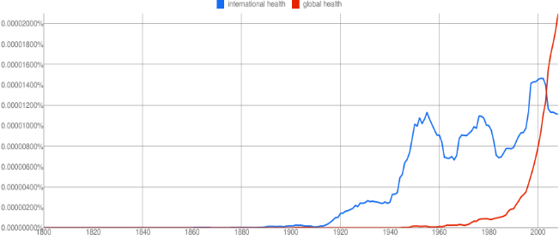

*Use of global health vs. international health in a sample of published books*

The main principles of health agreed through the major international conferences in the last thirty years may be summarized as health for all peoples (WHO constitution), by all peoples (Alma Ata) and in all policies (Ottawa). These principles, however, are not reflected in many of the health initiatives claiming to be « global » while often restricted to some population groups or diseases –as even the health MDGs- (not for all), by some central decissions taken vertically far from the targetted communtities, in capitals or even in Geneva or New York (not by all) or focused on medical interventions and detached from structural changes in socioeconomic policies (not in all policies). Many of these not-really « global » initiatives, concentrate a large share of the international resources for health and influence the international health agreements and committments.

[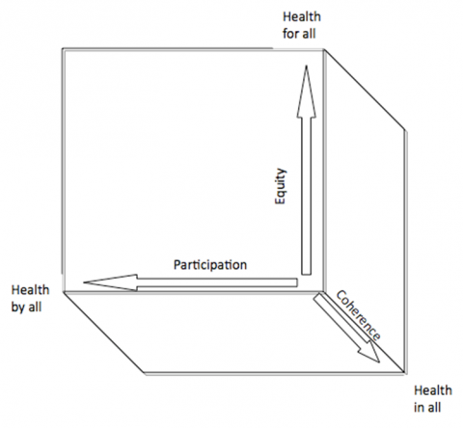](http://faceaface.revues.org/docannexe/image/745/img-6-small580.png)

*Principles and vectors of global health*

The complexity of factors and actors influencing the world’s health, together with the biased interests for some issues or groups, often prioritized in arbitrary ways and influenced more by lobbies than by evidence, are also a reflection of a weak democratic governance of international health today. If we’d wosh nothing less for the democratic governance of health than waht we demand for a democratic government in all countries, we’d wish a democratic forum of health representatives (Ministers of health) which would gather in a parliament (World Health Assembly) influence international decissions according to their population weight. At present,the Vatican’s vote at the World Health Assembly counts as much as China’s, with over one million times population. Is that democratic? The resolutions proposed for this biased vote, are linked to targetted fundings coming from those with greater financial capacity (hence influencing the international health agenda) or some private groups or foundations (one being at present the largest founder of this menat-to-be international government of health). Imagine Coca-Cola contributing to a large share of your government’s budget and influencing laws, public investments and socioeconomic policies ?. A democratic WHO requires a budget through binding and regular contributions according to financial capacities ( as in an equitable tax system), which turns democratically (according to population weights) agreed reslutions into programmes aimed at health for all, by all and in all policies[1].

1. *Identifying the root causes of health equity : Converging and structuring the health links to the social and environmental determinants*

The analysis of the Commission on Social determinants for health reached reccomends –chapters 5-16 of the report- actions in the areas of early child development, healthier and safer cities, quality housing, rural land tenure and rights; agricultural development, full and fair employment and decent work, universal comprehensive social protection, health-care services with the principle of universal coverage of quality services, progressive taxation, international finance for health equity, health and health equity impact assessments in national and international economic agreements , gender equity, fair representation in decision-making, supports to marginalized groups, in particular indigenous peoples and improvement of civil registration for births and deaths. Such long lists of areas of action related to health and health equity lacks an analysis of their attributable risk to global or national health or health equity. Hence, the recommendations lack structural analysis and rationale in the selection of priority areas. For instance, progressive taxing and social spending through public financing is an structural condition for health, education and social protection services and should not be in the same lists of actions, but in a structured approach. On the other side some policy areas not as explicit in the recommendations such as secondary school drop-outs, people with disabilities, children rights, regulations on the production and marketing of unhealthy foods or the abuse of virtual media undermining physical and psycho-social activity, just to name a few.

As a more systematic analysis of risks associated with ill health, WHO published a report in 2004 of the weight of 24 health risks associated to mortality and morbidity. That report included risks related to childhood and maternal under nutrition, other nutrition-related risk factors and physical activity, addictive substances, sexual and reproductive health, environmental risks, occupational risks and others such as child sexual abuse or unsafe health-care injections. These factors included exposure to global dynamics (e.g. climate change), environmental (e.g. air pollution) or social (e.g. Child sexual abuse) hazards, unhealthy lifestyles (e.g. unsafe sex, physical inactivity or low fruit intake) or drugs (e.g. alcohol or tobacco), effects in blood markers (such as zinc, iron, vitamin A, cholesterol or glucose), clinical findings (as high blood pressure) or access to public health measures (such as contraceptives). Such mix of nature of the causes makes it difficult to assess the multivariate dynamics between them.

The GBD 2010 study decided on a larger list of risk factors (67) influencing health which is also selected without a sufficiently described priority analysis and lacking a hierarchical structure of causes. It again mixes the different hierarchies of cases from the 2004 report, it includes many new environmental and occupational chemical risks, and unhealthy dietary behaviours (though surprising advocating for cow’s milk), and surprisingly excludes others such as unsafe sex, claimed in 2004 to be the second attributable risk of ill health globally. In line with the influence of economic rather than democratic dynamics guiding the analysis, decisions and policies and actions of WHO, these reports have been led by private institutions.

In an attempt to structure the root causes of ill health and health inequities, we have used the logic of the Maslow pyramid to structure health needs, and grouped the root causes influencing those needs:

*Simplified framework of root causes and health needs*

This framework may serve as a way to rationalize the somehow chaotic (if not biased) selection and categorization of causes influencing health, from the root causes to the satisfaction of health basic needs (water, nutrition ), security needs (from physical, chemical, biological or radio-magnetic –yet absent in the analysis- hazards) and the conditions to maximize our health potential in physical –including sexual- and pshyco-social potentials (not as yet considered in any world health report and critical to mental health).

Root causes of how societies and persons are able to enjoy their health potential have to do with four main areas: legal and regulatory frameworks which ensure equal rights in relation to the needs mentioned above, an ecological environment where persons may enjoy their healthy relation with nature, a balanced flow of knowledge and participation in society, and an equitable distribution of economic resources (including access to goods and services).

1. *Measuring global and national health equity :from ratios to targets, thresholds and health inequity burden estimates*

The CSDH report calls on national governments to establish a national health equity surveillance system, with routine collection of data on social determinants of health and health inequity, and on WHO to steward the creation of a global health equity surveillance system as part of a wider global governance structure.

So far the WHO equity monitor has gathered on disaggregated data of some reproductive and child health prevention and care services and health outcomes (fertility, child malnutrition, obesity and under five mortality) and ratios across three variables influencing health distribution : place of residence (urban or rural), education level of the mother (none, primary or secondary) and income quintiles (first, second, third, fourth and fifth quintile), and a fourth, sex, when assessing children indicators.

On average, data are reported from some 60 countries (less than a third of all), all of them low and middle income countries, and most of the data are from demographic health surveys which date back five years or more.

This response, already five years after the CSDH report, is very limited, in the proportion of countries reporting, in the population sub-groups targeted (under-fives and pregnant women, less than a third of the population in those countries) and in the analysis, as it only measures ratios or comparisons, and cannot estimate the burden of health inequity.

* In order to estimate the burden of health inequity we need to first agree on its definition. Equity is not equality. A state of inequity is a situation with unfair levels of inequality (inequalities being a constant feature of the distribution of variables in nature). An equitable strategy targets attention and resources according to needs, hence not in equal terms for all, but allowing positive discrimination to those in greatest risk or need. Hence, health equity is the fair distribution of health inequalities.Whitehead (1992)added to the unfair dimension, the feature of **“**avoidable”, interestingly reflecting the WHO’s constitutional objective of best “feasible” levels of health for all.

But which are the fair levels of inequalities? Inequalities are a mathematic feature measured, in a large enough sample where variables tend to have a “normal” distribution, by the standard deviation (average differences with the mean value) and the dispersion index (the relation of the standard deviation, to the mean). Some development indexes are based on statistical measures: for instance, the Human Poverty Index for OECD countries includes a so-called “dimension of social exclusion” as the proportion of people with income below the “poverty line”, defined –arbitrarily- as 50% of the median (less affected than the mean by extreme values) adjusted household disposable income. But what is a fair distribution in health? Which standard deviation is acceptable? And which should be the minimum threshold? The statistical approach can only be chosen by convention and, besides, would not be correlated to the underlying causes of health inequalities. Identifying fair limits of inequality through the distribution of the most influencing variable of health distribution, adds an ethical component. In 2006 Paula Braveman proposed a definition of health inequity in this sense: “Systematic health differences between socially advantaged and disadvantaged groups”. If we combine the features of Whitehead and Braveman’s definitions, we would point at a threshold of health equity based on social differences which are unfair and avoidable.

So, the first challenge is to define the most influential variable conditioning health differences. If we assess –with national average valies- the correlation of health indicators with the variables measuring each of the root causes proposed in the former section, we would observe the following relations:

The UN democracy index includes a number of features related to freedom and participation rights and the governance role of the state in promoting and respecting its citizen’s rights. The correlation between national indexes and life expectancy national means is quite high (r2=0,50, p<0,01) yet if we would use a weighted averages according to population sizes, it would be lower given the discrepancy values of China and India (better health of the former, with lower democracy index).

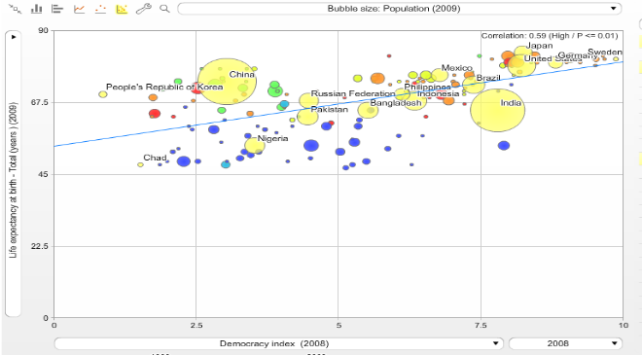

*Correlation between democracy index and life expectancy*

Regarding the root cause of knowledge (and we would need to correlate it with factors previously included in the democracy index, such as –knowledge based- social –not just political- participation), there is an even higher correlation between the average number of years of education (from primary to university) and the average life expectancy (0,81, p<0,01). However, the sample is limited as so is the information available from many countries, and, on the other side, recent evidence as the PISA studies, tells us that the quality of education is more important than the quantity and we should take that variable with caution.

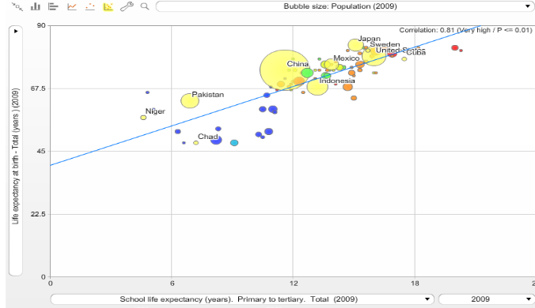

*Correlation between years of education and life expectancy*

The ecological environment is truly an essential condition for a healthy life. However, there is a profound contradiction in this correlation: those countries – and populations within countries- enjoying best health indicators, are also those depleting natural resources (in hectare use per capita) and polluting the atmosphere (in CO2 emissions) at a higher rate. It is therefore a complex variable which requires global responsibility and we will not include it in this analysis aimed at identifying the most influential variable on the distribution of health.

The root cause of equitable distribution of resources is closely correlated to the distribution of health. When correlating national averages of per capita GDP with life expectancy, we find a strong logarithmic correlation which would explain some 70% of those differences. In large enough samples we may likely also find that through multivariate analysis this correlation does not only remain but is strengthened by the influence of income in the access to education and the exercise of rights. This correlation is slightly lower for healthy life expectancy and for under five mortality, especially in girls, as the table below shows.





*Correlation between GDP per capita and life expectancy and related indicators*

What is most interesting of this correlation is that above some 12000 GDP pc, there is no correlation, that is, higher level of resources does not translate in higher levels of life expectancy.

So, the main variable (social difference) influencing the distribution of health across countries is income, measured in GDP pc. If we go back to the definition of the right to health, it should be universal regardless of social condition. The mean value of life expectancy of the countries –and populations in countries- enjoying the higher income levels, should be hence considered as the level of life expectancy desired for all (regardless their social conditions). For practical purpose, and also with the statistical rationale of a large enough sample to allow unavoidable differences –geographic, genetic, others-, the upper income quintile in countries and the high income countries in the world, could be taken as the reference populations enjoying the best conditions (income) and the best life expectancies, desirable for all.

But are these differences in life expectancies related to higher income conditions, avoidable? The average income levels in the high income countries is of over 20,000 GDP pc, having doubled in the last 20 years. Clearly, these income levels are not replicable for the whole of the world’s population as there would not be enough resources for all. On the other side, none of the high income countries in the world and during the last 20 years, has had ecological rates in terms of hectare use per capita or carbon emissions, replicable at global level to allow the recyclable capacity of the planet. Hence, high income countries are not replicable nor sustainable development models. However, there are a number of countries, some with even below 50% of the world’s median GDP, which are based on ecologically sustainable economies and enjoy as well health indicators within the confidence interval (p<0,05) of high income countries[2]. These models prove right the third feature for health equity thresholds: that the income differences are avoidable in a world with a fair degree of inequality and yet preserving resources for future generations (inter-generational equity).

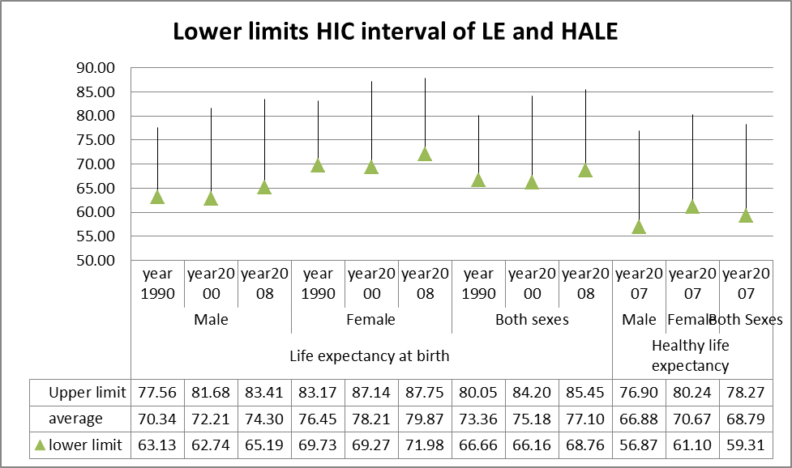

*Confidence intervals of health indicators in high income countries*

Once we agree that the mean health indicators of high income countries are the health standards desirable and feasible globally (WHO’s original objective “best health for all”), we can estimate the health inequity burden: the difference between the present health situation and the desired/feasible one. The graph below shows that, according to the world health statistics, life expectancy has increased in a parallel way across all income regions, yet maintaining the inequalities.



*Trend of life expectancy across low, middle and high income countries 1990-2000 and 2010.*

Any information on the progress or failure on the objective of health equity at country or global levels, needs to be accessible and easy to interpret by statisticians, health professionals, policy makers, politicians and civil society alike. Over 90% of the premature deaths before the lower limit of the confidence interval of life expectancy of high income countries (68,7 years) take place during the first five years of life (under five mortality) and from 15 to 60 years of age (adult mortality) and there are international data of both. When we compare, adjusting for demographic data (adjusted mortality rates), the present and desired under-five and adult mortalities, we estimate the excess mortality due to global health inequity: the Global Inequity Death Toll (GIDT)[3].

When we then apply – with data from the world health statistics annual reports- the desired high income adult and under five mortality rates to the under-five and adult populations of the other-than high income countries, and compare that figure with the present levels of under-five and adult deaths in low and middle income countries, the estimates of excess mortality due to global inequity is close to 20 million deaths per year. This represents over one third of all deaths and the numbers and proportions have remained stagnant over the last two decades. The following graphs show those figures and proportions, by age group and income groups.







*Global health inequity death toll (GIDT) based on World health Statistics data 1990-2010 by : Top right :age groups (<5s and adult), Lower right : income groups of countries, Top left :Proportion of all deaths and Lower left : proportion of all deaths by income groups.*

When the data of the GBD 2010 were made public, with national average mortality rates since 1970 by five year age groups, the same estimates were analyzed, this time with a much finer age adjustment of mortality rates by 190 countries, during 40 years and across 16 age groups each country and year. The results are very similar to the more gross estimates based on under five and adult mortality rates alone form the World Health Statistics, and confirm the hypothesis of a very high and stagnant level of health inequity:

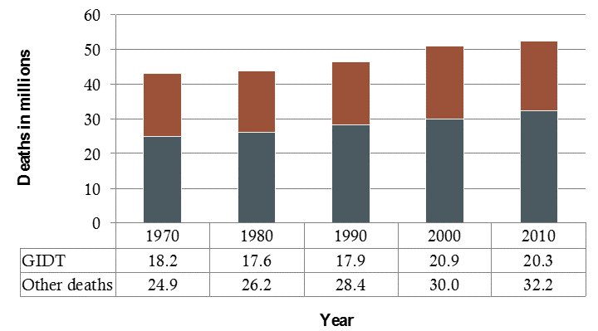

*GIDT net and proportion values based on GBD data analysis 1970-2010.*

This method may be applied to estimate the levels of national health equity, if the adult and under-fie, or even narrower age groups’ mortality rates are known disaggregated by income groups. At present, as mentioned above, WHO only reports health equity indicators from one in three countries, and only on under five mortality.

WHO should expand the health equity monitor approach to cover for all countries, all age groups, and aim, by setting best health targets, at measuring the burden of health equity, in excess mortality and burden of disease. Countries should set health equity surveillance systems, as the one being prepared in Uruguay, and assess the burden of health inequity due to global (if the average health indicators of high income countries are better than the country’s upper quintile’s) and national (comparing the present situation with that if the average health indicators would equal those of the upper income quintile).

As the burden of health inequity is influenced by the root legal, knowledge and resource frameworks, and by every single sector policy, it reflects the best indicator of social cohesion.

1. *Agreeing on an international convention on the right to health and health equity: towards a sufficient, equitable, aligned and binding framework based on global and ethical responsibility*

Global health inequities are related to the unfair distribution of economic resources. The only mitigation to this unfair distribution causing such tragic annual death toll, is the international cooperation. The level of cooperation was targeted (yet not complied by most) at 0,7% over 40 years ago. Such target was never based on n analysis of redistribution needs. It may be about time to do so.

The definition of best and feasible health standards for all, not only allows the monitoring of the burden of health inequity (the gap towards WHO´s constitutional objective) but also enables the analysis of the minimum level of economic resources to allow the opportunity to enjoy the right to health. Such level is defined as the threshold of economic resources (at global measured in GDP pc) below which no country no time has reached the best and feasible health standards for all. Such threshold results in some 3000 GDP pc in PPP US $, and affects over 60 countries at present with a total population of 1200 million people. The overall deficit of these countries is 2,2 trillion dollars annually. According to the world´s average of public revenues from GDPs, close to 20%, the gap of public resources in those countries to finance social services and regulate and invest in inclusive and sustainable economies, would be of 440 Bn US $, some four times the present levels of ODA yet only 0,4% of the world´s GDP.

Based on this gap analysis, unlike the arbitrary 0,7% and other targets, there are two dilemmas to face :

First: In a world with one fifth of the population living in countries with insufficient resources to enable the right to health (undermining the very right to life), is it ethical the accumulation of resources by some countries and some groups within those countries, with the objective of constant growth? Isn´t the extreme poverty related to the extreme abundance mathematically related? In a normal distribution, if we want to limit the lower end (minimum threshold) to a minimum (say less than 1%, and ensure social protection mechanisms to detect and support that group), knowing the average, we may estimate the maximum threshold which should limit it to < 1% and, as with the group under the minimum threshold, have fiscal mechanisms to detect them and redistribute those excesses. It happens that the maximum threshold would be at 19,000 GDP pc, close to the average of the high income countries. The dilemma therefore is : in the context of 20 million deaths every year die to unfair distribution of resources, is it ethical for those living with some seven times higher resources than needed to enjoy the right to health (and life!) to have no other socioeconomic model than constant growth? Two other factors that reinforce this dilemma are the facts that no country above those levels of resources per capita has based its economy in eco-sustainable levels (measured by hectare use per capita and carbon emissions) rendering therefore inter-generational inequity, and, on the other side, and as indicated in the curve correlating resources with life expectancy, beyond those levels of resources health does not improve, and this also applies to most indicators of social wellbeing[4].

Second: How could the level of unmet minimum resources be met by a global redistributive mechanism aimed at a minimum level of resources for dignity and the right to health and life? Based on the universal principle of human rights, we should want for all world´s citizens what we want for our fellow-countrymen. In that logic, at country level, governments decide on economic regulations, fiscal redistributions and public social spending to prevent or limit the conditions of poverty of their citizens. Such mechanisms are binding (through taxes) and progressive in a way that (should) limit both ends: poverty and excess abundance. Based on the EU model, the region that has achieved greater levels of equity and social rights, some 80% of those public revenues come from direct taxes to individual incomes and properties, and 20% from indirect taxes (lower redistributive effect given its horizontal nature) on consumption. What is missing in present-days fiscal systems is a relation (which could be mathematically estimated) between the GINI index and the progressivity of taxes and between the carbon footprint and a policy on direct taxes to adjust production and consumption to eco-sustainable levels (and inter-generational inequity).

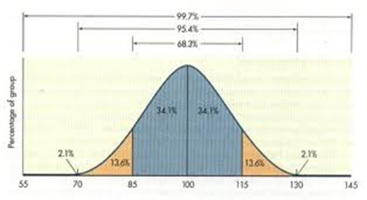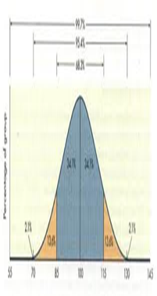

*Narrowing the health gaps between and within countries to fair levels of inequality (equity)*

If we were to apply, in a universal ethical way, the best national social models enabling low levels on inequity, to the world´s required levels of international solidarity, the levels of contribution from countries above the minimum threshold, to a global solidarity fund for countries with resources below the minimum requirements for the right to health, would range , in a progressive mode, from 0,1% of the low-middle income countries to some 1,5% of the high income countries. Additional contribution mechanisms could be designed to collectively progress on global public goods and continue enabling progress, yet in an equitable way and preventing the tragic and silent global death inequity toll.

1. *Public health strategy based on the ethics of equity : from mitigation to transformation.*

Both at global and at national levels, the evidence presented above requires ¡of a new public health strategy that truly includes the principles of health by all, for all and in all, in a transformational way.

At present, most health policies, strategies and services, focus on the provision of health services aimed at being universal and equitable. The equity in the access to and use of health services is most often missing or very weak given the predominant fragmentation of health services in their financing and or provision, according to the income and labor nature of the citizens. Only a dozen of systems worldwide have pooled health financing for and equal to all citizens, but they are gradually suffering as well the infiltration of private insurances and providers capturing a growing share of the middle class as health care costs of progressively unhealthy (and in a parallel way un-eco-sustainable) lifestyles and an high margins of the health care industry, continue to rise. After the Ottawa charter, it became clear that the best provision of health preventive and curative services would, at best, rescue some 30% of the health lost to other causes beyond the health sector.

Thereafter, the strategies of "health in all policies" have progressed in many countries through health impact assessment of sectors influencing health outcomes. However, the level in which health has influenced critical policies to health levels and its distribution has been, to be very diplomatic, limited, For instance, how health influences the most influencing variable in the access and satisfaction of health needs, protection and potential, that is, resources, through economic regulations and fiscal redistribution, has been very exceptional and limited. In general, the provision of health preventive and curative services, and the influence in some other policies often aimed at limiting their potential negative impact, has been of a mitigating nature, far from addressing and changing the "factory of inequality" underlying the dynamics of health inequity. As countries comply with their reporting on national health inequities, we may see which multi-sectorial health policies have a greater impact in reducing health inequities.

A new philosophy and strategy of public health based on the ethics of equity, will require some preconditions : to be based on legal frameworks that ensure equal rights for all (including the access to equal scope and quality of health preventive and care services), with address equity in all policies and which ensure participatory mechanisms so that all citizen have access to the information on the health distribution, its dynamics and the public policies and finance mechanisms to aim at greater equity, so that health is by all.

Once these preconditions are met, the best feasible state of health should be agreed upon, starting from some global minimum levels, as described in the previous sections.

Such target will allow the definition of the burden of health inequity through healthy live years lost and through excess (and avoidable) deaths ( a more understandable notion for all). The burden of health inequity should be the or one of the key indicators in measuring the inclusiveness of a society and its socioeconomic policies and strategies. It is the best indicator of social cohesion as no other one incorporates the dynamics of virtually all social and ecological factors and policies.

The (unfair) distribution of the most influencing variables of root causes of ill health and unequitable distribution (mainly income, knowledge/education and geographic settings -which combines the ecological and social conditions-) may then be assessed by their contribution to the burden of inequity. What is most important, the threshold of these conditions under which the enjoyment of the right to health and its standards is not feasible, should be set. The definitions of these thresholds (e.g. minimum income) should influence structural changes in policies (e.g. fiscal policies) ensuring the prevention of such conditions.

Equity should also be the guiding principle in all health information systems by disaggregating data by the root causes (income, education, location) and the fixed determinants (such as sex, age and ethnic origin). Disaggregated data collection and analysis of health related information (including lifestyles, risks, incidence of diseases and access, use and quality of preventive and health care services) will enable the equity focus in health and all other policies.

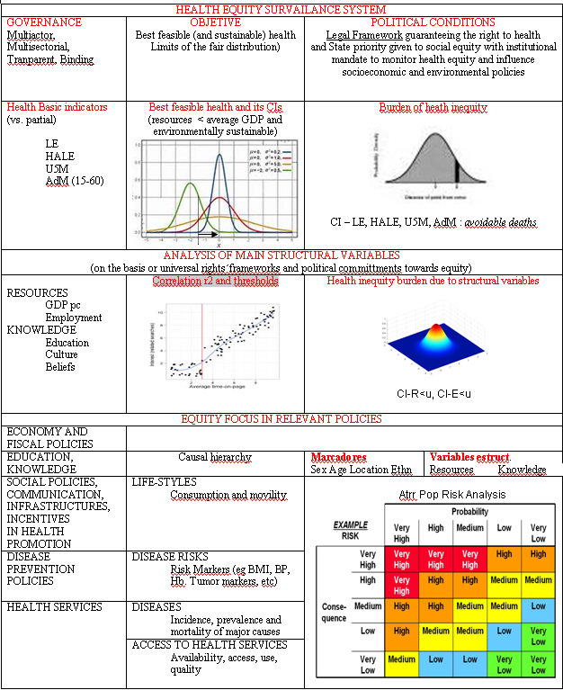

*Public health strategic framework based on the ethics of equity*

1. http://faceaface.revues.org/745
2. Costa Rica, Colombia, Salvador, Belize, Tunisia, Cuba, Moldova, Vietnam and Sri Lanka have health indicators within the range of high income countries yet with GDP pc below the world’s average, the latter four below half of the world’s average GDP pc, and have economies which are ecologically sustainable at global level (hectare use per capita < 1,6 pc, and carbon emissions < 3 Tm pc).
3. https://apha.confex.com/apha/141am/webprogram/Paper291133.html
4. Wilikinson and Picket : The Spirit level.