EFFECTIVE PASTORAL RESOURCE MANAGMENT IN NORTHERN KENYA:

PRESENTATION TO THE SEMINAR: “HOT TOPICS IN AGRICULTURE”
HELD IN BRUSSELS FROM 12TH TO THE 14TH JULY 2010.

By Daoud Tari Abkula
Email:dabkula2000@yahoo.com
Tel: +254712406212
Isiolo
Kenya

MANAGING THE RANGELANDS: THE CASE OF NORTHERN KENYA PASTOTALISTS.

Introduction:
Pastoralists are one of the most researched yet least understood groups in the world. Despite decades of empirical research, many policy makers, government staff, NGO personnel, and the broader public do not fully understand or appreciate the rationale and dynamics of pastoral livelihood systems. This poor understanding has resulted in inappropriate policies and development interventions, which have systematically undermined pastoral institutions and their strategies for responding to environmental adversity, particularly in arid and semi-arid environments. Ever since colonial times policy makers have viewed pastoralists as archaic, unproductive and environmentally damaging relics of the past, which need to be brought into line with “progressive and modern” development. Policies have consistently focused on settlement as the way of bringing pastoral communities improved services and economic opportunities. Land titling, privatisation of the commons and provision of permanent water are some of the interventions that have been used to “modernise” pastoral people. The vast majority of these actions have proved ineffective as well as costly, in both social and economic terms. Although poverty and marginalisation are neither exclusive to pastoral people nor affect all pastoralists equally, compared with other groups in East Africa they suffer disproportionately from insecurity, poor access to social and economic services, social dislocation, political marginalisation and poverty.

The greatest paradox is that an enormous amount of research, carried out over the last thirty years, provides sound scientific evidence that pastoralism is a viable form of land use that is well adapted to the unstable environmental conditions of dryland Africa. So why is it that the perception of pastoralism as a backward, economically unproductive and environmentally damaging system is so pervasive amongst so many actors in the development community?

The reasons for the persistence of such deep-rooted prejudice are highly complex; rooted in history, culture and past and present socio-economic and political processes, they also differ from one country to the next. However, two broad explanations seem to underpin this paradox, at least in part: a knowledge gap and an imbalance of power.

Inadequate & inappropriate
institutional environment for pastoral development
Giving rise to a whole series of problems including land alienation, destitution, conflict & crime, lack of appropriate services, etc.

Power Imbalance

Knowledge Gap

The knowledge gap among policy makers and development workers
This lack of knowledge about pastoralism can be attributed to several related factors, among which:
- Little of the research on pastoralism filters down to those who most need it. This is partly because it is published in books and articles that are not readily available or accessible in Africa. In addition, relatively few universities and technical colleges in Africa and the North incorporate it into their courses attended by future policy makers and development workers. Typically, pastoralism features as a sub-component of broader disciplinary courses on subjects such as range management, livestock production or animal health.
- Northern cultural values and ideologies, which are widely shared by Southern policy makers, continue to shape environmental policy in dryland Africa. Within this analysis, pastoralists are singled out as the main culprits for environmental degradation.
- Pastoral groups themselves lack the knowledge, capacity and resources with which to fight their own cause. Pastoralists are frequently unaware of the stakes at play in the policy arena and they are unable to challenge the perceptions that the rest of the world has about them and their way of life.

The imbalance of power between pastoral communities, the State and other interest groups
Information alone will not induce policy makers to change their policies. Policy design is essentially a State-driven political process aimed at reconciling the divergent needs of multiple stakeholders. As with all processes involving conflicting and diverging interests, those interests that are backed by political and/or economic power that are the ones to prevail. Thus, although policies are theoretically supposed to respond to the common needs of the nation as a whole, in practice they tend to favour politically or economically dominant elites who have the power to influence policy in their favour.
In East Africa, pastoralists generally lack the political or economic “weight” required to influence policy decisions. Among the many reasons for this, two elements should be taken into account:

- First, governments have little economic or political interest in promoting pastoral interests per se, as they tend to see pastoralists as a “minority vote”, given the fact that there are relatively few of them occupying what is considered to be marginal land with little economic potential. The situation is not much better in countries where pastoralists are in the majority, such as Somalia or Somaliland, where political power is concentrated in the hands of an elite who tend to use it to pursue their own short-term political and economic agendas rather than for the common good.

- Second, although pastoral civil society groups are beginning to occupy a prominent place in East Africa, and are commanding an increasing proportion of development aid, they remain relatively weak. In many cases they are ill equipped to articulate and defend the interests of their members, and have limited financial resources and poor management skills. A major constraint is their difficulty in establishing a common front with each other and forging strong institutional links with other groups. Many groups are lead by educated urban elites who although they come from a pastoral background do not necessarily represent the interests of, or report to, local people.

Opportunities for brokering political leverage exist for pastoral people, but to do they need to be better informed to develop appropriate policy arguments and better organised to make those arguments heard by policy makers. Pastoral people need to familiarise themselves with the policy process and put themselves at the centre of the local and national debates aimed at addressing their priorities and needs.

Policy education for self-determination
The process of supporting self-determination is long and complex in any community, and is particularly difficult among pastoral people, given their levels of poverty and a policy environment that is at best indifferent and at worst hostile to their livelihood systems. Yet, until pastoral citizens develop the skills and confidence to define and defend their vision for their development, they will remain vulnerable to others' interpretations of what is best for them.

Helping pastoralists (as individuals and as members of representative associations) understand the dynamics of their own livelihood system in relation to the dynamics of the East African environment, as well as comprehend ongoing institutional reforms (decentralisation, PRSPs, privatisation, land legislation,CONSTITUTION etc.) is an essential pre-requisite for self-determination. Improving their knowledge will help them to identify their own solutions to current problems and speak in an informed and authoritative manner on policy issues of concern to them. The ability to use the “language” of policy makers will give them a more equal footing in discussions with government and the development community, as well as the confidence to challenge outsiders’ perceptions of pastoralism. Extending this understanding to the grassroots membership of pastoral groups will trigger internal processes of accountability as local people start to understand the issues and demand more democratic control over their associations.

Many organisations in East Africa support pastoral capacity building. Their activities focus on improving pastoralists’ ability to manage rural service delivery (e.g. decentralised animal health care), or to understand the institutional context in which they find themselves (e.g. civic education programmes). Increasingly attention is being paid to help pastoral communities understand, analyse and ultimately contest the overall policy framework regulating their livelihood systems, and the underlying forces that keep them in poverty and on the margins of society.

RESOURCE USE AND MANAGEMENT IN NORTHERN KENYA:



Pastorallism thrives in a dis-equilibrium environment that is characterised by uncertainty and variability of resource base. Critical resource like rains and ensuing growth of pasture cannot be clearly determined on fixed timeline and proportional out put. It is spread over time and space between seasons and this therefore calls for management system that is constantly adapted to changing environment and circumstances, that is fluid and flexible. Mobility is thus a key strategic tool used by pastoralist to opportunistically exploit these spatial and temporally spread resources. Movement between dry season grazing areas and the wet season grazing lands are key features that keep the vibrancy of pastoral system in place. To ensure not only resource use prudence but orderly availability during periods of scarcity, pastoralists have developed elaborate management systems over water use that is tools for managing not only access to water but pasture and even contain livestock numbers and other resources. This is guided by intricate and sophisticated negotiations between groups, observance of principles of reciprocal rights and property regime right as defined by pastoralist customs

Water and rights over its use are critical in determining access not only to water, but also to pastures and other resources in pastoral areas. The location, legal status and technical characteristics of a water source are critical components that determine the conditions under which pastoralists can access and manage pastures. Understanding the links between water and natural pastures is important for appreciating how the pastoral system works as a system. Governments usually only see water provision in pastoral areas either from a livestock perspective and do not take into account issues of how it will impact on pasture management or solely in terms of water quality and accessibility for people, particularly women. Rarely are the dual requirements of water for both livestock and people considered in policy and development projects.

MARTI RANGELAND USERS ASSSOCIATION:

The borans of Marti plateau in Isiolo district of northern Kenya have lived in this part of the last two centuries raising livestock for their living. They have domesticated the rangelands with the famous beef producing boran cattle that feeds the upcountry part with meat. Faced with challenges like all other pastoralist that emanate from hostile government policy and programmes, changing climate with its impact, growing population and overall changing social political dynamics in the region, they have to adapt and up their game if managing the rangelands that is the source of support to their livelihood. They thus evevolved a management system that heavily borrows from their age old management system of dedha(is the largest resource management system used by the Boran for the purpose of resource management}

A hybrid institution that is accountable to its members and uses rules and regulation that is internal to the community and can also engage external actors like government and others manages the range lands. As said earlier the key strategic component is water around which other resources like pasture, livestock numbers ,movement time and also the impact on wet season grazing areas are determined. They use this arrangement which they had over the years to govern and use the rangelands.

STRUCTURE OF BORAN SOCIETY:

The following case study illustrates the roles, responsibilities and social relations among Boran pastoralist society.

The organizational structure of Boran society is generally described in terms of a hierarchy, which includes the household, extended families, encampments or villages (ollaa), neighbourhoods containing encampments (madda), and regional associations of neighbourhoods (dheeda). The smallest unit is the hearth (ibidda) with one male household head, his wife or wives and children. This is followed by warra - the fundamental component of production – which comprises households with extended family including up to four other relatives who live and eat with the herd owner’s family (see Figure 1 below). Cross-cutting this territorially-based hierarchy are the mana (lineage) and gosa which broadly nests clans within sub-moieties and moieties.

In support of production and management systems, functional aspects of pastoral society include decision-making and allocation of responsibilities and resources. Although the household (warra) is the basic unit of production and consumption, some types of work are carried out cooperatively. These labour-sharing activities include herding, watering animals, marketing dairy products, and constructing corrals and fences. Additionally, benefits in terms of social activities, group security and information sharing play a vital role in the development of encampments. Within the production system, herding involves females and males from 6 to 25 years of age. Younger boys and females in general are engaged in doing most of the caring for ruminants and warra (resident cattle) as well as foora herding. Watering animals from deep wells is an arduous dry-season activity, which is primarily the task of young men, but it is also common to see older youths of both female and male engaged. Within encampments (ollaa), women share marketing duties, through rotation, especially if they reside far from the market and thus have a large opportunity cost in terms of the time needed to get to the market. Women and youths also cooperate during construction of communal enclosures and bush fences.

Figure 1: Customary Borana Institutions (non-clan)
abba gadda
Gadda
Borana people

jaarsa dheeda council

dheeda

dheeda
Territory

jaarsa maddaa council
maddaa
maddaa
Locality/PA
warra
warra
warra
warra
olla
olla
Household
Village

Hearth
ibidda
ibidda

******************************************************************************************************

In the Boran social system descent is recognised only through the male line and men and women descended from a common ancestor constitute a corporate group in that they share many collective rights and obligations. Men who head the warra are called Abba Warra or father of the household and make strategic decisions regarding livestock production and sales. The father of the encampment (or Abba Ollaa), who is selected from among the Abba Warra, is a respected individual who provides leadership to other members of the ollaa. Lineages (mana) are the basic components of the descent system and determine roles in ritual, water management and wealth distribution. On the other hand, clans (gosa) are groups of lineages that share a common male ancestor. Clan members are expected to help each other in times of hardship in addition to providing a wider network of mutual assistance than individual lineage. Members of clans reportedly settle their disputes amicably at clan meetings (kora gosaa) in which clan elders (jaarsa gosaa) use moral authority to settle disagreements, through imposing fines on wrongdoers and seizing property. Additionally, they have roles in ritual, maintenance and regulation of water resources and the redistribution of wealth among the pastoralists.

In Boran society there are two moieties (Sabboo and Goona) that represent the highest social division. Members of one moiety can only marry into opposite moiety, and moieties are approximately equal in population size. The source of social justice in the system is the balance of power between Sabboo and Goona that permeate all aspects of collective decision-making. Moieties play a prominent role in the election of Gada councillors. The heads of the two moieties are called qaallu, who have ritual leadership duties, responsible for organizing the election of Gada leaders, and act as the ultimate adjudicators of major conflicts. Gada leaders are elected at the Gumi Gayo assembly held in Dirre every eight years. The clan leaders are known as jallaba and have the responsibility to attend the clan meetings, besides playing other roles in the Gada system representing the clan.

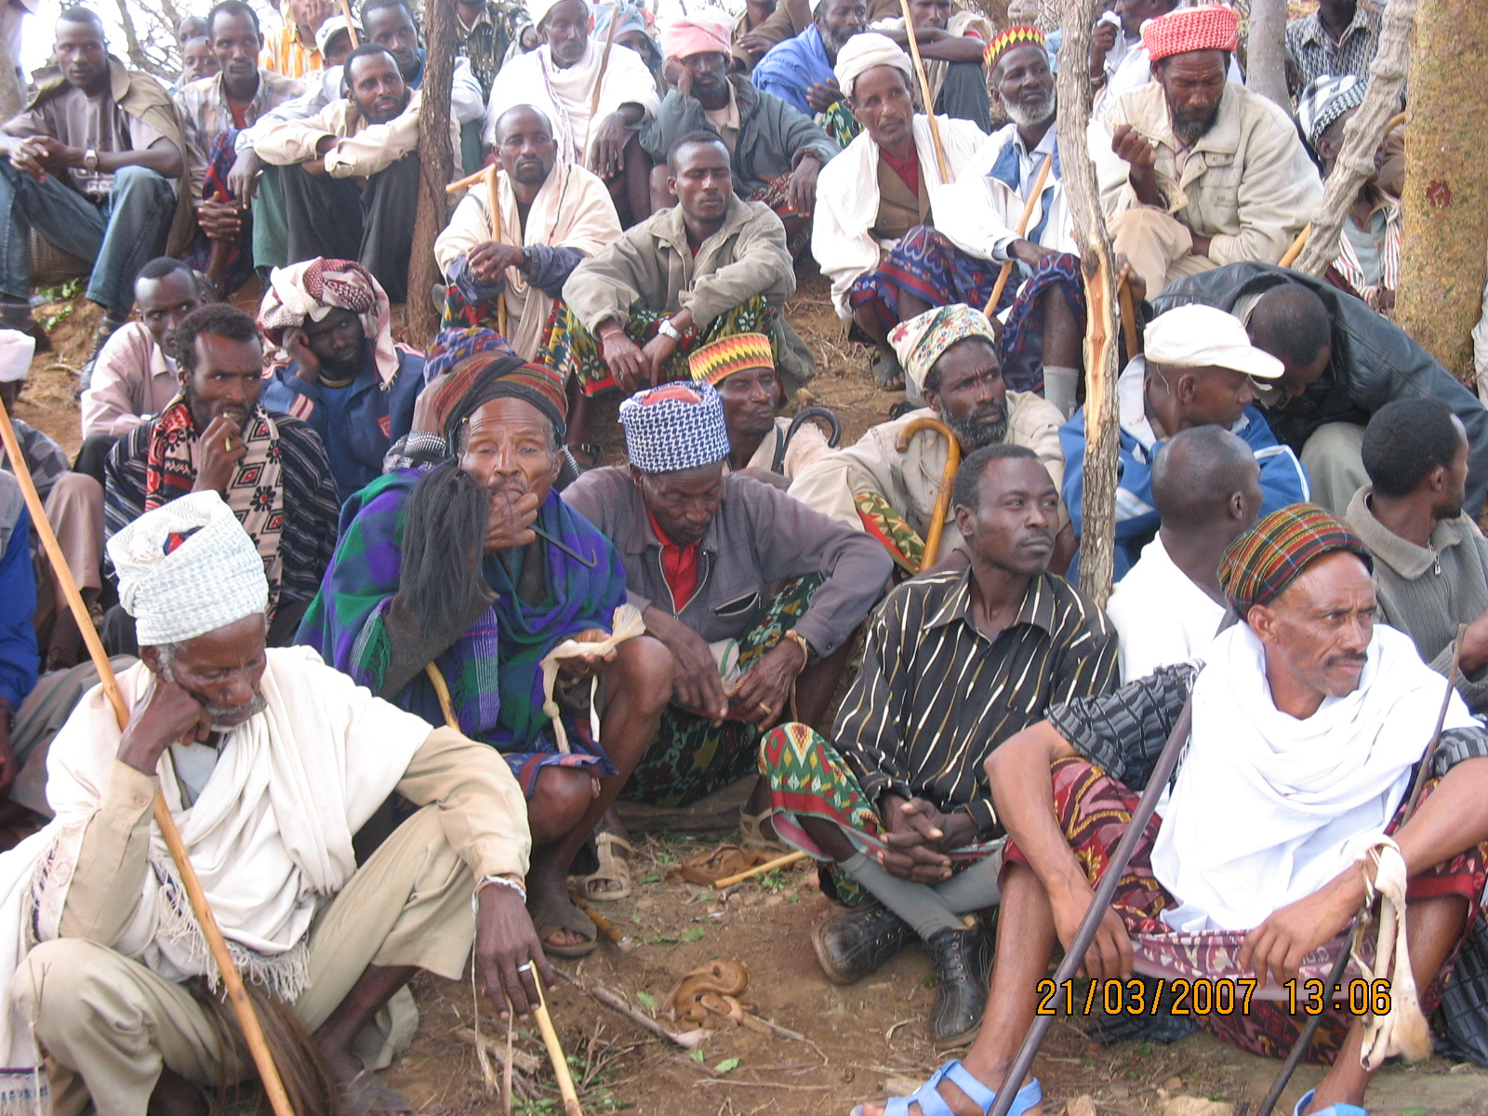
Boran elders at gathering to deliberate over natural resource and other community issues.

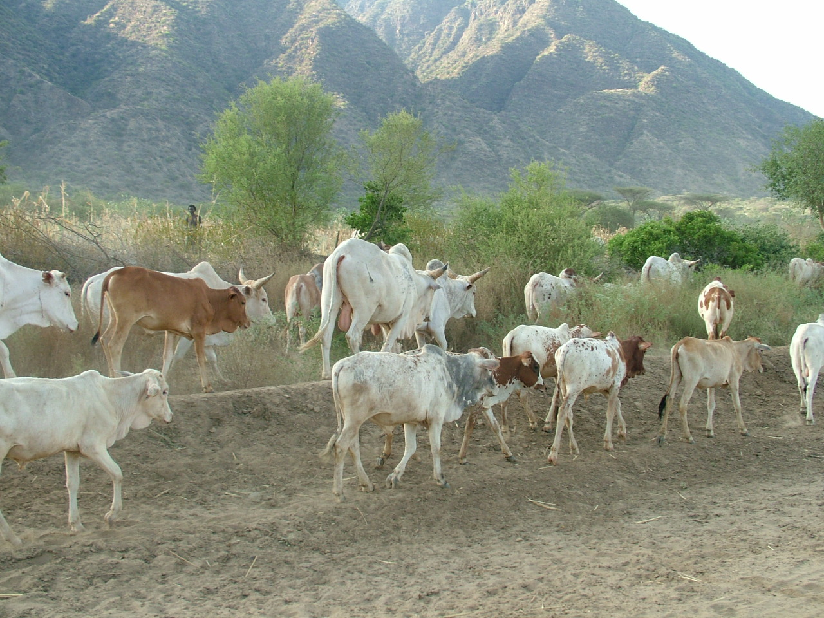

Boran Cattle on their way to water.

Key theories underpinning these beliefs are the Tragedy of the Commons (Hardin, G. 1968); Vegetation Change and Succession (Clements, F.E 1916, Sampson, A.W 1917); and the Cattle Complex (Herscovits, M.J. 1926).

