Supporting Capacity Development in Government Audit
Donors have always understood the importance of effective government audit to strengthen public expenditure. In the past decade, the increasing use of budget support and partner country systems for delivering aid have united countries and their development partners behind a common need: more effective government audit. However, support provided to Government audit bodies (National Audit Offices, Auditor Generals Offices, Cour des Comptes/Court of Accounts) has been piecemeal, focused on donor priorities rather than on comprehensive capacity development. A new cooperation between 16 international development agencies and INTOSAI, the global umbrella organization for the external government audit community, is putting capacity development at the heart of support to government audit.
Why Does Effective Government Audit Matter?
Effective government audit matters for three reasons.
- Firstly, government audit is a key component of public financial management (PFM). Weak government audit means that systemic problems in the collection and spending of public funds, and the use of public assets, may go unnoticed, while strong government audit can be a catalyst to continual improvement in PFM, strengthening government performance and service delivery, as well as reducing opportunities for corruption.
- Secondly, strengthening state-society relations. This is the area most often overlooked. Effective external audit bodies with the necessary independence from the executive are uniquely placed to contribute to building state-society relations. Where they are recognized by non-state actors as being independent and are able to undertake and report transparently to society on the utilization of public funds, they contribute to enhancing the legitimacy of the state, as well as strengthening the formal accountability chain between state and society. Their work also supports the core functions of the state: those basic building blocks which all states need to function effectively. For example, thorough improving the efficiency of the collection of state revenues and management of natural resources, ensuring public funds are utilized in accordance with the law, and strengthening the financial control environment to reduce the occurrence of corruption, which can otherwise undermine state legitimacy.
- Thirdly, managing donors’ fiduciary and development effectiveness risk. When development funds are channeled through partner government systems, donors rely on government audit to check whether funds are used for the purposes intended and achieve expected results.
Working Together to Strengthen Government Audit
The International Organization of Supreme Audit Institutions (INTOSAI) was established in 1953 to foster collaboration between external government audit bodies, known collectively as Supreme Audit Institutions (SAIs). INTOSAI is an autonomous, independent, and nonpolitical organization of SAIs from 189 countries that operates as an umbrella organization for the external governmental audit community. INTOSAI aims to promote good governance by enabling SAIs to help their respective governments improve performance, enhance transparency, ensure accountability, maintain credibility, fight corruption, promote public trust, and foster the efficient and effective receipt and use of public resources.
INTOSAI and the donor community share common goals of enhancing accountability, transparency, good governance and the sound utilization of public funds. Recognizing these common goals and the need to work together more effectively, INTOSAI and 16 international development agencies, including the European Commission, signed a Memorandum of Understanding establishing an initiative that has become known as the INTOSAI-Donor Cooperation.
The INTOSAI-Donor Cooperation provides a strategic focus for donors and the SAI community in supporting the capacity development of SAIs. The Cooperation’s guiding principles are based on sustainable capacity development and aid effectiveness, such as: the development of country-led strategic and development actions plans; donors respecting SAI country leadership; and donor support harmonized and aligned behind SAI-led plans. The Cooperation itself is governed by a Steering Committee chaired jointly by INTOSAI and Donor representatives, and supported by a Secretariat within the INTOSAI Development Initiative (IDI). The IDI was established to help develop the capacity of Supreme Audit Institutions in developing countries through needs-based, collaborative and sustainable development programs, and draws on 25 years capacity development experience.
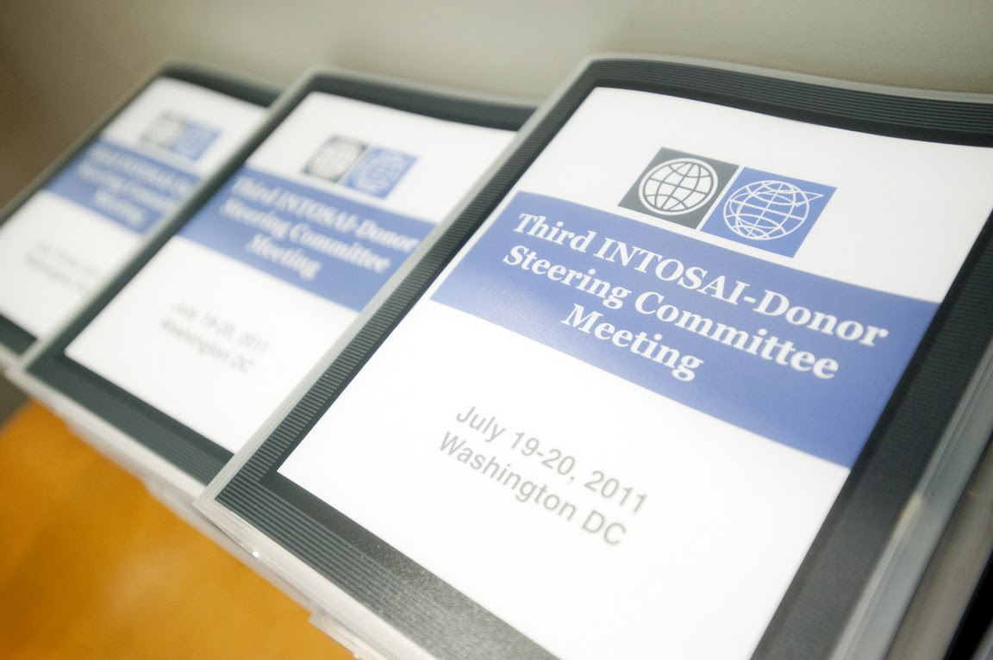
The State of Government Audit
The INTOSAI-Donor Cooperation was established partly in recognition of weaknesses in support to SAIs.
- Firstly, support was often poorly coordinated at the country level. Peer support from other SAIs as well as donor financed support projects sometimes worked in isolation rather than in partnership, with SAIs and consultancy firms competing and proposing different solutions to the same challenges. Support was often piecemeal and not linked to a coherent approach to sustainable capacity development.
- Secondly, there were weaknesses in the allocation of resources for SAI capacity development. Some SAIs and regions with significant support needs received little support, whilst others had overlapping support projects. Support was often driven by donors’ priorities rather than SAI’s priorities, and in many cases the SAI had not determined its own development priorities.
- Thirdly, there was no clear global picture on the results of support to SAIs. For all the money spent on support to SAIs, it was not possible to measure globally whether SAIs had become more independent, increased the quality and coverage of their audit work, and contributed to improved accountability, transparency, good governance and the utilization of public funds. Looking forward, it was also unclear how much support SAIs in different regions required, how much was being provided, and where major resource gaps existed.
A 2010 Stocktaking report ‘Capacity Development of Supreme Audit Institutions: Status, Needs and Good Practices’ carried out by the INTOSAI-Donor Cooperation painted the first ever global picture of the state of external government audit. Previous studies of public financial management reform, synthesized in ‘What do Public Financial Management Assessments tell us about PFM reform?’ (ODI, 2010) had drawn on PEFA data to highlight that external audit and legislative oversight appeared to be among the weakest components of PFM. But the Stocktaking was the first study to look in detail at external government auditing, and covered 183 countries.
The Stocktaking showed mixed results. The majority of SAIs performed well on timely issuing of annual audit reports and on coverage of financial audit. But measured by audit coverage, one in six SAIs were barely carrying out their core mandate. And the development of performance auditing remained particularly weak in many countries. Data on performance improvement over time is scarce, but early analysis of those countries that have carried out repeat PEFA assessments during 2005-10 suggests SAI performance improved in more countries than it declined. At the country level, performance improvements were easier to observe. For example, support to the Office of the Auditor General of Zambia from 1997-2010 contributed to audit reports being submitted to Parliament within 12 months of the year end (from 2-3 years previously), audit coverage increasing from 20-30% to 75% of the audit client base, and a reduction in mismanagement of public funds to 2% of GDP per year.
2010 Stocktaking Findings
Global SAI Performance
- 75% of SAIs issued annual audit reports within the established legal time limits
- Financial audit coverage: 59% of SAIs managed to audit more than 50% of their client base annually
- …but 16% of SAIs audited less than 10% of their client base annually
- 66% of SAIs were not meeting their own expectations in performance auditing
Strategic Planning
- 71% of SAIs had a strategic plan in place
- 63 SAIs expressed a need to develop or update their strategic plan
Capacity Development Needs and Support
- Capacity development support was being provided to 98 SAIs
- …but additional future funding needs were estimated at US $269 million
- …or around US $2 million per SAI with major support needs
- Support is being provided by 48 SAIs, 8 INTOSAI regional / sub-regional bodies, and the IDI
Responses to the Stocktaking identified the following factors as crucial for sustainable capacity development.
- SAI ownership of a comprehensive needs assessment…
- …transformed into long term strategic plan and medium term development action plan
- …forming the basis for measurable results and activities of capacity development programs
- …designed to build on past successes and contribute to incremental change
- …in professional staff capacity, organizational systems capacity and wider institutional capacities
- Requiring commitment of SAI leadership and management
- …with external support based on long term partnerships to foster trust, cooperation and understanding
- …with well planned, gradual exit strategies from external support
Strengthening and Scaling-up Support to SAIs
The INTOSAI-Donor Cooperation has already secured or is negotiating funding of around US $8 million for high priority global and regional programs to support capacity development of SAIs in developing countries. This includes support to strategic planning, management development, implementation of the International Standards of Supreme Audit Institutions (ISSAIs), and roll-out of an INTOSAI guide on Building Capacity in Supreme Audit Institutions (available in English and French). To scale up support and reach out to SAIs, in September 2011 the Cooperation launched a Global Call for Proposals for SAI capacity development initiatives in need of additional financial, in-kind or peer-to-peer support. Proposals should demonstrate, in particular: the benefit to SAIs in developing countries; ownership and demand by SAIs; alignment behind strategic and development actions plans; coordination with ongoing support; and strong frameworks to monitor and evaluate results. It is hoped that proposals will be financed through a variety of support mechanisms, including SAI peer-to-peer support, bilateral donor support, pooled funds at the country level, and a possible global multi-donor trust fund. The latter may be particularly useful for SAIs in real need of support operating in countries with limited donor presence.
Final proposals for support must reach the INTOSAI-Donor Secretariat by 14th November 2011.
For information on the INTOSAI-Donor Cooperation, visit www.idi.no or email intosai.donor.secretariat@idi.no

