Sustainable and Disaster-resilient Development in Vulnerable Countries
Context: The degradation of ecosystems – such as forests, wetlands, coastal and marine systems, and drylands – is a major driver of disaster risk and a key component of disaster vulnerability. Conversely, the impacts of disasters on vulnerable communities can be lessened with improved ecosystem management. This approach is known as Ecosystem-based Approaches to Disaster Risk Reduction or Eco-DRR.
Objective: Between 2013 and 2016, the UN Environment Programme (UNEP), in partnership with the European Commission, implemented Eco-DRR demonstration projects in the countries of Afghanistan, Democratic Republic of the Congo, Haiti and Sudan. The goals of the interventions were: to improve ecosystem management to boost local resilience to disasters and lessen climate change impacts; to demonstrate the cost-effectiveness of the Eco-DRR approach; and to enhance local and national capacities to integrate Eco-DRR in national and local development planning.
Facts & Figures
- A national training course on Eco-DRR reaches 300 participants, mostly from government ministries

- Approximately 50 universities worldwide deliver a post graduate course on Eco-DRR

- 300 faculty members from 200 academic and teaching institutions trained

- Massive Open Online Courses attracts 17,000+ participants from 183 countries
Results: In Afghanistan, Eco-DRR is now included in climate change adaptation and resilience projects under the newly established Afghanistan Resilience Consortium. https://www.youtube.com/watch?v=nLzDdoS0fmQ
In the Democratic Republic of the Congo, Eco-DRR was incorporated into the Action Plan of the Lukaya River Basin Users Association for the period 2016-2021, and there is donor interest in supporting related agroforestry action. https://www.youtube.com/watch?v=lXjPEsu6jPM
In Haiti, Eco-DRR is integrated into the country’s nascent protected area management framework, and UNEP helped to facilitate Inter-American Development Bank funding of US$4 million to the Ministry of Tourism. https://www.youtube.com/watch?v=eThpDsywyzc
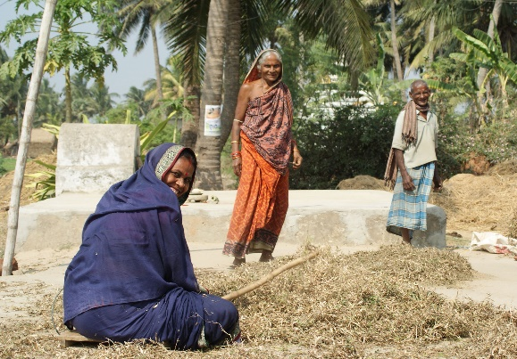
In Sudan, disaster resilience was incorporated into the establishment of the Water Forum in the State of North Darfur. https://www.youtube.com/watch?v=ZsX_Nv6LZzY
Building on the success of this project, UNEP received additional funding from the European Commission to scale up and mainstream Eco-DRR approaches in its focus countries. The agency has also mobilized additional funding from the Government of Norway for regional activities and partnership building.

