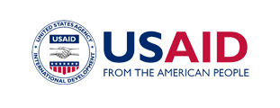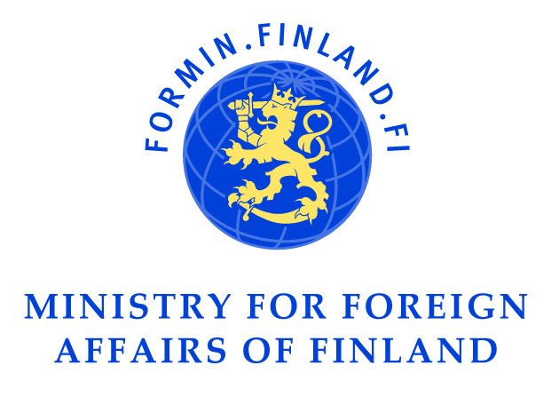

The U.S. Agency for International Development and the Ministry for Foreign Affairs of Finland present a performance by:

"Signmark" * and a panel discussion on “Aid effectiveness principles necessary for disability inclusive development”.

The panelists:

Ms. Heidi Hautala, Minister for International Development, Ministry of Foreign Affairs of Finland

Ms. Charlotte McClain-Nhlapo, Coordinator, Office for Disability and Inclusive Development, USAID

Prof. Hyungshik Kim, Korea University of International Studies, Member
of UN Convention on the Rights of Persons with Disabilities Committee

Dr. William Rowland, Representative of the International Disability Alliance

Date: Thursday, 1st December 2011

Time: 1.30 p.m. - 3.00 p.m.

Venue: Bexco conference centre- MH#202(1-3)

*Signmark (a.k.a. Marko Vuoriheimo) is the Special Representative of Ministry for Foreign Affairs of Finland. He was born deaf. He is the first deaf person to sign a record deal with Warner Music. He will perform a few songs.

All delegates are invited to attend.

