Improving the soil management practices in urban critical zones through Knowledge@Terra classes

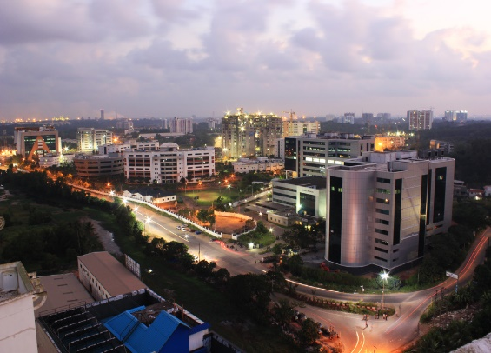

Image source: wikipedia
Kerala, the southern state of India is blessed with many rivers, streams and unique geology with a combination of highlands, midlands and lowlands. The state, renowned as the lad of coconut palms is famous for paddy, spices and other agricultural products like plantain and tapioca. Cochin, an important Indian urban agglomeration in Kerala is a dynamic city with a lot of growth possibilities. The opportunities on Kochi is very high due to the presence of Special Economic Zone, the metro rail service connecting the various small towns etc. The city has historic importance and had trade connection with Portuguese, Dutch and English. The connection with culture and art forms are still maintained in spite of urbanisation by hosting various art and cultural events like the Muziris Biennale. The city has a number of constructions which is increasing day by day and hence, reduction of land is a major problem in the region. Correspondingly, the agricultural production has also decreased compared with traditional times. A major produce of vegetables are coming from other Indian states. But the city has a growing awareness on organic farming due to the knowledge related to the use of harmful pesticides and their negative effects on human health. The government also has been supporting organic farming over these years. A few regions have been focussing on organic farming methods but the concept has to be scientifically developed and popularised throughout the region. The current main gaps are proper branding of organic products, the costs involved in organic branding etc. There are also other constraints in soil testing like high costs involved in the detection of pesticides and heavy metals and the absence of low cost soil analysis units which is beyond the budget of a common farmer. Also the Kerala region has been experiencing floods in August 2018 and 2019 which has made the situation worse in mountain regions. There were landslides as a result of torrential rains that resulted in deaths and agricultural loss in the mountain areas. Knowledge @ Terra can find some solutions to the soil quality related problems. In the region and can contribute to improve the existing constraints related to organic farming and soil analysis. With this aim a short study was conducted on the existing scenario of Kochi region and we are looking at possible solutions to the major issues listed in the study.

